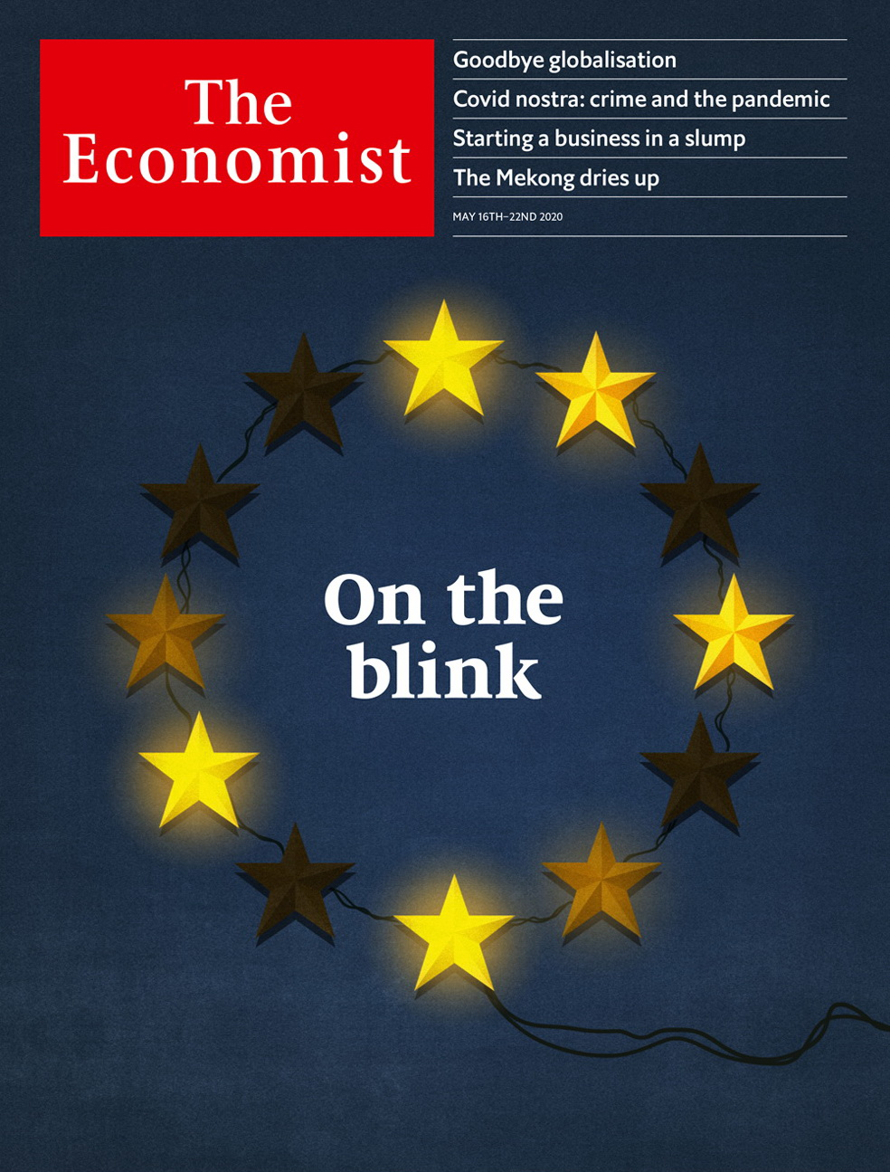

# Table of Contents

The world this week

Politics this week

Business this week

KAL’s cartoon

Leaders

The world economy: Goodbye globalisation

The EU’s bad crisis: On the blink

Escaping the lockdown: First, do no harm

Unemployment: Reopen and shut

Hydropower in Asia: Water torture

Letters

Letters to the editor: On reopening schools, golf, religion, St Helena, underpants

Briefing

Europe under strain: Searching for meaning

Globalisation: Torn apart

Business resilience: Hanging together

United States

Welfare and work: The jobless market

Social mobility: Is zipcode destiny?

Donald Trump’s taxes: On the money

Irish pubs: Craics in the business model

The rule of law: Friends with benefits

Lexington: Mike Pompeo’s followership

The Americas

Bolivia: In limbo

Venezuela: Bay of piglets

Bello: Looking back on the Shining Path

Asia

The Mekong: Torrent to trickle

Sino-Indian border disputes: High dudgeon

Covid-19 in South Korea: A catchy beat

Sexual mores in Taiwan: Philanderers hold their breath

Banyan: Soldiers everywhere

China

Mental health: Picking up the pieces

Tibet: The lost boy

Chaguan: Keeping it local

Middle East & Africa

Covid-19 in Africa: The long game

Elections 1: We don’t need no observation

Ethiopia: Democracy delayed

Syria: Family feud

Saudi television: Series of changes

Europe

France leaves lockdown: Free at last

Controlling covid-19: The Swedish way

North Macedonia: Lies, damned lies…

Naval strategy: Northern fights

Charlemagne: Real life and postcard views

Britain

Britain’s international reputation: How others see us

Toothache in a pandemic: Say cheese!

Immigration: Who cares?

The economy: Acute to chronic

Public Health England: Carry on covid

Schools: Pencils down

Trade unions: A whiff of smoke-filled rooms

International

Crime and covid-19: Covid nostra

Business

Bankruptcies: Chapter 11’s new chapter

Profits seeping: America’s profit warning

Bankruptcies in Europe: Buying time

Chinese brands: Upping the Anta

Bartleby: Teachable moment

Austerity in Silicon Valley: The next garage

Schumpeter: The gathering swarm

Finance & economics

The global economy: A good kind of bubble

Turkey in trouble: A host of difficulties

Geopolitics and capital markets: Feuding over funds

European Central Bank: Lane speaking

Free exchange: The great levelling

Schools brief

Bad times: The widespread damage from climate change

Science & technology

Health data and privacy: Looking without looking

Protecting great apes from covid-19: Maintaining other species’ barriers

Wirelessly charging electric cars: It’s time to cut the cord

Industrial standards: Shear, veer, cheer

Books & arts

Disinformation and democracy: The rhythm of struggle

British fiction: Down to Brixton

Johnson: What’s that again?

Home Entertainment: Catch up on the finest French television dramas

Home Entertainment: Design your own board game

Perspectives: Confinement has always been part of human life

Economic & financial indicators

Economic data, commodities and markets

Graphic detail

Travel and covid-19: The covid network

Obituary

Eavan Boland: Visions in the ordinary



### Friday, May 15, 2020

|  |  |
| --- | --- |
| The world this week | 3 |
| Leaders | 5 |
| Letters | 1 |
| Briefing | 3 |
| United States | 6 |
| The Americas | 3 |
| Asia | 5 |
| China | 3 |
| Middle East & Africa | 5 |
| Europe | 5 |
| Britain | 7 |
| International | 1 |
| Business | 7 |
| Finance & economics | 6 |
| Schools brief | 1 |
| Science & technology | 4 |
| Books & arts | 6 |
| Economic & financial indicators | 1 |
| Graphic detail | 1 |
| Obituary | 1 |

|  |  |  |
| --- | --- | --- |
|  | Sections | Leaders |

The world this week

Politics this week

.

Business this week

.

KAL’s cartoon

.

|  |  |  |
| --- | --- | --- |
|  | Sections | Leaders |

|  |  |  |  |
| --- | --- | --- | --- |
|  | Articles | Sections | Next |

# Politics this week

May 16th 2020 |

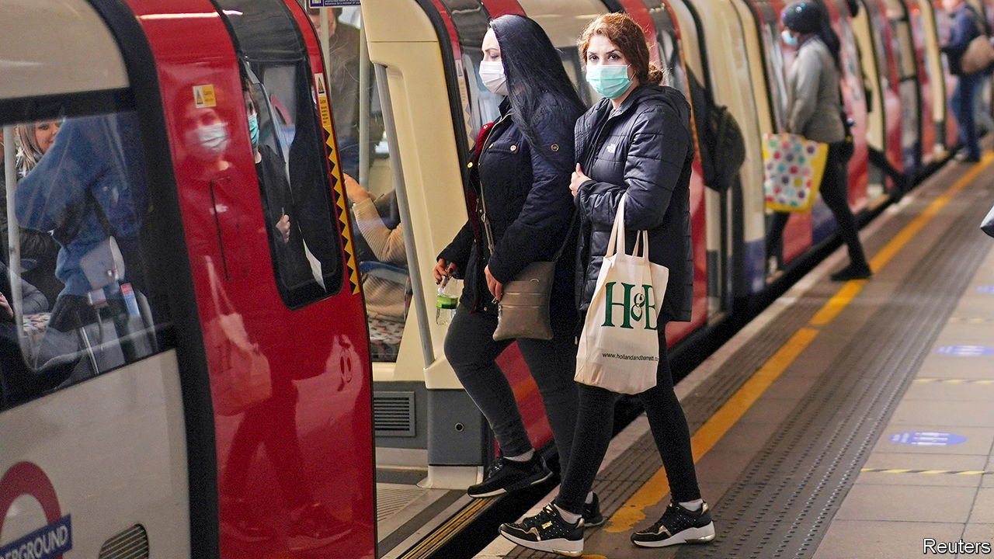

Boris Johnson, Britain’s prime minister, set out a path for easing lockdown in England. His message has changed from “stay at home” to “stay alert”. Restrictions will be eased in phases, depending on how quickly infections fall. Those who can’t work from home are urged to return cautiously to their jobs. Northern Ireland, Scotland and Wales published their own advice. See article.

## Emerging, into the light

France lifted many lockdown restrictions. Primary schools and nurseries have reopened. Most people are allowed to go back to work, with social distancing. Even hairdressers are operating again, but with compulsory masks and no coffee to chat over. See [article](https://www.economist.com/europe/2020/05/14/france-leaves-lockdown).

New York state also took tentative steps towards reopening; three of its regions have met seven criteria, such as a 14-day decline in hospital admissions from covid. In Wisconsin the state Supreme Court ruled against the Democratic governor and overturned an extension to his stay-at-home order.

Anthony Fauci, an expert on infectious diseases who is advising the White House, told the Senate (via a video link) that rushing to end lockdowns before the pandemic has ended would result in more “suffering and death” and do more economic harm in the long run.

The governor of California, Gavin Newsom, said that ballot papers for November’s elections would be posted to all homes. Far fewer polling stations will open than normal.

William Barr, America’s attorney-general, astounded Washington by dropping the criminal case against Michael Flynn, DonaldTrump’s first national security adviser, who had pleaded guilty to misleading the Mueller inquiry. See article.

Two advisers to Juan Guaidó, who is recognised by scores of democracies as Venezuela’s interim president, resigned after a failed attempt to topple the regime of Nicolás Maduro. One of them, Juan Rendón, a Miami-based member of the Venezuelan opposition, admitted negotiating a preliminary agreement with the American security firm behind the botched raid, but says he backed away from the plan. See article.

Moisés Escamilla May, a leader of Los Zetas, a Mexican drug gang, died in prison of covid-19. He was serving a 37-year sentence for crimes, including beheading 12 people in Yucatán. Mr Escamilla supplied cocaine to Cancún.

Avianca, Colombia’s main airline, filed for bankruptcy protection in New York. Founded in 1919, it claims to be the world’s second-oldest continuously operating airline. Its boss blamed covid-19.

India’s government said it would spend $266bn (10% of GDP) on stimulus measures to diminish the economic damage done by its covid-19 lockdown. Around 120m Indians have lost their jobs over the past two months.

Terrorists attacked a maternity ward in Afghanistan, killing 24 people including mothers, babies, medics and a policeman. A suicide-bomber killed 32 mourners at a funeral. The Taliban denied responsibility for both attacks, but the government ordered the army to go back on the offensive, after a period in which it had sought to reduce violence.

Indian and Chinese soldiers brawled at two different spots along the two countries’ long and ill-defined border. See article.

## Beef beef

China announced a ban on imports of meat from four abattoirs in Australia, citing “food safety”. In unrelated news, Chinese officials are furious that Australia is calling for an international probe into the origins of covid-19. China also threatened to impose a tariff of over 80% on Australian barley in response to alleged dumping.

Donald Trump’s administration said work visas given to Chinese journalists would have to be renewed every 90 days. Previously they were open-ended. Liberals fretted that America cannot outdo a dictatorship in curbing reporting, and should not want to.

China warned France not to sell weapons to Taiwan, which is seeking an upgrade of French-made warships it bought in 1991. France said it respected its contractual obligations to Taiwan.

A missile fired by an Iranian naval vessel mistakenly struck an Iranian support ship, killing 19 sailors.

The IMF agreed to lend Egypt $2.8bn to help it cope with the economic fallout from covid-19. “The global shock has resulted in a tourism standstill, significant capital flight, and a slowdown in remittances,” said the fund. Meanwhile, President Abdel-Fattah al-Sisi approved changes to Egypt’s state of emergency that grant him and the security services more power. Human-rights groups say he has used the pandemic to tighten his grip.

Ethiopian troops accidentally shot down a Kenyan plane carrying humanitarian supplies to Somalia, according to a leaked report of the incident.

Three UN peacekeepers were killed when a UN convoy in northern Mali hit a roadside bomb. The peacekeeping mission is the UN’S most dangerous ongoing operation.

## Coronavirus briefs

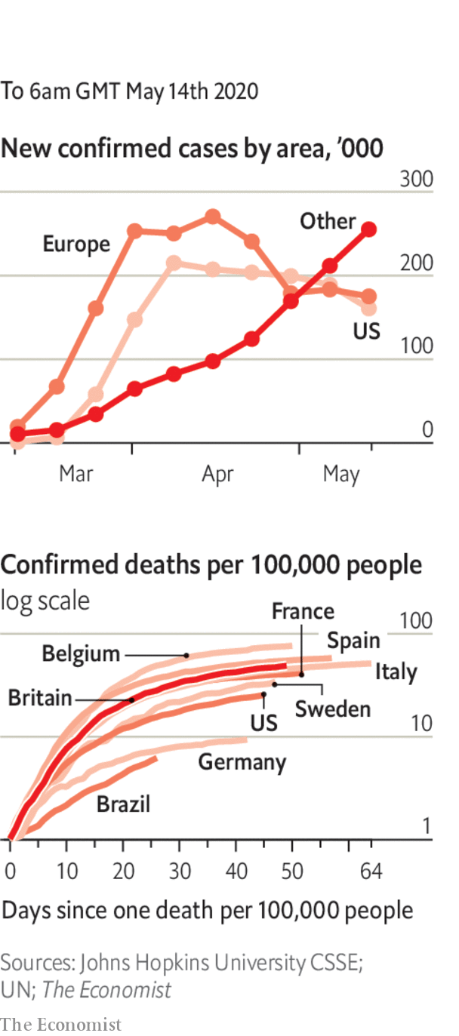

The Chinese city of Wuhan, which recently ended a stringent lockdown, recorded its first new infections since early April. South Korea, which had also largely brought the epidemic under control, reported a cluster of new cases linked to nightclubs in Seoul. See [article](https://www.economist.com/asia/2020/05/14/infections-at-nightclubs-mar-south-koreas-relaxation-of-restrictions).

Lebanon reimposed its lockdown after a spike in covid-19. The government has faced widespread protests recently. It blamed people who ignore social-distancing rules.

Brazil recorded its highest daily death toll. It is the sixth-worst affected country by cases and fatalities.

Disneyland Shanghai reopened for business after shutting for three months. The limited number of visitors must have a digital health code.

The White House ordered everyone in the building to wear a face mask, except Donald Trump and Mike Pence.

This article was downloaded by calibre from <https://www.economist.com/the-world-this-week/2020/05/16/politics-this-week>

|  |  |  |  |
| --- | --- | --- | --- |
|  | Articles | Sections | Next |

|  |  |  |  |
| --- | --- | --- | --- |
| Previous | Articles | Sections | Next |

# Business this week

May 16th 2020 |

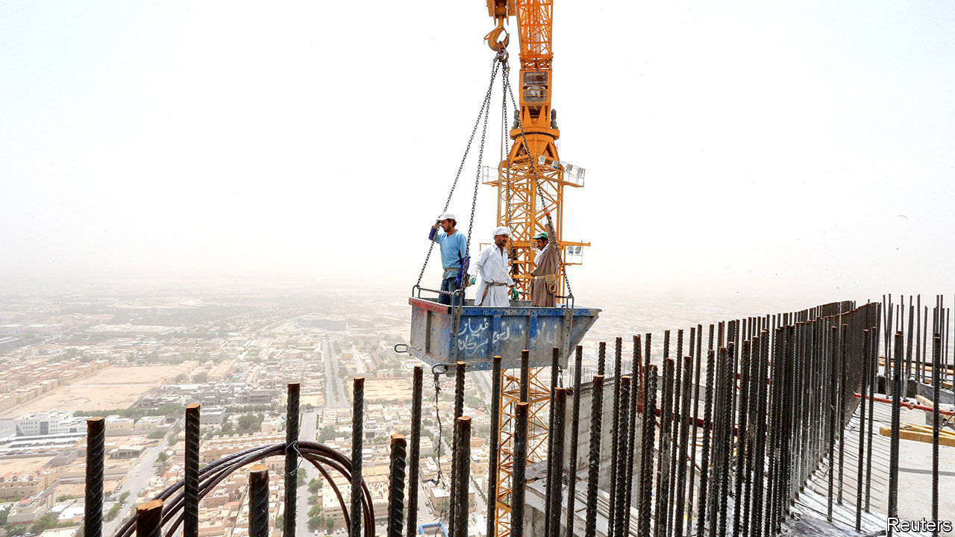

Saudi Arabia said it would cut oil production by another 1m barrels a day from next month, furthering its effort to shore up oil prices. Kuwait and the United Arab Emirates swiftly followed with their own reductions. OPEC’s deal with Russia last month, which ended their abrupt price war and made record cuts to output, has done little to increase prices. Brent crude is trading at around $30 a barrel, half its level in mid-February.

Saudi Aramco reported that its net profit had fallen by 25%, year on year, in the first quarter, to $16.7bn. The state- controlled oil company will still pay a shareholder dividend, most of which goes to the Saudi government. With oil revenue sinking, the government is looking at other ways to raise money, and has tripled the kingdom’s value-added tax rate to 15%.

## Back to Cannery Row

America officially lost 20.5m jobs in April. The number for just one month dwarfs the 8.6m jobs that were lost over the whole of 2008 and 2009 during the financial crisis. The unemployment rate has soared to 14.7%, the highest since the second world war. Steven Mnuchin, the treasury secretary, conceded that it could hit 25% in the coming months, a level last seen during the Depression. See article.

Stockmarkets took fright after Jerome Powell, the chairman of the Federal Reserve, warned that more stimulus from Congress will be required. The Democrats have proposed an extra $3trn in spending, though their plan is not supported by Republicans.

Despite avoiding a prolonged lockdown, the South Korean economy shed almost half a million jobs in April, the most since 1999 at the tail end of the Asian financial crisis. The pandemic has created a “wartime situation” in the economy, said the country’s president, Moon Jae-in.

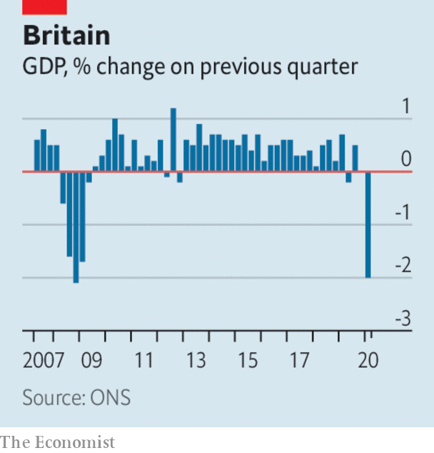

Britain’s economy was 2% smaller in the first quarter than in the previous three months, the fastest rate of contraction since the global financial crisis of 2007-09. However, the figure only captured a glimpse of the chaos caused by covid-19. Britain’s lockdown began in late March; the economy was 5.8% smaller in that month than it was in February. Forecasters think the economy could shrink by 20-30% in the second quarter. A study by academics at the London Business School found that household spending has plunged by 40-50% during the crisis. See article.

The British government extended its pay-protection plan until October, through which furloughed workers receive 80% of their wages subject to a salary cap. But the government said that in the summer it would ask companies to start sharing the scheme’s cost in order to ease the strain on public finances.

Kristalina Georgieva, the head of the IMF, warned that the outlook for the global economy had worsened since the fund published a gloomy scenario just last month. See article.

PNC Financial, America’s ninth-largest bank, announced the sale of its 22% stake in BlackRock. The stake is worth around $17bn. PNC was BlackRock’s biggest shareholder, but as a regional bank it is potentially exposed to souring loans in the energy and hospitality industries during the pandemic. Selling its holding bolsters its capital defences.

Turkey’s financial regulator lifted a brief ban on BNP Paribas, Citigroup and UBS from trading in its currency market. According to the regulator the banks were barred because they had not settled with their Turkish counterparts. But the ban coincided with the lira falling to another record low, suggesting that the government was trying to prop it up. See article.

Vehicle sales in China rose by 4.4% last month compared with April 2019, according to the China Association of Automobile Manufacturers. It is the first increase since mid-2018 (when a tax break on car purchases ended) and was driven by a surge in sales of commercial vehicles. Sales of passenger cars remain subdued.

Toyota said it expects operating profit for the current financial year to fall by 80%. The world’s second-biggest carmaker thinks its sales will drop to a nine-year low.

While industries in the physical world bear the brunt of locked-down economies, those in the virtual realm continue to thrive. Tencent, one of the world’s biggest tech conglomerates, reported a 26% rise, year on year, in quarterly sales, as the number of subscribers to its video service surged to 112m and that for its music service to 43m. It made a profit of 28.9bn yuan ($4.1bn) in the quarter.

## Getting greedy?

Uber was reportedly in talks to merge Uber Eats, its food-delivery service, with Grubhub, a rival in that market. The combined operations would take a 55% slice of the food-delivery industry in America. That might be too much to swallow for trustbusters in Washington.

This article was downloaded by calibre from <https://www.economist.com/the-world-this-week/2020/05/16/business-this-week>

|  |  |  |  |
| --- | --- | --- | --- |
| Previous | Articles | Sections | Next |

|  |  |  |  |
| --- | --- | --- | --- |
| Previous | Articles | Sections | Next |

# KAL’s cartoon

May 14th 2020 |

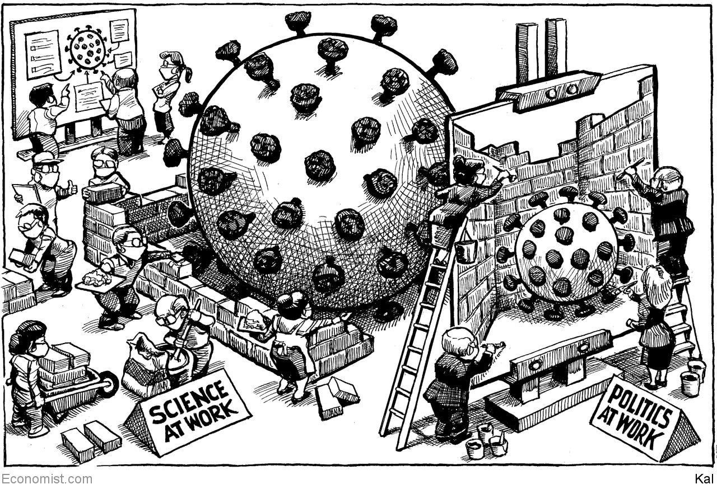

This article was downloaded by calibre from <https://www.economist.com/the-world-this-week/2020/05/14/kals-cartoon>

|  |  |  |  |
| --- | --- | --- | --- |
| Previous | Articles | Sections | Next |

|  |  |  |
| --- | --- | --- |
| The world this week | Sections | Letters |

Leaders

The world economy: Goodbye globalisation

.

The EU’s bad crisis: On the blink

.

Escaping the lockdown: First, do no harm

.

Unemployment: Reopen and shut

.

Hydropower in Asia: Water torture

.

|  |  |  |
| --- | --- | --- |
| The world this week | Sections | Letters |

|  |  |  |  |
| --- | --- | --- | --- |
|  | Articles | Sections | Next |

#### Globalisation unwound

# Has covid-19 killed globalisation?

The flow of people, trade and capital will be slowed

May 14th 2020 |

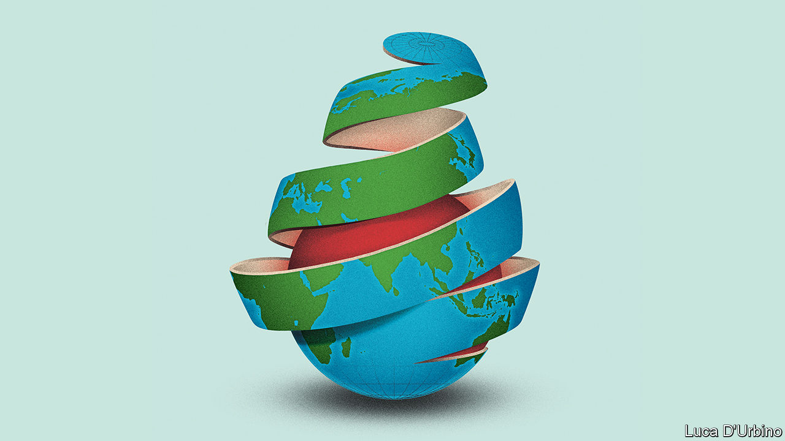

EVEN BEFORE the pandemic, globalisation was in trouble. The open system of trade that had dominated the world economy for decades had been damaged by the financial crash and the Sino-American trade war. Now it is reeling from its third body-blow in a dozen years as lockdowns have sealed borders and disrupted commerce (see Briefing). The number of passengers at Heathrow has dropped by 97% year-on-year; Mexican car exports fell by 90% in April; 21% of transpacific container-sailings in May have been cancelled. As economies reopen, activity will recover, but don’t expect a quick return to a carefree world of unfettered movement and free trade. The pandemic will politicise travel and migration and entrench a bias towards self-reliance. This inward-looking lurch will enfeeble the recovery, leave the economy vulnerable and spread geopolitical instability.

The world has had several epochs of integration, but the trading system that emerged in the 1990s went further than ever before. China became the world’s factory and borders opened to people, goods, capital and information (see Chaguan). After Lehman Brothers collapsed in 2008 most banks and some multinational firms pulled back. Trade and foreign investment stagnated relative to GDP, a process this newspaper later called slowbalisation. Then came President Donald Trump’s trade wars, which mixed worries about blue-collar jobs and China’s autocratic capitalism with a broader agenda of chauvinism and contempt for alliances. At the moment when the virus first started to spread in Wuhan last year, America’s tariff rate on imports was back to its highest level since 1993 and both America and China had begun to decouple their technology industries.

Since January a new wave of disruption has spread westward from Asia. Factory, shop and office closures have caused demand to tumble and prevented suppliers from reaching customers. The damage is not universal. Food is still getting through, Apple insists it can still make iPhones and China’s exports have held up so far, buoyed by sales of medical gear. But the overall effect is savage. World goods trade may shrink by 10-30% this year. In the first ten days of May exports from South Korea, a trade powerhouse, fell by 46% year-on-year, probably the worst decline since records began in 1967.

The underlying anarchy of global governance is being exposed. France and Britain have squabbled over quarantine rules, China is threatening Australia with punitive tariffs for demanding an investigation into the virus’s origins and the White House remains on the warpath about trade. Despite some instances of co-operation during the pandemic, such as the Federal Reserve’s loans to other central banks, America has been reluctant to act as the world’s leader. Chaos and division at home have damaged its prestige. China’s secrecy and bullying have confirmed that it is unwilling—and unfit—to pick up the mantle. Around the world, public opinion is shifting away from globalisation. People have been disturbed to find that their health depends on a brawl to import protective equipment and on the migrant workers who work in care homes and harvest crops.

This is just the start. Although the flow of information is largely free outside China, the movement of people, goods and capital is not. Consider people first. The Trump administration is proposing to curtail immigration further, arguing that jobs should go to Americans instead. Other countries are likely to follow. Travel is restricted, limiting the scope to find work, inspect plants and drum up orders. Some 90% of people live in countries with largely closed borders. Many governments will open up only to countries with similar health protocols: one such “travel bubble” is mooted to include Australia and New Zealand and, perhaps, Taiwan and Singapore (see article). The industry is signalling that the disruption to travel will be lasting. Airbus has cut production by a third and Emirates, a symbol of globalisation, expects no recovery until 2022.

Trade will suffer as countries abandon the idea that firms and goods are treated equally regardless of where they come from. Governments and central banks are asking taxpayers to underwrite national firms through their stimulus packages, creating a huge and ongoing incentive to favour them. And the push to bring supply chains back home in the name of resilience is accelerating. On May 12th Narendra Modi, India’s prime minister, told the nation that a new era of economic self-reliance has begun. Japan’s covid-19 stimulus includes subsidies for firms that repatriate factories; European Union officials talk of “strategic autonomy” and are creating a fund to buy stakes in firms. America is urging Intel to build plants at home. Digital trade is thriving but its scale is still modest. The sales abroad of Amazon, Apple, Facebook and Microsoft are equivalent to just 1.3% of world exports.

The flow of capital is also suffering, as long-term investment sinks. Chinese venture-capital investment in America dropped to $400m in the first quarter of this year, 60% below its level two years ago. Multinational firms may cut their cross-border investment by a third this year. America has just instructed its main federal pension fund to stop buying Chinese shares, and so far this year countries representing 59% of world GDP have tightened their rules on foreign investment. As governments try to pay down their new debts by taxing firms and investors, some countries may be tempted to further restrict the flow of capital across borders.

## It’s lonely out there

Don’t be fooled that a trading system with an unstable web of national controls will be more humane or safer. Poorer countries will find it harder to catch up and, in the rich world, life will be more expensive and less free. The way to make supply chains more resilient is not to domesticate them, which concentrates risk and forfeits economies of scale, but to diversify them. Moreover, a fractured world will make solving global problems harder, including finding a vaccine and securing an economic recovery.

Tragically, this logic is no longer fashionable. Those three body-blows have so wounded the open system of trade that the powerful arguments in its favour are being neglected. Wave goodbye to the greatest era of globalisation—and worry about what is going to take its place.■

This article was downloaded by calibre from <https://www.economist.com/leaders/2020/05/14/has-covid-19-killed-globalisation>

|  |  |  |  |
| --- | --- | --- | --- |
|  | Articles | Sections | Next |

|  |  |  |  |
| --- | --- | --- | --- |
| Previous | Articles | Sections | Next |

#### On the blink

# The European Union is having a bad crisis

By failing to face up to its difficulties, the European Union makes them only worse

May 14th 2020 |

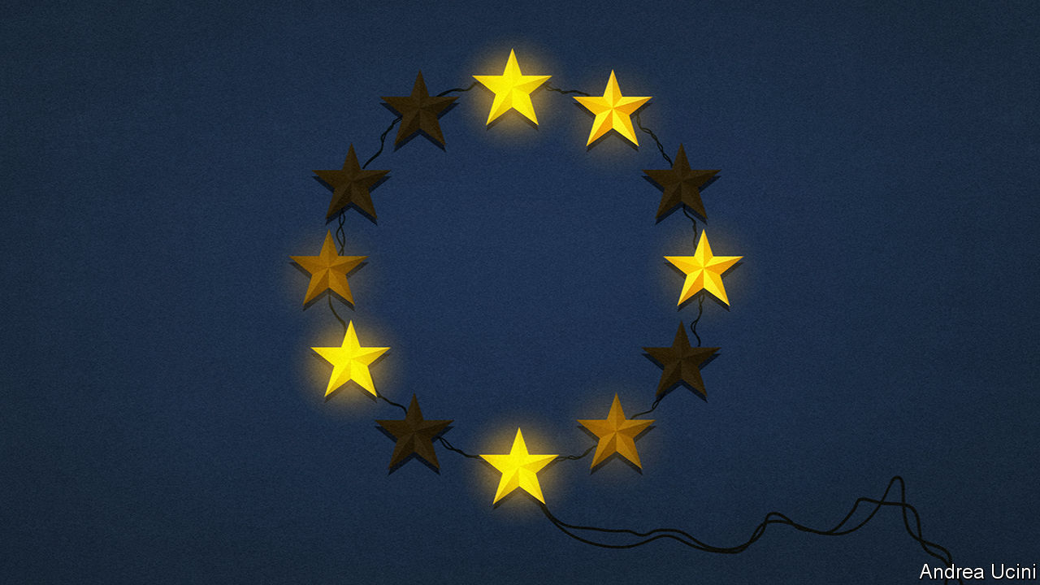

Editor’s note: The Economist is making some of its most important coverage of the covid-19 pandemic freely available to readers of The Economist Today, our daily newsletter. To receive it, register [here](https://www.economist.com/newslettersignup). For our coronavirus tracker and more coverage, see our [hub](https://www.economist.com/coronavirus)

SEVENTY YEARS ago this month Robert Schuman, the French foreign minister, proposed a European “coal and steel community”. With that humble agreement governing two commodities, six war-ravaged countries created a common market that evolved into the European Union.

The journey towards integration since then has been bumpy, but it has had a sense of direction. National leaders came and went, the Berlin Wall rose and fell, economic hurricanes struck and blew themselves out. Somehow, the EU muddled through. It deepened, building the world’s largest single market, letting its people move freely across borders and creating a common currency. It broadened, as 22 states joined the original six, including 11 that had suffered for decades under communism. It cemented peace and spread prosperity. Today, Europe is a beacon of liberal values and an exemplar of a gentler type of capitalism.

Yet the EU has also lost its way. The pandemic in Europe is not just an economic crisis, as elsewhere in the world, but is fast becoming a political and constitutional crisis, too. This is solvable in principle, but the EU’s members cannot agree on what is needed to make their union more resilient, nor on how to bring about reform. Now of all times, when America and China are at loggerheads, that is a tragic missed opportunity.

Belonging to the EU is supposed to bring countries safety in a dangerous world. Instead the pandemic is testing the bonds of membership, just as the financial crisis of 2007-09 did (see Briefing). One example is the single market. This is governed by strict rules limiting subsidies, but they have been suspended as governments pour €2trn ($2.2trn) into saving businesses from collapse. Half of this was in Germany: a problem if you are a producer based in a country that cannot afford to be so generous, but which must accept German-made goods.

Another example is the single currency. As countries cushion the effects of lockdowns, their debts are rising sharply. Because governments in the euro zone borrow in a common currency but must finance themselves, these debts could rise to unsustainable levels. The problem is severe in Italy, which was in trouble even before covid-19 struck and had gross public debts of €2.4trn, or 135% of GDP. Italy’s Eurosceptic firebrand, Matteo Salvini, is hammering the EU for doing too little to help; his party may yet ride this crisis to power, where it would thrive on creating outrage and exploiting divisions with far-off Brussels.

A third example is the status of EU law. Earlier this month Germany’s constitutional court questioned whether the European Court of Justice (ECJ) should have ruled that the European Central Bank could, in effect, backstop the euro by buying debt. Separately, Poland has disputed the ECJ’s precedence over its own supreme court. The EU is built on law. If the stresses of the pandemic weaken the ECJ’s foundations, the entire union will shake.

All these problems can be solved with vision, compromise and reform. Indeed, before the pandemic France’s president, Emmanuel Macron, warned that the EU needed to fortify itself against a less forgiving world. But such sentiments crumble before countries’ different views of what the EU should be for. The prosperous north hates the idea of a “transfer union” that subsidises the needy south—and it hates even more the prospect of mutualising any of the poorer members’ debt. Members cannot agree on what to do about the erosion of democracy and the rule of law in Hungary and Poland. Even before the first death from covid-19, they struggled to forge common policies on defence, Russia, migration and much more besides.

Ominously, the mechanism of reform is also broken. Ever since Schuman’s day, the EU has grown by repeatedly amending the treaties that govern it. But EU leaders have shied away from treaty change since the plan for a new constitution was thrown out by French and Dutch voters in 2005. Leaders have not dared to put through a significant amendment since 2007.

Some northern European leaders recognise that they have a problem. In the coming months they are likely to agree to a one-off increase in the EU’s seven-year budget, but the terms are in dispute—the southerners are calling for as much as €1trn-1.5trn and they want grants, not loans. There is also a proposal to issue common debt as a token gesture, but that is disputed, too.

If the EU is to thrive, it will have to be a lot more ambitious than the northerners admit. For a start, if it is not to stagnate it will need to adapt, and this means overcoming the taboo against treaty change. Successful treaty change entails a broader acknowledgment that different countries want different things from the union and that such a “multi-speed Europe” can be more resilient than today’s unmet aspirations. That, in turn, requires the EU to complete projects like the euro that are vulnerable to shocks because they are only half-done.

Doomsters have often predicted the break-up of the EU or the euro, only to be proved wrong. Muddling through can go on for a long time—especially now that Britain has shown how painful and expensive divorce would be. In the end, though, political systems are judged by their outcomes. The failure to reform treaties puts a burden on the ECJ and the rule of law; German subsidies risk undermining the single market; and economic stagnation will poison the euro.

## The Zoom where it happens

So long as the EU remains a conduit for spreading crises, the risk of collapse will be high. To stiffen their resolve, its leaders should reflect on a more remote anniversary. In June it will be 230 years since the Compromise of 1790, when Alexander Hamilton persuaded Thomas Jefferson and James Madison to allow the new United States government to assume the debt of the 13 individual states. Europe does not need to go so far, and a latter-day Hamilton has no obvious carrot to offer the rich states (in 1790 the deal put America’s new capital city in the South). But there is a stick: if Europe’s wobbly members do not get help, the euro and the single market could eventually implode. European leaders currently negotiating by videoconference must therefore be bold. Bigger transfers and significant debt mutualisation would be hard, but as a down payment to avert catastrophe and to set the EU on the path to stability, they would be worth it. ■

Dig deeper:  
For our latest coverage of the covid-19 pandemic, register for The Economist Today, our daily [newsletter](https://www.economist.com/newslettersignup), or visit our [coronavirus tracker and story hub](https://www.economist.com/coronavirus)

This article was downloaded by calibre from <https://www.economist.com/leaders/2020/05/14/the-european-union-is-having-a-bad-crisis>

|  |  |  |  |
| --- | --- | --- | --- |
| Previous | Articles | Sections | Next |

|  |  |  |  |
| --- | --- | --- | --- |
| Previous | Articles | Sections | Next |

#### Escaping the lockdown

# Don’t rely on contact-tracing apps

Governments are pinning their hopes on a technology that could prove ineffective—and dangerous

May 16th 2020 |

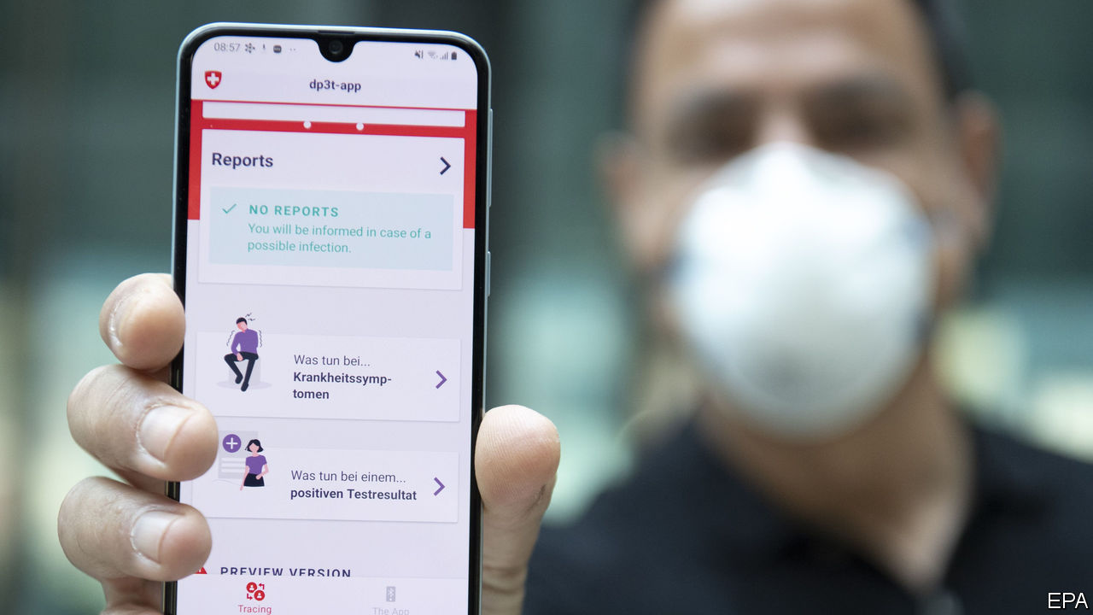

Editor’s note: The Economist is making some of its most important coverage of the covid-19 pandemic freely available to readers of The Economist Today, our daily newsletter. To receive it, register [here](https://www.economist.com/newslettersignup). For our coronavirus tracker and more coverage, see our [hub](https://www.economist.com/coronavirus)

EVERYTHING HAPPENS faster in a crisis. Faced with covid-19, vaccine-makers are cutting as many corners as they safely can. Anti-viral drugs are being rushed into clinical trials. Even so, it will be months until anything is available. With 297,000 people recorded dead, the wait is agonising. But caution is crucial. Medicine’s history is full of promising treatments that, when tested, turned out not to work or even to cause harm.

Many governments hope salvation can come sooner, with contact-tracing apps on smartphones—even as a row brews over Apple’s and Google’s grip on the technology. These apps can be used to automate the difficult process of tracking down people who have been in contact with those diagnosed with covid-19, which is vital for keeping tabs on the virus. Countries from Bahrain and Bulgaria to Indonesia and Iceland have developed such apps.

They are an attractive idea. Yet contact-tracing apps are also an untested medical invention that will be introduced without the sort of safeguards that new drugs are subjected to. Inaccurate information can mislead health officials and citizens in ways that can be as harmful as any failed drug. Governments should proceed with care.

Coverage is one complication. Epidemiologists reckon that apps might be useful if around 60% of people use them. Yet even in Europe, where adoption is highest, only 76% of people have mobile-internet subscriptions. That number is lower among the elderly, the most vulnerable to covid-19. A recent survey suggested less than half of Americans would use a contact-tracing app.

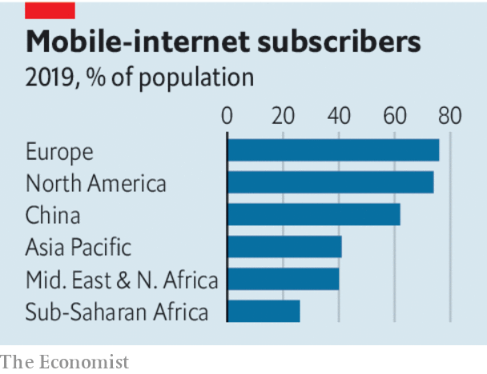

Accuracy is an issue, too. Such apps are designed to listen out for nearby mobile phones, registering a contact if another device comes close enough. Yet the strength of the radio signals used to do this is affected by all sorts of things besides distance. Human bodies impede transmission, for instance, meaning a phone in a pocket will behave differently from one in a hand.

That could make it hard to calibrate the system—and a mistake would have consequences. Too sensitive, and you risk a deluge of “false positives”: contacts deemed close and significant that were actually distant and irrelevant. Too forgiving, and genuine cases of viral transmission will go undetected.

Moreover, the apps themselves might change behaviour. An over-reassuring app could spur people to go out before it is safe. Privacy must be weighed against transparency, for medical reasons as well as for civil liberty. South Korea publishes detailed summaries of cases uncovered by its contact-tracers. A recent jump in cases was linked to a man who visited gay nightclubs. The resulting stream of homophobic invective could deter others from co-operating with the authorities, electronically or otherwise.

The efforts of some governments, including those of Britain, France and Germany, have been complicated by Apple and Google, which between them hold sway over almost every smartphone on the planet. The firms have made privacy a priority, deeming that users will be anonymous and information stored mostly on devices rather than uploaded to central repositories. That has infuriated many officials. Centralisation offers advantages, they say. And in any case, why should coders in Silicon Valley overrule decisions made by medical experts and elected officials?

As a rule, governments are right to worry about the unaccountable power of the tech giants. In this case, though, Google’s and Apple’s cautious approach is sensible. In a pandemic, experimenting with novel public-health responses such as mass surveillance should be done carefully, in case it subsequently turns out to have nasty side-effects. With high-tech software, caution is as valuable as it is with pills and potions. ■

Dig deeper:  
For our latest coverage of the covid-19 pandemic, register for The Economist Today, our daily [newsletter](https://www.economist.com/newslettersignup), or visit our [coronavirus tracker and story hub](https://www.economist.com/coronavirus)

This article was downloaded by calibre from <https://www.economist.com/leaders/2020/05/16/dont-rely-on-contact-tracing-apps>

|  |  |  |  |
| --- | --- | --- | --- |
| Previous | Articles | Sections | Next |

|  |  |  |  |
| --- | --- | --- | --- |
| Previous | Articles | Sections | Next |

#### Re-open and shut

# When lockdowns end, governments will have to free labour markets

Managing the transition will bring many risks

May 16th 2020 |

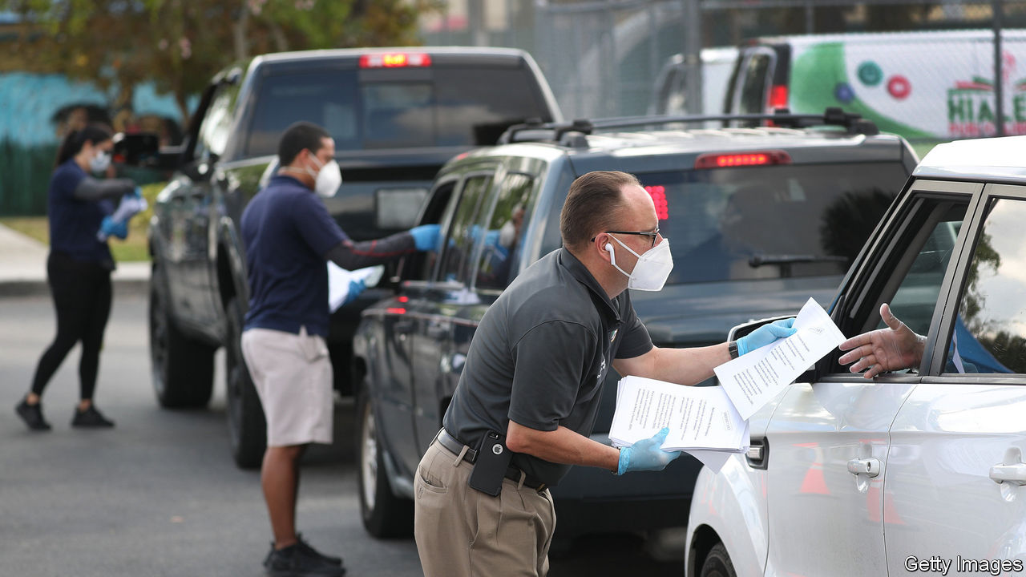

Editor’s note: The Economist is making some of its most important coverage of the covid-19 pandemic freely available to readers of The Economist Today, our daily newsletter. To receive it, register [here](https://www.economist.com/newslettersignup). For our coronavirus tracker and more coverage, see our [hub](https://www.economist.com/coronavirus)

NEVER BEFORE have governments erected safety-nets as generous as those they have created during the pandemic. In Britain 7.5m furloughed workers’ wages are being paid in large part by the state, which is spending more on them than it is on health care. In France the government is topping up the majority of private-sector workers’ incomes after their hours were cut. America has increased unemployment benefits by $600 per person per week, almost trebling the average payout. Since March a staggering 34m or so claims for this kind of support have been made (see article). Germany and Japan have boosted their existing subsidy schemes for furloughed or partially furloughed workers.

These policies have been indispensable. Replacing lost incomes has averted suffering, prevented economies from falling apart and ensured public support for social-distancing measures. Yet governments need to prepare an exit strategy not just from lockdowns, but also from their emergency policies (see [article](https://www.economist.com/europe/2020/05/14/france-leaves-lockdown)). They cannot replace private incomes indefinitely. If today’s transfers are maintained for too long, they will be ruinously expensive and prevent labour markets from adapting to the new way of life that emerges from the pandemic.

Many of today’s schemes reflect the idea that economies need to be placed in deep freeze in order to be revived intact once the crisis subsides. Yet it seems increasingly likely that economies will instead be permanently changed. Consumers may emerge from lockdown with new habits and fears about mixing, spending less on restaurants, cinemas and travel, and spending more on deliveries, home-improvement and video-streaming. Employees may, reasonably, demand higher wages to perform some jobs, such as construction or butchering, which involve working elbow-to-elbow with others all day. And industries starved of immigrant labour because of border controls may have to entice in more locals. Four in ten American jobs lost in the pandemic will not return, according to one estimate based on surveys, historical patterns and stockmarket signals. Three in ten gross job losses have already been offset by new hiring.

The necessary adjustments will not take place while the state pays workers to wait for their old jobs to return—often on better money than they got before. In America roughly three-quarters of recipients of unemployment insurance are receiving more than they did in work. That blunts the incentive to seek new jobs. And yet cutting support abruptly would leave legions of unemployed workers fending for themselves in brutal conditions, especially in America with its thin welfare system.

Governments thus face a difficult balancing act: withdraw support too readily, and many people will suffer; withdraw it too late, and the economy will ossify. To find the right path, the most lavish support should be maintained only in industries which the government is forcibly keeping closed. Once shops, restaurants and cinemas are allowed to open, the market must decide if they have a future. These signals should not be ignored for long.

Schemes should also encourage flexibility. Idled workers should be allowed to return to their companies part-time, as Britain this week pledged. America should make more use of work-sharing schemes, already in place in about half of the states, which, as in Europe, provide benefits on the basis of lost hours of work, not just lost jobs. This should be paired with unemployment insurance, though neither scheme should pay so much that it discourages seeking full-time work.

Finally, governments should help people find new jobs. That means boosting support for training, tearing down barriers to opportunity such as unnecessary licensing rules, and cutting payroll taxes to encourage hiring. As in normal times, governments must not stand in the way of economic change. They should instead grease its wheels—while offering a helping hand to those who are left behind. ■

Dig deeper:  
For our latest coverage of the covid-19 pandemic, register for The Economist Today, our daily [newsletter](https://www.economist.com/newslettersignup), or visit our [coronavirus tracker and story hub](https://www.economist.com/coronavirus)

This article was downloaded by calibre from <https://www.economist.com/leaders/2020/05/16/when-lockdowns-end-governments-will-have-to-free-labour-markets>

|  |  |  |  |
| --- | --- | --- | --- |
| Previous | Articles | Sections | Next |

|  |  |  |  |
| --- | --- | --- | --- |
| Previous | Articles | Sections | Next |

#### Water torture

# If China won’t build fewer dams, it could at least share information

Its secrecy means that farmers and fisherman in downstream countries cannot plan

May 16th 2020 |

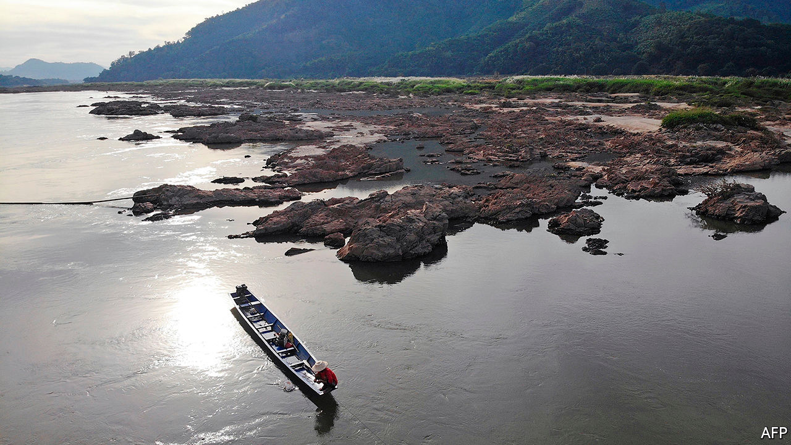

RIVERS FLOW downhill, which in much of Asia means they start on the Tibetan plateau before cascading away to the east, west and south. Those steep descents provide the ideal setting for hydropower projects. And since Tibet is part of China, Chinese engineers have been making the most of that potential. They have built big dams not only on rivers like the Yellow and the Yangzi, which flow across China to the Pacific, but also on others, like the Brahmaputra and the Mekong, which pass through several more countries on their way to the sea.

China has every right to do so. Countries lucky enough to control the sources of big rivers often make use of the water for hydropower or irrigation before it sloshes away across a border. Their neighbours downstream, however, are naturally twitchy. If the countries nearest the source suck up too much of the flow, or even simply stop silt flowing down or fish swimming up by building dams, the consequences in the lower reaches of the river can be grim: parched crops, collapsed fisheries, salty farmland. In the best cases, the various riparian countries sign treaties setting out how much water each will guarantee to the next. In the worst, bickering over the flow is a source of constant tension and recrimination.

Tension and recrimination have been the order of the day for China and its neighbours, alas. In part, this is because a river like the Mekong does not contain enough water to go round. China has already built 11 dams across the main river (never mind its tributaries) and has plans for eight more; the downstream states have built two and are contemplating seven more. Last year, during a drought, the river ran so low that Cambodia had to turn off a big hydropower plant (see [article](https://www.economist.com/node/21786159)). Even when rainfall is normal, the altered flow and diminished siltation are causing saltwater to intrude into the Mekong delta, which is the breadbasket of Vietnam, and depleting the fish stocks that provide the only protein for millions of poor Cambodians.

China has long resisted any formal commitment to curb its construction of dams or to guarantee downstream countries a minimum allocation of water. It will not even join the Mekong River Commission, a body intended to help riparian countries resolve water-sharing disputes. The problem is not just that China gets huffy about anything that could be construed as foreign interference in its “internal affairs”. The country’s leaders are also mesmerised by big engineering projects and seldom show much concern for the people displaced or disadvantaged by them, even when the victims are their fellow citizens. So keen is China on big dams, in fact, that it is helping Pakistan build several on the Indus—a river too small and remote in its Chinese reaches to be worth damming—and is trying to persuade Myanmar to build a huge barrage across the Irrawaddy, whose tributaries flow through China for just a tantalising couple of kilometres.

But even if China’s rulers cannot overcome their engineering fetish, they could do plenty more to reassure their neighbours. Sharing data on water levels routinely, without interruption, would be a good start. During a row over a poorly demarcated section of their shared border in 2017, China stopped providing India with information about the flow of the Brahmaputra that is used to provide flood warnings to villagers downstream. It took a summit of the two countries’ leaders to get the information flowing again. By the same token, downstream countries would love to know when Chinese hydropower plants plan to retain or discharge water, to allow farmers and fishermen in the lower reaches time to prepare. And it would not hurt China to undertake to alleviate droughts when it can. That would send a flood of gratitude flowing uphill. ■

This article was downloaded by calibre from <https://www.economist.com/leaders/2020/05/16/if-china-wont-build-fewer-dams-it-could-at-least-share-information>

|  |  |  |  |
| --- | --- | --- | --- |
| Previous | Articles | Sections | Next |

|  |  |  |
| --- | --- | --- |
| Leaders | Sections | Briefing |

Letters

Letters to the editor: On reopening schools, golf, religion, St Helena, underpants

.

|  |  |  |
| --- | --- | --- |
| Leaders | Sections | Briefing |

|  |  |  |  |
| --- | --- | --- | --- |
|  | Articles | Sections | Next |

#### On reopening schools, golf, religion, St Helena, underpants

# Letters to the editor

A selection of correspondence

May 16th 2020 |

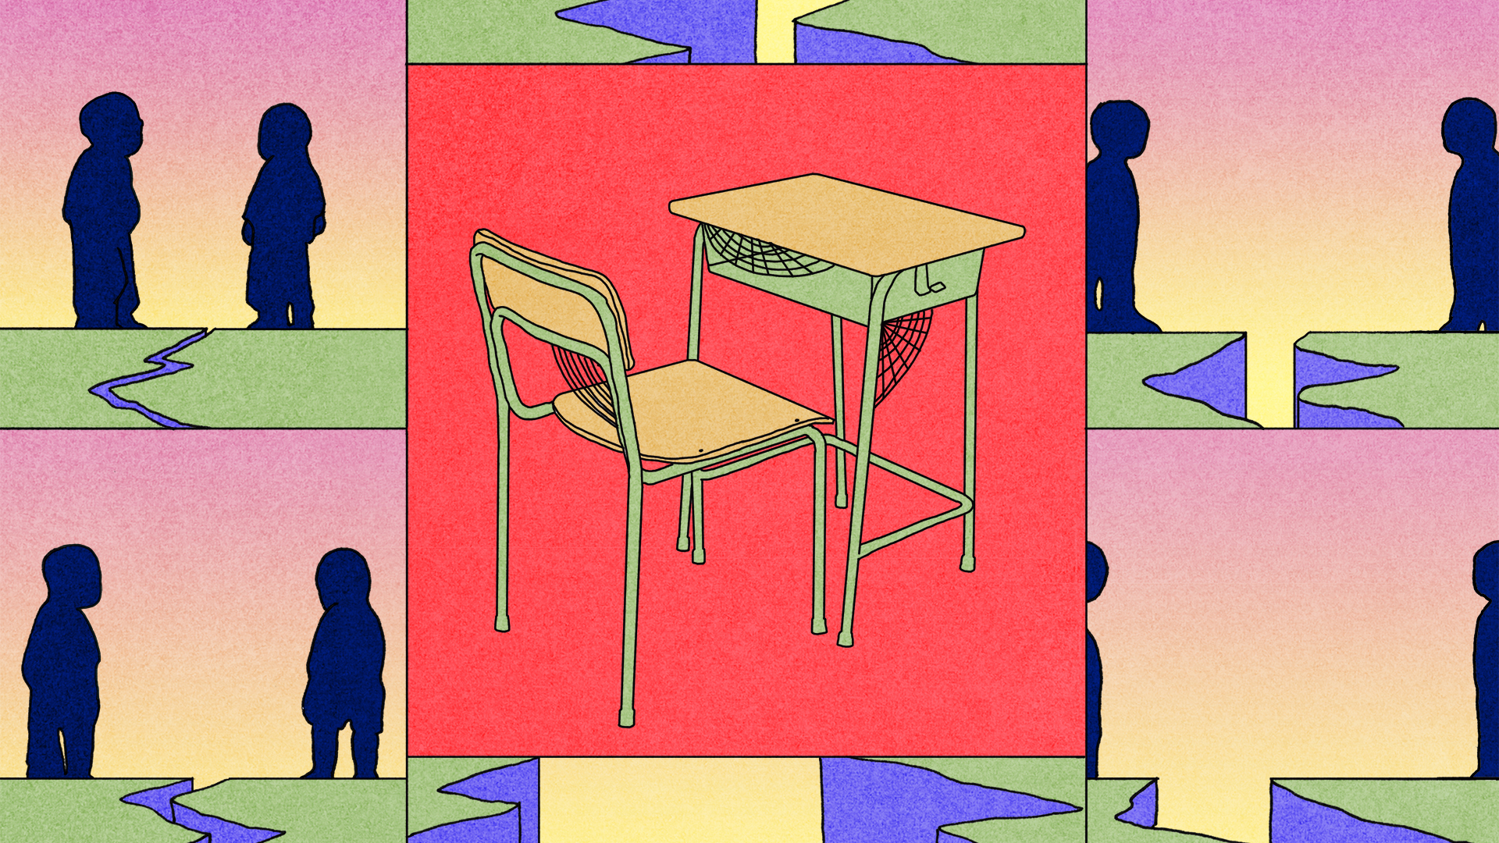

## Is it safe to go back?

I was dismayed by your leader calling for schools to reopen (“[Open schools first](https://www.economist.com/leaders/2020/04/30/when-easing-lockdowns-governments-should-open-schools-first)”, May 2nd). Terry Jones of the Department of Zoology at Cambridge University and his colleagues in Germany studied 3,700 patients with covid-19 and found no significant difference in the viral load in patients among age categories, including children. The study reckoned that children may be as infectious as adults. Paul Hunter of the Norwich Medical School found that closing schools was one of three of the most effective measures in reducing the transmission rate of the disease. (Both studies have not been peer-reviewed.)

You speculated, moreover, that people working from home with young children are less productive. I am a consultant psychiatrist in a high-risk category for covid-19 and the mother of primary-school-aged children. Because I now do not have to commute nor do the school-run my productivity has gone up. I do home visits by computer in areas it would otherwise take me a day to travel to. Vulnerable children often have health issues. Many have to care for adults. Their parents may be too scared to send them to school. Single parents worry about the logistics of sending one child to school while others stay home.

Children at home might not all be completing worksheets or giving thumbs-up emojis in Zoom classrooms, but to suggest they are not learning belies the resourcefulness of those children and their families. Young children, especially, learn through play and watching adults. The unusual situation of the lockdown is giving them opportunities to do that much more so than before. Children are learning all the time: to exercise indoors, to negotiate with siblings, to be patient, to be grateful. These virtues won’t be measured in exams.

You concluded that a rushed return to school may feel like “a rash experiment with young lives”. Children from all socioeconomic backgrounds learn least under stressful conditions. Instead of sending them back on the basis of erroneously extrapolated scientific conclusions, let us make wise, informed, safe choices on their behalf.

SABINA DOSANI  
Consultant child and adolescent psychiatrist  
London

Although you addressed the inequities of returning to the classroom, the biggest consideration for American public schools remains funding. Without additional resources to pay for summer schools, longer hours and shorter holidays this is all a pipe dream.

HELEN LLOYD  
Director of communications  
Alexandria City Public Schools  
Alexandria, Virginia

As a 16-year-old pupil, I can tell you that children thrive off social contact. Some will not comply with social distancing. Others will not be able to resist temptations. Even the most conscientious will breach the rules. It is not realistic to think we can transform crowded common rooms and corridors, with their hugs and handshakes and shared sweets and drinks, into safe spaces.

HARRIS WHITFORD  
Sheffield

The teachers at my school have had to rethink how they approach learning. For my part as a 17-year-old, I have had to grasp how to use the old technology of email. The shutdown has made school administrators aware of the tech disparities among students, which should have been obvious before the pandemic. All said, however, I am very much looking forward to returning to the classroom.

SABINE ZEDNIK-HAMMOND  
Brussels

## Above par

Your special report on [South Korea](https://www.economist.com/special-report/2020/04/08/south-korea-is-going-through-deep-social-economic-change) (April 11th) had much to say, mostly negative, about the plight of women in the country as well as its growing worldwide cultural influence. However, there is one area in which South Korean women completely dominate: golf. Four Korean women—Jin Young Ko, Sung Hyun Park, Sei Young Kim and Jeon Eun Lee—are in the top ten of the Rolex World Rankings. The highest placed male, Sungjae Im, is ranked 23rd. South Korean cultural influence on the world of golf is firmly in female hands.

JAMES LENNOX  
Professor emeritus of history and philosophy of science  
University of Pittsburgh

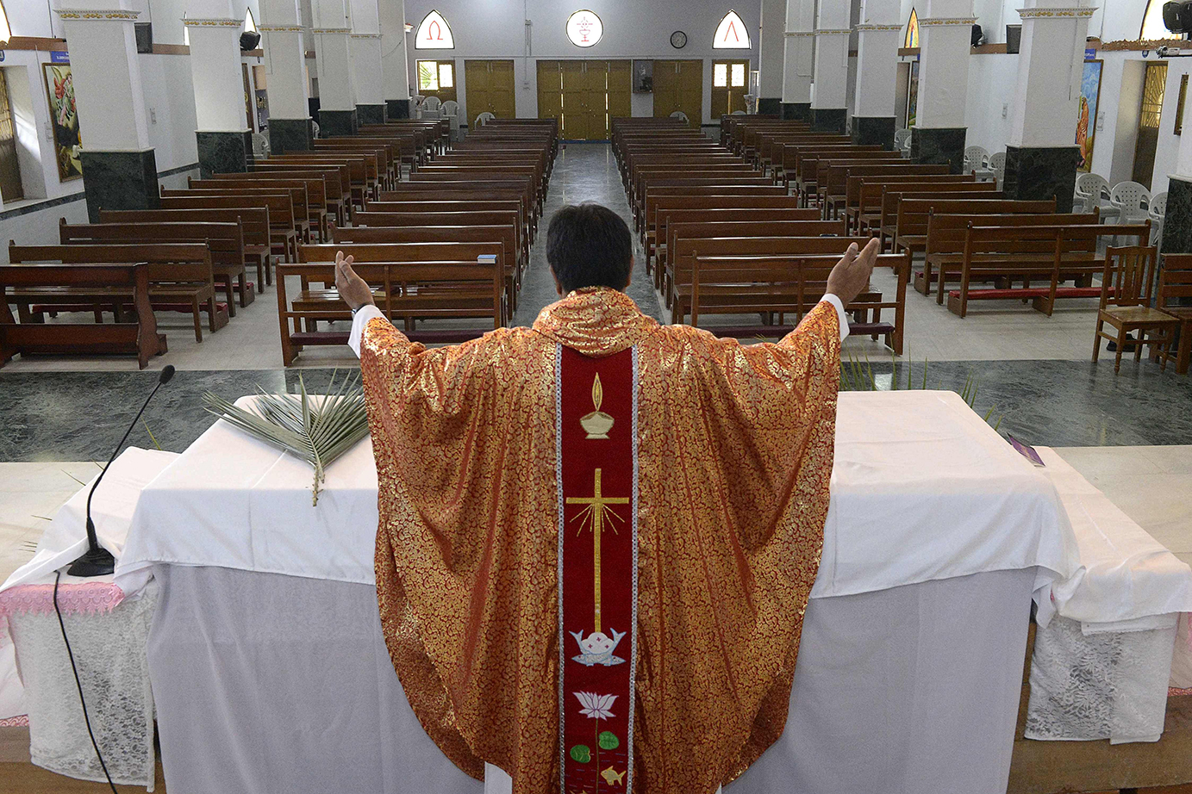

## Smells and bells

There is a basic reason why virtual worship online will not replace the traditional visit to a house of God (“[Our Father, who art in cyberspace](https://www.economist.com/international/2020/04/11/churches-turn-to-the-internet-to-reach-their-flocks)”, April 11th). Religious rituals have been designed to stimulate all five senses. Think of the spectacle of a Catholic mass, the colourful religious processions of the Hindus, the adhans of the mosque, the horns of Tibetan monasteries, the cake and wine of the Eucharist, the chashni of the Zoroastrians, the incense of Shinto shrines and the ghee poured into the Hindu havan, just a few of the world’s thousands of religious rituals that stimulate the senses of their followers.

As for the sense of touch, this obviously needs more than one worshipper to be present. It is for this same reason that virtual company meetings are insipid compared with the real thing.

NAWSHIR MIRZA  
Mumbai



## Hail to the Saints

I read with great interest Banyan’s [column](https://www.economist.com/asia/2020/04/11/the-eternal-fanciful-allure-of-the-south-pacific) juxtaposing the allure and perceived immunity of remote islands in the face of disease with the harsh reality of history (April 11th). By fortunate happenstance, I recently had the pleasure of spending five weeks on St Helena as the covid-19 crisis quickly deepened. Although perhaps best known as the home to Napoleon in exile, St Helena was also one of two places unaffected by the Spanish flu of 1918 to 1920, the other being Antarctica.

I arrived there in mid-March after two weeks at sea to a world greatly changed. Myself and dozens of other cruising sailboats suddenly found ourselves in limbo as country after country along the traditional sailing routes back to North America or Europe closed their ports. There are individuals, couples and families around the world in their small floating homes with no ports at which to call for water, fuel, or provisions (apparently some countries now find maritime safety conventions to be optional).

The Saints, however, welcomed us all with open arms, despite a few, fortunately false, rumours that covid-19 had come to the island and some understandable concerns about the impact on their own scarce resources.

KENNON JONES  
At sea, on passage from St Helena to the US Virgin Islands

## The lockdown pants

In response to your invitation for readers to share their covid-19 experiences ([Letters](https://www.economist.com/letters/2020/04/08/letters-to-the-editor), April 11th) I am a PhD student and have evidently been practising for just such a scenario. Staying indoors, reading and writing in my underpants all day has been almost the sole agenda on my calendar for over a year now.

Laundry has given rise to mixed feelings. I have to do it because there are only so many pairs of underwear. However, there is very little else to add to the machine. A waste of $3 each time. Every penny counts on a student budget, but at least I can put off shopping for trousers a bit longer.

NAREG SEFERIAN  
Arlington, Virginia

This article was downloaded by calibre from <https://www.economist.com/letters/2020/05/16/letters-to-the-editor>

|  |  |  |  |
| --- | --- | --- | --- |
|  | Articles | Sections | Next |

|  |  |  |
| --- | --- | --- |
| Letters | Sections | United States |

Briefing

Europe under strain: Searching for meaning

.

Globalisation: Torn apart

.

Business resilience: Hanging together

.

|  |  |  |
| --- | --- | --- |
| Letters | Sections | United States |

|  |  |  |  |
| --- | --- | --- | --- |
|  | Articles | Sections | Next |

#### Searching for meaning

# The covid-19 pandemic puts pressure on the EU

An old question has resurfaced: what is the point of the bloc?

May 14th 2020 |

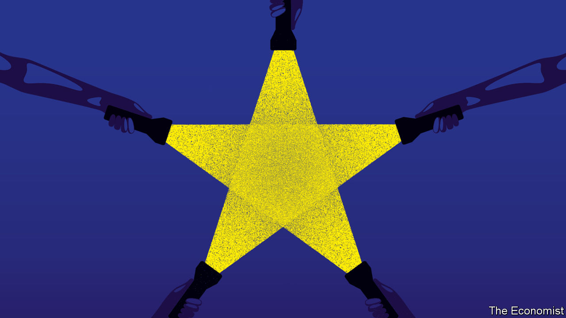

Editor’s note: The Economist is making some of its most important coverage of the covid-19 pandemic freely available to readers of The Economist Today, our daily newsletter. To receive it, register [here](https://www.economist.com/newslettersignup). For our coronavirus tracker and more coverage, see our [hub](https://www.economist.com/coronavirus)

IN JANUARY BRUSSELS was an optimistic place. The European Union (EU) had survived a decade that included the near collapse of the bloc’s currency, a refugee crisis and its second-largest economy, Britain, voting to leave. For the first time in years, officials had time to think of the future rather than clear up the messes of the past. Then 120,000 people died.

Sweeping lockdowns confined citizens to their homes, in Paris and Warsaw alike. A bloc that prided itself on removing borders—“the scars of history” in the words of Josep Borrell, the European Commission’s foreign-policy chief—reintroduced them in chaos. Commuters were stranded at Poland’s borders with both Lithuania and Germany, some of them for days.

The bloc’s GDP is expected to drop by 7.4% this year, compared with a 4.3% fall in 2009, the worst year of the financial crisis. Investors betting on the collapse of the euro have started to drive up Italy’s borrowing costs. European politicians have attacked each other with a ferocity not seen since the euro crisis, when the bloc’s future was last in doubt. After Wopke Hoekstra, the Dutch finance minister, suggested some countries had themselves to blame for their financial troubles, Antonio Costa, the prime minister of Portugal, issued a fierce response. “This speech is disgusting,” he said. “Disgusting.”

The whole world is struggling with covid-19. But in the EU, the pandemic has triggered a concatenation of crises. What started as a health crisis became an economic crisis, then a political crisis, then a financial crisis, says Pepijn Bergsen of Chatham House, a think-tank. Now it risks becoming a constitutional one, after Germany’s constitutional court challenged the legal supremacy of the European Court of Justice earlier this month.

In its current form, the EU amplifies crises rather than solving them. Sticking with the current system is untenable. Altering it will be difficult. Fundamentally different expectations of the EU divide Europeans. At the heart of these disagreements is an inability to find an answer to a decades-old question: what is the EU actually for?

## There’s something evolving

It began as a peace project. On May 9th 1950, five years after the second world war ended in Europe, Robert Schuman, then France’s foreign minister, unveiled a scheme to make war between his country and West Germany “not merely unthinkable, but materially impossible”. His method? Combining the coal- and steel-production capabilities of the two countries, along with any other willing European nations, and putting them under the control of an independent authority. Two years later the European Coal and Steel Community, the forebear of the EU, was born.

Prosperity soon followed, with European co-operation framed as a path to riches thanks to free movement of goods, workers, capital and services in the original club of six countries (as well as France and West Germany it included Italy, Belgium, the Netherlands and Luxembourg). The small club first expanded to its north, with Ireland, Denmark and Britain joining. Then in the 1980s the young democracies in southern Europe, such as Spain, Portugal and Greece were included. By the mid-2000s, much of eastern Europe had signed up, too.

Building up the bloc was a piecemeal process, as Schuman had envisaged, arguing that “Europe will not be made all at once, or according to a single plan.” Slowly and quietly, bureaucrats in Brussels and judges in European courts disassembled barriers to trade and harmonised regulations. In 1992 the single market programme, backed by Margaret Thatcher, the generally Eurosceptic British prime minister, made trade even easier. It took two constitutional earthquakes for European voters to notice that the foundations of their governments had shifted: the introduction of the euro and the expansion of the bloc to include former communist countries in eastern Europe.

These changes had visible effects. A mass movement of people from central and eastern Europe to richer countries in the west made clear that freedom of movement was not just a nebulous concept, but one which affected people’s daily lives; mostly for good but, in the perception of some, for ill. In 2010 the euro-zone crisis was a potent reminder that the fate of the currency in a Belgian’s wallet was in part determined by the actions of governments in Athens, Rome and Madrid. European voters became painfully aware of the EU’s price, and that led to increasingly anxious questions about its purpose.

## The world keeps revolving

Today a common goal is hard to find. The challenges that the EU now faces—on fiscal policy, foreign policy, defence and migration—cut to the heart of sovereignty. Dreams of the EU as a superpower require a strategic unity not easy to find among a 27-member bloc that stretches from Lisbon to Tallinn. Even attempts to turn the EU into an advocate of liberal democratic values fail to inspire everyone. In the past, disagreements on direction could be settled by standing still. Now, the forces that held the EU together risk pulling it apart.

Take the single market. According to the European Commission, allowing the free movement of labour, capital, services and workers adds between 8% and 9% to the EU’s collective GDP. Because all companies in the EU can access each other’s markets, the bloc has strict rules on how much help a government can give to domestic companies. When covid-19 hit, the commission loosened them, allowing governments to hand out cash to industries they feared might go under. Such aid, in the form of guarantees or wage supplements, has amounted to €1.9trn ($2trn) so far. German guarantees for German businesses account for just over half of this figure.

Once a reasonably level playing field, the single market is now lopsided. In the downturn to come, Spain and Italy will endure deeper recessions than Germany, leaving them even less financial muscle to help domestic businesses. Both the Spanish and Italian economies will contract by more than 9% this year, predicts the European Commission. By contrast, Germany’s GDP will fall by 6.5%. Not for the first time in the bloc’s history, the burden falls heaviest on those least able to bear it.

To rebalance the EU’s economy, an alliance of countries led by Spain suggested grants totalling €1.5trn, paid for with debt backed collectively by the EU as a whole. It would be in the self-interest of all EU countries, argues Luis Garicano, a liberal Spanish MEP. Collapsing southern European economies would wreck the cozy economic settlement that has been so beneficial to the likes of Germany and the Netherlands. The euro has enabled Germany to run huge trade surpluses without being hindered by an appreciating currency. Fiscal transfers from north to south would be a small price to pay. Without such a comprehensive recovery fund, the single market risks entrenching inequality rather than spreading wealth.

However this plan was staunchly opposed by small, rich, mostly northern countries, several of which have also had slightly fewer covid-related deaths than others (see map). The Netherlands, Demark and Sweden all pooh-poohed the idea. The Dutch government offered a one-off grant of €1bn, about a tenth of a percent of the sum demanded by the Spanish government, as a gesture of goodwill.

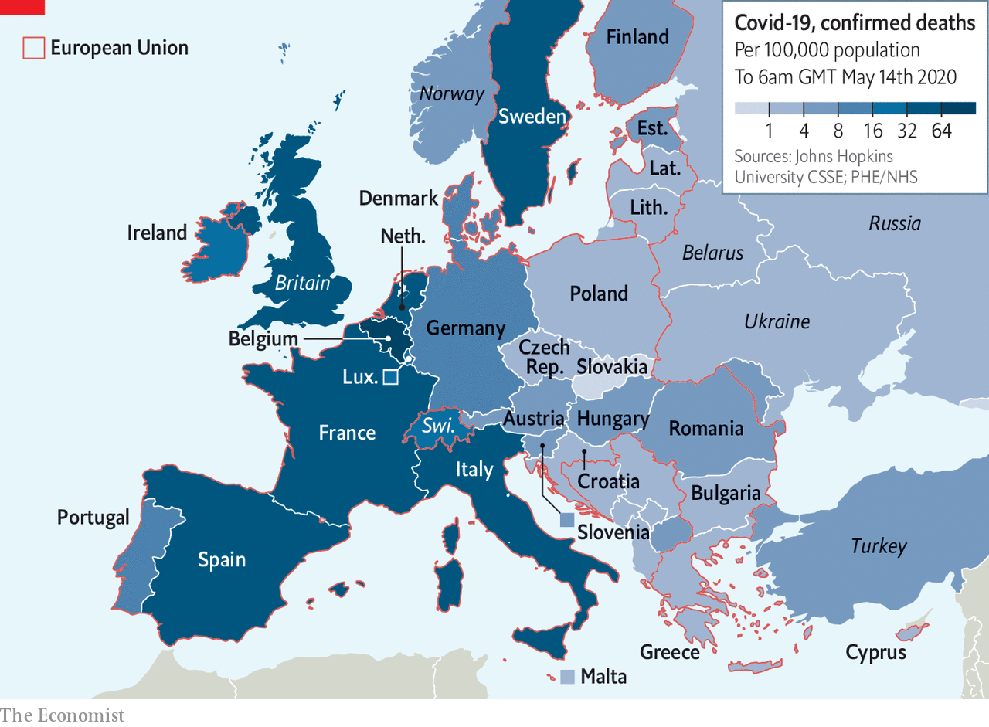

The German government, meanwhile, will stretch only to modest grants, arguing that any EU recovery fund should consist mainly of loans. In the middle, the European Commission is tasked with devising a scheme that keeps both sides happy. It will propose a mixture of grants and loans to indebted countries, paid for out of the EU’s budget. Countries will spend much of the year haggling over it.

The argument over how to respond to the economic crisis reveals another faultline that has long run through the EU: a shared currency but no shared spending policy. This was originally a feature of the euro’s design, not a bug, argues Jan Techau of the German Marshall Fund, a think-tank. The euro’s creators “wanted this tension to be there”, he says. Given the obvious problems of running a currency without a unified budget or transfers between richer and poorer members, fiscal union—considered a step too far when the euro was introduced—would eventually have to follow. What the euro’s designers did not envisage was that Europe’s leaders would balk, repeatedly, at that deeper integration, thus endangering the currency’s survival.

## They say the next big thing is here

Economic integration has failed to provide the EU with a compelling common purpose. Other, less tangible goals have taken on greater importance. A Europe based on shared values looms large in the imagination of Europhiles. Today Eurocrats are more likely to discuss ways of protecting and promoting the “European way of life” than the merits of close economic ties.

This view taps into a long memory of the EU as a civilising force. “Spain is the problem, Europe is the solution,” declared José Ortega y Gasset, a Spanish writer, in 1910. If his phrase has become a cliché of his country’s political life it is because after the end of the long dictatorship of Francisco Franco in 1975, most Spaniards wanted their country to become a normal European democracy. It is a view shared in Germany. “German problems can only be solved under a European roof,” declared Konrad Adenauer, West Germany’s first chancellor, in 1962.

However, this view is not universal. Memories of authoritarian regimes may linger in the politics of most EU states. Yet no such memory concentrates minds in, say, Sweden, meaning that supranational shackles can be seen as an affront to sovereignty rather than a necessary constraint on the state.

Shared values matter to a continent coming to terms with its past. They also matter for a continent that increasingly tries to influence the world, portraying itself as a global power. Ivan Krastev, a political scientist and the bloc’s most impish critic, sees two paths for the EU. Either it becomes more of a “mission”, going forth and evangelising European values globally, or it becomes a “monastery” and preaches only to Europeans within its precincts.

The idea of a European mission has its fair share of supporters. Ursula von der Leyen, the new president of the European Commission, said it would be a more “geopolitical” body under her leadership. Enrico Letta, a former prime minister of Italy and now the head of the Jacques Delors Institute, a think-tank, argues that the EU should aim to become a third superpower between America and China.

## I’ve seen it before, and I’ll see it again

Indeed, the EU already has immense regulatory clout. It sets global standards on everything from privacy to processing chemicals to environmental rules. Rather than use different standards across the globe, businesses obey the EU’s (usually more stringent) regulations to save costs, a phenomenon known as “the Brussels effect”. Translating this into more tangible forms of power is difficult. Superpowers require strategic unity, which may be hard to build in a club that has very different views on Russia, to give just one example.

If the EU rolls back its global ambitions and goes down the second route suggested by Mr Krastev—becoming a monastery—it will have to deal with a war among the monks. Any claim that the EU is united in its support for liberal democratic norms is disproven by the fact that Poland and Hungary have steadily eroded the rule of law—and yet they remain members of the club. Poland’s government has tried to nobble its supreme court. Hungary’s prime minister, Viktor Orban, has subverted or sidelined most of his country’s checks and balances over the past decade, and seized on the pandemic as an excuse to rule by decree indefinitely. Meanwhile, cronies of his ruling party are gorging on aid from Brussels.

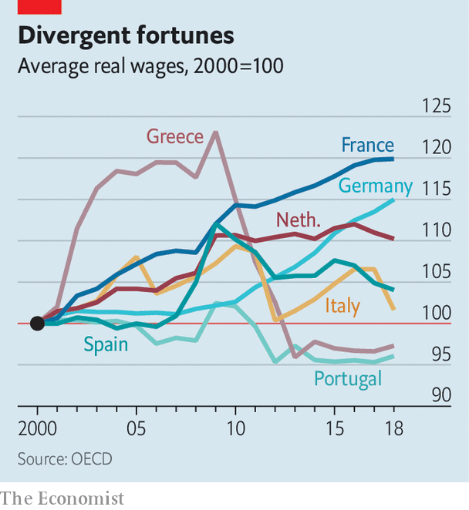

Even previously unchallenged parts of the EU’s dogma, such as its legal order, look more shaky. In May Germany’s constitutional court ruled that the European Court of Justice in Luxembourg was acting beyond its authority in the way it ruled on the European Central Bank’s bond-buying in 2018. In effect, the German court declared that since the EU is not a federal state, national courts can decide whether the ECJ has gone beyond its remit. The ECJ disagreed, leaving the two courts jostling for supremacy. The European Commission is examining whether to launch sanctions against Berlin for breaking the EU’s treaties. (The ECJ would have the final say.) A bizarre situation looms in which the German government is criticised for the actions of its independent court.

These warring judges have also called into question the future of actions taken by the ECB to stem the financial effects of the covid-19 crisis. A €750bn bond-buying programme launched in March by the ECB saw the central bank hoover up debt from Italy and Spain, in a bid to dampen the effects of the pandemic. As a result, Italy and Spain can easily borrow on the open market. This contrasts sharply with the start of the euro crisis, when the euro zone’s future seemed to hang in the balance every time Italy held a bond auction.

However, the ECB has created moral hazard. Bold action by the central bank has led to political complacency among the EU’s northern states. It has thus relieved pressure on Europe’s leaders to take tricky decisions, such as whether they should provide southern Europe with enough fiscal power to get out of the crisis. Germany and the Netherlands once railed against the ECB’s largesse; now they are among its beneficiaries, delaying difficult choices in the knowledge that the bank will continue to keep the bloc afloat. For a project that seems to move decisively only when in peril, this is a problem.

The result is that a constitutional reckoning has never seemed more necessary, yet it has never felt less likely. Hard questions proliferate: whether or not the EU will pursue deeper integration, what role the bloc will play in global politics, and so on. Even dilemmas unimaginable a decade ago, such as whether the EU is only for liberal democracies, need to be cleared up.



Although Britain’s chaotic departure was not exactly a tempting advertisement for the joys of leaving the bloc, it is still likely that big changes to the EU’s rules would lead to a slew of tricky plebiscites. Eurocrats have painful memories of past referendums. A fully fledged “constitution” was rejected by French and Dutch voters in 2005. Indeed deeper ties in Europe have always been controversial. In 1992 French voters agreed by just 51% to adopt the Maastricht treaty, which led to the monetary union.

Bold federal steps would help. But a sturdier constitution would result in even more fractious politics. If pushed, German officials will insist that they have no fundamental objection to a mutualisation of debt. At the same time they insist it would have to be accompanied by a corresponding centralisation of fiscal power over how national governments spend, which is likely to upset many European governments. For countries in southern Europe, fiscal union is seen as freedom; for Germany it is seen as tighter control.

## Just little bits of history repeating

Either way resentment is brewing, particularly in southern Europe. Italians have been among the most communitaire of Europeans. In a survey for the commission in 2000, just before the euro became legal tender, only 9% were against EU membership, compared with an EU average of 14%. But by May 7th almost 44% were ready to quit. “Italians feel betrayed,” says Gianluca Borrelli of Termometro Politico, the institute that conducted the latest poll. Apocalyptic rhetoric flows from southern Europe’s leaders. Portugal’s prime minister, Mr Costa, declared: “Either the EU does what needs to be done or it will end.”

A more complacent view exists in the EU’s northern capitals, particularly in Berlin. When it comes to common debt, a feeling exists that Spain, Italy and France—which has supported the two southern countries throughout—are trying it on, using the crisis to mask opportunism. “How do you distinguish between genuine necessity and political opportunity?” asks one ambassador from a northern European country. In this view a compromise will be found; yet another chapter in the EU’s long history of muddling through.

According to an old joke, economists have predicted nine of the past five recessions. Those predicting the demise of the EU may look similarly foolish. The bloc, its currency and its institutions are so central to much of European political life that unpicking them all would require a level of wanton destruction that not even the EU’s harshest critics have advocated. However after a decade of crises survivor bias afflicts the EU’s supporters and fresh thinking is urgently needed. An uncomfortable journey is justified if the destination is worthwhile. But without a clear answer to the question of what Europe stands for, the next decade or so will resemble a rather pointless ride. ■

Dig deeper:  
For our latest coverage of the covid-19 pandemic, register for The Economist Today, our daily [newsletter](https://www.economist.com/newslettersignup), or visit our [coronavirus tracker and story hub](https://www.economist.com/coronavirus)

This article was downloaded by calibre from <https://www.economist.com/briefing/2020/05/14/the-covid-19-pandemic-puts-pressure-on-the-eu>

|  |  |  |  |
| --- | --- | --- | --- |
|  | Articles | Sections | Next |

|  |  |  |  |
| --- | --- | --- | --- |
| Previous | Articles | Sections | Next |

#### No safety net

# Covid-19’s blow to world trade is a heavy one

And pre-existing conditions seem to worsen the prognosis

May 14th 2020 | WASHINGTON, DC

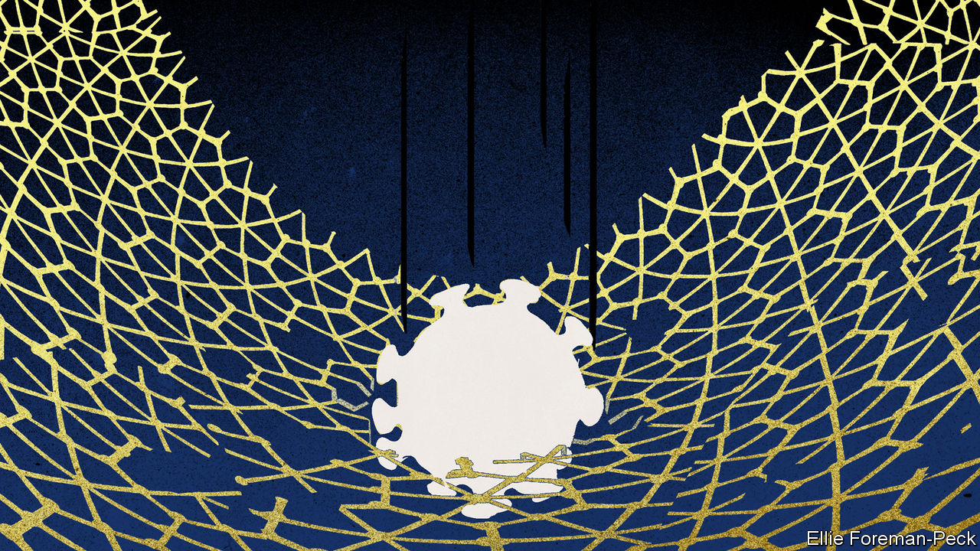

Editor’s note: The Economist is making some of its most important coverage of the covid-19 pandemic freely available to readers of The Economist Today, our daily newsletter. To receive it, register [here](https://www.economist.com/newslettersignup). For our coronavirus tracker and more coverage, see our [hub](https://www.economist.com/coronavirus)

THE 2010S WERE not a happy decade for proponents of global trade. Though fears of an increase in protectionism following the financial crisis of 2007-09 did not materialise, nor did the growth of the 1990s and 2000s re-establish itself. Finance was tamer; China was richer and developing its internal market; transport was no longer getting cheaper. As a share of global GDP, neither global trade, foreign direct investment, nor stocks of cross-border bank lending returned to their 2000s peak.

And then, belatedly, fears about protectionism came good with the election of President Donald Trump. In 2018 he launched a trade war against China; he applied tariffs in the name of national security; his administration hog-tied the World Trade Organisation’s appellate court.

Optimists might have seen the 2020s getting off to a slightly better start. The “Phase One” deal between America and China, signed on January 15th, left tariffs six times higher than they had been before Mr Trump launched his trade war. But at least it seemed a step in the right direction.

The covid-19 pandemic has since, by curtailing trade across the Pacific, made it very hard to see how China can increase its imports from America in line with the Phase One deal’s requirements. But that is the least of the trading world’s worries. The United Nations Conference on Trade and Development is predicting that covid-19 will reduce flows of foreign direct investment by 30-40%; the World Bank expects remittances to fall by 20%; the WTO reckons trade could fall by as much as a third. Much of this carnage is because of crashing demand, not new barriers to trade. But the crisis has not made international commerce any easier.

Travel bans, quarantines and a widespread desire to stay at home even among those not ordered to do so means that the movement of individuals from place to place, the one aspect of globalisation that had continued from strength to strength, came to a juddering halt.

Fewer passengers means fewer planes means less room for air freight. In a forecast of covid-related costs made this April, the WTO took into account higher air-cargo prices, extra time spent in transit for goods having to go through more stringent border checks, and travel restrictions making trade in services and the delivery of equipment that needs bespoke installation more difficult. Overall, the WTO thinks the rise in costs could be equivalent to a 3.4% global tariff. For comparison, in 2018 the global average tariff was around 8%.

As firms have foundered, fears have mounted that foreign state-supported companies will swoop in and snap them up. The European Commission has urged member states to be “particularly vigilant” in making sure businesses are not sold off. The German, Italian and Spanish governments have all tightened their processes for screening foreign investment. The Australian government is requiring that all foreign investments be approved by the Foreign Investment Review Board. India has enacted new restrictions, too; China calls them “discriminatory”.

Around the world, governments responsive to their people are concerned with little more than keeping them something close to safe and solvent. Meeting the needs of the public is taken to mean being able to provide for them independently. Kevin O’Rourke of NYU Abu Dhabi sees a parallel with the period which came immediately after the second world war. Policy was neither being driven by corporate interests seeking protection from foreign competitors, nor by a calamitous attempt to impose capital controls, but rather voters’ desire for safety. It is a powerful justification for protective measures.

## Let me down easy

Take medical supplies. In 2018 China alone supplied about 42% of the world’s exports of personal protective equipment. Almost three-quarters of Italy’s imported blood thinners come from China; so do 60% of the ingredients for antibiotics imported by Japan. Such dependence on any country seems unwise. Such dependence on China, which has been known to abuse its market dominance, seems idiotic. Smaller, poorer countries have little choice but to build stockpiles. But the bigger, richer countries and blocs are thinking of ways to shake up the status quo.

On April 27th Bernd Lange, head of the European Parliament’s Committee on International Trade, suggested that requirements could be imposed on companies to source certain intermediate products from several countries, or to develop strategic agreements with companies for their assembly lines to change quickly in a crisis. Alternatively, the EU could create a list of strategic goods for which European production would be required.

Mr Trump’s trade adviser, Peter Navarro, is clearly itching to set procurement rules which would force health-care providers to buy American-made products. Mr Trump’s administration is reportedly also trying to remedy what it sees as a strategic vulnerability by convincing Intel and Taiwan Semiconductor Manufacturing Company, two companies on the frontiers of chipmaking, to build new factories in America. A survey of members of the Global Business Alliance, a group of companies with investments in America, published on May 11th, revealed that 77% expected the country to become more protectionist in terms of cross-border mergers and acquisitions, government procurement and trade because of the pandemic.

Those businesses, and their peers, are currently in crisis-management mode. When the dust gets to settling, they have some reconfiguring to do. Adjusting their supply chains will probably accelerate the trend towards regionalisation, particularly in complex cases where assemblies cross borders repeatedly. This will have the knock-on effect, desired by some, of reducing the centrality of China.

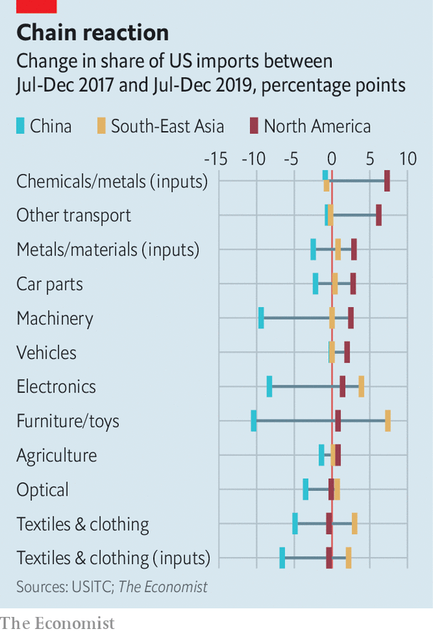

Take regionalisation first. In the automotive supply chain, which stretches from the leather for seats to the chips for dashboard displays, 59% of trade is already intraregional. Such integration is self-reinforcing; it becomes increasingly easy, and enticing, to replace suppliers farther afield with ones nearer to hand. Comparing the second half of 2019 with the second half of 2017, China’s share of car parts imported by the United States fell by 2.2 percentage points. The share coming from elsewhere in North America increased by 2.8 percentage points (see chart).

What works for cars, though, does not work for everything. Near-shoring imports of furniture, toys and clothes may not be worth the fuss. As China’s (sizeable) share in America’s imports of clothing, toys and furniture fell between 2017 and 2019, North America’s barely budged. Drops in electronics imports from China were offset not by suppliers closer to home, but mostly by other Asian countries.

That demonstrates the other strategy companies are developing: globalisation with fewer Chinese characteristics. Last October a survey of American multinationals found that around 40% were either considering or in the process of relocating manufacturing or sourcing outside of China. A more recent survey suggested that 24% were planning to adjust their sourcing outside of China as a result of covid-19.

For some companies, this is not a straightforward retrenchment, but an embrace of what is known as “China+1”. The strategy is still to use Chinese suppliers, not least so as to go on serving the very attractive Chinese market, but also to encourage suppliers elsewhere in case something goes wrong. Witness Google’s reported investment in Vietnam to produce its Pixel smartphone or Microsoft’s to produce its Surface tablet. The strategy’s purported benefits, though, are not bought cheaply, argues Jake Parker of the US-China Business Council, a lobby group. It will take five years for any such reconfigured supply chain to achieve costs as low as what they would have been if based in China. In the meantime prices will have to rise.

In the longer run, and once companies have more cash to spare, it is possible that they will attempt to set up new clusters of production. Mike Jette of GEP, a supply chain consultancy, reports hearing from some electronics manufacturers that they want to get 30-40% of their supply chain within the same region as the customer, leaving around half in China.

If the customer is in Asia, that will be fairly easy. If the customer is elsewhere, it will be harder. Their historical and geographic ties give the nexus of Asian electronics suppliers a huge advantage over comparatively isolated firms elsewhere, even if customers are actively trying to encourage the challengers. The Asian advantage will be hard to dislodge.

To the extent that companies do go looking for new secure sources of supply, they will keep in mind how countries have responded to covid-19. Kristin Dziczek of the Centre for Automotive Research says that the Mexican government’s haphazard approach to the pandemic generated huge uncertainty for car companies, and raised questions about their reliance on the country as a supplier.

## Rise of the robots

Such concerns will be weighed against countries’ other advantages, such as trade deals, existing sophisticated manufacturing capacity, and competitive labour costs. In Mexico’s case, an incoming trade deal with America and Canada will increase the incentives to source car parts from within the region. Pierre Sauvé of the World Bank reckons that deals with America and/or the European Union mean that the likes of Colombia, Costa Rica, Morocco and Tunisia could also gain from shifting supply chains, as could Malaysia and Vietnam, which enjoy broad, well-established trade ties with Japan and Korea.

Such countries need not limit themselves to whittling away at China’s manufacturing role. Trying to supply digital services could be a better long-run strategy—one that the pandemic may be making easier. White-collar workers have just been jolted into a mostly digital existence. If managers get used to supervising staff remotely, why should they not get used to managing more overseas? Employers will be keen on cost savings after the shutdown, notes Richard Baldwin, who works at the Graduate Institute in Geneva.

That said, trade is not the only way to realise savings. Bernard Hoekman of the European University Institute warns that companies may choose to automate services rather than to offshore them. The same warning applies, in reverse, to people hoping that reshoring production brings back jobs. It may do if you are an engineer. It will not if you wait tables.

As defenders of the status quo try to explain that strength lies in openness, and critics crow about globalisation going too far, the reality is that both will probably get their way. The medical and pharmaceutical sectors should expect pressure to localise more of their production in those countries that have enough clout to apply it. Those Chinese companies hoping to take advantage of the global market in ideas will find it harder to access. Foreign acquisitions will be treated with suspicion. American scrutiny of their suppliers will make international commerce harder.

But once companies can start investing again many will continue to set up their supply chains in such a way as to chase the next source of growth—mindful, of course, of governments prone to placing obstacles between them and their favoured suppliers. It is something global business knows how to do pretty well (see article). “If I were advising Davos man, I would advise him to keep quiet and take it on the chin,” says Mr O’Rourke, adding that his study of history has taught him the benefits of moderation in all things.

That return to the norm could be impeded if political leaders see the public desire for security as requiring an all-out assault on what went before. “It was clear that this kind of globalisation was ending its cycle,” Emmanuel Macron, the president of France, recently told the Financial Times in a disquisition on the lessons of the covid-19 pandemic and the retrenchment it might bring. If so, better for the world to start a new, rebalanced cycle, less centred on a single dominant exporter, than to give up on the process altogether.■

Dig deeper:  
For our latest coverage of the covid-19 pandemic, register for The Economist Today, our daily [newsletter](https://www.economist.com/newslettersignup), or visit our [coronavirus tracker and story hub](https://www.economist.com/coronavirus)

This article was downloaded by calibre from <https://www.economist.com/briefing/2020/05/14/covid-19s-blow-to-world-trade-is-a-heavy-one>

|  |  |  |  |
| --- | --- | --- | --- |
| Previous | Articles | Sections | Next |

|  |  |  |  |
| --- | --- | --- | --- |
| Previous | Articles | Sections | Next |

#### Supple supplies

# Businesses are proving quite resilient to the pandemic

But that does not make up for a lack of demand

May 16th 2020 |

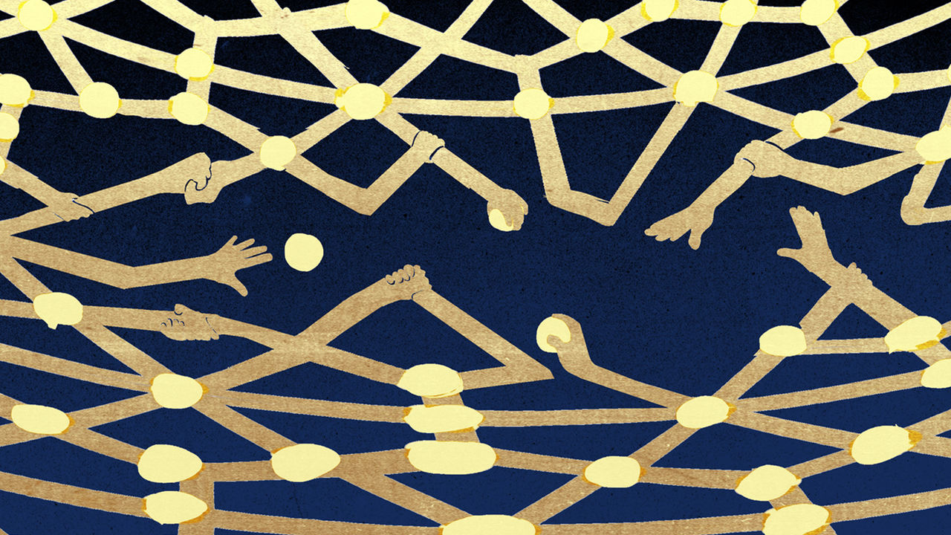

Editor’s note: The Economist is making some of its most important coverage of the covid-19 pandemic freely available to readers of The Economist Today, our daily newsletter. To receive it, register [here](https://www.economist.com/newslettersignup). For our coronavirus tracker and more coverage, see our [hub](https://www.economist.com/coronavirus)

IF A VENGEFUL deity were to design a weapon to wield against the global supply chains that characterise modern business, it might well hit on a virus which hit production facilities all around the world. In the face of covid-19, though, the sinews of business have, for the most part, held up remarkably well.

Air freight has suffered, but shipping has steamed on—and its comparatively long transit times have provided a buffer to the supply shocks which followed China’s shutdown. Prologis, an American company which operates one-and-a-half Manhattans-worth of warehouse space around the world, says that 95% of its customers have remained at least partially operational. Systemic risks such as those which brought the banking industry crashing down during the financial crisis have, as yet, failed to materialise.

This is not to say that business is booming. But it is demand, not supply, that is lacking. To the extent that the sinew is not working it is for want of a task, not for want of strength.

That companies have been aflurry over their supply chains is not in doubt. From January to May supply-chain disruption was mentioned nearly 30,000 times in the earnings calls of the world’s 2,000 biggest listed firms, up from 23,000 in the same period last year. Mentions of “efficiency” declined from 8,100 to 6,700. Managers know that supply chains are good conduits of economic pain. Looking at the aftermath of the tsunami and earthquake which hit northern Japan in 2011 Vinod Singhal, Brian Jacobs and Kevin Hendricks, three management scholars, found that the share prices of suppliers to companies directly affected dropped by 4%, and those of their customers by 3%.

The sources of disruption, and thus pain, can be impressively obscure. In 2012, a month after a fire at a factory in Germany, carmakers from Düsseldorf to Detroit found themselves facing production cuts. It turned out that Evonik, the factory’s owner, was responsible for between a quarter to a half of the world’s supply of cyclododecatriene, a precursor chemical to a resin widely used in the business. Otto Kocsis, who works for Zurich, an insurance firm, has found that while the proportion of disruptions that can be attributed to “tier one” suppliers—those with which manufacturers deal directly—fell during the first half of the 2010s, the proportion which could be attributed to companies that manufacturers hardly knew they were dealing with, like Evonik, shot up.

One way to avoid such pain is to keep as diverse a supplier base as feasible—something which also helps you deal with customers quick to change their fancies. Zara, a Spanish fashion retailer, exemplifies the approach, with its different frock lines reaching the shops entirely independently. Another is to maintain spare manufacturing capacity. Though companies may pride themselves on their lean manufacturing, the world’s factories do not typically run at full tilt: across the world the proportion of their potential capacity which industrial firms actually use has been flat or falling over the past two decades.

Then there is inventory. It is widely assumed that modern supply chains relentlessly eat away at this source of resilience, but that is not entirely true. Investors can punish firms if they start piling up stock, especially if there are other signs of trouble. But they also look askance at firms that cut too close to the bone.

Hong Chen, Murray Frank and Owen Wu, another trio of business-school professors, have looked at the period between 1981 and 2000 when average inventories in America Inc declined from 96 days to 81 days. The share prices of the companies which slashed inventories by the most and of those which did not cut at all both suffered compared with those which made moderate cuts. Work by Ananth Raman and a colleague at the Harvard Business School shows that when a sharp increase in operational performance is followed by some sort of downturn, investors pay heed to the nature of the setback. If it is down to some exogenous factor, such as a flood, the firm goes unrebuked. If it is down to an internal issue, and so suggestive of excessive cost-cutting, returns on investment decline by 3.8 percentage points.

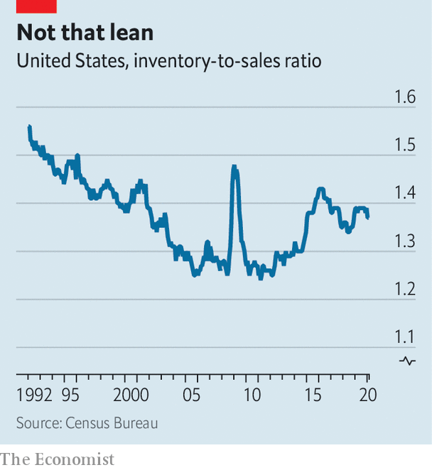

Since the financial crisis of 2007-09 companies have actually been increasing the amount of stock they have on hand. In America the ratio of inventories to sales just before the pandemic had risen to levels last seen in the early 2000s (see chart). The expansion of warehouse space that has recently been seen around the world is not just down to the rise of e-commerce—which typically requires three times as much as retailers who sell in physical locations. Some is down to firms concentrating on being near to the consumer, which increases the amount of storage a company needs. Prologis says that there has been an uptick in pricier short-term leases in warehouse space over the past few years, suggesting that companies are happy to pay a premium for flexibility.

Further evidence for buffering in the system can be seen in figures on working capital, which is calculated by subtracting what companies owe suppliers from the value of their inventories plus what they are owed by customers. Reducing working capital is the cheapest way for firms to get cash, since they need pay no interest to do so. Yet many companies are not making the most of it.

A recent survey of 15,000 large firms undertaken by PwC, a consultancy, divided them into quartiles based on their working-capital performance. If each firm in the three lower quartiles matched the performance of companies in the quartile above which were in the same line of business they would liberate $1.4trn in cash, equivalent to 55% of their cumulative capital spending. But despite this theoretically copious incentive, working-capital efficiency has not changed since 2016. Part of this is down to the increase in inventories seen in recent years, but another factor is reduced payables. Companies appear willing to spend money on their relationships with suppliers, which speaks to a sensitivity to supply-chain management.

It may also speak to the fact that many companies are already sitting on stacks of cash. Few boast sofas as plumply padded as Apple, Microsoft, Amazon, Alphabet and Facebook, which have $270bn in net cash between them, enough to finance many countries’ covid-related fiscal stimulus. But the total cash holdings of the world’s 2,000 biggest listed non-financial corporations increased from $6.6trn in 2010 to $14.2trn today.

Diversified suppliers, spare capacity, inventory and cash provide companies, especially big ones, with a certain degree of security. But whether their current “portfolios of resilience”, as Panos Kouvelis of the Boeing Centre for Supply Chain Innovation at Washington University puts it, can withstand the pandemic is another matter altogether. With respect to supply chains, the answer has so far been yes. But appetite for most non-essential goods and services among social-distancing consumers has evaporated. For some things, like air travel, ocean cruises or cinema, it may never fully recover.

How, though, could business have been better prepared? It might be possible, in principle, to self-insure against a disastrous drop in overall demand by sacrificing margins in order to build up buffers and to keep open strategic options the company will probably never willingly choose to use. But good luck convincing investors of that approach. Strategies which pay off handsomely in the event of even the worst worst case are terribly expensive.

Consider the Eurekahedge Tail Risk Hedge Fund Index, which tracks vehicles that try to make money out of “black swans”, highly improbable events that have a very large impact. If you had bet on the index on January 1st this year you would have seen a rise of 52%. But if you had bet on January 1st 2008 you would now be 25% below where you started. Insuring against lots of rare risks can never be cheap. Mr Kocsis says that insurance policies against disruptions caused by problems throughout the supply chain, including insolvencies of business partners, tend to cost 1% or more of the turnover insured annually. That is ten times what it would cost to protect the same amount of stock sitting in a warehouse from property damage.

## Straighten out

Another worry is that a company which spends on resilience may end up at a disadvantage if others survive without making such provisions, for example by extracting concessions from suppliers or bail-outs from governments, says Debra Dandeneau of Baker McKenzie, a law firm. Such firms would get the benefits of insurance without having paid the premiums.

Today, having built up buffers that keep things going looks smart. But in time the attractions of cutting back will begin to assert themselves again. Yes, long supply chains bring some added risk. But as ManMohan Sodhi of the Cass Business School in London puts it, “Nothing in the operational world is risk-free.” An American company that offloads capital-intensive operations to suppliers in China is weighing the boost in value that provides against the risks—though if the Chinese supplier does a deal with one in Vietnam which then does a deal in Bangladesh, the level of risk may be hard to assess. Low inventories may expose you to disruptions in supply, but they save you from losses due to excessively rosy forecasts of demand, notes Sunil Chopra of the Kellogg School of Management in Chicago. The boss of a big European retailer doubts that his industry will return to heavy stockholding. “We value that efficiency because it keeps prices low,” he explains.

In the age of covid-19 producing closer to home is both an understandable urge and smiled on by many national governments (see article), especially for necessities like medicines or face-masks. But a company’s home country is not necessarily the least disruptive place for operations. Many factories in America are closed or running at low capacity: on May 11th Elon Musk reopened the Tesla factory in Fremont, California, in defiance of a public-health order from Alameda county. Meanwhile, Tim Cook of Apple, which continues to make most of its iPhones in China—and sell millions to Chinese consumers—recently told investors that “we have been gratified by the resilience and adaptability of our global supply chain.”

Mr Kouvelis expects companies mostly to go back to their old ways of thinking about the efficiency-resilience trade-off. Firms “manage one shock at a time”, he says. Having so far emerged from this one relatively unscathed, Mr Cook and others may well stick to Andrew Carnegie’s advice to “put all your good eggs in one basket and then watch that basket.” Until the next black swan waddles along. ■

Dig deeper:  
For our latest coverage of the covid-19 pandemic, register for The Economist Today, our daily [newsletter](https://www.economist.com/newslettersignup), or visit our [coronavirus tracker and story hub](https://www.economist.com/coronavirus)

This article was downloaded by calibre from <https://www.economist.com/briefing/2020/05/16/businesses-are-proving-quite-resilient-to-the-pandemic>

|  |  |  |  |
| --- | --- | --- | --- |
| Previous | Articles | Sections | Next |

|  |  |  |
| --- | --- | --- |
| Briefing | Sections | The Americas |

United States

Welfare and work: The jobless market

.

Social mobility: Is zipcode destiny?

.

Donald Trump’s taxes: On the money

.

Irish pubs: Craics in the business model

.

The rule of law: Friends with benefits

.

Lexington: Mike Pompeo’s followership

.

|  |  |  |
| --- | --- | --- |
| Briefing | Sections | The Americas |

|  |  |  |  |
| --- | --- | --- | --- |
|  | Articles | Sections | Next |

#### Unemployment insurance

# Inefficiencies bedevil America’s response to soaring joblessness

America’s welfare system is creaking

May 16th 2020 |

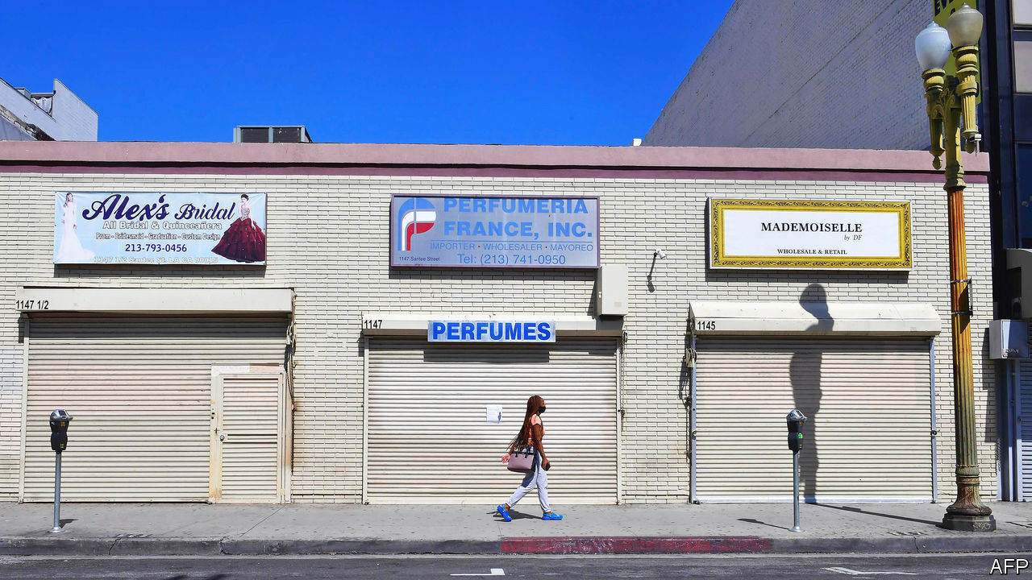

Editor’s note: The Economist is making some of its most important coverage of the covid-19 pandemic freely available to readers of The Economist Today, our daily newsletter. To receive it, register [here](https://www.economist.com/newslettersignup). For our coronavirus tracker and more coverage, see our [hub](https://www.economist.com/coronavirus)

EILEEN SHEPPARD has been cutting hair professionally for 20 years. Now 39, she lives in a small town in upstate New York, and lost her livelihood when Andrew Cuomo, the state’s governor, shut down hair salons and other personal-care businesses on March 20th. Millions have found themselves in a similar position, pushing America’s unemployment rate to an 80-year high (see left-side chart). As elsewhere, New York’s computer systems could not handle the rush of applications for unemployment insurance (UI). Ms Sheppard spent hours each day refreshing the site, which kept crashing and losing the information she had entered, while trying to care for her son, who was out of school (her husband was at his job hours away). She eventually managed to apply, but nearly two months after she lost her job she has received no money—just a letter with further application instructions.

So rapid a rise in unemployment would stress any country’s UI system. Some, such as Britain’s, have coped surprisingly well. America’s has not. The federal government funds the administration of these benefits through grants tied in part to how much each state paid in UI claims in the previous year. America’s long economic expansion left its system woefully underfunded. So although the weekly $600 top-up that Congress approved in late March is nominally generous, millions of people have not had their money. Preliminary data analysed by The Economist suggest that up to 15m Americans who applied for UI in March and April had not received money by the start of May.

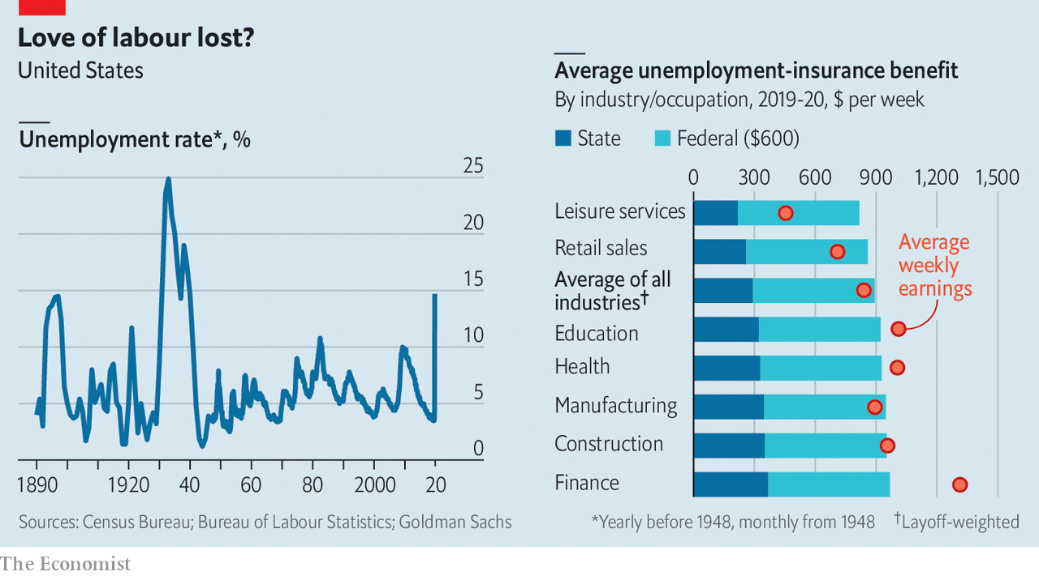

Compounding these administrative problems are looming political battles. The $600 booster expires at the end of July. Worries that America’s UI system is too generous and discourages work are growing on the right.

Like much else in America, UI is less one system than dozens, held together with some federal glue. It is intended to replace a share of lost wages while a recipient looks for work. Democrat-run states in the north-east tend to be more generous than Republican-run southern states, but overall, pre-pandemic America had perhaps the rich world’s stingiest system. The average payout in 2019 was equivalent to about 40% of previous earnings. Tough rules ensured that only those diligently seeking work would be granted welfare, and payouts were strictly time-limited.

Now America may have the world’s most generous system. Work-search requirements have been waived—rightly so, since people should be at home rather than pounding the pavement—and states have extended time limits on payouts. Workers deemed ineligible for ordinary UI, because they are self-employed, business owners or have an irregular work history, can now apply for benefits. And the extra $600 a week means that some can expect a hefty pay rise (see right-side chart). Goldman Sachs, a bank, estimates that three-quarters of laid-off workers are in line to receive benefits that exceed their former wage. Payments may be slow to arrive, but workers will in theory receive back-pay when their claims are finally processed.

The creation of some odd economic incentives was, to an extent, unavoidable. The states’ UI systems are archaic, relying on programming languages devised as long ago as 1959, making it impossible to tailor payouts more sharply. Hence the flat $600-a-week boost, which is, roughly, the difference between the national average weekly wage in 2019 ($970) and the average unemployment payout that year ($370). Giving some workers more money than they had earned in a job may not be the best use of public resources, but the people who benefit most are likely to be among America’s poorest. And the money thus “wasted” (about $80bn, on the highly unrealistic assumption that 30m workers are on the programme for an entire year) would amount to just 3% of America’s total fiscal stimulus.

## Back to work

Anyone hoping to game the benefits system is likely to be disappointed. Regulations are designed to foil people who quit a job in order to pick up an unemployment cheque. Having to quarantine because of household illness or care for a dependant with covid-19 will not cause anyone to lose their UI; refusing to work out of a general fear of illness will. Some reopening states, including Iowa, Ohio and Texas, encourage employers to report workers who refuse a job offer, disqualifying them from benefits.

Some economists want the government to do more to encourage employers to reduce working hours rather than laying people off—especially useful when businesses are allowed to reopen but face weak demand. With such programmes, explains Annelies Goger of the Brookings Institution, a think-tank, workers “don’t get the message that they’ve lost their jobs. They get the message that things are on pause.” Just over half of American states have short-term-work programmes, with UI covering the lost hours, but take-up had been low. Since the pandemic began take-up has increased, and Michigan has expanded its programme; workers in the schemes remain eligible for supplemental benefits. Katharine Abraham at the University of Maryland points to research suggesting that merely raising employers’ awareness of such programmes could make a big difference.

Another option would be to prolong the more generous unemployment system past July. Michael Bennet, a Democratic senator from Colorado, has proposed extending the current level of federal UI until the public-health emergency ends, and then gradually reducing benefits. But at some point such payouts will hinder the economic recovery, in particular the reallocation of workers from declining sectors to up-and-coming ones. Some research has indicated that a reduction in unemployment benefits in 2014-15 helped kick-start America’s pre-pandemic jobs boom.

Most probably, the unemployment system will return to its pre-pandemic ways sooner rather than later. Lindsey Graham, a Republican senator, has said the $600-a-week programme would be extended “over our dead bodies”. The economy is reopening and bosses are looking for workers. Congressional Republicans have pressed for broader protections for employers, similar to those given by President Donald Trump to the meat industry, which would shield them from liability for covid-related deaths provided they follow minimum federal safety standards. Democrats may reluctantly fall in line in exchange for more state and local aid in the next round of relief. Before long, many American workers will face unpalatable choices. ■

Dig deeper:  
For our latest coverage of the covid-19 pandemic, register for The Economist Today, our daily [newsletter](https://www.economist.com/newslettersignup), or visit our [coronavirus tracker and story hub](https://www.economist.com/coronavirus)

This article was downloaded by calibre from <https://www.economist.com/united-states/2020/05/16/inefficiencies-bedevil-americas-response-to-soaring-joblessness>

|  |  |  |  |
| --- | --- | --- | --- |
|  | Articles | Sections | Next |

|  |  |  |  |
| --- | --- | --- | --- |
| Previous | Articles | Sections | Next |

#### Reasons for social immobility

# Two leading economists disagree about the flagging American Dream

Heckman v Chetty

May 16th 2020 | WASHINGTON, DC

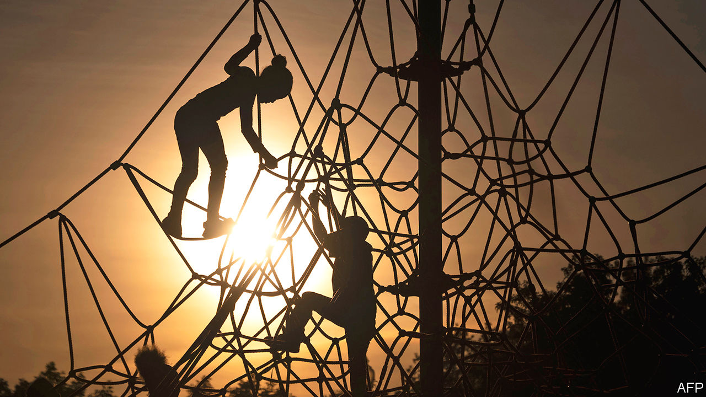

MOST AMERICANS worry that they live in an age of reduced social mobility. Raj Chetty, a Harvard economist, has done as much as anyone to provide empirical heft for that malaise. Armed with data from nearly all the tax returns filed in America for decades, he and his co-authors have pieced together an astonishing series of findings: that absolute mobility (the chance that a child will go on to earn more than their parents) has dropped from 90%, a near certainty, to 50%, a coin-toss; that the gap in life-expectancy between rich and poor has widened even as that between blacks and whites has narrowed; and that although the chances of upward mobility differ greatly from one neighbourhood to the next, in nearly every part of America the path for black boys is steeper.

Mr Chetty has also compiled evidence that mobility (or immobility) depends a lot on the types of neighbourhood that Americans grow up in. Re-analysing the Moving to Opportunity (MTO) experiment, which randomly assigned vouchers to poor families in five American cities to live in less poor places, he and his colleagues found dramatic effects for children who moved while young: a 32% higher chance of attending college and 31% higher earnings. His research consortium has ranked neighbourhoods according to their chances of propelling poor children upwards, publishing an online Opportunity Atlas. A new MTO-style experiment in Seattle is investigating these dynamics in real time.

“It’s like Rousseau [in ‘The Social Contract’]: ‘Man is born free and everywhere he is in chains.’ We just remove the chain of neighbourhood. And it’s not that simple,” says James Heckman, an economist at the University of Chicago, who has grown critical of the research and the implications drawn from it. Mr Heckman, who won a Nobel prize for work on teasing out cause and effect from messy, real-world data, thinks there is more statistical uncertainty in the neighbourhood-mobility findings than is widely recognised. A working paper by Magne Mogstad, another economist at the University of Chicago, and his colleagues argues that the “noise”, or random fluctuation, in Mr Chetty’s data means “it is not possible to draw firm conclusions about which counties in the United States have high or low values” of upward mobility from the poorest 25% of households.

Mr Heckman acknowledges that there are clear differences in mobility according to neighbourhood. But the ultimate drivers could lie in family structure, parenting habits, exposure to crime or the quality of schooling. All these are difficult to derive from American tax-return data.

Pundits take the research on “neighbourhood effects” as evidence that “zipcode is destiny”. Mr Heckman bristles at that. It overlooks the fact that Asians and black women do fairly well in mobility relative to whites. “It diverts attention away from other plausible explanations for why African-Americans are not doing well. Put discrimination on the table…but family structure is the one thing that is just off the table in American society,” he says.

That topic has a history of descending into ugly spats about the personal culpability of the poor, which may ward off social scientists. Mr Heckman sees his own research—tracking long-term outcomes for children and parents randomly assigned to a high-quality early-learning scheme—as strong evidence that families can become more stable and that disadvantaged children can be helped without having to move. The point is not to yearn for a return to “shotgun marriages”, he says, but to encourage stable cohabiting relationships.

This debate matters not just because two prominent economists disagree, but because they suggest different methods for tackling the urgent problem of intergenerational immobility. Mr Chetty’s experimental work on the primacy of place will be an important test of his theories, yet it also has a limit on its scale: every disadvantaged American plainly cannot be moved to opportunity. Mr Heckman’s project of encouraging early-childhood education has some scaling questions, too: could every child in America receive a programme as intensive as the ones he studies? For now, the answer, as with all messy scientific debates, is to let the experiments proceed. ■

This article was downloaded by calibre from <https://www.economist.com/united-states/2020/05/16/two-leading-economists-disagree-about-the-flagging-american-dream>

|  |  |  |  |
| --- | --- | --- | --- |
| Previous | Articles | Sections | Next |

|  |  |  |  |
| --- | --- | --- | --- |
| Previous | Articles | Sections | Next |

#### Donald Trump’s finances

# The Supreme Court will not agree on the president's taxes

Donald Trump could yet keep his finances out of the newspapers

May 16th 2020 | NEW YORK

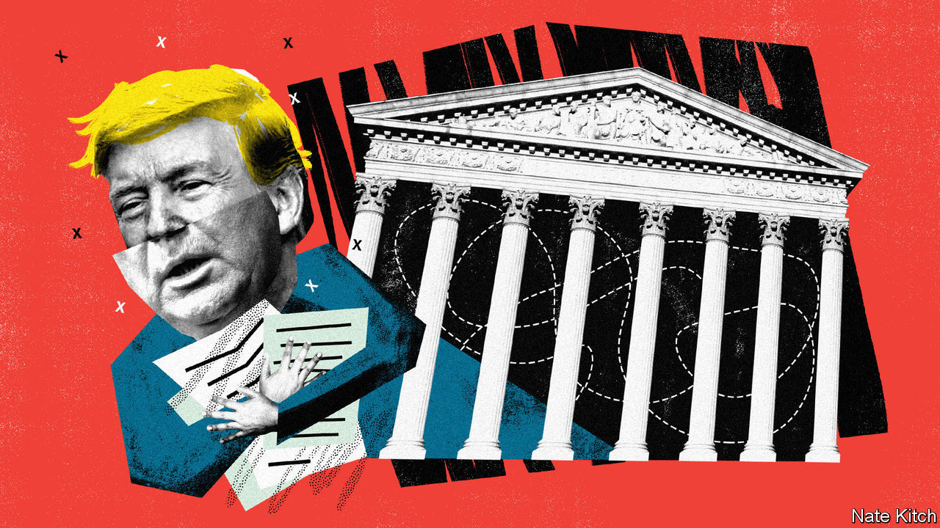

THE SEPARATION of powers, the founders’ bulwark against tyranny, is not what it might seem. As James Madison explained in the Federalist Papers No. 47, the idea is not to keep the legislative, executive and judicial departments “absolutely separate and distinct”. Rather, Madison wrote, each must exercise a measure of “control” or “agency” over its fellow branches. Negotiating the overlapping portions of the Venn diagram has often fallen to the judiciary, as it did on May 12th, when the Supreme Court took up two challenges to President Donald Trump’s quest to keep his taxes and other financial records secret.

Mr Trump is the first president since Richard Nixon to refuse to share at least some tax information with the American people. But in April 2019, with the Democrats back in control of the House of Representatives, three congressional committees subpoenaed years of papers from Mr Trump’s banks and his accounting firm. A few months later Cyrus Vance, Manhattan’s district attorney, sought similar records for a grand-jury investigation into Mr Trump’s alleged hush-money payoffs to an adult film star and a Playboy model before the election in 2016. Lower courts rejected Mr Trump’s pleas to block the subpoenas, leaving the nine justices with the final say.

The first pair of cases, argued by telephone (the court is not meeting in person during the pandemic), concerned House subpoenas to Capital One and Deutsche Bank, two of Mr Trump’s lenders, and Mazars USA, his accountant. The Oversight Committee had demanded documents to help it consider revising government ethics laws. The Intelligence and Financial Services Committees said they wanted to investigate money-laundering and foreign interference in the 2016 election.

Patrick Strawbridge, Mr Trump’s lawyer, described the House efforts as a “dragnet”. He seemed to raise the eyebrows of Chief Justice John Roberts, though, when he cast doubt on all congressional oversight of presidents. “Quite frankly,” Mr Strawbridge said, “the House has limited powers to regulate the presidency itself.” Jeff Wall, supporting Mr Trump from the Department of Justice, added that the subpoenas were designed to “undermine the president” and the House had not “even come close” to explaining why it needs the documents.

The House’s lawyer, Douglas Letter, seemed to have precedent on his side. In 1927 the court observed that the “power to secure needed information…has long been treated as an attribute of the power to legislate.” And in 1974 it unanimously ordered Nixon to comply with a subpoena for his White House tapes. But when pressed to identify a limit on Congress’s subpoena power, Mr Letter faltered. Justice Samuel Alito, one of the court’s most skilful questioners, backed him into a Socratic corner. There is “really no protection”, he asked, “preventing the harassment of a president”, because subpoenas require only a “conceivable legislative purpose, and you can’t think of a single example of a subpoena that wouldn’t meet that test?”

Justice Elena Kagan sought to elicit more persuasive responses from Mr Letter and vividly depicted Mr Trump’s request as placing a “ten-ton weight on the scales between the president and Congress”. Yet even Justice Stephen Breyer, a member of the liberal wing, worried that the House subpoenas might be unduly burdensome. He was bothered, he said, by the prospect of a red-baiting “future Senator McCarthy” haranguing “a future Franklin Roosevelt”.

When rulings arrive this summer, Mr Trump may win a majority in Trump v Mazars—keeping his finances out of the newspapers, for now. But he seems likely to lose Trump v Vance, the clash over the New York subpoena (if so, only the grand jury would be privy to Mr Trump’s records while he remains in office). In Vance, Jay Sekulow, Mr Trump’s lawyer, offered a royalist vision of the presidency shielded by “absolute immunity” from criminal investigation. But he struggled to explain how, in 1997, the court could unanimously order Bill Clinton to appear for depositions in a sexual-harassment suit, whereas a grand jury probing Mr Trump’s alleged payoffs to paramours was constitutionally barred from peeking at the president’s papers.

Noel Francisco, the solicitor-general, defended Mr Trump on somewhat less outlandish grounds. Carey Dunne, ably representing Mr Vance, argued that the investigation was “well within the scope of legal process permitted by this court” since 1807. If the justices side with Mr Trump, Mr Dunne warned, presidents may wind up unchecked and “above the law”. ■

This article was downloaded by calibre from <https://www.economist.com/united-states/2020/05/16/the-supreme-court-will-not-agree-on-the-presidents-taxes>

|  |  |  |  |
| --- | --- | --- | --- |
| Previous | Articles | Sections | Next |

|  |  |  |  |
| --- | --- | --- | --- |
| Previous | Articles | Sections | Next |

#### Changing drinking habits

# Last call for Irish pubs

Covid widens craics in the business model

May 16th 2020 | NEW YORK

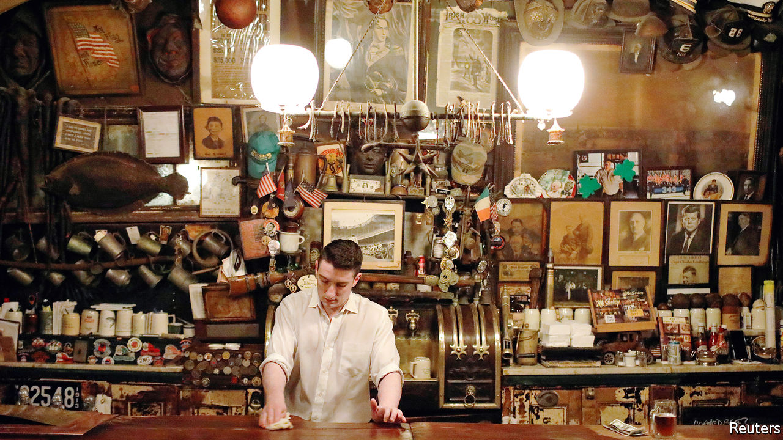

Editor’s note: The Economist is making some of its most important coverage of the covid-19 pandemic freely available to readers of The Economist Today, our daily newsletter. To receive it, register [here](https://www.economist.com/newslettersignup). For our coronavirus tracker and more coverage, see our [hub](https://www.economist.com/coronavirus)

ST PATRICK’S DAY was nearly two months ago, but shamrocks and leprechauns still decorate the windows of shuttered New York City Irish pubs. On the eve of one of the most profitable weeks of the pub year, in an attempt to stop covid-19 from spreading, City Hall closed down Irish pubs, along with other bars and restaurants. Some will never reopen.

“Even before the lockdown, the structural problems causing the decline of the Irish pub were already in place,” says Kevin Kenny, a historian at New York University. Many pubs in New York and Boston were struggling. Increases in rents and the minimum wage were eating into profits. And drinking habits have changed. Boozy lunches are frowned upon. People want healthier food than traditional pub fare. To survive, some pubs are becoming less overtly Irish. “You can’t get away with shepherd’s pie and chicken potpie anymore,” says Sean Hayden, co-owner of four establishments in midtown Manhattan.

Doyle’s Cafe in Boston pulled its last pint last year, ending 137 years in business; its owners sold its coveted liquor licence for a reported $450,000. Coogan’s, after nearly four decades in Manhattan’s Washington Heights, said it would close when it faced a steep rent rise in 2018. That prompted a public protest, and the owners managed to renegotiate the contract. Now the lockdown has done for it. It announced last month that it would not reopen.

Some neighbourhood bars have a chance of surviving the lockdown. It helps that they often own the building (rents in midtown Manhattan can be as high as $60,000 a month). They have lower overheads than those catering to tourists and the corporate-worker crowd. Their customers tend to be regulars. But it won’t be easy. Niall Henry, who owns three pubs in Upper Manhattan, including Tryon Public House, is open for food pick-up and deliveries for first-responders, but has seen an 85-90% drop in revenue. Seamus Clarke, who owns J.P. Clarke’s Saloon on McLean Avenue, just north of New York City, would be happy just to break even for the next few years. Rory Dolan, who owns a normally bustling pub on the same street, expects it will be at least two years before there is a return to normal.

Mike Carty, owner of Rosie O’Grady’s in midtown Manhattan, says he cannot see reopening his usually busy pub until October at the earliest. He may rejig the layout. Mr Clarke, meanwhile, will temporarily not allow people to sit at the bar. An Irish pub without bar service, he admits, is almost a contradiction in terms.

Still, many owners are confident that customers will be back. Mr Dolan thinks it will be impossible to stop young people socialising. Irish pubs such as McSorley’s survived Prohibition, when selling alcohol was banned for more than a decade. Molly’s Shebeen, operating since the 19th century, spent Prohibition selling groceries.

Historically, “the Irish pub was the place where business was done, jobs were found and favours were traded, a very important social function,” says Mr Kenny. Danny Price, an immigrant, says he got his first job in America and his first apartment through contacts made at J.P. Clarke’s. But although politicians still hold functions at pubs, they are no longer the hub for neighbourhood political-party machines.

People will keep going for the craic (Irish for fun). Not all pubs need to reinvent themselves, says Andrew Rigie, head of the New York Hospitality Alliance, an industry group. “Sometimes just being traditional and keeping to your roots is the best business plan possible.” But the days when you could slap an “O’Reilly’s” sign over the front door and get crowds are long gone. ■

Editor’s note: The Economist is making some of its most important coverage of the covid-19 pandemic freely available to readers of The Economist Today, our daily newsletter. To receive it, register [here](https://www.economist.com/newslettersignup). For our coronavirus tracker and more coverage, see our [hub](https://www.economist.com/coronavirus)

This article was downloaded by calibre from <https://www.economist.com/united-states/2020/05/16/last-call-for-irish-pubs>

|  |  |  |  |
| --- | --- | --- | --- |
| Previous | Articles | Sections | Next |

|  |  |  |  |
| --- | --- | --- | --- |
| Previous | Articles | Sections | Next |

#### William Barr’s Justice Department

# The misrule of law

Donald Trump has found his Roy Cohn, alas

May 16th 2020 | WASHINGTON, DC

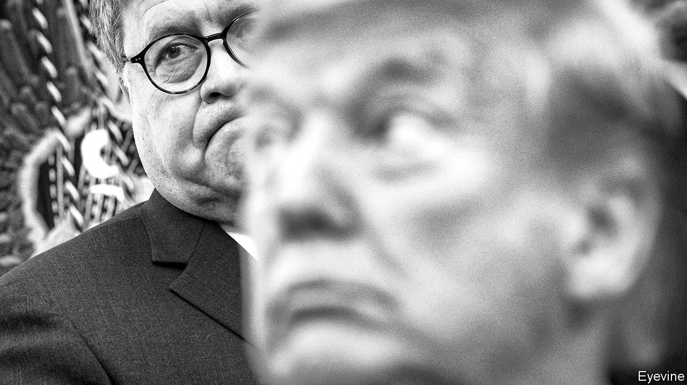

“WHERE’S MY Roy Cohn?” President Donald Trump asked in early 2017, after Jeff Sessions, his first attorney-general, recused himself from the probe into Russian election-meddling. Mr Sessions explained that, since he was involved with the campaign, he should not be involved in any campaign investigation.

Mr Trump had no patience for such qualms. He wanted a man who would serve his interests as the legendarily fierce Cohn, a private lawyer in New York, had done—and as he believed Robert Kennedy had done for his brother John, and Eric Holder had done for Barack Obama. In William Barr (pictured behind the president), Mr Sessions’s replacement, Mr Trump seems to have found what he sought.

The attorney-general is America’s top law-enforcement officer, presiding over the Department of Justice (DoJ). Partly by statute, but mostly by norm and practice, both the DoJ and its boss, particularly since Watergate, maintain a degree of independence from the president, unlike other cabinet departments. This independence is not absolute, nor could it be when the president appoints, and can fire, the attorney-general, his two top deputies, those leading the department’s divisions and the prosecutors heading each of the 93 US attorneys’ offices around America and its territories.

To some extent, every president’s DoJ reflects his policy preferences and priorities. Mr Obama’s vigorously pushed to expand voting rights and civil-rights protections, for instance, and George W. Bush’s filed more briefs favouring religious liberty than Mr Obama’s.

But the department also defends settled federal law, and its career lawyers pride themselves on defending statutes they may disagree with politically. Mr Obama’s DoJ, for instance, backed the Defence of Marriage Act, which defined marriage as a union between a man and a woman, even though Mr Obama had called for its repeal. Mr Sessions upended this norm: his DoJ refused to back the Affordable Care Act’s constitutionality. A former department lawyer says this reversal was “unheard of”.

Since Watergate, most attorneys-general and the department’s civil servants have jealously guarded their remove from politics. As a veteran of its civil-rights division explains, “Most of the people who work there, and it’s true of me too, believe in the mission of representing the United States. We believe that justice should be carried out even-handedly. That’s what it means to have a democracy.” During her confirmation hearings Loretta Lynch, Mr Obama’s second attorney-general, repeatedly promised independence. Griffin Bell, Jimmy Carter’s first—and the first truly post-Watergate one—screened all communication from the White House “to insure that any improper attempts to influence a decision” did not reach senior officials.

Mr Trump brushes aside such niceties. “I have an Article 2,” he has said, referring to the constitution’s article which vests executive power in the president, “where I have the right to do whatever I want as president.” Norms and judicial precedent disagree. But Mr Barr has long held a similarly maximalist view of executive power.

Months before his appointment he wrote a memo to Rod Rosenstein, then the deputy attorney-general, explaining that the probe into Russian meddling “cannot provide a legitimate basis for interrogating the president,” because, in Mr Barr’s view, “the President alone constitutes the Executive branch,” has “all-encompassing” authority over federal law enforcement and cannot commit obstruction of justice through the lawful exercise of his power—such as firing an official involved in an investigation into presidential misconduct.

Since taking over, Mr Barr has stated that the Russia probe was “one of the greatest travesties in American history,” launched “without any basis…to sabotage the presidency.” The DoJ’s independent inspector-general found the investigation justified, and executed without bias. That did not mollify Mr Barr, who has assigned John Durham, a federal prosecutor, to look into its (well-established) origins.

He has intervened to press for a lighter sentence for Roger Stone, a Trump campaign adviser convicted of witness-tampering and lying to Congress. On May 7th he dropped a case against Michael Flynn, Mr Trump’s former national security adviser. The DoJ argued that it could not “prove its case beyond a reasonable doubt”—despite the fact that Mr Flynn had pleaded guilty and accepted responsibility in open court for lying to federal investigators. But his unusual move has encountered unusual resistance: the sentencing judge has appointed a former prosecutor to oppose the DoJ’s motion, and may even be mulling a perjury charge against Mr Flynn.

## Enemies, beware

Both of those decisions by Mr Barr prompted DoJ lawyers to withdraw from the cases they helped prosecute. Mr Trump is now pushing an “Obamagate” theory that Mr Obama and his vice-president, Joe Biden, orchestrated the Russia investigation to hobble him.

Many worry that the next step will be using the DoJ to pursue Mr Trump’s enemies. More than 2,000 former employees have signed a letter calling on Mr Barr to resign, and for Congress to censure him for his “repeated assaults on the rule of law”. The civil-rights-department veteran says that morale has plummeted. “People I talk to [at the DoJ] feel like the institution is being damaged…The notion that government lawyers act in a non-partisan way to enforce the law is being assaulted.” Such damage is much easier done than undone. ■

This article was downloaded by calibre from <https://www.economist.com/united-states/2020/05/16/the-misrule-of-law>

|  |  |  |  |
| --- | --- | --- | --- |
| Previous | Articles | Sections | Next |

|  |  |  |  |
| --- | --- | --- | --- |
| Previous | Articles | Sections | Next |

#### Lexington

# Mike Pompeo’s politicisation of foreign policy is so damaging

The secretary of state is confusing global leadership with bashing his opponents

May 16th 2020 |

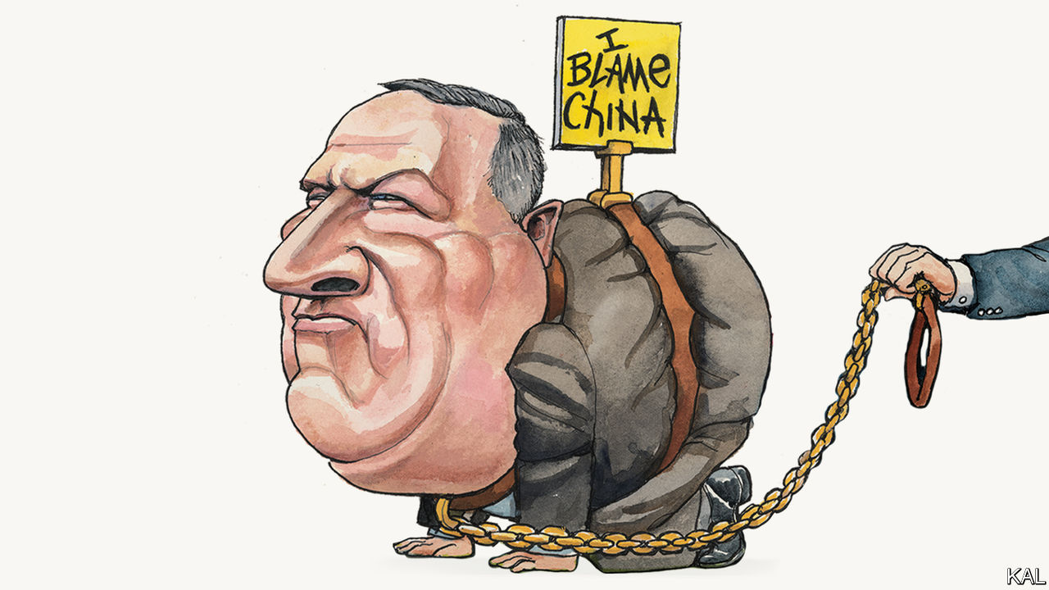

Editor’s note: The Economist is making some of its most important coverage of the covid-19 pandemic freely available to readers of The Economist Today, our daily newsletter. To receive it, register [here](https://www.economist.com/newslettersignup). For our coronavirus tracker and more coverage, see our [hub](https://www.economist.com/coronavirus)

FOR A MAN acknowledged to be highly intelligent, Mike Pompeo has a long history of talking nonsense. As a greenhorn House member, brought to Congress by the Tea Party wave of 2010, he made his name by pushing conspiracy theories about Hillary Clinton. He claimed, without evidence, that she was complicit in the murder of four Americans at an outpost in Benghazi, Libya, to a degree that was “worse, in some ways, than Watergate”. As Donald Trump’s secretary of state, he has encouraged a comparison, popular with Trump-loving evangelicals, between the irreligious president and the Jewish heroine Esther. His recent insistence that covid-19 probably emerged from a Chinese laboratory—a conclusion American spies appear not to share—was of this pattern.

The world has taken that into account. While Mr Pompeo has enraged the Chinese, hardly anyone else outside the Republican base seems to have taken his allegation all that seriously. The other half of America discounted it on the basis that Mr Pompeo said it. Officials in Australia, Germany and elsewhere similarly cast doubt on it. It is hard to think the words of any previous American chief diplomat, a role traditionally considered supra-partisan to a degree, have carried less weight.

Yet, in an administration of mediocrities, Mr Pompeo remains a substantial figure. He is one of its last significant talents. Even his critics note his smarts—famously displayed in a stellar record at West Point and Harvard Law School—and policy seriousness. His articulation of an America First foreign policy that engages with the world consistently but sceptically is a fair stab at making Trumpism coherent. Mr Pompeo, contrary to the impression he sometimes gives, is a serious grown-up, who has at least grudging respect from many in the foreign-policy establishment. His basic vision, of a confident America working with allies, is pretty standard foreign policy, suggests Leon Panetta, a former Democratic CIA director and defence secretary.

At the same time, almost uniquely among those who are neither related to the president nor rich, he has managed to retain Mr Trump’s confidence. Since the sacking of John Bolton eight months ago, he has been the administration’s foreign-policy tsar. Mark Esper and Robert O’Brien, the defence secretary and national security adviser, are nonentities by comparison.

Hence his recent prominence, haranguing China and Afghanistan’s feuding leaders and this week flying to Israel to discuss annexation and Iran. Along the way he has secured a few small but worthwhile successes. America’s capitulation to the Taliban would have been even more hasty had Mr Pompeo not opened a diplomatic effort with Pakistan to slow it. This is a more nuanced record than Mr Pompeo’s conspiracy-theorising might suggest.

At the root of this is that he holds, and on occasion pushes, fairly conventional conservative views, yet is more willing to defer to Mr Trump than were Mr Bolton or any of the president’s other discarded advisers. Like Jim Mattis and John Kelly, the secretary of state has a bullish military manner that the president loves. But unlike the generals, Mr Pompeo, who served in the army for only a few years, is always ready to take orders. His China-baiting, an obvious effort to distract from Mr Trump’s struggles with the pandemic, was a case in point. So, too, the many times he has found the words to defend presidential impulses he clearly abhorred: such as Mr Trump’s threatened troop withdrawal from Syria.

Two particular reasons seem to explain Mr Pompeo’s flexibility. One is personal. After a promising early career, he spent 12 years in Kansas on a series of undistinguished business ventures. He then came to Washington, DC, hungry to make up for lost time. His attacks on Mrs Clinton were a statement of intent. Yet his subsequent climb is mainly due to Mr Trump’s need for fresh faces for an administration that many Republicans were unwilling to join or, because of past criticism of the president, unwelcome in. Mr Pompeo could not otherwise have soared from a little-known congressman to a front-ranker with realistic presidential ambitions. No one in the administration owes Mr Trump more than he does.

The other explanation is that Mr Pompeo represents a broader politicisation of foreign policy, which predates Mr Trump. In 2013 he and Tom Cotton, then a fellow House member but since elected to the Senate, wrote a column urging Republicans to grant Barack Obama’s request for congressional support for an attack on Syria. It is hard to imagine them—two ultra-partisan Republicans—supporting any Democratic initiative now. This seepage of partisanship into one of the few remaining holdouts was perhaps inevitable. Yet it has accelerated under Mr Trump, in part because blaming the other side is the easiest way for establishment Republicans to justify his protectionism and other offences against conservative orthodoxy. It is no coincidence that Mr Pompeo’s signature concern, his extreme hostility to the Iranian regime and the nuclear deal Mr Obama made with it, is one of the most polarising there is. This makes it an issue the secretary of state might privately cite, if he ever felt the need back in Kansas one day, to justify any number of compromises for Mr Trump.

## Back to Kansas

The hyper-partisanship of foreign policy Mr Pompeo has come to represent is a dreadful lookout, unworthy of his talents. It carries a risk of endless instability, with successive administrations seeking to undo their predecessors’ legacy, just as Mr Trump has sought to dismantle Mr Obama’s. It also introduces a new rationale for American diplomacy as far removed from its expansive, globally minded strengths as it is possible to imagine. This wretched moment exemplifies that. On current form, Mr Pompeo will not be remembered for squeezing Iran. He will be remembered for undercutting the world’s reasonable case against China’s handling of the virus by throwing mud for his boss in the midst of a pandemic. That is not American leadership.■

Editor’s note: The Economist is making some of its most important coverage of the covid-19 pandemic freely available to readers of The Economist Today, our daily newsletter. To receive it, register [here](https://www.economist.com/newslettersignup). For our coronavirus tracker and more coverage, see our [hub](https://www.economist.com/coronavirus)

This article was downloaded by calibre from <https://www.economist.com/united-states/2020/05/16/mike-pompeos-politicisation-of-foreign-policy-is-so-damaging>

|  |  |  |  |
| --- | --- | --- | --- |
| Previous | Articles | Sections | Next |

|  |  |  |
| --- | --- | --- |
| United States | Sections | Asia |

The Americas

Bolivia: In limbo

.

Venezuela: Bay of piglets

.

Bello: Looking back on the Shining Path

.

|  |  |  |
| --- | --- | --- |
| United States | Sections | Asia |

|  |  |  |  |
| --- | --- | --- | --- |
|  | Articles | Sections | Next |

#### In limbo

# Bolivia needs an election, but covid-19 makes that hard

The opposition fears the interim president is using the pandemic to cement her power

May 16th 2020 |

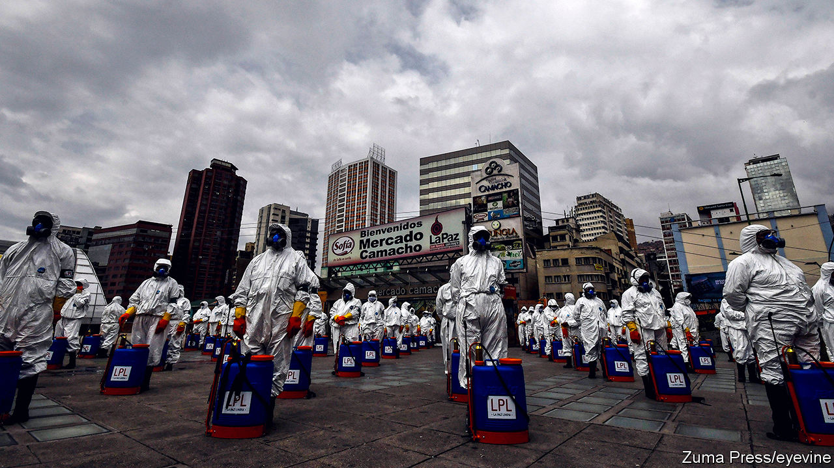

Editor’s note: The Economist is making some of its most important coverage of the covid-19 pandemic freely available to readers of The Economist Today, our daily newsletter. To receive it, register [here](https://www.economist.com/newslettersignup). For our coronavirus tracker and more coverage, see our [hub](https://www.economist.com/coronavirus)

ON APRIL 21ST, a month into Bolivia’s lockdown, police in riot gear swarmed the home of Patricia Arce, the mayor of Vinto, a city in the department of Cochabamba, and a senate candidate for the left-wing Movement to Socialism (MAS). Her family, their driver and a friend were celebrating her son’s 27th birthday with cake and chicha, a fermented-corn drink. All nine were jailed for two nights and charged with violating quarantine orders.

Two weeks later, photos surfaced on Facebook of a birthday party in La Paz, Bolivia’s administrative capital, for the daughter of the country’s interim president, Jeanine Áñez, a conservative Catholic. Two guests had hitched a ride from Tarija, a department in the south, on an air-force jet. Ms Áñez’s critics accused her of hypocrisy. She had denounced such abuses of power by Evo Morales, her MAS predecessor, who resigned late last year after an attempt to rig his re-election led to protests in which at least 36 people died.

Ms Arce, as it happens, was a casualty of those protests. On November 6th, a mob of Mr Morales’s opponents dragged her from the town hall, cut her hair, doused her in red paint and paraded her through town. Ms Áñez’s rule-breaking birthday bash shows that, now that she is in power, the former opposition is “doing exactly what they criticised”, says Ms Arce.

This tale of two festivities is a sign that last year’s wounds are still raw. To heal them, Bolivia was supposed to hold a re-run of presidential and congressional elections on May 3rd, free from the fraud that marred last October’s vote. The pandemic has postponed them. Ms Áñez has imposed one of Latin America’s strictest lockdowns, with harsh punishments for violators, and resisted setting a date for elections. She initially promised to leave office when a newly elected president took over. But in January she said that she would be among the candidates. Foes accuse her of misusing the pandemic to secure her hold on power.

A fair election would either wrest from Ms Áñez the power she has amassed or legitimise her hold on it. The country needs such a vote to avoid a return of violence. But most people support her handling of the pandemic and are in no rush to vote. No one knows when the lockdown limbo will end. While it lasts, Bolivians will have to be on guard to ensure that Ms Áñez does not abuse the trust they have placed in her.

In Bolivia, a strict lockdown is the government’s “only weapon” against covid-19, says a diplomat. With a population of 11m, the country has only 430 intensive-care beds and 190 doctors qualified to treat patients who occupy them. Mr Morales, who benefited from a boom in natural-gas revenues during his 14-year presidency, spent money to reduce maternal and infant mortality. But he did little to strengthen the health system. Last year, as a pre-election ploy, he launched free universal health care. But he failed to budget for clinics, supplies and the 20,000 professionals needed to provide it, says Fernando Romero of Sirmes, the public-health workers’ union in La Paz. Doctors reacted by staging months of strikes. By May 13th this year, Bolivia had conducted just 13,605 tests for the virus, among the lowest rates in the region.

Under Ms Áñez’s lockdown rules just one person from each household is allowed out once a week, between 7am and noon. Some measures seem more political than protective. The decree establishing the lockdown, published on March 25th, criminalises “individuals who incite non-compliance” and “misinform or cause uncertainty to the population”. This has been used to prosecute dozens of “digital warriors”. Mauricio Jara, for example, downplayed the threat of the virus and called the government “dictatorial” on WhatsApp groups such as “Evo the Best”. He was charged with sedition and endangering public health, and jailed. On May 10th the government toughened the decree. Now information of “any form, whether written, printed or artistic”, that undermines the quarantine can lead to charges.

Such behaviour raises fears that Ms Áñez is replacing Mr Morales’s authoritarian rule with her own conservative version. “We need evidence that once the most critical stage of the pandemic is over, the government’s intention is to finish its mandate as soon as possible,” says Carlos Mesa, a centrist candidate for president. On April 30th the legislature, which is controlled by MAS, passed a law setting a deadline of August 2nd for elections. (The electoral tribunal had proposed a date between June 7th and September 6th.) Lawmakers from Ms Áñez’s party challenged the law in the constitutional court when the legislature overturned her veto.

This, plus allegations of corruption in the defence ministry and the state oil and gas firm, has alienated critics of Mr Morales who had initially supported her. “During the honeymoon, we all looked the other way,” admits Raúl Peñaranda, a journalist. Forty-eight journalists issued a statement calling Mr Jara’s arrest illegal. Even Ms Áñez’s running-mate, Samuel Doria Medina, does not defend the part of the decree on which it was based. “Frankly, it was a mistake, absurd,” he says. “In a democracy you don’t do that kind of thing.” He blames the justice ministry, not Ms Áñez.

In parts of Bolivia, suspicion of her along with the deprivation caused by the lockdown are causing new outbreaks of violence. On April 30th protesters in El Alto, a poor neighbour of La Paz, threw stones at buses carrying medical workers. They were demanding new elections and an end to the lockdown. On May 11th security forces tear-gassed protesters in Cochabamba who were blocking roads and burning tyres. “If there’s no bread for the poor, there’s no peace for the rich,” one sign read.

MAS hopes to profit from such sentiments. It splintered after Mr Morales fled the country. Under his leadership from exile in Argentina it has lately become more united and strident. Luis Arce (no relation to Patricia), the party’s presidential candidate, is his pick. Some MAS politicians have suggested that the pandemic is an invention of the right. Mr Doria Medina accuses the party of exploiting privation.

Still, the malcontents are a minority. In a poll by Ipsos conducted on May 2nd-7th, 69% of respondents approved of Ms Áñez’s handling of the pandemic. The government has given grants to families and informal workers worth up to 500 bolivianos ($73) per person, which may help explain that support. Bolivians adhere to the lockdown more rigorously than citizens of any other Latin American country, according to data from Google Analytics. Two-thirds do not want elections to take place within the next 90 days. A survey by Ciesmori in April found that Ms Áñez led the eight presidential candidates, with 26% of voters planning to back her. Mr Arce was just behind at 24%. They may face each other in a run-off.

Salvador Romero, the respected president of the electoral tribunal, plans to hold the election by the legislature’s August 2nd deadline, assuming the constitutional court does not overturn it. Bolivia cannot follow the example of richer countries that have spread out voting over several days or shifted to mail-in ballots, says Mr Romero. That would be a logistical nightmare. The commission plans to train poll workers in small groups. The vote itself will take place as usual, probably with hand sanitisers and face masks. Voting is mandatory, but many Bolivians may stay home unless they think the pandemic is under control. That may prompt the losers to challenge the legitimacy of the results. Bolivia is still a long way from a political cure. ■

Editor’s note: The Economist is making some of its most important coverage of the covid-19 pandemic freely available to readers of The Economist Today, our daily newsletter. To receive it, register [here](https://www.economist.com/newslettersignup). For our coronavirus tracker and more coverage, see our [hub](https://www.economist.com/coronavirus)

This article was downloaded by calibre from <https://www.economist.com/the-americas/2020/05/16/bolivia-needs-an-election-but-covid-19-makes-that-hard>

|  |  |  |  |
| --- | --- | --- | --- |
|  | Articles | Sections | Next |

|  |  |  |  |
| --- | --- | --- | --- |
| Previous | Articles | Sections | Next |

#### Bay of piglets

# Nicolás Maduro celebrates a farcical attempt to remove him from power

A botched raid embarrasses opponents of the dictatorship

May 16th 2020 |

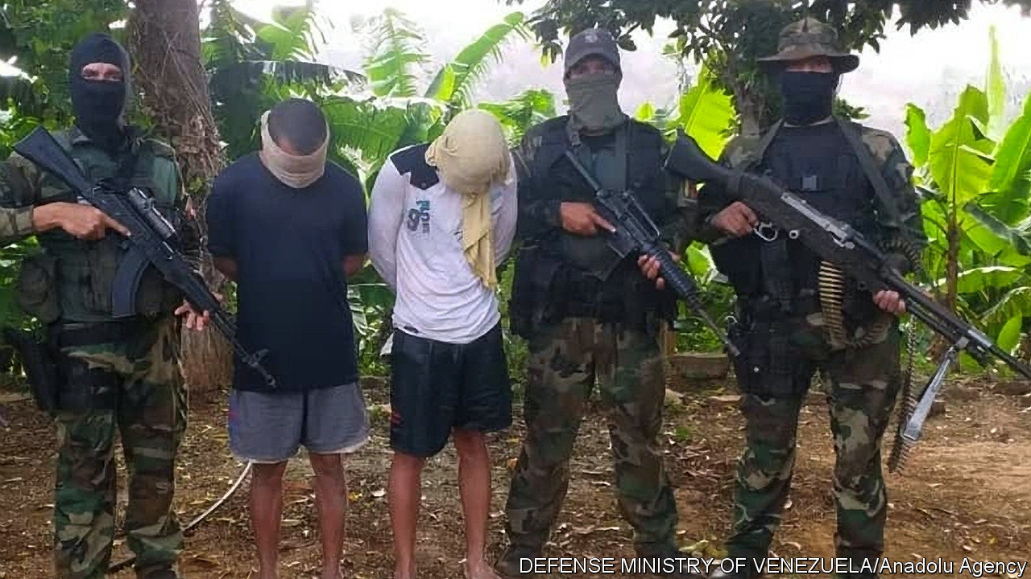

NICOLÁS MADURO, Venezuela’s dictator, always welcomes a distraction from the calamity of his rule. Early this month his enemies provided a good one. Two boats carrying a score of mercenaries attempted to land near Caracas, the capital. In a skirmish on May 3rd, Venezuelan forces killed eight raiders. The next day, two American former soldiers, apparently suffering from seasickness, were among the invaders captured from a skiff as it drifted 20km (12 miles) west of the earlier incursion. During their interrogations, later broadcast on state television, they confessed to taking part in a plot to kidnap Mr Maduro and fly him to the United States.

Some Venezuelans, used to Mr Maduro’s diversionary tactics, refused to believe the story. “It cannot possibly be real,” said Edgar, a van driver in Caracas. But it seems the plot was real, and that the plotters at least initially had the backing of the leaders of the opposition.

In September 2019 a team representing Juan Guaidó, the head of the National Assembly, who is recognised by most Western democracies as Venezuela’s interim president, met in Miami to consider plans to remove Mr Maduro by force. Juan Rendón, a political consultant who led the delegation, later said that Mr Guaidó had made it clear that he should explore “all options”. The team heard a pitch from Jordan Goudreau, an American special-forces veteran who is boss of Silvercorp, a previously obscure Florida-based security outfit. Its website portrays him boxing bare-chested. His private email address, now disabled, included the number 007. He proposed assembling several hundred fighters, mostly deserters from the Venezuelan army, to nab Mr Maduro and Diosdado Cabello, his number two. His price: $212,900,000.

Apparently impressed, the delegation signed a contract in October. The document, which Mr Rendón later described as “exploratory”, is detailed and delusional. The “service provider” would receive monthly instalments averaging $14.8m for a 495-day mission. After “project completion” its (undisclosed) financial backers would have “preferred-vendor” status with the government of a liberated Venezuela. Silvercorp would take 14% of the value of any art, cash and gold it seized.

Mr Goudreau says Mr Guaidó approved the plan, dubbed Operation Gideon. He has given the media a copy of a contract with Mr Guaidó’s signature. Mr Guaidó has denied signing it. The opposition says it ended the contract in November, when Mr Goudreau started behaving erratically and demanding huge payments. He accuses the opposition of reneging.

Despite that, Mr Goudreau set up camps in Colombia and began securing weapons with help from Clíver Alcalá, a former Venezuelan general. Waiting for guns, recruits trained with broomsticks. According to some reports, the American CIA urged Mr Goudreau to abandon the plan. In March the United States indicted General Alcalá (along with Mr Maduro and other regime members) for drug-trafficking.

The day before his voluntary extradition from Colombia, General Alcalá publicly revealed details of the plot, thus ensuring its failure. A rump of the invasion force went ahead anyway, perhaps enticed by bounties offered in March by the United States ($15m for Mr Maduro, $10m for Mr Cabello). Venezuelan troops awaited them. Mr Goudreau stayed at home.

The farce is such a godsend to Mr Maduro that many Venezuelans no doubt suspect him of having somehow connived in it. In other areas, his regime is in trouble. The price of oil, Venezuela’s main export, has plunged. Mismanagement, plus American sanctions, have led to fuel shortages. The pandemic has cut remittances from Venezuelans abroad. (It has also eased fuel shortages by reducing traffic.)

Thanks to Operation Gideon, the opposition, fractured at the best of times, is in no shape to take advantage of Mr Maduro’s weakness. Moderates may distance themselves from Mr Guaidó. International support may flag. The raid provoked much mockery, but Carmen, a shopkeeper in Caracas whose three children emigrated last year, has a wiser response: “This is a tragedy without end.”■

This article was downloaded by calibre from <https://www.economist.com/the-americas/2020/05/16/nicolas-maduro-celebrates-a-farcical-attempt-to-remove-him-from-power>

|  |  |  |  |
| --- | --- | --- | --- |
| Previous | Articles | Sections | Next |

|  |  |  |  |
| --- | --- | --- | --- |
| Previous | Articles | Sections | Next |

#### Bello

# Looking back on Peru's Shining Path

The battle against murderous Maoist guerrillas changed Peru, for better and worse

May 16th 2020 |

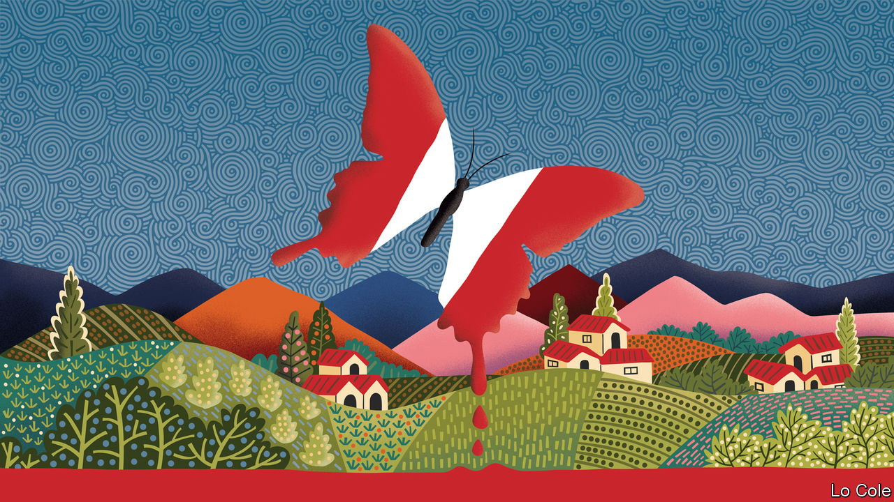

FORTY YEARS ago this week, on the eve of a presidential election that ended a military dictatorship, five masked intruders set fire to the ballot box in Chuschi, a village in the Ayacucho region of the Peruvian Andes. Their action kicked off modern Latin America’s strangest and most brutal guerrilla insurgency, the 12-year terrorist war of Sendero Luminoso (Shining Path), a fundamentalist Maoist outfit akin to Pol Pot’s Khmer Rouge in Cambodia.

Today, although unexpected death has returned in the form of covid-19, Peru is a vastly better place. But the terror unleashed by Sendero (as Peruvians called the group), often matched by the state’s response, exposed social fractures and left scars. A Truth and Reconciliation Commission later reckoned that 69,000 people were killed or “disappeared”, and around 500,000 were driven from their homes. It blamed Sendero for nearly half of the dead, government forces for around a third and village militias for most of the rest.

Sendero was the creation of Abimael Guzmán, a philosophy professor who gained control of the university in the colonial city of Huamanga, Ayacucho’s capital, in the 1970s, recruiting students and teachers, especially women. His insurgency’s centre was Ayacucho’s rural hinterland of rutted dirt roads, bleak mountains and lonely villages of Quechua-speaking subsistence farmers. Sendero would come to be abhorred by most Peruvians. But its lynchings of abusive officials and traders in a neglected region of an unjust country initially garnered it some popular support.

Bello made half-a-dozen reporting trips to Ayacucho in those years and recalls the atmosphere of menace and grief in a faceless war, often conducted at night. Villagers soon tired of Sendero. Both it and the army committed massacres. Only when the army recognised villagers as allies, organising them in militias, was Sendero defeated in its heartland. By then it had taken its terror and bombings to Lima. It contributed to and fed on an economic collapse.

Mr Guzmán created a bombastic personality cult, calling himself “President Gonzalo” and bracketing himself with Marx, Lenin and Mao as the “fourth sword of Marxism-Leninism”. He acted with absolute moral dissonance. He directed the slaughter from the comfort of rented houses in posh districts of Lima. When old-fashioned detective work tracked him down in 1992, he meekly surrendered. Now aged 85, he has spent decades in jail. A few thousand of his supporters lurk in Lima’s shantytowns.

Alberto Fujimori, who presided over Sendero’s defeat and the economy’s revival, used its threat to erect a dictatorship. Hailed by many as a saviour, and hated by many others as a corrupt authoritarian, Mr Fujimori continues to divide. In different ways, both he and Sendero weakened institutions.

Max Hernández, a psychoanalyst, argues that despite the Truth Commission, the country “never carried out the job of grieving, of trauma relief”. He says that the war revealed that, after five centuries of racial mixing, Peru had yet to bridge the divide between its indigenous population and the rest. Three-quarters of the victims of the war were Quechua-speaking rural people, treated with contempt by Mr Guzmán and with indifference by the state.

In this century a flood of books about the Sendero years has appeared. In 2015 a museum of memory opened in Lima. Based on the work of the Truth Commission, it is moving and even-handed, telling the stories of victims on all sides. It has few visitors. Many Peruvians who lived through their country’s darkest recent chapter want to forget.

As for Ayacucho, “terrorism destroyed everything,” says Carlos Añanyos, whose family set up a soft-drinks business in Huamanga in 1988 that is now a multinational headquartered in Madrid. The region’s income per person is still only two-thirds of the national average. Mr Añanyos has set up a foundation that, pre-pandemic, was promoting tourism in Ayacucho, as well as the region’s products, such as speciality potatoes, natural colourings and handicrafts.

There are other grounds for hope. Out of the wreckage of the 1980s Peru created a successful market economy that slashed poverty. The racial divide has blurred, especially among the young. Economic growth has reached people in the Andes, thanks to better communications. Ayacucho means “corner of the dead” in Quechua. Covid-19 aside, at least that is no longer true.

This article was downloaded by calibre from <https://www.economist.com/the-americas/2020/05/16/looking-back-on-perus-shining-path>

|  |  |  |  |
| --- | --- | --- | --- |
| Previous | Articles | Sections | Next |

|  |  |  |
| --- | --- | --- |
| The Americas | Sections | China |

Asia

The Mekong: Torrent to trickle

.

Sino-Indian border disputes: High dudgeon

.

Covid-19 in South Korea: A catchy beat

.

Sexual mores in Taiwan: Philanderers hold their breath

.

Banyan: Soldiers everywhere

.

|  |  |  |
| --- | --- | --- |
| The Americas | Sections | China |

|  |  |  |  |
| --- | --- | --- | --- |
|  | Articles | Sections | Next |

#### The shrinking Mekong

# South-East Asia’s biggest river is drying up

Chinese dams are partly responsible

May 16th 2020 | SINGAPORE

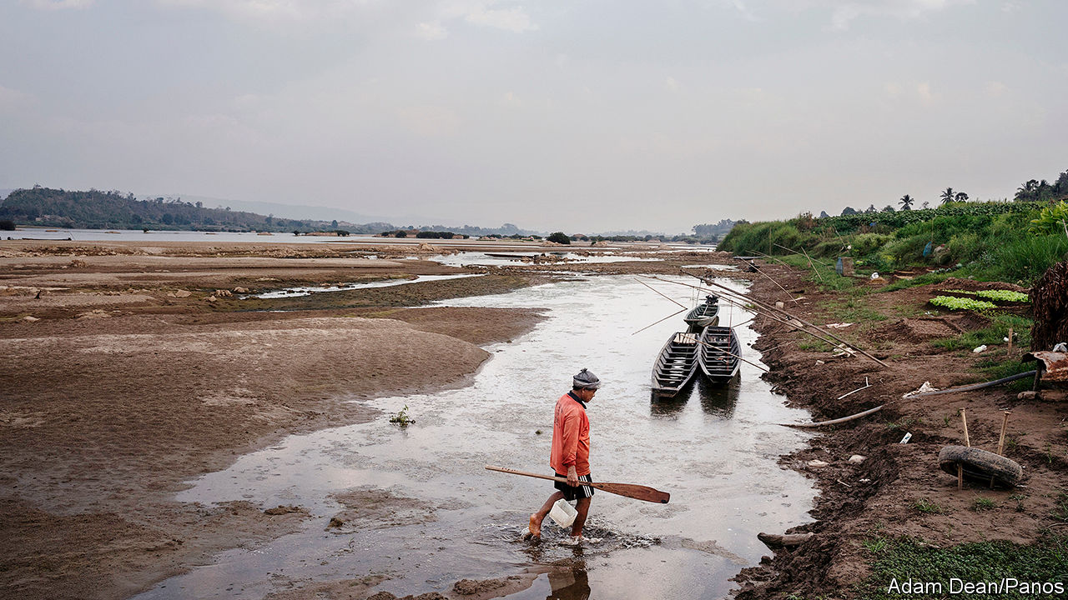

FISH WRITHE frantically in the shallow pool, as their schoolmates stranded on the exposed sandbar breathe their last. It is November, the end of the monsoon season, yet the water in the Mekong river is perilously low. On this stretch, in north-eastern Thailand, the bank is so parched the earth has cracked, and once-leafy bushes are bone dry. Visitors have flocked to the desiccated river bed to catch the trapped carp with their bare hands, but their delight does not diminish the disquiet of locals. “These fish were parent fish,” says Ormbun Thipsuna, a local fish farmer, recalling the scene. “No life any more,” she sighs.

The Mekong animates a vast swathe of Asia, from the snow-packed mountains of south-western China from which it springs, to Thailand, Laos, Cambodia and Vietnam in the lower portion of the basin. As it meanders along its 4,500km route, it feeds and waters some 66m people.

Yet the river is ailing. Last year the water in the Mekong fell to its lowest level since records began more than 60 years ago. Cambodia endured months of debilitating electricity blackouts because there was too little water to run a big hydropower plant. Fish catches declined by as much as 80-90% in parts of the country, whose citizens obtain almost two-thirds of their protein from their nets. The parched conditions are thought to have lopped $1.5bn off Thailand’s GDP, according to Krungsri, a local bank. In Vietnam the measly flow spurred saltwater intrusion in the delta, leaving many people with no fresh water to drink. “All the environmental indicators are in the red,” says Marc Goichot of the WWF, a global conservation group.

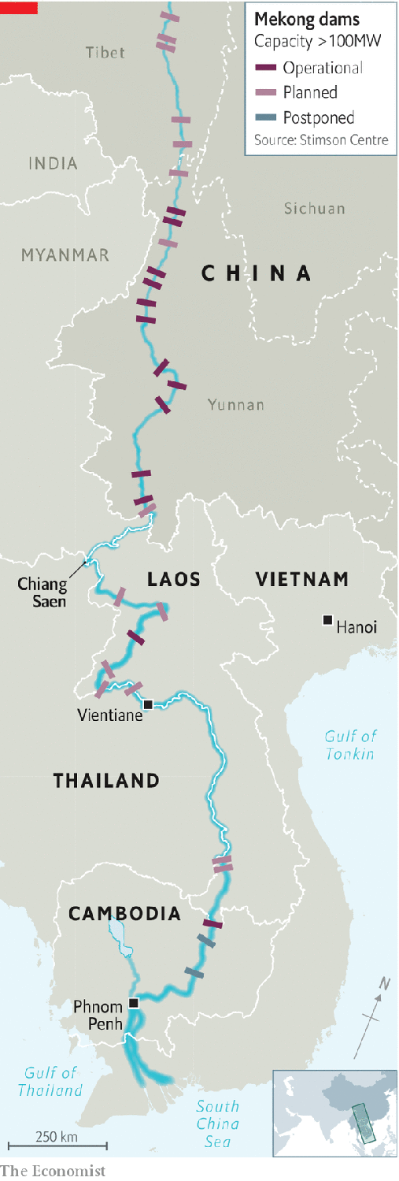

A drought in the lower basin played a big part in the atrophying of the river. But disappointing rains may not have been the whole story. A new study claims that the 11 dams built on the Chinese portion of the Mekong (see map) exacerbated the water shortage. Alan Basist and Claude Williams, of Eyes on Earth Inc, an environmental consultancy, used records of precipitation, snowmelt and water levels before most of the dams were built to develop a model of how much water would normally flow into Thailand under different weather conditions. They then compared this “natural” water level to the actual flow after the dams had been built. During the monsoon season, the lower Mekong normally floods; during the dry season the waters recede. Since the first big dams began operating in 2012, this annual pulse has been tamed: more water is now sent downstream than is typical during the dry season and less is dispatched during the wet season.

The study also found that in 2019 China’s part of the basin received more rain and snow than normal, despite the government’s claims that China, too, was suffering from drought. Had all that water flowed downstream, the river would have been between seven and eight metres deep as it entered Thailand—higher than usual for that time of year. In fact, it was less than three metres. Just two of China’s dams can store almost as much water as the Chesapeake Bay, an estuary of more than 11,000 square kilometres in America. During the dry season the upper reaches of the basin should contribute about 40% of the water flowing through the lower Mekong. “The Chinese basically shut off the tap,” Mr Basist says. Turning it on, he argues, “would have certainly helped alleviate the drought”.

The study, which was funded by America’s government, has its critics. China’s foreign ministry rubbished it, and even the Mekong River Commission (MRC), which works with the governments of Cambodia, Laos, Thailand and Vietnam to manage the river, has reservations. Anoulak Kittikhoun of the MRC says drought was the main reason for the Mekong’s meagre flow. He does agree, however, that it would be helpful to have a better sense of the part China’s dams played.

“The point still remains”, says Maureen Harris of International Rivers, a pressure group, “that China could have done and can do more to alleviate the conditions being felt downstream.” Indeed, it has done so before. In 2016, when the lower Mekong was afflicted by another severe drought, China released water from its dams at the MRC’s request. “It goes without saying that friends should help each other when help is needed,” said China’s foreign ministry. In January, China boosted the flow again, this time at Thailand’s behest.

The extra water is coming at the wrong time, unfortunately. A damp dry season prevents birds from laying eggs on exposed riverbanks, and farmers from planting crops in the rich sediment deposited during the monsoon. In Thailand sudden torrents of water have washed away boats and entire river banks, reports Pianporn Deetes of International Rivers. Ms Ormbun can no longer sell the fish she raises at the markets that normally spring up on beaches exposed during the dry season. “The river is at its best when it can run its natural course,” says Brian Eyler, author of “The Last Days of the Mighty Mekong”.

China has not signed any agreements about managing the Mekong with the other countries it flows through, so is not obliged to share a particular amount of water with them, nor even provide data on the flow or any warning about the operations of its dams. It does provide the MRC with a trickle of information about water levels and planned releases from dams, which helps with flood-control lower down the river.

Mr Eyler hopes that studies like Mr Basist’s will prompt China to go a bit further. Again, there are encouraging signs. Last November the Lancang Mekong Cooperation, an organisation founded by China in 2016 to promote trade among the Mekong countries, agreed to team up with the MRC to investigate what caused last year’s drought. But as promising as that is, greater transparency will not create more water.

The Mekong is “at breaking point”, says Ms Harris. To save it, the countries that share it need to bin plans for additional dams: China intends to build eight more and Laos seven. Cambodia is moving in the right direction. In March the government declared a moratorium on all hydropower projects on the Mekong for the next decade. Unless other countries follow suit, Ms Harris frets that “the Mekong river basin as it’s been known for thousands of years…will not be the same in the future.” ■

This article was downloaded by calibre from <https://www.economist.com/asia/2020/05/16/south-east-asias-biggest-river-is-drying-up>

|  |  |  |  |
| --- | --- | --- | --- |
|  | Articles | Sections | Next |

|  |  |  |  |
| --- | --- | --- | --- |
| Previous | Articles | Sections | Next |

#### High dudgeon

# The Chinese and Indian armies settle a clash by fisticuffs

There may have been some rocks thrown, too

May 16th 2020 |

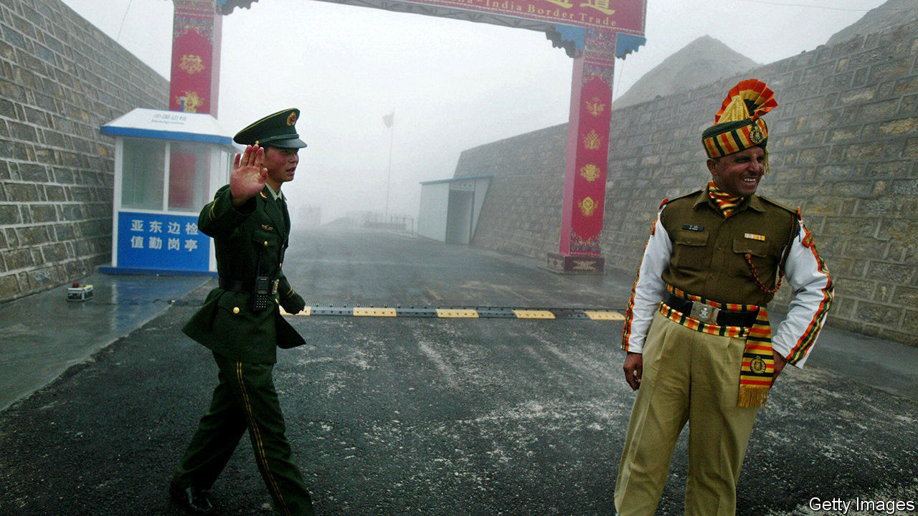

THE LAST Indian soldiers to die on the country’s frontier with China, the longest disputed border in the world, were shot in 1975, when patrols from the two countries stumbled across one another in dense fog. The nuclear-armed neighbours have beefed up their border forces considerably since then, but have also worked to ensure that their disputes do not lead to bloodshed. That is why two clashes between Indian and Chinese soldiers in recent days have been limited to a relatively genteel form of combat: fisticuffs.

The most recent Sino-Indian confrontation occurred three years ago. In June 2017 China began building a road in a spot known as Doklam, where India, China and the tiny mountainous kingdom of Bhutan meet. That led to a tense 73-day standoff between Indian and Chinese forces before both sides agreed to fall back. An informal summit the following April between Narendra Modi, India’s prime minister, and Xi Jinping, China’s president (in, of all places, the Chinese city of Wuhan, soon to become the birthplace of covid-19), seemed to soothe relations between the rivals. But the “Wuhan spirit”, as boosters termed it, has clearly faded.

During April tensions appeared to build between Indian and Chinese troops in Ladakh, a high plateau at the western edge of Tibet. On May 5th these erupted into violence when Chinese troops reportedly took issue with an Indian patrol on the north bank of Pangong lake, where the two countries have overlapping claims. The resulting fist-fight and stone-pelting resulted in injuries on both sides, including to senior officers. Indian officials remain concerned about Chinese construction activity in Ladakh near Daulat Beg Oldi, a vital airfield, and Demchok, a strategically located village. Then on May 9th another skirmish broke out 1,000km to the east at Naku La, a mountain pass near Doklam. Shortly afterwards Nepal, another small kingdom wedged between the two giants, which Mr Xi visited in October, complained about India’s own road-building in yet another disputed border area.

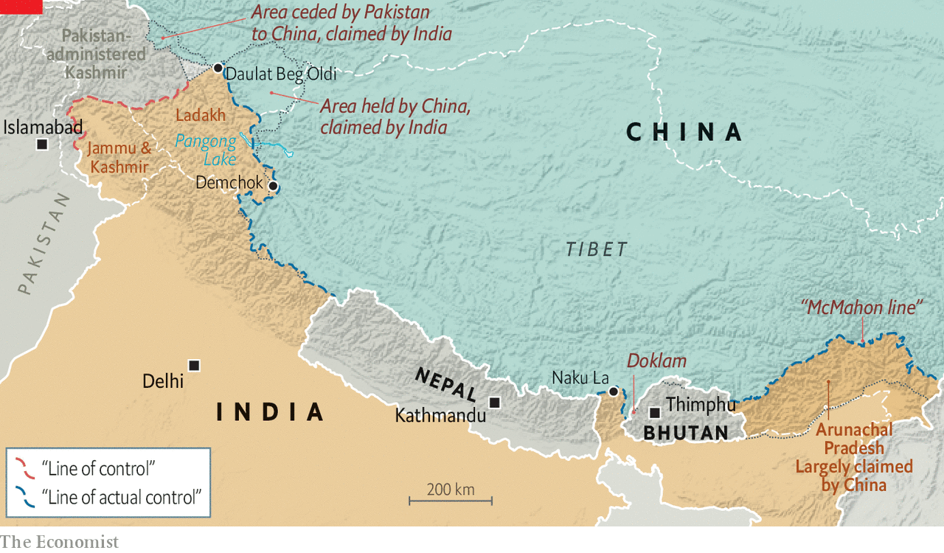

Small dust-ups are common. Thanks in part to slapdash colonial cartography, the boundary between India and China is undefined. Whereas India and Pakistan agree where the “line of control” separating their forces runs in the disputed territory of Kashmir, India and China have different views about the exact location of the “line of actual control” they are patrolling. Encounters between units from the two sides are therefore inevitable. Agreements signed in 1996 and 2003 established protocols to deal with such incidents, including promises not to use weapons. The resulting gunless confrontations range from mere jostling to more serious melees, complete with rock-throwing and acrobatic flying kicks.

Such scuffles might become yet more frequent. Negotiations to define the border have made little progress, and troops are bumping into each other more often. Tanvi Madan of the Brookings Institution, a think-tank, points out that, after years in which China improved infrastructure and increased the military presence on its side of the border, India has recently been doing the same. At the Wuhan summit Messrs Modi and Xi both agreed to give “strategic guidance” to their respective armies to cool it. “The exact opposite is happening,” says Jabin Jacob of Shiv Nadar University. “Nationalist narratives in both countries are beginning to percolate down to the militaries in difficult-to-control ways.”■

This article was downloaded by calibre from <https://www.economist.com/asia/2020/05/16/the-chinese-and-indian-armies-settle-a-clash-by-fisticuffs>

|  |  |  |  |
| --- | --- | --- | --- |
| Previous | Articles | Sections | Next |

|  |  |  |  |
| --- | --- | --- | --- |
| Previous | Articles | Sections | Next |

#### A catchy beat

# Infections at nightclubs mar South Korea’s relaxation of restrictions

But domestic flights and resorts remain packed

May 16th 2020 | SEOUL

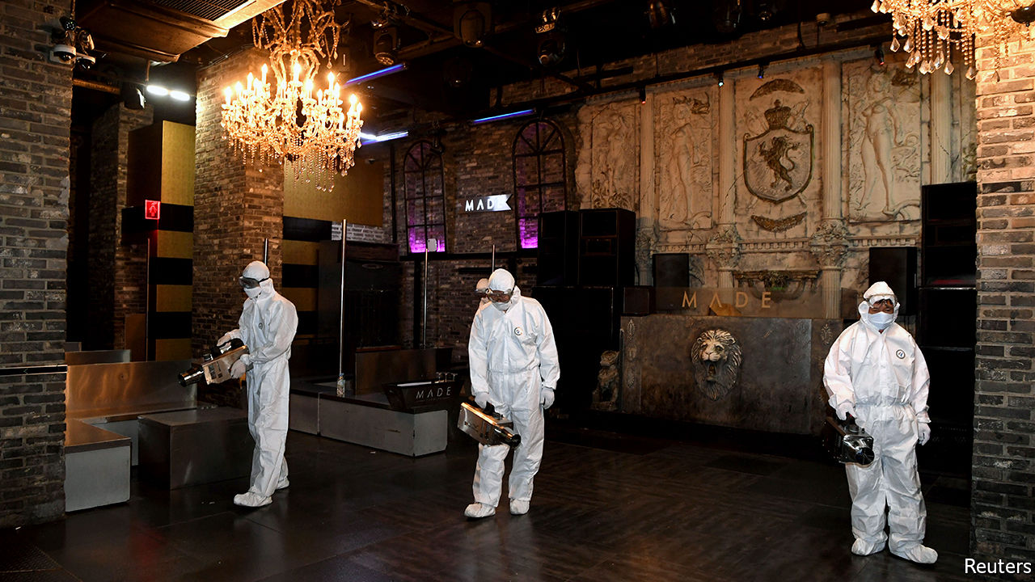

Editor’s note: The Economist is making some of its most important coverage of the covid-19 pandemic freely available to readers of The Economist Today, our daily newsletter. To receive it, register [here](https://www.economist.com/newslettersignup). For our coronavirus tracker and more coverage, see our [hub](https://www.economist.com/coronavirus)

APART FROM the temperature checks at the boarding gate and the face masks worn by passengers and crew, there was nothing unusual about the flight that left Seoul’s Gimpo airport for the southern island of Jeju on the morning of May 1st. There was not a single spare seat on the plane, nor on many of the 108 others that departed for the same destination that day.

Buoyed by much-relaxed social-distancing recommendations following weeks of very few new cases of covid-19, Seoulites emerged from their cramped apartments to spend the long holiday weekend by the sea. Closer to home, thousands of partygoers from both Seoul and the rest of the country flocked to the capital’s bars and clubs, which had reopened after a brief closure in April.

The return of domestic tourism and nightlife reflected public confidence in South Korea’s ability to keep the virus at bay. But in at least one instance, that confidence was misplaced. The tourists who frolicked by the sea suffered few adverse consequences beyond a spot of sunburn. Revellers in Seoul’s clubs, however, were not so lucky. Shortly after the long weekend, it emerged that customers had carried the virus into several busy nightspots. More than 100 new infections have been traced to clubs in Itaewon, a popular entertainment district. Since the affected areas saw thousands of visitors on the date in question, the number of infections is likely to continue to rise.

Tracking down potential patients, which has been South Korea’s main strength in suppressing the virus, has proved harder than during previous outbreaks. Contact-tracing initially focused on a handful of gay bars visited by a man who later tested positive. Homosexuality is often stigmatised in South Korea. Being outed as gay (the effective result of the man’s home town and workplace becoming public knowledge in the process of contact-tracing) can lead to people being fired from their jobs and ostracised by friends, family and neighbours. Many of the names and telephone numbers on the lists of customers that clubs have been obliged to keep since reopening turned out to be fake.

In response, authorities are adjusting their tracing methods. They are now offering free and anonymous testing for anybody who went near the affected areas in late April and early May. In a break with previous practice, they are seeking to reassure people that they will publish minimal information about their identity and routes. But delays associated with worries about privacy have probably already pushed up the number of infections associated with the incident.

The new outbreak has slowed the resumption of normal life. Clubs have been ordered to shut again until June 7th. The reopening of schools, originally planned for this week, has been pushed back by a week. Thousands of cram schools have also been told to close after a teacher and several students tested positive.

The outbreak has probably spread more widely than it might have given the recent uptick in domestic travel, with cases related to the Itaewon clubs being discovered as far afield as Busan and Jeju. The bounce-back in domestic tourism has been swift, as people have grown keener to get away from it all but have little scope to travel abroad. Flight capacity from Seoul to Jeju, the world’s busiest air route, is back to 95% of its usual average after dropping by half in March, when social-distancing recommendations were at their most stringent.

During the May holiday weekend, Jeju felt little changed from before the pandemic, bar a dearth of Chinese tour groups. Beaches, coffee shops and bike lanes were packed with visitors, many of whom appeared to have left their face masks at the airport. A guesthouse-owner on the island, who caters mainly to tourists in their 20s, says that occupancy has reached around 80% of the typical level: “Everything is starting to get back to normal.” Unfortunately, periodic surges in infections and consequent adjustments to the rules are also likely to become normal. ■

Dig deeper:  
For our latest coverage of the covid-19 pandemic, register for The Economist Today, our daily [newsletter](https://www.economist.com/newslettersignup), or visit our [coronavirus tracker and story hub](https://www.economist.com/coronavirus)

This article was downloaded by calibre from <https://www.economist.com/asia/2020/05/16/infections-at-nightclubs-mar-south-koreas-relaxation-of-restrictions>

|  |  |  |  |
| --- | --- | --- | --- |
| Previous | Articles | Sections | Next |

|  |  |  |  |
| --- | --- | --- | --- |
| Previous | Articles | Sections | Next |

#### Liberty for libertines

# Taiwan’s courts may decriminalise adultery

Jail terms for extramarital affairs are at odds with the country’s otherwise liberal laws

May 16th 2020 | TAIPEI

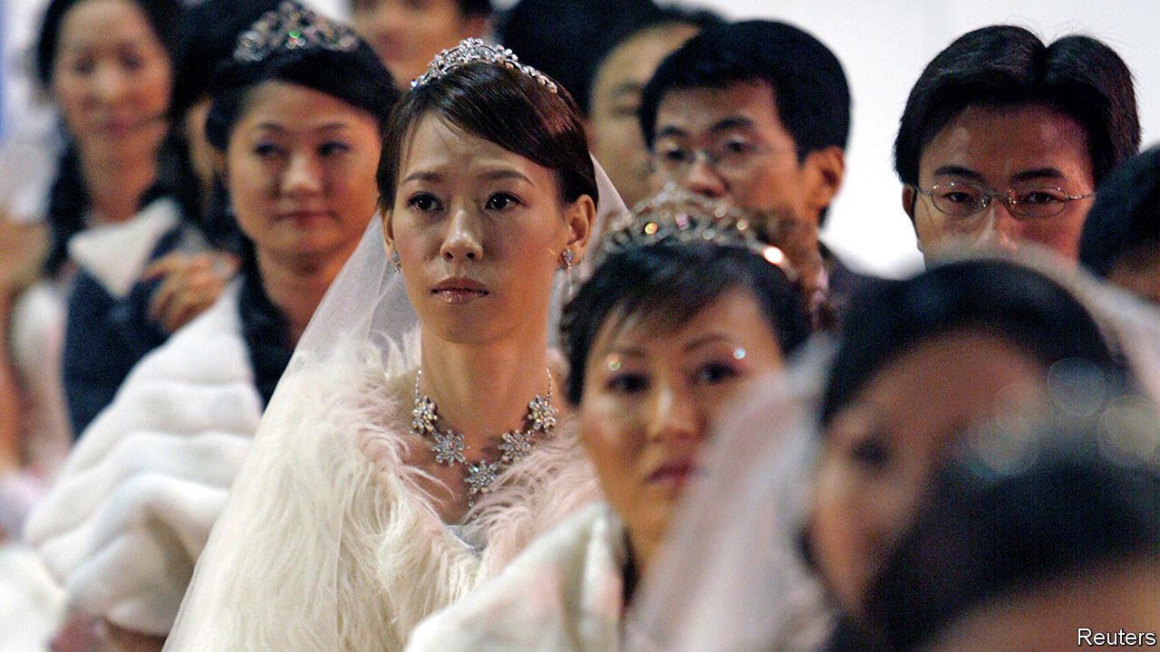

IT IS AN odd mix. Taiwan is the only country in Asia to have legalised gay marriage (unless you count Australia and New Zealand). But it is also one of the few countries in Asia, along with conservative Muslim places such as Afghanistan and Brunei, where adultery remains a crime. From 2016 to 2019 the police investigated more than 10,000 people they suspected of philandering. More than 1,200 were convicted. The guilty all received fines, averaging 90,000 Taiwan dollars ($3,000). They could in theory have been jailed for up to a year. And many straying spouses end up with a criminal record.

Worse, the weight of prosecutions falls largely on women. When husbands are caught cheating, some wives forgive them, but insist on pressing charges against the other woman. Cuckolded men, by contrast, tend to press charges against both their wives and their lovers. The result is that 54% of those convicted in recent years have been women. For other crimes in Taiwan, men earn roughly 80% of all convictions.

The adultery law dates from 1935 and its age leads to further peculiarities. The term it uses for adultery—tongjian—has long been held by the courts to refer to vaginal intercourse between a man and a woman. It is not clear, therefore, whether the law applies to gay couples, says Shawn Tsai Ching-hsiang, the minister of justice.

What is more, the narrow definition of the crime and the reluctance of courts to convict in the absence of clear proof have fostered a cottage industry: private investigators attempt to demonstrate not just that a married person has been having surreptitious trysts with someone of the opposite sex, but also that the pair have been having intercourse. The snoops have been known to wait outside hotel rooms listening for moans before bursting in, camera in hand. A couple caught together in bed once escaped conviction, notes Kuan Hsiao-wei of National Taipei University, by claiming they were just chatting, albeit naked. But it is worth scorned spouses’ while to try to catch their partner in flagrante, since the threat of pressing charges can help secure a more favourable divorce settlement.

Despite all these flaws, Taiwanese seem to like the adultery law. A poll conducted in 2017 by the Taiwanese Public Opinion Foundation found that 69% of adults wanted to keep it on the books. An earlier government survey found even stronger support for retaining the law. “In Taiwanese society, everyone thinks a stable marriage and family is the foundation of social stability,” Mr Tsai says.

Nonetheless, several lower courts have asked the constitutional court to review the law. It heard oral arguments on the subject on March 31st, and says it will announce a ruling at the end of May. The court upheld the law as recently as 2002, but since then has issued a series of more liberal rulings. It was the court, for example, which ordered parliament to legalise gay marriage in 2017. Mr Tsai says the government is open-minded about the law’s future. The judges, however, are likely to be more categorical. ■

This article was downloaded by calibre from <https://www.economist.com/asia/2020/05/16/taiwans-courts-may-decriminalise-adultery>

|  |  |  |  |
| --- | --- | --- | --- |
| Previous | Articles | Sections | Next |

|  |  |  |  |
| --- | --- | --- | --- |
| Previous | Articles | Sections | Next |

#### Banyan

# Sri Lanka’s new president is putting soldiers in charge of everything

Never mind the damage to national reconciliation after a long civil war

May 16th 2020 |

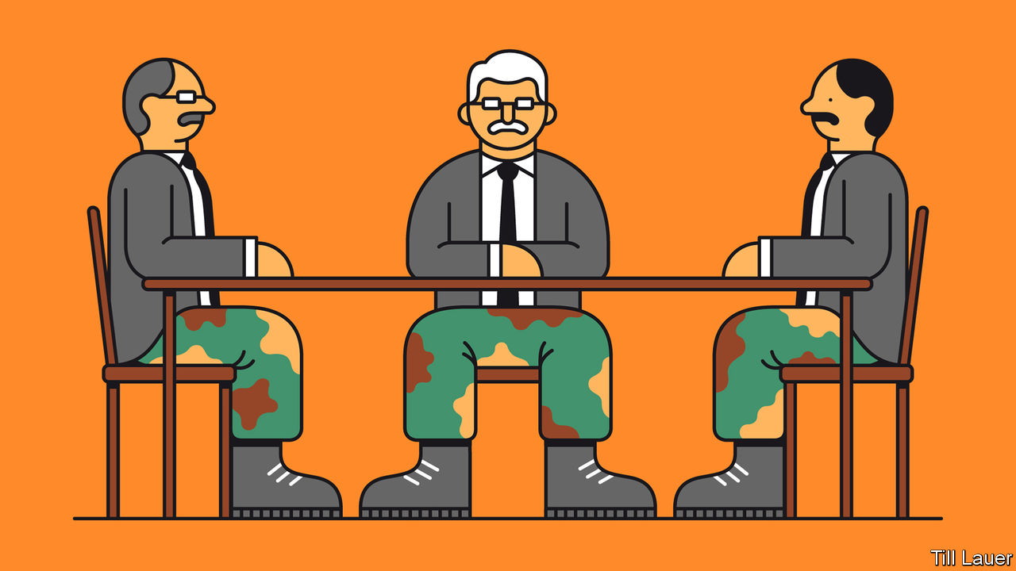

BEFORE THE presidential election he won last November, Gotabaya Rajapaksa laid out for Banyan his vision for Sri Lanka. It was a sunlit upland of peaceful, inclusive “knowledge-based” development. All the political bickering of recent years, “Gota” promised, would be swept aside by his programme of brisk, technocratic proficiency. His years as an army officer would ensure that.

A military timbre to the former lieutenant-colonel’s rule was always on the cards. Mr Rajapaksa’s campaign dwelt on the need for a “disciplined society”. Viyathmaga, a social movement with political ambitions that backed him, counted many former officers among its leaders. The president’s personal network is rooted not just in his family (his elder brother, Mahinda, now prime minister, was himself president from 2005 to 2015). Gota commands the loyalty of past and present soldiers, a band of brothers from his time fighting a horrific, long-running civil war against Tamil insurgents, first as an officer and latterly as the powerful secretary of defence under Mahinda.

After the war, the army and intelligence played a big role in public life and, most Sri Lankans assumed, in the disappearance of critics of the government, until Mahinda was unexpectedly defeated in the presidential election of 2015. Yet few predicted the extent to which under Gota’s rule military types would move into senior positions in government, development and even health, fighting the covid-19 epidemic.

In a tally by the International Truth and Justice Project, a human-rights group, current or former officers include the president’s chief-of-staff and the heads of national intelligence, prisons and prisoner rehabilitation. Generals, past or present, are in charge of customs, the port authority, development, agriculture and poverty eradication. The army commander, General Shavendra Silva, runs the coronavirus task-force. Top brass are also expected to be named to plum ambassadorships.

The president’s backers bridle at any suggestion that this is an unhealthy trend. They point out that the top customs job is an irresistible temptation to civilian incumbents. Yet they do not explain how it would be any more resistible to military men. As for handling the coronavirus, given that the bureaucracy is hidebound and civilian capacities are weak, deploying the armed forces and their logistical abilities makes sense—besides, the armed forces are widely admired. Yet it is weird for them to police a dubious liquor ban imposed by the teetotal president. And their enforcement of quarantine areas with hazmat suits and assault rifles is surely overkill. Moreover, the commanders’ claims of covid-competence have been undermined by outbreaks on military bases. Of 900-odd reported cases in Sri Lanka, over 500 are members of the armed forces or their close contacts.

Nor is there much reason to believe that military men will do a better job of running ports, reducing poverty or increasing crop yields. For now, the main question is accountability. The positions filled by officers have little civilian oversight. It does not help that Mr Rajapaksa has dissolved the old parliament, while elections for a new one have been thwarted by the epidemic. The president and his aides govern by decree.

It reinforces what Kanishka Jayasuriya of Australia’s Murdoch University calls the “normalisation” of military influence in the civilian sphere, as informal networks become formal under Mr Rajapaksa. The normalisation extends to business, where—as has long been the case in, for example, Myanmar—military types prosper alongside a new, assertive bourgeoisie grown rich on the back of property and infrastructure deals, much of it lubricated by Chinese loans. Former officers advise on projects’ security, while the army gets involved in slum clearance to make way for development. Academics and journalists say they are afraid to investigate the business links.

Thus does Sri Lanka lurch further from liberal democracy. Gota has in the past railed at Banyan about the unfairness of external critics. He has no time for the UN’s call for an investigation into crimes that may have been committed in the closing days of the civil war. He defends General Silva, who was banned from America earlier this year over suspected involvement in extra-judicial killings. As he and his band of brothers have long seen it, having saved Sri Lanka from fracturing, they are entitled to an outsize role in its future. With military efficiency, they are taking it.

This article was downloaded by calibre from <https://www.economist.com/asia/2020/05/16/sri-lankas-new-president-is-putting-soldiers-in-charge-of-everything>

|  |  |  |  |
| --- | --- | --- | --- |
| Previous | Articles | Sections | Next |

|  |  |  |
| --- | --- | --- |
| Asia | Sections | Middle East & Africa |

China

Mental health: Picking up the pieces

.

Tibet: The lost boy

.

Chaguan: Keeping it local

.

|  |  |  |
| --- | --- | --- |
| Asia | Sections | Middle East & Africa |

|  |  |  |  |
| --- | --- | --- | --- |
|  | Articles | Sections | Next |

#### Picking up the pieces

# In China, covid-19 has focused attention on mental health

In Mao’s day, sufferers were accused of lacking revolutionary zeal

May 16th 2020 | BEIJING

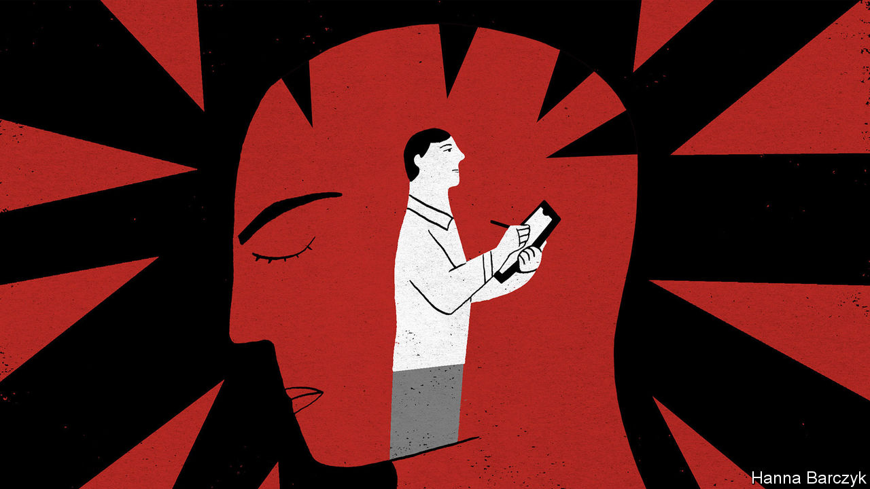

LATE IN JANUARY Shen Yinjing, a therapist in Shanghai, volunteered to help distressed people in the coronavirus-stricken city of Wuhan by offering counselling over the phone or by text. Before long she was running an online support group for people being treated in one of Wuhan’s makeshift hospitals for covid-19 patients. Now Ms Shen wonders how she should assist those bereaved by the disease. She worries that many people will not think to ask for help, even though the loss of a loved one can cause lasting mental trauma.

Ms Shen is among a small army of mental-health professionals who have provided support during the coronavirus outbreak, which reached a peak in China in January and February. Hundreds of universities and charities have set up “psychological hotlines” for people suffering from ailments such as anxiety and depression. Their efforts have enjoyed strong backing from the government, which has issued dozens of directives to guide the mental-health response to the epidemic.

Such attention reflects a profound change in official and public attitudes. Under Mao Zedong, modern approaches to psychology and psychiatry were suppressed. Mental ailments were treated as a deficiency of revolutionary zeal—nothing that earnest study of the chairman’s works couldn’t cure. In the post-Mao era political taboos surrounding mental health were lifted. But cultural ones persisted. Among citizens, psychological problems remained shrouded in shame. The government still paid little attention to developing expertise in the science. It tended to regard those with psychiatric disorders as potential troublemakers rather than as people in need of sympathetic care.

In recent years, however, the government has begun to stress the importance of mental health in the country’s long-term development goals. A mental-health law, passed in 2012, advised against the previously common practice of confining people in psychiatric wards against their will. The government’s “Healthy China 2030” plan, issued in 2016, called for a stronger “mental-health service system”.

These days many Chinese recognise that mental-health problems are common. Zhiying Ma of the University of Chicago says that young Chinese, in particular, have grown comfortable using terms such as depression and anxiety when talking about their difficulties. A Chinese government-funded survey published in 2019 found that such disorders were becoming more common in China. The study’s authors suggested that “rapid social change” was intensifying “psychological pressure and stress”.

At the same time, mental-health counselling has become more widely available, particularly for those willing to pay for private treatment. Between 2002 and 2018 more than 1m people completed brief government-certified courses in counselling skills. A devastating earthquake that struck the south-western province of Sichuan in 2008, killing more than 60,000 people, helped to promote interest in work involving psychology. In its wake, more Chinese took up careers as therapists.

Mental-health workers who have responded to the covid-19 outbreak appear better-organised and better-trained than the volunteers who flocked to care for victims of the earthquake, says Huang Hsuan-Ying of the Chinese University of Hong Kong. During the covid crisis, counsellors have formed online networks to co-ordinate their efforts to help the afflicted. Yu Zhihong, a professor of social work at Wuhan University, set up one such group. Its members provide psychological support for nearly 30 people who lost loved ones to the virus. Ms Yu says some of them are suffering from feelings of guilt, believing they were the source of a fatal infection, or worrying that they did not do enough to help a person who died.

But Ms Yu says that some people are reluctant to seek help from her network. She says this may be because grief is a private family matter in Chinese culture, and stigma still surrounds those who seek help from mental-health professionals.

There remain far too few such specialists to cope with China’s needs. The country has about two registered psychiatrists per 100,000 citizens, only about a sixth of the number in rich countries. Few Chinese have access to top-notch primary health care, so mild mental problems can go undetected until they are severe. Hospitals do not offer good care, either. Doctors often prescribe drugs, even when more subtle treatment, such as psychotherapy, might suffice. That is in part because they lack expertise and in part because it is more profitable to dispense pills.

The mental-health system that the government says it is building would make it easier for ordinary Chinese to receive counselling in local clinics or schools. The rich southern city of Shenzhen is one of about 30 places that were instructed in 2019 to pilot such reforms. By the end of this year it plans to have a staffed “psychological counselling room” in all of its larger local clinics. By the end of 2021 it aims to make counselling available in 85% of primary and secondary schools.

The reforms may help. But officials often refer to them not as a way of boosting public health, but as a means of improving “social governance”—in other words, strengthening control. It is possible that the counselling rooms will provide some assistance to people who are suffering, but also make it easier for the government to keep tabs on unhappy people.

Stories from Wuhan provide reasons to be sceptical. Grieving relatives report that they have been obliged to take government officials with them when they bury ashes, perhaps to ensure that funerals are kept brief and low key. Members of one family were ordered by police to delete an online group they had created in order to help bereaved people connect with each other. The government wants Chinese to talk more about their emotions, but not if they say the wrong things. ■

This article was downloaded by calibre from <https://www.economist.com/china/2020/05/16/in-china-covid-19-has-focused-attention-on-mental-health>

|  |  |  |  |
| --- | --- | --- | --- |
|  | Articles | Sections | Next |

|  |  |  |  |
| --- | --- | --- | --- |
| Previous | Articles | Sections | Next |

#### The lost boy

# Why there are two Panchen Lamas, and one is missing

China’s atheist ruling party wants to pick Tibetan Buddhist leaders

May 14th 2020 |

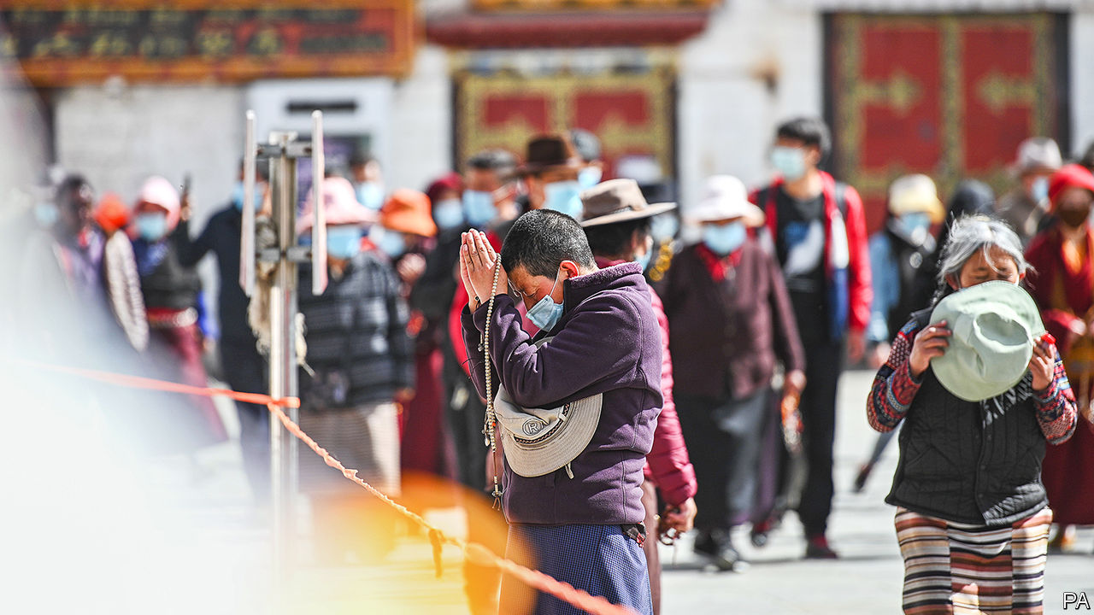

TO THE GREAT WALL of mutual suspicion and recrimination that divides China and the United States, the American Senate is adding another brick. It will soon consider the Tibet Policy and Support Act, a piece of bipartisan legislation that was passed by the House of Representatives in January. When, as seems likely, it becomes law, China will be furious. It regards its conduct in Tibet as above criticism by meddling foreigners.

Among other measures, the law would make it American policy that only Tibetan Buddhists can choose their religious leaders, including an eventual successor to the most senior of them all, the Dalai Lama, who is 84 and lives in exile in India. The law would demand that sanctions be imposed on any Chinese official who attempts to control the process of finding the Dalai’s Lama’s reincarnation. Odd as it seems, China’s avowedly atheist government is indeed intent on fixing the outcome. In 2007 it issued “management measures for the reincarnation of living Buddhas”.

An anniversary this month recalls how seriously China takes Tibetan religious succession. On May 17th, 25 years ago, Gedhun Choekyi Nyima, a six-year-old boy, was taken along with his parents from their home in Tibet. Three days earlier, in a ceremony in northern India, the Dalai Lama had proclaimed him as the 11th Panchen Lama, the second-most senior monk in the hierarchy, the tenth of whom had died in 1989. In Tibetan tradition, the Dalai and Panchen Lamas have important roles in identifying each other’s reincarnations.

The boy, whom activists would call “the world’s youngest political prisoner”, has not been seen in public since. Occasionally, China has tersely declared that he is living life as “normal”. In 1995 it named its own candidate as the 11th Panchen, Gyaltsen Norbu, who appears in public occasionally, but lacks credibility among Tibetans.

Exiled activists see the anniversary as a chance to remind the world of China’s brutality in Tibet and the hollowness of its promises of “autonomy” there. But in Tibet itself, the day will pass without notice. The region has emerged from its covid-19 lockdown into the political lockdown that passes for normal life there. The official media are indulging in a propaganda blitz around a new law, passed by the regional assembly in January, that came into effect on May 1st: “Regulations on the Establishment of a Model Area for Ethnic Unity and Progress in the Tibet Autonomous Region”.

Matthew Akester, a Tibet researcher based in India, says the regulations, under which government and private organisations must “strengthen ethnic unity” and combat separatism, contain nothing new. Rather, they formalise a trend in China’s policy towards its ethnic minorities. This stresses “unity” rather than diversity, let alone autonomy. Tibetan exiles fear that, by promoting intermarriage between Tibetans and Han Chinese, Han migration into Tibet and the urbanisation of Tibet, China aims to eradicate Tibetan identity.

No American law is going to deter China from trying. But neither will Tibet’s new regulations change an enduring fact: the strongest symbol of Tibet’s identity remains the Dalai Lama himself and the hold he has on Tibetan loyalties, despite 61 years in exile. As China should have learnt from the history of the Panchen Lamas, the Communist Party will never be accepted by Tibetans as the arbiter of their faith. ■

Editor's note: This article was updated after publication to remove a reference to a meeting of the Senate Foreign Relations Committee on May 14th, which was in fact postponed.

This article was downloaded by calibre from <https://www.economist.com/china/2020/05/14/why-there-are-two-panchen-lamas-and-one-is-missing>

|  |  |  |  |
| --- | --- | --- | --- |
| Previous | Articles | Sections | Next |

|  |  |  |  |
| --- | --- | --- | --- |
| Previous | Articles | Sections | Next |

#### Chaguan

# A small town in China makes half of Japan’s coffins

Such hyper-local production may prove resilient against decoupling

May 14th 2020 |

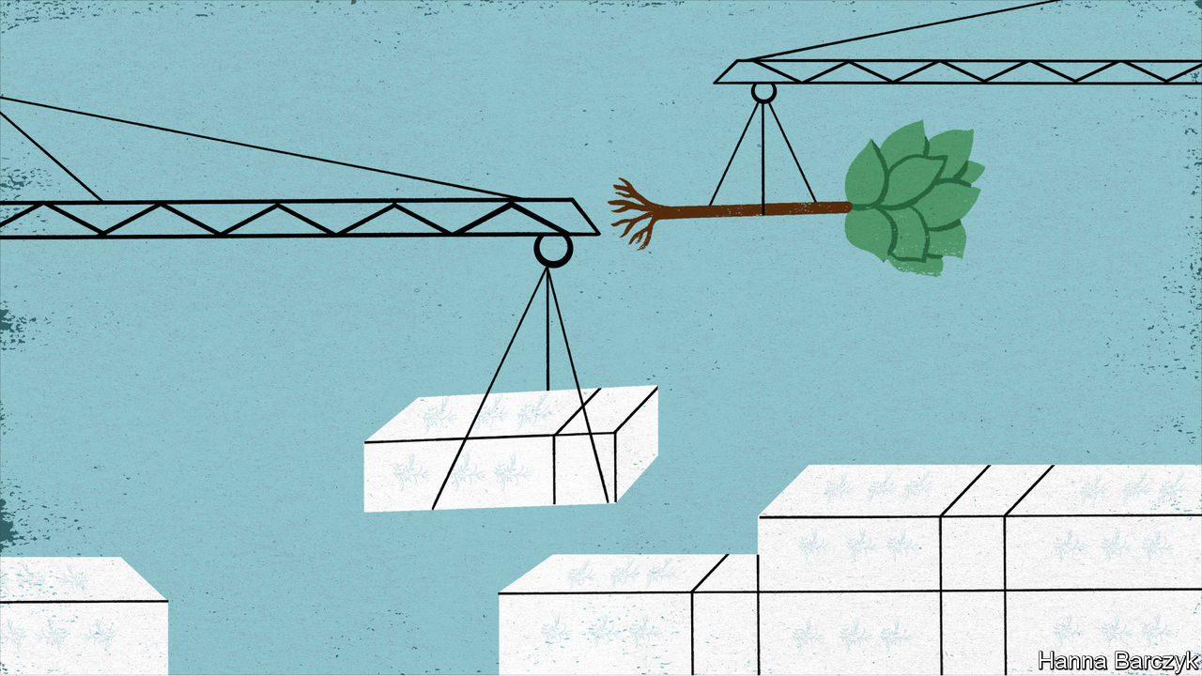

SINCE ANCIENT times, Chinese poets have revered the purple-flowering paotong as something rare: a tree in which a phoenix will land. Musicians cherish lutes made from its wood. The fast-growing plant, often used in sandy areas prone to soil erosion, even has a place in the Communist Party’s iconography. It is the subject of a rare poem by President Xi Jinping, who wrote of watering a paotong with his tears, shed in memory of a Mao-era official who battled cancer to supervise mass-planting of the tree.

Chaguan, a flintier-hearted sort, would like to propose the paotong (Paulownia elongata to botanists) as a metaphor for something less romantic: a distinctive Chinese business model that rarely makes international headlines, but which has helped to power the country’s rise. Governments everywhere are debating the future of globalisation in general, and dependence on China in particular. Politicians and CEOs fret about supply chains that cross oceans in search of value, but that now look vulnerable to trade barriers thrown up by pandemics or ideological disputes.

In Washington, China hawks talk of “decoupling”, unveiling plans that would see medicines, microchips and other sensitive products made in America again. In Japan the government has earmarked $2bn to help firms move high-value production back home from China. Meanwhile, Chinese officials seem bent on trampling their own country’s reputation for reliability. Chinese diplomats, playing the role of nationalist “wolf warriors”, have ordered foreign governments to offer vocal thanks if they wish to buy Chinese medical equipment. Chinese ambassadors have threatened trade boycotts against countries that displease the party’s leaders in Beijing. On May 12th a Chinese spokesman announced a ban on many beef imports from Australia. The official cited food-safety reasons, but almost in the same breath condemned Australia’s “erroneous words and deeds” in calling for an international probe into the origins of covid-19.

In this turbulent moment, the paotong tree is a timely reminder that globalisation, China-style, does not always involve globe-spanning supply chains of the sort now causing so much political angst. Since the country embraced capitalism more than 30 years ago, its astonishing growth has also been driven by an intensely localised variety of globalisation, in which a specific export sector is dominated by a single Chinese city or county.

The coffin-makers of Zhuangzhai, a leafy township of 100,000 people in the eastern province of Shandong, are a case in point. Between them, Zhuangzhai’s three main manufacturers export 740,000 coffins annually, almost all of them to Japan. With just under 1.4m deaths in Japan last year, that gives one Chinese township something around half the Japanese coffin market.

But when Japanese television journalists visited Zhuangzhai in 2017, they treated its share of the market as cause for larky curiosity rather than alarm. Their calm reflected the obvious synergies between Japan and this corner of Shandong. The largest local firm is Yunlong Woodcarving, which ships 20,000 coffins to Japan each month. Its 56-year-old founder, Li Ruqi, has coffin-making in the blood. His grandfather and father made caskets as well as furniture for locals, defying the superstitious horror that many rural Chinese feel for anything linked to death. In 1995 his firm began supplying a Japanese coffin-maker with panels decorated with phoenixes and lotus flowers. Most were carved from the wood of the paotong, which grows all around Zhuangzhai. Historically, Chinese preferred coffins of heavy cypress or cedar. They thought of paotong wood, which is creamy in colour and light in weight, as fit only for burying the poor. In modern Japan, where cremation in pale-coloured coffins is the norm, paotong is ideal.

Yunlong began making complete coffins for export in 2000, as labour costs in an ageing Japan soared to ten or 20 times those found in Zhuangzhai. Back then Mr Li’s Chinese workers were in their 20s, freshly graduated from local schools. In contrast, when Mr Li visited his Japanese customers, their workshops “didn’t have a lot of young people”. Now China is catching up. With about one in nine citizens over 65, China is at the point on the ageing curve that Japan hit in 1987. Today Mr Li’s 600 workers are mostly in their late 30s and 40s. Youngsters prefer service-sector jobs, he sighs.

Cold commercial logic sent Japanese coffin-makers to Zhuangzhai. Shandong offered skilled artisans, easy access to the right trees and a good climate for woodwork—neither dry nor too humid. Japanese clients came with “very high requirements”, Mr Li recalls without resentment. Over the years his firm and its customers have innovated, using hollow panels so that a single tree now provides the wood for 20 coffins or more, rather than two or three as was once the case. In one corner, workers are checking a new line of flat-pack coffins. With their pegs and holes and drop-in end panels, they eerily resemble caskets that IKEA might make. Mr Li demonstrates the way that two small doors in each coffin lid would open to reveal the face of the deceased. Their hinges must be perfectly silent or risk causing tremendous offence, he explains.

## Demographics trumps politics

Mr Li is unfazed by talk of the rich world decoupling from China. Some Japanese clients did try sourcing coffins in Vietnam and Indonesia, he concedes. But they found that workers in South-East Asia lacked “discipline”, so returned to Shandong. His corner of China has paotong trees, skilled labour and trusted suppliers. “Price-wise, talent-wise, this place is pretty far ahead,” he says.

Demography is a bigger worry. It is not just Zhuangzhai’s workers who are ageing. With more than one in four Japanese over 65, coffin sales are brisk. But clients from Japan remind Mr Li that Japan’s population is shrinking fast. “They told me I’ve got about 30 years in this line of business,” he says. China’s hyper-local version of globalisation may prove surprisingly resilient in the face of decoupling. But some storms will overcome the deepest roots. ■

This article was downloaded by calibre from <https://www.economist.com/china/2020/05/14/a-small-town-in-china-makes-half-of-japans-coffins>

|  |  |  |  |
| --- | --- | --- | --- |
| Previous | Articles | Sections | Next |

|  |  |  |
| --- | --- | --- |
| China | Sections | Europe |

Middle East & Africa

Covid-19 in Africa: The long game

.

Elections 1: We don’t need no observation

.

Ethiopia: Democracy delayed

.

Syria: Family feud

.

Saudi television: Series of changes

.

|  |  |  |
| --- | --- | --- |
| China | Sections | Europe |

|  |  |  |  |
| --- | --- | --- | --- |
|  | Articles | Sections | Next |

#### The smouldering pandemic

# Why covid-19 seems to spread more slowly in Africa

Transport links are worse

May 16th 2020 | JOHANNESBURG

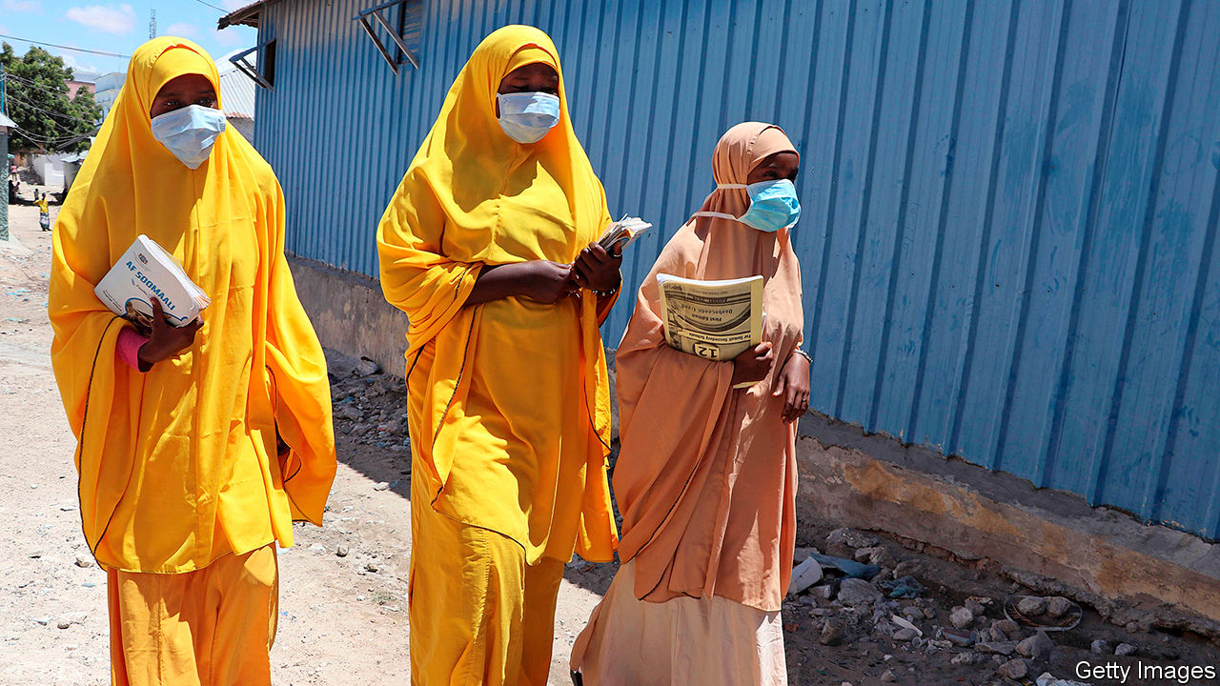

IT WAS NOT what fishermen usually mean by a good catch. Last month a worker at a fish factory in Tema, a port city in Ghana, infected 533 people with the virus behind covid-19. President Nana Akufo-Addo linked the “super-spreader” to about 10% of the country’s 5,408 cases.

That Ghana could identify the person is a tribute to its response. It has tested more than 155,000 people, the fourth-highest per-person rate in Africa, according to data from CDC Africa, a public-health body. Elsewhere a lack of testing makes it harder to assess the true course of the disease. But what data there are, and new analysis by the World Health Organisation (WHO), suggest the virus is spreading more slowly in Africa than elsewhere—and that its path will vary across the continent.

Africa, which contains about 17% of the world’s population, has less than 2% of its confirmed cases of covid-19. By May 13th CDC Africa had counted 69,947 cases and 2,410 deaths. Over the past month reported cases have doubled roughly every two weeks. Until recently American cases were doubling about every three days.

This may partly reflect insufficient testing. Africa has checked just over 1m people—a day’s work for officials in Wuhan. South Africa and Ghana account for nearly half. The Partnership for Evidence-Based Response to Covid-19, a public-health consortium, notes that “the true number of infections is likely to be much greater than currently known.” Its rough estimate suggests a tally eight times higher.

Another sign of undercounting is the share of covid-19 tests coming back positive. The “test-positivity-rate” is an imperfect guide. But assuming those being tested have covid-like symptoms, a rate above 5-10% suggests there are many uncounted cases, says Jason Andrews of Stanford University. At least 22 African countries have rates above 10%, including Algeria (91%), Sudan (87%) and Tanzania (78%).

John Magufuli, Tanzania’s president, does not believe his country’s results. “We only see them releasing positive, positive, positive results,” he said. He claims that the national laboratory was sent papaya, goat and sheep samples that tested positive. (The lab denies this.) No new official data have been released since April 29th.

Opposition activists and NGOs say that there have been dozens of burials of covid-19 victims in Dar es Salaam, Tanzania’s largest city. On May 12th the American embassy said that hospitals there were “overwhelmed”. “It is a cover-up,” says Zitto Kabwe, an opposition leader.

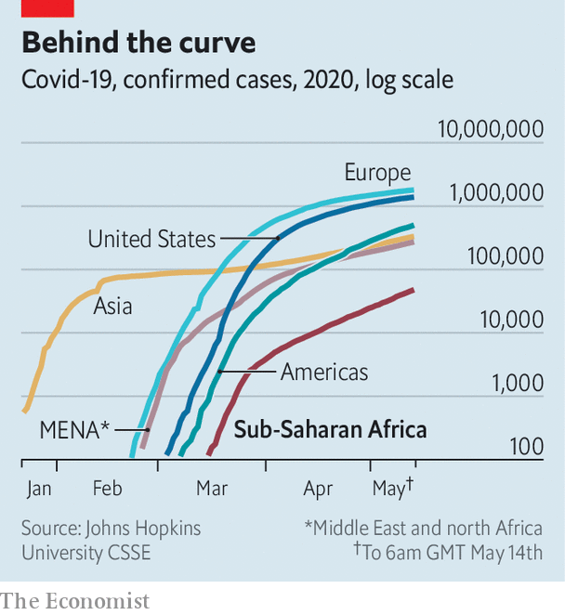

There are similar reports of undocumented surges in other countries. In Kano, in northern Nigeria, hundreds of unexplained deaths have been alleged by gravediggers. In Mogadishu, the capital of Somalia, medics claim that the deaths they are seeing do not chime with official totals.

Nevertheless there are few signs that these “ghost hotspots” are ubiquitous. Some countries, including Mauritius, Namibia and the Seychelles, have not reported a new case for two weeks. Ethiopia, Rwanda and Uganda have fewer than 700 cases between them and positive-test rates below 1%. Nor are there reports of surges. “In a society like ours there’s simply no way this could be kept secret,” says Berhanu Nega, an Ethiopian opposition leader.

Crucial in slowing the early spread of covid-19 was the swift introduction of containment measures. Most African countries implemented lockdowns far earlier than rich countries did. By the end of April at least 42 African countries had done so; 38 of these were in place for at least 21 days.

So despite undercounting, official data are still a rough reflection of reality in many countries, say those leading the response. “While covid-19 likely won’t spread as exponentially in Africa as it has elsewhere in the world, it likely will smoulder in transmission hotspots,” says Matshidiso Moeti, the director for the WHO in Africa.

Her view of a slower, longer pandemic is explained in a paper by WHO colleagues, published by bmj Global Health on May 14th. Unlike other models, which tend to apply patterns seen elsewhere in the world to Africa, theirs claims to make assumptions based on the continent’s “unique socio-ecological context”. For example, it takes into account the fact that Africans travel less, thanks to sparse road networks.

The authors reckon that without containment measures 16-26% of those in the WHO Africa region would be infected in the first year, with higher shares in well-connected countries like South Africa. About 29m-44m people would be symptomatic. This is a lower estimate than other models yield. The WHO also calculates that there would be 83,000–190,000 deaths without mitigating steps—implying a lower rate of infected people dying than in rich countries, mostly because Africans are younger. However, Africa does not have rich countries’ hospitals. Surges in cases would overwhelm health systems.

Because the model assumes no mitigating measures such as lockdowns, the actual tallies should be lower. Yet many African governments are in the midst of loosening restrictions, as they try to balance the harm of covid-19 with that to their economies and public health more broadly. Researchers at Imperial College London reckon that in some countries the knock-on effects on treatment for HIV, TB and malaria could be of the same order of magnitude, in terms of years of life lost, as that of covid-19.

Many rich countries are easing lockdowns after reaching, in theory, peaks in new cases. African countries may be doing so while case-rates accelerate. Africa seems to be suffering a slower pandemic, but the risks are still immense. ■

This article was downloaded by calibre from <https://www.economist.com/middle-east-and-africa/2020/05/16/why-covid-19-seems-to-spread-more-slowly-in-africa>

|  |  |  |  |
| --- | --- | --- | --- |
|  | Articles | Sections | Next |

|  |  |  |  |
| --- | --- | --- | --- |
| Previous | Articles | Sections | Next |

#### We don’t need no observation

# Covid-19 helps ballot-dodgers in Africa

Foreign election monitors are staying at home

May 16th 2020 | NAIROBI

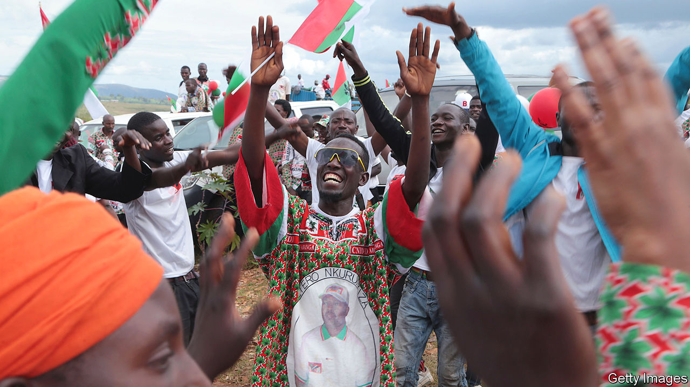

Editor’s note: The Economist is making some of its most important coverage of the covid-19 pandemic freely available to readers of The Economist Today, our daily newsletter. To receive it, register [here](https://www.economist.com/newslettersignup). For our coronavirus tracker and more coverage, see our [hub](https://www.economist.com/coronavirus)

STRONGMEN TEND to find election observers rather a nuisance. The sharper-eyed ones make trickery harder to get away with. Which is why autocrats see an upside to covid-19. These days, even the nosiest monitors are disinclined to travel.

Alpha Condé, Guinea’s president, has taken full advantage of the pandemic. On March 22nd he pressed ahead with a parliamentary vote he had postponed four times before. The coronavirus was apparently not a good enough reason to warrant a fifth delay. Foreign observers, who had previously raised concerns about possible tampering with the electoral register, stayed away, as did the opposition, who declared a boycott. Mr Condé’s ruling party’s share of seats in parliament duly rose to more than two-thirds. Because the president also slipped in a referendum on relaxing term limits, Guineans may now enjoy his rule until 2032, when he will be 94.

President Pierre Nkurunziza of Burundi is similarly determined not to let the virus stop his people having their say. Burundians will crowd into polling stations on May 20th to choose a new president and parliament. Most observers are planning to stay away, which suits Mr Nkurunziza just fine. Nonetheless, 12 days before the election his government took no chances, telling the East African Community that any monitors it might still think of sending would have to spend 14 days in quarantine.

Mr Nkurunziza has been less strict when it comes to protecting his own people from the virus. Beyond quarantining observers, his regime has imposed few restrictions. Bars, restaurants and churches remain open. Burundi has been the only African country to continue top-tier football. Games were suspended on April 13th, but only so that stadiums could be used for campaign rallies. Fixtures will resume the day after the poll. “The coronavirus is killing people everywhere else,” said General Evariste Ndayishimye, the party apparatchik the president has chosen to succeed him. He told supporters not to worry: “Do not be afraid. God loves Burundi.”

Opposition types are less keen on the absence of monitors. Agathon Rwasa, Burundi’s foremost opposition candidate, suggests that many abuses are now going undocumented. His supporters are being intimidated. Several have been attacked, arrested or even murdered. He also complains that the electoral commission has not published voter lists, which makes them easier to manipulate.

Given that the commission is almost entirely made up of members of the ruling CNDD-FDD, election officials are under no pressure to listen to Mr Rwasa. Besides, many opposition supporters may never get the chance to cast their ballots anyway. Voter cards are doled out by local chiefs. As these also all belong to the CNDD-FDD, they are inclined to give the cards only to those known to be party supporters.

There is little the opposition can do about any of this. So Mr Nkurunziza, who has had himself named “Eternal Supreme Guide” and may attempt to rule through his successor, is likely to see his gamble pay off. His nominee, General Ndayishimye, is all but certain to win.

Others will pay the price. Packing voters into campaign rallies and polling stations is hardly sensible during a pandemic, as Guinea’s example shows. The country had been relatively unscathed by covid-19 when voters went to the polls, with just two cases recorded. It is now the eighth-worst affected in Africa, with more than 2,300 recorded cases. The head of Guinea’s electoral commission and Mr Condé’s chief of staff are among the 14 who have died. The opposition now accuses the president of spreading the virus.

Burundi, too, has apparently had relatively few cases—only 15 confirmed ones by May 13th, though just 284 tests had been conducted. As in Guinea, those numbers could easily jump. If they do, the president’s cynicism will be partly to blame.

Covid-19 is the excuse that keeps giving. John Magufuli, Tanzania’s president, is likely to press ahead with an election in October, when he is expected to fend off a browbeaten opposition. Though he is as casual as President Nkurunziza about the virus, he could use it as an excuse to block foreign observers. This would be particularly handy in Zanzibar, a restive island where elections were annulled in 2015 because of foul play.

The virus can also furnish a pretext for dodging a ballot entirely. Uganda’s Yoweri Museveni says it would be “madness” to hold elections scheduled for next year. He would probably win them because they are unlikely to be free or fair. Even so, Mr Museveni is nervous. If he held an unfair vote and still failed to win convincingly, he could face calls from within his own party to stand down.

Malawi’s president, Peter Mutharika, risks defeat in an election on July 2nd that he is being dragged kicking into. In February judges annulled his victory in a poll last year after finding evidence of vote-rigging, and ordered a re-run. On May 8th they threw out his “embarrassing” and “unprofessional” appeal.

Mali’s ruling party felt obliged last month to go ahead with an election even though it expected to lose seats. It did not try to stop the ballot because it knew that without a new parliament, a peace deal with separatists could not go ahead.

Many Big Men are trying to exploit the pandemic. The key to stopping their shenanigans, in times of sickness as in those of health, is independent judges, uppity activists and brave voters. ■

Dig deeper:  
For our latest coverage of the covid-19 pandemic, register for The Economist Today, our daily [newsletter](https://www.economist.com/newslettersignup), or visit our [coronavirus tracker and story hub](https://www.economist.com/coronavirus)

This article was downloaded by calibre from <https://www.economist.com/middle-east-and-africa/2020/05/16/covid-19-helps-ballot-dodgers-in-africa>

|  |  |  |  |
| --- | --- | --- | --- |
| Previous | Articles | Sections | Next |

|  |  |  |  |
| --- | --- | --- | --- |
| Previous | Articles | Sections | Next |

#### Vote again another day

# Ethiopia is entering constitutional limbo

Postponed elections may leave it without a legal government

May 16th 2020 | ADDIS ABABA

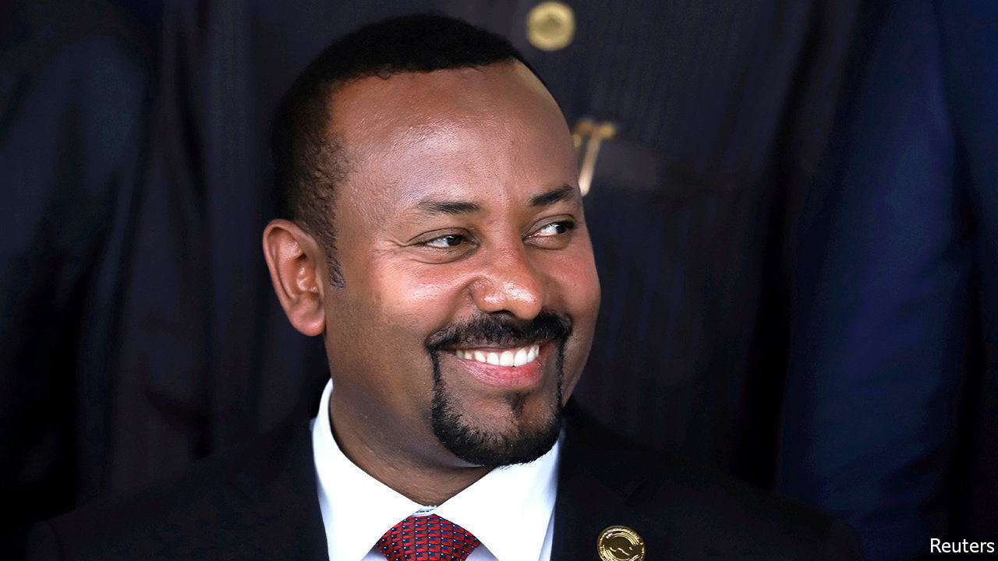

EVEN IN NORMAL times Ethiopia’s plans to hold national elections in August would have been fraught with uncertainty. Would they be free and fair? Would they help restore peace to a country riven by ethnic violence? Now, with the polls postponed indefinitely by covid-19, Ethiopia is approaching a constitutional crisis.

By law Ethiopia’s parliament will reach the end of its constitutional five-year term on September 30th. That could leave the country without a legitimate parliament or government. Abiy Ahmed, a young reformer who took office in 2018 promising democracy after massive protests, says that because of the exceptional circumstances of the pandemic his government will stay in charge until elections can be held safely.

The delay has prompted a backlash from opposition leaders. Many of them had suspected long before the outbreak of covid-19 that Abiy’s Prosperity Party would try to rig or postpone the elections: its predecessor suppressed the opposition so thoroughly in 2015 that it won 95% of the vote.

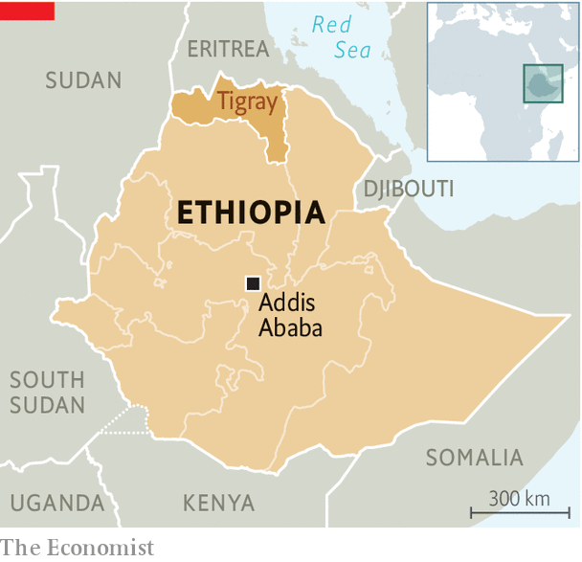

The Tigrayan People’s Liberation Front (TPLF), which called the shots in the country for nearly three decades until it was ousted by Abiy, accused the prime minister of exploiting the pandemic to dismantle the constitution and lay the groundwork for one-man rule. It said it will press ahead with polls in Tigray, the region it still controls, in defiance of the federal government. This squabble will further pull at the seams of a federation that has been badly fraying in recent years.

To avert a showdown the government has asked the Council of Constitutional Inquiry for an opinion on the postponement. But this is not an independent constitutional court. The council is merely an advisory body to the upper house of parliament, which is controlled by the ruling party, notes Zemelak Ayele of Ethiopia’s Centre for Federal Studies.

Although the constitution does not spell out the circumstances under which an election may be postponed, it still provides a “framework” allowing it , says Adem K Abebe, an expert based in The Hague. But such legal subtleties may count for little without the support of opposition leaders. To get this Abiy may have to bargain with them on matters such as the timing of the election, as well as allay their concerns about its fairness and the independence of state media and the security forces.

Jawar Mohammed, a popular figure among the Oromo ethnic group, wants Abiy to start talks about a caretaker administration taking charge until elections are held, among other matters. Abiy has met his opponents once to discuss the constitutional impasse. But he has dismissed calls for an interim government and warned that “illegal elections” will “harm the country and the people”. There is a risk, however, that without a compromise his prophecies become self-fulfilling. ■

This article was downloaded by calibre from <https://www.economist.com/middle-east-and-africa/2020/05/16/ethiopia-is-entering-constitutional-limbo>

|  |  |  |  |
| --- | --- | --- | --- |
| Previous | Articles | Sections | Next |

|  |  |  |  |
| --- | --- | --- | --- |
| Previous | Articles | Sections | Next |

#### A regime divided

# Trouble in Bashar al-Assad’s own ranks

A family feud risks dividing the Syrian president’s supporters

May 16th 2020 |

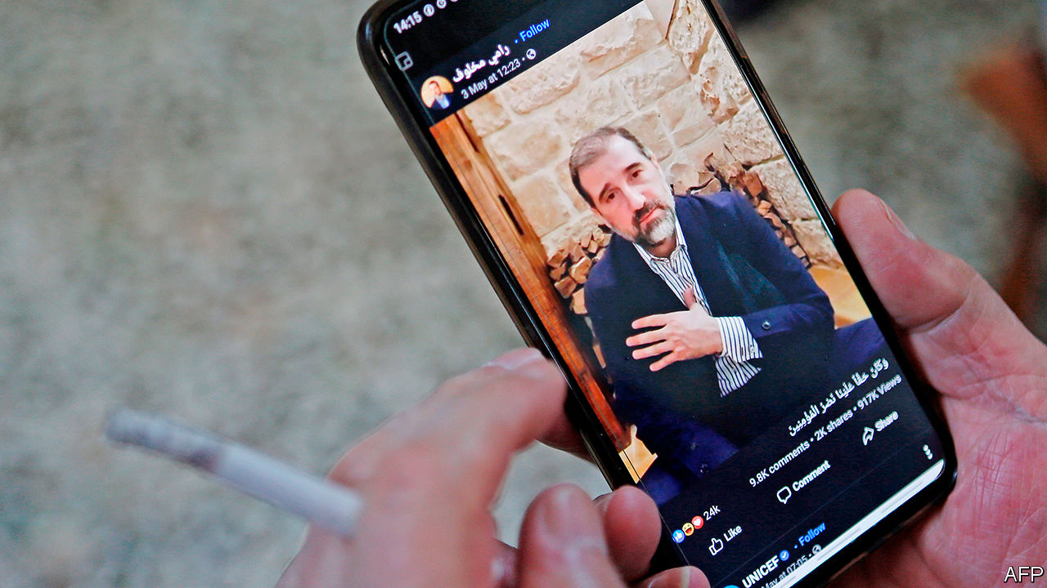

IN 1957 A young air-force officer from the highlands called Hafez al-Assad married a girl from the coast named Anisa Makhlouf. It seemed a good fit: Assad was ambitious; the Makhloufs were powerful. And indeed, after Assad took over in a coup in 1970 the two clans ran the country like a family business, propelling their esoteric Muslim sect, the Alawites, from Syria’s backwaters to the centre of power.

Half a century on, though, the partnership is unravelling. In a series of videos posted on Facebook Rami Makhlouf, Syria’s wealthiest tycoon, accused his cousin and Hafez’s son, President Bashar al-Assad, of confiscating his assets. Mr Makhlouf even complained, unironically, that the blood-soaked security forces, which he long sponsored, were treating his employees in “an inhumane way” and “attacking the people’s freedoms”.

Things had been moving against Mr Makhlouf for a while. The death of Anisa in 2016 deprived his clan of protection. Maher al-Assad, the president’s younger brother and commander of the Republican Guard, coveted his business empire. The president’s wife, Asma, wanted to empower her own clique and improve the prospects of their 19-year-old son, Hafez. In his most recent post Mr Makhlouf (pictured) seemed to blame her for his misfortune.

But the biggest reason for Mr Makhlouf’s fall is the president’s need for money after nine years of civil war that have devastated the economy. In December the government began seizing the businessman’s assets, citing “customs violations”. The shakedown came to a head last month when goons raided Syriatel, the country’s biggest mobile-network provider, owned by Mr Makhlouf. Senior managers were arrested and the state demanded at least $170m in licence fees. It was all part of an anti-corruption drive, said Mr Assad.

Normally the regime puts guns in the mouths of troublemakers and calls it suicide. But Mr Makhlouf poses an unusual challenge. His clan is larger than Mr Assad’s and is part of the powerful Haddadin tribe. Mr Makhlouf has courted their loyalty throughout the war. In 2012 he formed the Bustan Association, a charity with an armed wing, to protect and care for his kinsmen. It provided meals, health care and jobs—until Mr Assad curbed some of its activities last year.

Alawite hardliners bewail the downfall of Mr Makhlouf, whom they consider their protector. Some suggest the president is forsaking his own sect for the predominantly Sunni merchants who are close to his wife (also a Sunni). Most Alawites have lost loved ones fighting for Mr Assad, so they cringe at the thought of him handing the war’s spoils to Sunnis, many of whom rebelled against him. “Alawites feel threatened and will rally around Rami,” says a business associate of Mr Makhlouf. “If [the security forces] go after him, they risk destabilising the regime.”

Iran, which backs the regime, is looking on anxiously. Mr Makhlouf has “always been close to the Iranians”, says the associate. “He put all his eggs in the Iranian basket.” But Iran itself has bigger problems. The assassination in January of Qassem Suleimani, the commander of its foreign operations, and mounting financial trouble have made it harder for Iran to maintain its position in Syria. Israel has been increasing its air strikes on Iranian bases in the country and says Iran is retreating.

Russia, which also backs Mr Assad, may not mind seeing Iran go. It wants its own companies to benefit from reconstruction contracts in Syria. The S-300 air-defence system that it gave the regime never seems to work against Israeli missiles. Analysts say Russia is acquiescing in, if not facilitating, the strikes on Iranian positions. It has also moved its forces into areas prized by Iran and cut it out of negotiations over northern Syria, where rebels backed by Turkey continue to hold territory and the Kurds have carved out a proto-state.

With the regime in disarray some think Mr Assad might be more willing to negotiate a political solution with the rebels. Russia wants a settlement in order to convince Western powers to help fund reconstruction. Under one (optimistic) scenario, Mr Assad would accept a new constitution that devolves powers to a more conciliatory prime minister ahead of presidential elections next year.

Good luck with that. Mr Assad appears as stubborn as ever. Russian diplomats paint him as a disobedient client. Criticism of him is increasing in Russian media. Some reports even suggest that President Vladimir Putin would prefer to deal with someone else. But no alternative has emerged. No matter how much Mr Assad alienates his allies—and his own people—they appear stuck with him. ■

This article was downloaded by calibre from <https://www.economist.com/middle-east-and-africa/2020/05/16/trouble-in-bashar-al-assads-own-ranks>

|  |  |  |  |
| --- | --- | --- | --- |
| Previous | Articles | Sections | Next |

|  |  |  |  |
| --- | --- | --- | --- |
| Previous | Articles | Sections | Next |

#### Series of changes

# Friendly Jews, female bosses; Saudi TV promotes a new vision

But it ignores the kingdom’s current anxieties

May 16th 2020 | BEIRUT

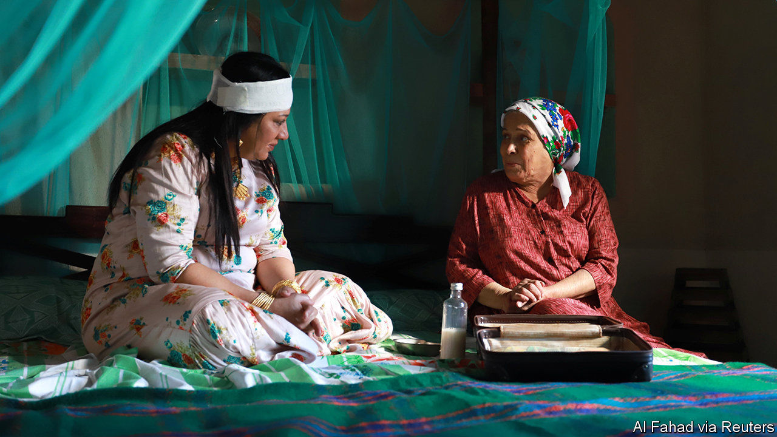

IN A WORLD flipped on its head, a note of constancy: the Middle East is arguing about Israel. “Exit 7”, a popular series aired on Saudi television this Ramadan, portrays a family led by Nasser al-Gassabi, a Saudi actor. One episode has his son Ziad befriend an Israeli, via an online video game. True to life, the friendship is cause for controversy. But not everyone is perturbed. Mr Gassabi’s on-screen father-in-law describes Israel as a reality and the Palestinians as ungrateful “enemies”.

Autocrats in the Middle East use television to push politics—especially during Ramadan, when big-budget series attract hours of post-prandial viewing. In Egypt scripts are vetted for patriotic themes. Turkey and the UAE, regional rivals, recently made duelling shows about the Ottoman empire: benevolent overlords in the former; unwanted occupiers in the latter. Critics say “Exit 7” and another Saudi show, “Um Haroun”, which features Jewish characters, are attempts to promote normalisation with Israel.

But much of “Exit 7” deals with changing mores in Saudi Arabia. It begins with Mr Gassabi donning a bisht, a ceremonial cloak, before going to receive a promotion. “This is the cloak of responsibility,” he gloats. The twist: not only is he passed over for the job, but his new boss is a woman. Another show, “Ureem”, focuses on a layabout forced to work as a taxi driver, the sort of job once reserved for migrants.

The shows, though, dance around the kingdom’s current anxieties. On May 11th the state announced austerity measures to blunt the budgetary shocks of a pandemic and low oil prices. It tripled the value-added tax. Civil servants lost a 1,000-rial ($266) monthly stipend. Unsurprisingly, the decree was not prime-time television: it came just after dawn.

Muhammad bin Salman, the crown prince, wagers that he can fashion a new society from the top down. Many of his changes, from letting women drive to permitting concerts, were long sought by Saudis. Looming economic changes will be more jarring. Generations of Saudis were insulated from market-based wages and competitive pressures. Some will face lower living standards. A whimsical TV show will not assuage them.

This article was downloaded by calibre from <https://www.economist.com/middle-east-and-africa/2020/05/16/friendly-jews-female-bosses-saudi-tv-promotes-a-new-vision>

|  |  |  |  |
| --- | --- | --- | --- |
| Previous | Articles | Sections | Next |

|  |  |  |
| --- | --- | --- |
| Middle East & Africa | Sections | Britain |

Europe

France leaves lockdown: Free at last

.

Controlling covid-19: The Swedish way

.

North Macedonia: Lies, damned lies…

.

Naval strategy: Northern fights

.

Charlemagne: Real life and postcard views

.

|  |  |  |
| --- | --- | --- |
| Middle East & Africa | Sections | Britain |

|  |  |  |  |
| --- | --- | --- | --- |
|  | Articles | Sections | Next |

#### Free at last

# France is leaving lockdown. Now the trouble begins

The process is hampered by adversarial labour relations and distrust of government

May 14th 2020 | PARIS

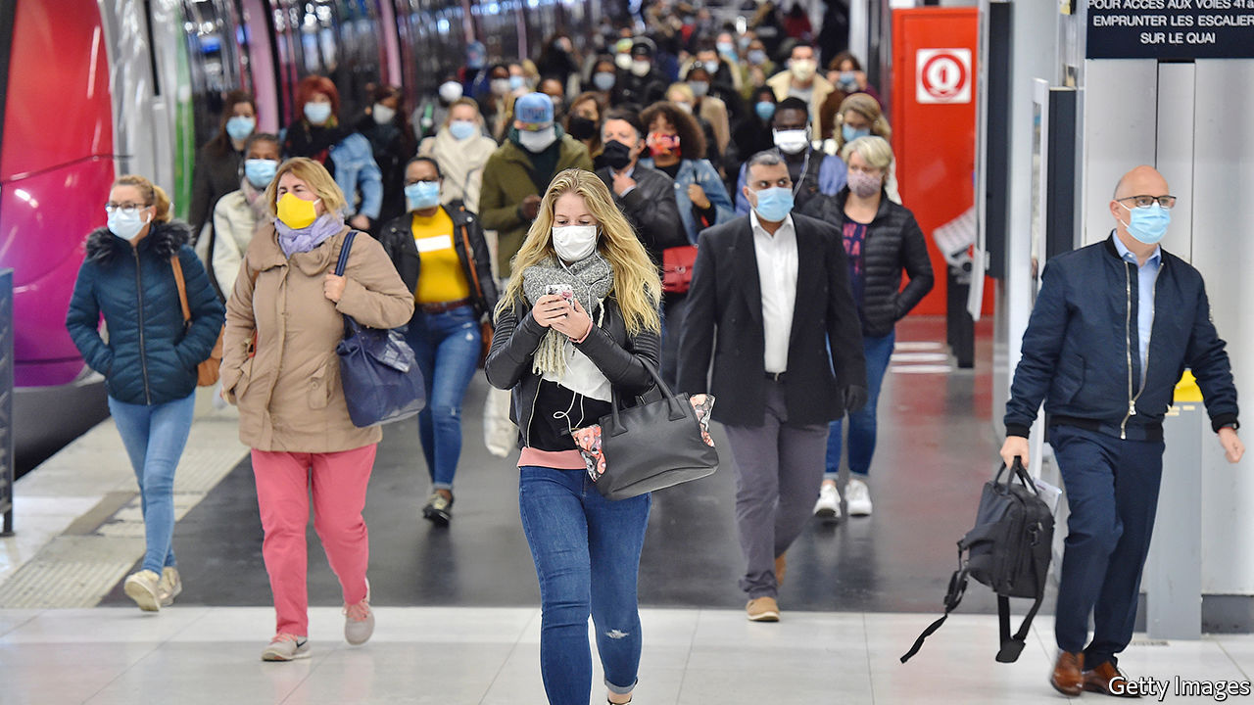

Editor’s note: The Economist is making some of its most important coverage of the covid-19 pandemic freely available to readers of The Economist Today, our daily newsletter. To receive it, register [here](https://www.economist.com/newslettersignup). For our coronavirus tracker and more coverage, see our [hub](https://www.economist.com/coronavirus)

ON THE ESTUARY of the river Seine in Normandy, the Renault factory at Sandouville lies silent and empty. Usually, the 1,900 workers at this plant turn out 132,000 vehicles a year, mostly delivery vans. But on May 7th a court in Le Havre ordered Renault not to reopen fully as planned on May 11th, when France began its déconfinement, or emergence from lockdown. It upheld a complaint brought by the Confédération Générale du Travail, a union with historical links to the Communist Party, that the firm had not followed procedure for consulting employees about reopening. Pending an appeal, the factory remains shut.

After eight weeks of confinement, France was supposed to resume work this week. Forms for permission to pop to the shops have been binned. Public transport was running at 75% of normal in Paris, with masks compulsory. Hairdressers, clothes shops, bookstores and all other commerce—except restaurants and cafés—were allowed to reopen. Some primary-school pupils returned to class. It was “essential” for the economy to get going again, said Bruno Le Maire, the finance minister.

Much of the complexity of organising this is not unique to France. The sourcing of masks, the spacing of seats on public transport or in classrooms, the distribution of hand gel in shops and offices: these problems are shared by all countries exiting lockdown. Yet, as the court decision against Renault shows, France also faces some quite specific difficulties.

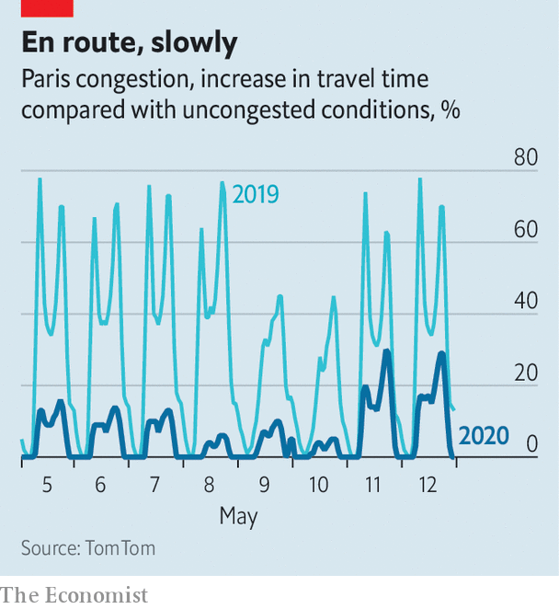

One is the adversarial nature of labour relations, combined with the French state’s enduring appetite for bureaucracy. Unions enjoy an entrenched role through mandatory works councils. President Emmanuel Macron simplified these, and merged even more tangled former structures into a single comité social et économique. But firms with over ten employees still have to hold monthly or bi-monthly meetings, partly to discuss issues concerning employee well-being. Talks are often long, and testy.

In preparing déconfinement, bosses report vastly more such consultations. The director of a services firm in the Paris region says that he has spent a full day each week on discussions to prepare for the return of just ten employees (out of 95) to the office. The government has produced a 20-page “national déconfinement protocol”, with guidelines on how, for instance, to calculate the new minimum workspace per employee (four square metres). “It’s really complicated,” says Jérôme, who runs a hairdressing salon. He has had to take out five of the 12 seats in his salon and says each haircut—much in demand after eight weeks—is taking an extra 15 minutes because of the time it takes to disinfect things. The price of not applying the rules can be high. The court ruled against Renault partly because the firm had organised a works-council meeting by email rather than, as the rules state, by post.

Furthermore, both company bosses and elected officials are criminally liable while in their jobs. Just five months ago a court sentenced France Telecom’s former boss to a year in prison (with eight months suspended) in a criminal case brought after the suicide of several employees over a decade ago. In normal times, this breeds caution. Under covid-19, as managers scrub offices and install plexiglass partitions, even more so. After much lobbying, the liability has been limited a bit for employers and mayors, but only during the crisis.

Already, an astonishing 63 legal complaints have been filed against ministers, including Edouard Philippe, the prime minister, and Olivier Véran, the health minister. Many of the complaints are bound to be dismissed. But ministers could yet be hauled before a special court. In 1999 a contaminated-blood case was brought against Laurent Fabius, a former prime minister. He was charged with manslaughter, but acquitted in court. That he faced such grave charges in the first place scares decision-makers today.

Still, many people are itching to go back to work. “I’m really relieved to be back, I couldn’t bear confinement,” says Joseph cheerfully on his first day back at a men’s outfitter in Paris. While shops were shut he was on chômage partiel, a furlough scheme under which the government paid 84% of his wages. Now he is back on full salary. Elsewhere in France, Renault has partially reopened car factories without difficulty. Many office staff continue le télétravail, or work from home, easing pressure on trains and buses. Despite the anxiety, 1.5m primary-school pupils, or roughly one in five, have filed back to the classroom.

Yet there is an underlying fearfulness, which Yann Algan, an economist at Sciences Po university, links to a “particular lack of trust in French society” towards institutions, employers and government. During confinement “distrust” was the single most-cited feeling by the French in a poll for Sciences Po, while for Germans and Brits it was “calm”. This, says Mr Algan, “is the key to understanding why the return to work will be slower and more complicated in France than in Germany”. In May, despite déconfinement, François Villeroy de Galhau, the governor of the Bank of France, expects the economy to operate at only 83% capacity, after 73% in April.

The balance between safety and prosperity is perilous. As Eric Chaney of the Institut Montaigne, a think-tank, points out, chômage partiel (which covers 12.4m workers) has been the right policy to avoid lay-offs, “but creates the wrong incentives about returning to work”. The government now talks about gradually shifting the cost of the scheme to employers from June. Having played so well to French angoisse to impose confinement, the government may find it peculiarly hard to secure the trust needed to assuage those fears, and get the country fully back to work. ■

Dig deeper:  
For our latest coverage of the covid-19 pandemic, register for The Economist Today, our daily [newsletter](https://www.economist.com/newslettersignup), or visit our [coronavirus tracker and story hub](https://www.economist.com/coronavirus)

This article was downloaded by calibre from <https://www.economist.com/europe/2020/05/14/france-is-leaving-lockdown-now-the-trouble-begins>

|  |  |  |  |
| --- | --- | --- | --- |
|  | Articles | Sections | Next |

|  |  |  |  |
| --- | --- | --- | --- |
| Previous | Articles | Sections | Next |

#### Herd on the street

# Is Sweden’s approach to covid-19 wise or reckless?

Its avoidance of a hard lockdown is unusual, but Swedes think it is working

May 16th 2020 |

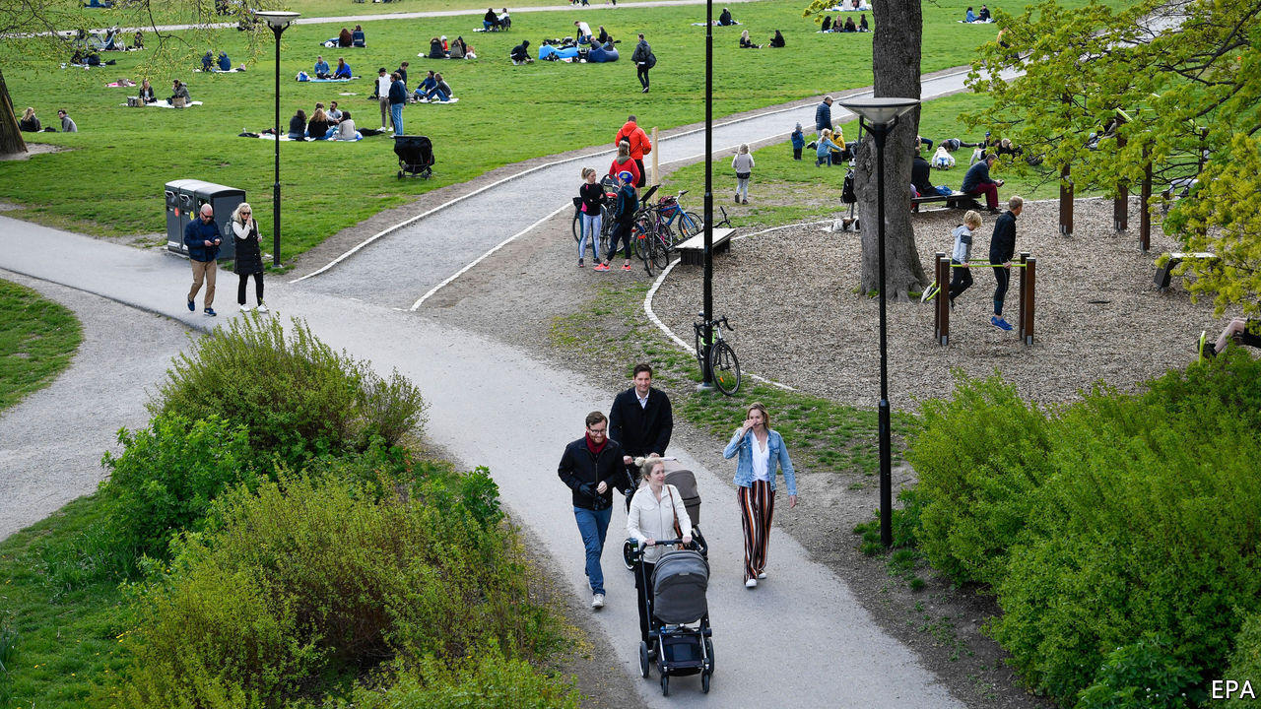

Editor’s note: The Economist is making some of its most important coverage of the covid-19 pandemic freely available to readers of The Economist Today, our daily newsletter. To receive it, register [here](https://www.economist.com/newslettersignup). For our coronavirus tracker and more coverage, see our [hub](https://www.economist.com/coronavirus)

AS BLEARY-EYED Europeans squint in the sun, freshly released from coronavirus lockdowns, worries about a second wave of infections are on everybody’s mind. Life cannot return completely to normal until a vaccine is available. What sort of semi-normal life might work in the meantime is the big question. Sweden may hold the answer.

In March, when governments across Europe seemed to be competing to impose the toughest anti-viral measures—from closing borders to forbidding people from venturing out even for a walk—Sweden resisted the temptation. It banned gatherings of more than 50 people. But nurseries and schools for children under 16 have remained open (with older students tele-learning from home). Bars, restaurants and gyms also stayed open, though with social-distancing rules. People were asked to work from home if they could. And the elderly, who are most at risk of dying if infected, were told to stay at home to protect themselves.

Sweden chose this path because it looked at the longer term, says Johan Giesecke, an epidemiologist advising the authorities. Full lockdowns are stop-gap measures, he says, and European governments rushed to put them in place without plans for what would replace them.

Swedes have been sensible. Use of public transport has fallen significantly. A third of people say they avoid going to their workplace (by working from home, for example)—up from 10% in mid-March. Daily restaurant turnover fell by 70% in the month through April 22nd. Elisabeth Peters, who is 67 and lives on one of the islands off the west coast of Sweden, believes there has been a “huge change” in people’s behaviour, aligned with official advice. Some people are not seeing their grandchildren at all now, she says. When her children and grandchildren visit everyone stays outside all day and keeps at a distance from her and her husband.

On first glance, Sweden seems to have paid a heavy price for choosing less stringent measures to keep people apart. By May 13th it had recorded 33 covid-19 deaths per 100,000 people, a rate more than three times that of Denmark and seven times higher than in Finland, which had shut schools and restaurants in March. Even so, Sweden’s mortality rate has been much lower than that in Britain, France and Spain. Swedes largely approve of their country’s approach, with two-thirds saying in polls that the government is handling the epidemic well.

Time will tell whether Sweden chose a better strategy than other countries, says Jussi Sane of the Finnish Institute for Health and Welfare, because the costs of lockdowns—in terms not only of economic damage but also harm to people’s mental health—are yet to be tallied. European countries will see more covid-19 deaths when people start moving about, because the share of those infected so far (and thus presumably immune, at least for some time) is still in the single digits. Mr Giesecke reckons that Stockholm will reach “herd immunity”, the 40-60% rate of infection needed to halt the spread of the coronavirus, by June. He thinks that when European countries count deaths a year from now their figures will be similar, regardless of the measures taken and the numbers now. The economic damage in Sweden, however, may be smaller. ■

Dig deeper:  
For our latest coverage of the covid-19 pandemic, register for The Economist Today, our daily [newsletter](https://www.economist.com/newslettersignup), or visit our [coronavirus tracker and story hub](https://www.economist.com/coronavirus)

This article was downloaded by calibre from <https://www.economist.com/europe/2020/05/16/is-swedens-approach-to-covid-19-wise-or-reckless>

|  |  |  |  |
| --- | --- | --- | --- |
| Previous | Articles | Sections | Next |

|  |  |  |  |
| --- | --- | --- | --- |
| Previous | Articles | Sections | Next |

#### Sketchy in Skopje

# No one knows how many people live in North Macedonia

Which makes planning hard for the government

May 16th 2020 |

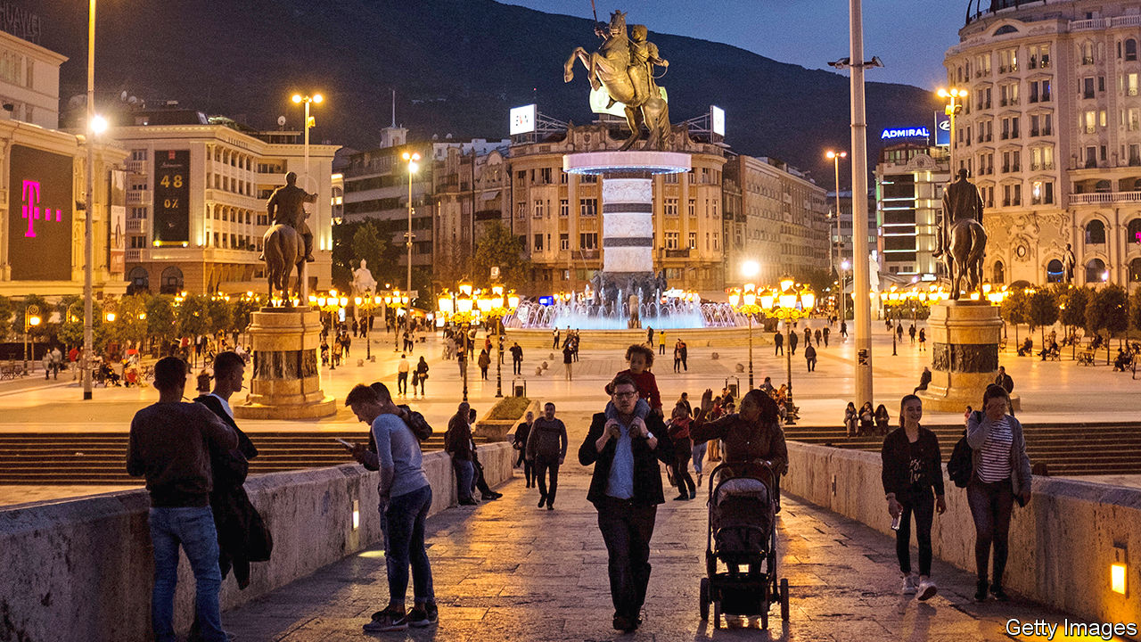

IT IS AN odd admission for the boss of a national statistical agency. Not only are many of his numbers wrong, says Apostol Simovski, head of North Macedonia’s statistical office, but he has no idea what the right ones might be. Officially, there are 2.08m people in his country. In fact, he says: “I am afraid there are no more than 1.5m, but I cannot prove it.”

Countless calculations—income per head, number of bathtubs per head—depend on knowing how many heads there are. If Mr Simovski is right and there are 27.5% fewer people in North Macedonia than officially estimated, then GDP per head, among other things, will be much higher. However, the true population may be between 1.6m and 1.8m, says Izet Zeqiri, an economist. Until there is a census, no one will know.

The last count was in 2002. An attempt to update it in 2011 turned into a fiasco. Nationalist Macedonian politicians and those from the country’s Albanian minority encouraged their supporters to list lots of family members who lived abroad. When officials realised that the totals would be fantastical, the process was aborted.

A new census was planned for April this year. However, when a snap election was called, the census was postponed. And the election itself was then postponed because of covid-19. As a result, says Verica Janeska, an economist, the government cannot make well-informed economic decisions.

In 2019, for the first time in history, more Macedonians died than were born. Births and deaths, at least, are accurately counted. Harder to gauge are the numbers who move abroad to work. Some 81,000 have Bulgarian passports. This means they can work easily and legally in the EU. It also means they don’t show up as Macedonians on any foreign database. Unemployment used to be a big problem. Now labour shortages are emerging as a bigger one. This is a problem across the Balkans, but in all Europe only North Macedonia and Ukraine, which last held a census in 2001, share the honour of not knowing even roughly how many people they have.

This article was downloaded by calibre from <https://www.economist.com/europe/2020/05/16/no-one-knows-how-many-people-live-in-north-macedonia>

|  |  |  |  |
| --- | --- | --- | --- |
| Previous | Articles | Sections | Next |

|  |  |  |  |
| --- | --- | --- | --- |
| Previous | Articles | Sections | Next |

#### Northern fights

# NATO is facing up to Russia in the Arctic Circle

An exercise in the Barents Sea signals that big-power rivalry covers every ocean

May 16th 2020 |



THE BARENTS SEA is not a hospitable place for visitors. “Frequent snow storms…blotted out the land for hours on end,” wrote an unlucky British submariner sent there to snoop around during the cold war. “We faced the beastliness of spray which turned to ice even before it struck our faces.” American and British warships have not exercised there since the 1980s—until they returned last week.

On May 1st a flotilla of two American destroyers, a nuclear submarine, a support ship and a long-range maritime-patrol aircraft, plus a British frigate, practised their sub-hunting skills in the Norwegian Sea. That is not out of the ordinary; NATO has been rediscovering its cold-war interest in the Arctic in recent years. In 2018, for instance, an American aircraft-carrier sallied into the Arctic Circle for the first time in 30 years, during a huge exercise in Norway.

But on May 4th some of those ships broke off and sailed farther north into the Barents Sea, along with a third destroyer, remaining there until VE Day on May 8th. Russia’s navy, whose powerful Northern Fleet is based at Severomorsk around the corner, was told in advance, but still greeted its visitors with live torpedo exercises.

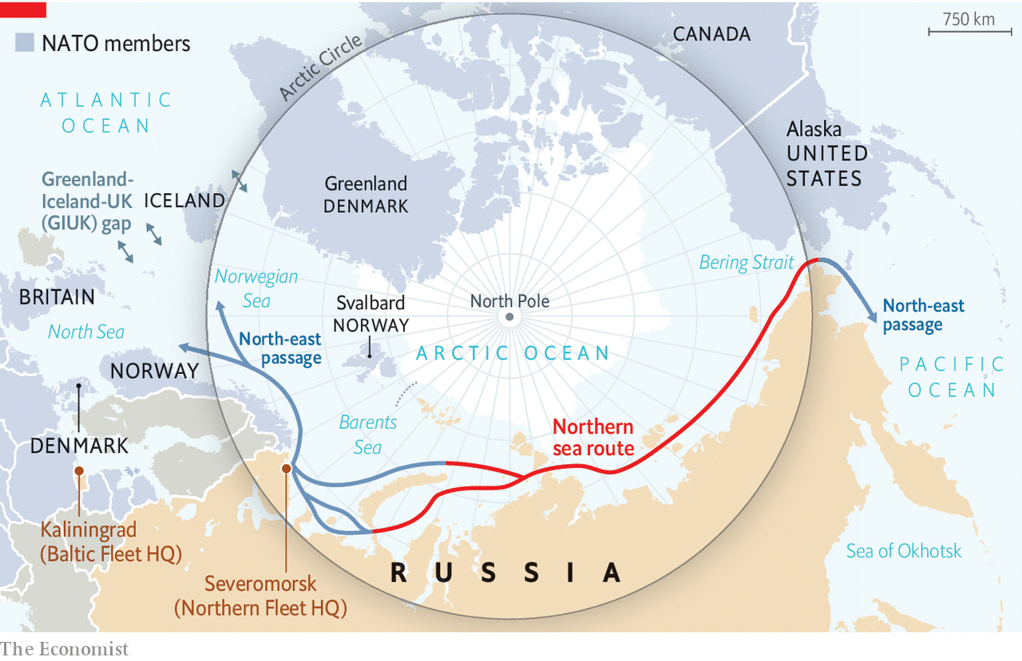

The decision to dispatch destroyers was a bold one. One aim was to show that covid-19 has not blunted swords, despite the virus knocking out an American and a French carrier. Another was to assert freedom of navigation in the face of Russia’s imposition of rules on the Northern Sea Route (NSR), a passage between the Barents Sea and the Pacific Ocean that is increasingly navigable as ice melts. Although last week’s exercise did not enter the NSR, it hints at a willingness to do so in the future.

More broadly, the Arctic is a growing factor in NATO defence plans. Russia has beefed up its Northern Fleet in recent years. The fleet’s submarine activity is at its highest level since the cold war, and the country’s new boats are quiet and well-armed. As a result, the alliance’s “acoustic edge”—its ability to detect subs at longer ranges than Russia can—“has narrowed dramatically”, reckons the International Institute for Strategic Studies, a think-tank.

The main task of Russian subs is defensive: to protect a “bastion”, the area in the Barents Sea and Sea of Okhotsk where its own nuclear-armed ballistic-missile submarines patrol. But NATO admirals worry that, in a conflict, some might pose a wider threat to the alliance. A separate Russian naval force known as the Main Directorate of Deep-Sea Research (GUGI, in its Russian acronym) could also target the thicket of undersea cables that cross the Atlantic.

The challenge is a familiar one. For much of the cold war, NATO allies sought to bottle up the Soviet fleet in the Arctic by establishing a picket across the so-called GIUK gap, a transit route between Greenland, Iceland and Britain that was strung with underwater listening posts. The gap is now back in fashion and NATO is reinvesting in anti-submarine capabilities after decades of neglect.

But defence in depth may not suffice. A new generation of Russian ship-based missiles, capable of striking NATO ships or territory from far north of the GIUK gap, represents “a dramatically new and challenging threat”, concludes the IISS. Similar concerns led the Reagan administration to adopt a more offensive naval posture, sending forces into the Soviet Union’s maritime bastion—“bearding the bear in its lair”, as a British MP once put it. “I’m struck by similarities with the 1980s,” says Niklas Granholm of the Swedish Defence Research Agency. “A forward maritime strategy to get up close and personal with the Russian Northern Fleet, rather than meet them farther south.” ■

This article was downloaded by calibre from <https://www.economist.com/europe/2020/05/16/nato-is-facing-up-to-russia-in-the-arctic-circle>

|  |  |  |  |
| --- | --- | --- | --- |
| Previous | Articles | Sections | Next |

|  |  |  |  |
| --- | --- | --- | --- |
| Previous | Articles | Sections | Next |

#### Charlemagne

# The enduring influence of Kraftwerk

Florian Schneider, who has died, left behind a tantalising non-vision of Europe

May 16th 2020 |

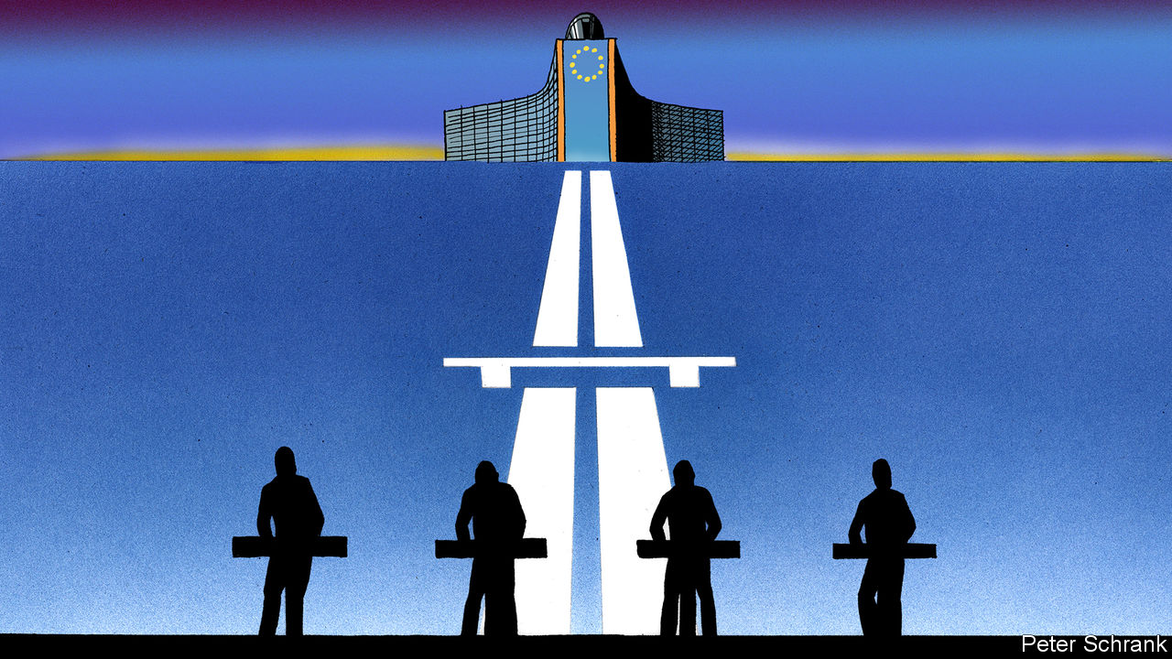

WHO SPEAKS for Europe? Henry Kissinger’s question has never found a satisfactory answer, but a literalist might turn to the press room of the Berlaymont building in Brussels. Here, day after day, well-groomed spokespeople for the European Commission calmly field questions from a potpourri of journalists in antiseptic surroundings, slipping smoothly from one language to another as they address the finer points of telecoms regulation, border irregularities or fisheries law. (At least they did, before covid-19 struck.)

It is hard for such a bloodless organisation to find appropriate cultural expression. The EU’s anthem, Beethoven’s “Ode to Joy”, satisfies its leaders’ self-regard but is an ill fit for a club with little hold on public affection. Better, surely, to turn to Kraftwerk, the German electronic group, the death of whose co-founder, Florian Schneider, was announced last week. Kraftwerk’s albums from the mid-1970s to early 1980s may have reinvented pop, spawning half a dozen genres and helping define the digital age. But they were also perfectly in tune with the construction of contemporary Europe.

Kraftwerk were too dedicated to the craft of sound to incorporate into their music anything so banal as a vision. But parts of “Trans-Europe Express” (1977) project a certain idea of Europe. “Europe Endless” sets a vaguely decadent description of a borderless continent (“Parks, hotels and palaces…”) to a stately, arpeggiated synth-line. Eight years later the Schengen agreement made this reality. The album’s title track chronicles a continental rail journey atop a rhythm emulating the sound of wheel on track. These were themes then almost untouched by contemporary rock music.

To be sure, theirs was a decidedly “old Europe”, centred on the Rhineland, where Schneider and Ralf Hütter, his co-founder, had grown up, with the Netherlands and Belgium just across the border and France not much farther away. The romantic sojourn sketched in “Trans-Europe Express” starts on the Champs-Élysées and makes it no farther east than the Café Hawelka in Vienna. Kraftwerk never played communist East Germany (though they did make it to Hungary and Poland in 1981). Nor could their music always hope to escape the gaze of the Stasi, says Olaf Zimmermann, who ran an electronic-music radio show in the GDR. The rebel yells of Bruce Springsteen or Mick Jagger anyway held more appeal to those living under communism’s yoke than the stiff beats of four wealthy, clean-cut straights from Germany’s far west.

Indeed, it was precisely those foreign assumptions about what rock music should be that Kraftwerk sought to shake off when they emerged from Düsseldorf’s small avant-garde in 1970. Simply to adopt a German name, to sing in German and to devote an album to the national leisure pursuit of driving effortlessly on the autobahn marked the group out as eccentric, perhaps dangerously so in a country still grappling with the horrors of its recent history.

As Kraftwerk shed their hirsute Krautrock roots for precision-engineered synthesised music, predictable jibes followed. “The final solution to the music problem?” scoffed the New Musical Express, tastelessly, in 1975. But their European reference points—Russian constructivism, the Belle Époque, Bauhaus’s fusion of art and technology—pre-dated Nazism. Indeed, this “retro-futurism” was the answer to Kraftwerk’s problematic heritage, notes Uwe Schütte, author of a book on the band. Rather than seek liberation via Anglo-American individualism, they would raid Europe’s past for points of reference that could help assemble a better future.

To hear Kraftwerk cycle through their universal, collective themes—man’s relationship with technology, broadcast communications, mobility—often in several languages, is thus to hear pop music re-engineered for an entirely fresh set of concerns. Owen Hatherley, an author, calls it “a kind of electronic Esperanto”. This is the soundtrack of the EU, anonymous elites knitting together a continent, unafraid of complexity, grounded in a quiet optimism. Like officials fine-tuning directives in airless Brussels offices, Kraftwerk shunned publicity, instead indulging their sonic perfectionism from inside their secretive Kling Klang studio in Düsseldorf. Only once, by remixing their 1975 hit “Radio-Activity” to reflect their conversion to the anti-nuclear cause, did they take anything that might be called a stand. Otherwise they preferred illumination to fulmination. Many bands seek to change the world. For Kraftwerk, the point was to describe it.

## It’s more fun to curl fruit

Which Kraftwerk tune should Brussels adopt? If “Europe Endless” might sit unhappily with countries that have fallen victim to Europeans’ occasionally expansive sense of borders, what about “The Telephone Call” (1986), repurposed to celebrate the EU’s success in reducing roaming charges; “The Robots” (1978), to honour the excellent performance of Eurocrats who “are programmed just to do anything you want us to”; or “Numbers” (1981), a recital of digits in more languages than even Frans Timmermans, the commission’s polyglot vice-president, can muster, set to a savage electro beat?

Perhaps the moment has passed. Eventually, as the world Kraftwerk had divined overtook them, the music fizzled. Their disappointing last album, from 2003, was devoted to cycling. Europe, too, moved on: widening, deepening, now fracturing. Yet it is a pity Kraftwerk never found the chance to explore the themes that shaped the continent in this century: cheap air travel, just-in-time supply chains, mobile technology (“Pocket Calculator”, a hymn to the creative possibilities of hand-held devices, gets halfway there).

Schneider left Kraftwerk in 2008. Since then the group, basically Mr Hütter and three friends, has toured continuously, thrilling fans with spectacular visuals. On May 16th, before the virus struck, Kraftwerk were to join the festivities for Beethoven’s 250th birthday in Bonn as they marked their own 50th anniversary. They were said to have been taken by the symbolism, as well they might: Europe’s official bard and its unofficial man-machine troubadours, united in celebration of the continent that made them possible. ■

This article was downloaded by calibre from <https://www.economist.com/europe/2020/05/16/the-enduring-influence-of-kraftwerk>

|  |  |  |  |
| --- | --- | --- | --- |
| Previous | Articles | Sections | Next |

|  |  |  |
| --- | --- | --- |
| Europe | Sections | International |

Britain

Britain’s international reputation: How others see us

.

Toothache in a pandemic: Say cheese!

.

Immigration: Who cares?

.

The economy: Acute to chronic

.

Public Health England: Carry on covid

.

Schools: Pencils down

.

Trade unions: A whiff of smoke-filled rooms

.

|  |  |  |
| --- | --- | --- |
| Europe | Sections | International |

|  |  |  |  |
| --- | --- | --- | --- |
|  | Articles | Sections | Next |

#### Reputation

# How coronavirus Britain looks from abroad

Britain’s handling of covid-19 is drawing unfavourable comparisons

May 16th 2020 |

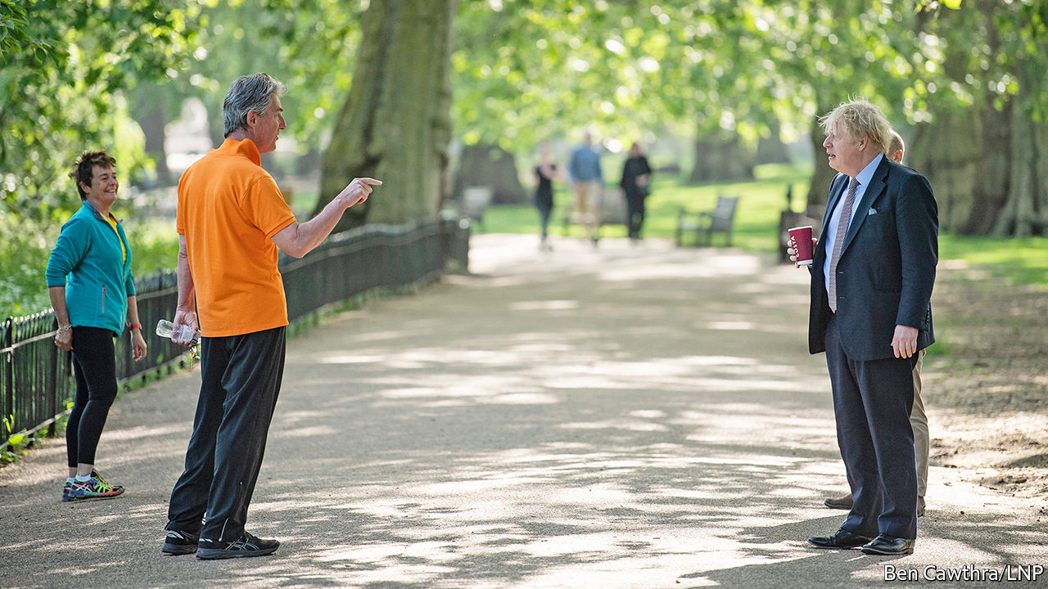

Editor’s note: The Economist is making some of its most important coverage of the covid-19 pandemic freely available to readers of The Economist Today, our daily newsletter. To receive it, register [here](https://www.economist.com/newslettersignup). For our coronavirus tracker and more coverage, see our [hub](https://www.economist.com/coronavirus)

A SLIDE TRACKING Britain’s coronavirus death toll against other countries’ had been a fixture of the daily government press conference. When it was first produced, on March 30th, it showed the United Kingdom trailing Spain, Italy, France and America in a grisly league table. On May 9th, the last time it was displayed, Britain was the highest in Europe. It has now disappeared from the briefings.

As The Economist went to press, the confirmed British death toll stood at 33,186, the second highest reported figure in the world behind America (see chart). Britain is fourth for fatalities as a share of population. On May 13th, Boris Johnson told the House of Commons that although the death count was “deeply, deeply horrifying”, it would be premature to make international comparisons until the figures of excess deaths were released, which would capture cases where covid-19 was not recorded as a cause of death. The Economist’s calculations of excess deaths per 100,000 people in Britain, Belgium, France, the Netherlands, Spain and Sweden puts Britain at the top; data for America and Italy are not available.

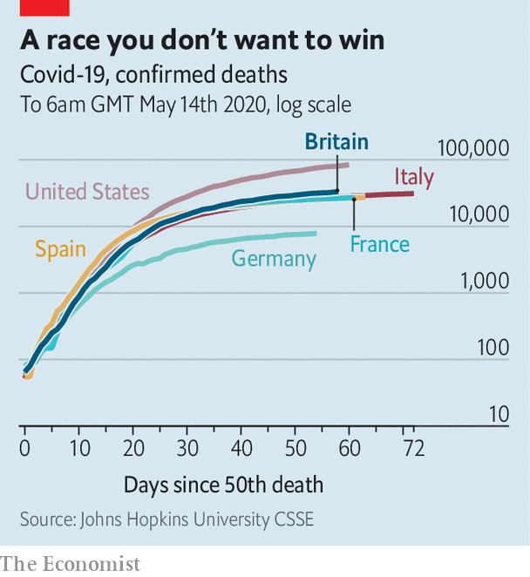

Britain is not alone in experiencing shortages of protective equipment, a deficient testing regime and uncontrolled outbreaks of the virus in care homes. It is too soon to say how far the death toll is attributable to government missteps, demography or geography. Yet to many foreign observers, Britain’s death toll serves as confirmation of deeper-rooted problems: a political culture of hubris and exceptionalism; atrophied public services; inequality and poor health.

At home, the crisis has become a political risk for Mr Johnson. His announcement on May 10th of tentative steps to unwind the lockdown did not go well. Only a third of voters said they understood what the new “Stay alert, control the virus” slogan asked of them. Teachers’ unions criticised plans to start to reopen schools on June 1st as unsafe. In London the Tube and some buses were busy, despite Mr Johnson’s plea for returning workers to avoid public transport. Mr Johnson’s poll ratings remain high, but have fallen back in recent weeks, and a poll by YouGov on May 12th showed Sir Keir Starmer, the Labour Party’s new leader, more popular than him.

Voters still approve of the government’s handling of the crisis, by a net 12 points according to a survey released on May 9th by Opinium, a pollster. But the figure is down from 21 points two weeks earlier, and respondents increasingly think foreign governments have handled things better. In a poll published on April 25th they judged Britain’s government to have performed worse than those of China, Germany, France, South Korea, Japan and Australia. By May 5th, Italy and Spain had joined that list. Only America gets lower marks of ten countries polled. Voters who supported Brexit tend to take a rosier view of Britain’s performance than Remainers, but both are becoming increasingly negative.

Attitudes at home are reflected abroad. Chinese parents panicked on social media about children studying in a plague-ridden basket-case. But the Europeans are most vociferous. Coronavirus has reinforced unfavourable views formed during the Brexit saga. The British government’s early dismissal of lockdowns was seen as reminiscent of Mr Johnson’s disregard for the risks of leaving the bloc. The German press has been particularly scathing. Süddeutsche Zeitung concluded that unequal and unhealthy Britain made “a good breeding ground for the pandemic”. Poland’s government, which locked down early, cited Britain as a case study of what not to do. Scott Morrison, the Australian prime minister, described the “herd immunity” strategy that Britain had initially favoured as a “death sentence”.

Mr Johnson’s election victory last year went some way towards restoring an image of stability and competence after Theresa May’s chaotic attempt to negotiate Britain’s departure from the EU. Covid-19 risks derailing that, and foreign policy hands worry about its impact on Britain’s reputation for good governance. Expertise in public administration and fields such as global health has long been one of Britain’s calling cards in international forums. New Zealand’s standing has been enhanced by its rapid elimination of the outbreak. Mr Johnson’s decision to shun an EU scheme to procure medical kit collectively sent a blunt message about its appetite for co-operation after Brexit, according to Fabian Zuleeg, of the European Policy Centre, a think-tank in Brussels.

Reputation is soft power, and big cheeses in the foreign-policy world worry about the impact on Britain’s ability to sway opinion. “During the Brexit process I was very struck by the decline in Britain’s authority,” says a former foreign secretary, noting particular dismay in Japan. “We weren’t treated as grown-ups.” Esteem for Britain is probably recoverable, says Michael Jay, a former head of the foreign office, but securing top international posts may be tricky for a while.

Declinism is a national pastime in Britain, and some aspects of the country’s response have been impressive. The National Health Service has held up remarkably well, thanks to swift reorganisation. Mr Johnson is driving an international effort to produce a vaccine, and has pledged generous sums in support of it. Britain’s vast jobs rescue package, announced by Rishi Sunak, the chancellor, originally announced in March and extended until October on May 12th, compares favourably with schemes deployed elsewhere. Oxford University’s vaccine research programme is one of the world’s most advanced; success there, or in one of a series of British trials for antiviral therapies, would be a fillip for a battered government.

But the recent knocks to Britain’s reputation will have consequences. “I would not want to be going around, as we all used to do, saying whatever its defects the British government system is one of the best in the world and other countries should borrow it,” says Lord Jay.■

Dig deeper:  
For our latest coverage of the covid-19 pandemic, register for The Economist Today, our daily [newsletter](https://www.economist.com/newslettersignup), or visit our [coronavirus tracker and story hub](https://www.economist.com/coronavirus)

This article was downloaded by calibre from <https://www.economist.com/britain/2020/05/16/how-coronavirus-britain-looks-from-abroad>

|  |  |  |  |
| --- | --- | --- | --- |
|  | Articles | Sections | Next |

|  |  |  |  |
| --- | --- | --- | --- |
| Previous | Articles | Sections | Next |

#### Say cheese!

# The alarming popularity of prehistoric dentistry

Unable to see a dentist, people are taking things into their own hands

May 16th 2020 |

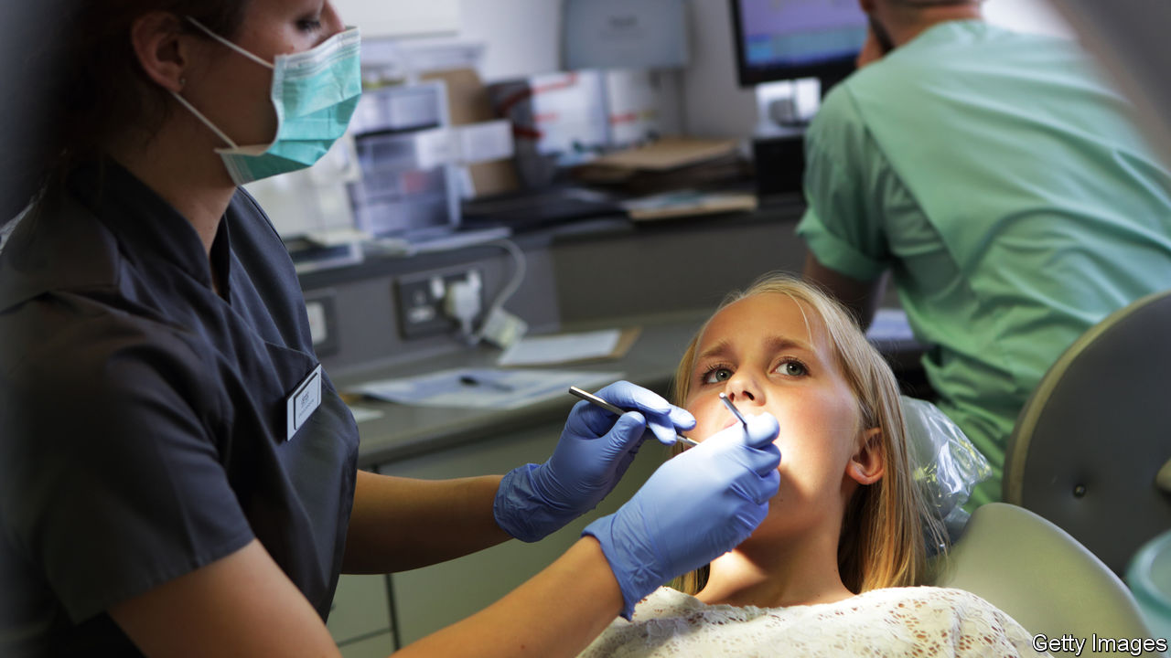

“I’VE BEEN using the wax from a Babybel,” admits a sufferer of chronic toothache; she has stuffed cheese-casing into a cavity to replace a lost filling. With most surgeries in Britain out of action due to lockdown, home dentistry has become worryingly common. “People are using needles to burst abscesses,” says James Goolnik, a dentist in London. “They’re using knives and forks to take teeth out, and nail files to cut down broken teeth.”

Britain has long had a reputation for bad teeth, perhaps dating back to the second world war, when American soldiers were horrified by rows of bare gums. Today it is unfair: Americans are more likely than Britons to be missing teeth. But the nation’s teeth are not going to improve in the near future.

Since March 25th, all routine treatment has been cancelled. Dentists offer just the “three As”—antibiotics, analgesics and advice. Someone with a lost crown will be dealt with over the phone. MyDentist, with around 650 practices in Britain, has warned its patients: “DO NOT USE SUPERGLUE or FIXADENT to fit your crown.” A hygienist reports that a patient had become suicidal with pain.

Only those with problems such as breathing difficulties due to swelling or nerve exposure qualify for urgent treatment. The British Dental Association (BDA), a trade union, says the new urgent care system has faced teething problems, with a lack of the protective kit needed for “aerosol-generating procedures” (ie, ones where spit or blood will be flying around). As a result, in some practices the only treatment on offer is teeth removal. “In this day and age that’s pretty prehistoric,” says Dr Goolnik.

Many dental practices either rely entirely or partly on private income, rather than NHS contracts, and are thus facing financial collapse. Some, unlike shops or restaurants, do not qualify for business-rates relief. “I can’t help feeling forgotten when I walk down the street and see the vape shop, which is getting a £25,000 grant and rates relief, painting and decorating,” sighs the hygienist.

When dentists reopen, they will struggle to satisfy the pent-up demand they are bound to face. Safe dentistry in a pandemic is slow. Waiting areas must be kept empty, protective kit procured and surgeries disinfected. At practices that are now doing urgent care, such restrictions mean traffic is down by three-quarters. If there is a similar drop-off in service when others return, care will continue to be rationed. Bad news for anyone with toothache. Good news for Babybel manufacturers.

This article was downloaded by calibre from <https://www.economist.com/britain/2020/05/16/the-alarming-popularity-of-prehistoric-dentistry>

|  |  |  |  |
| --- | --- | --- | --- |
| Previous | Articles | Sections | Next |

|  |  |  |  |
| --- | --- | --- | --- |
| Previous | Articles | Sections | Next |

#### Labour market

# How post-Brexit immigration rules will exclude key workers

Many of the people whom Britain celebrates as “heroes” would fall foul of tighter regulations

May 16th 2020 |

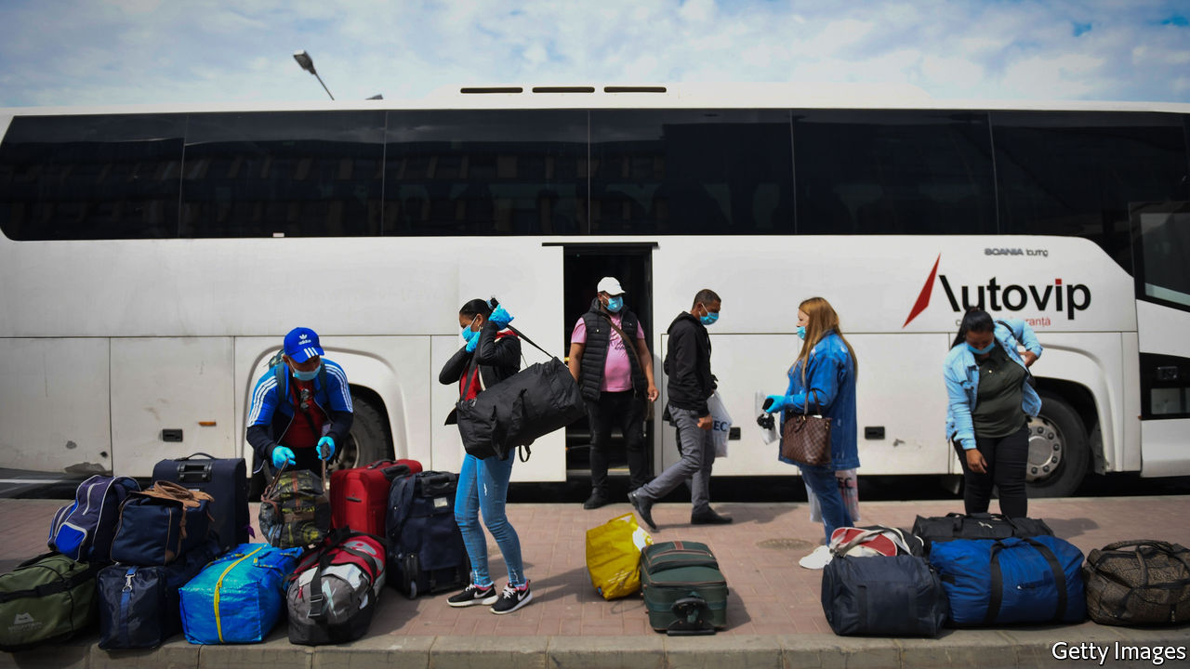

Editor’s note: The Economist is making some of its most important coverage of the covid-19 pandemic freely available to readers of The Economist Today, our daily newsletter. To receive it, register [here](https://www.economist.com/newslettersignup). For our coronavirus tracker and more coverage, see our [hub](https://www.economist.com/coronavirus)

“CARE WORK isn’t just bum wiping,” insists Karolina Gerlich. In the 12 years since she swapped her native Poland for Britain, aged 18, she has learnt that it involves being a “PA, a nurse, a therapist, an occupational therapist, a dietician and a friend”. She now runs a charity supporting other carers, while working as one herself. Yet under post-Brexit immigration rules due to take effect in January, a similar applicant would be turned down for a visa, since the job is classed as low-skilled. “I feel disrespected, offended and like my contribution to the economy and to the country has not been recognised at all.”

The timing of the covid-19 pandemic puts Priti Patel, the hardline home secretary, in an awkward spot. Recognising that Britain’s vote to leave the EU in 2016 was in part down to a desire to curb immigration, she plans to end freedom of movement from the bloc and apply the same salary threshold (£25,600, or $31,200, for most) and skills requirement to prospective migrants wherever they come from. Yet many of the incomers such a policy would rule out—including care-home workers—are those classified by the government as the pandemic’s “key workers”.

A paper by researchers at Oxford University, in the Oxford Review of Economic Policy, published on May 14th, finds that nearly one in five of those working in essential care-related occupations are immigrants. In all, a little more than half of EU migrants now classed as key workers would not have qualified for a work visa under the new dispensation. Using a different definition of key worker (the category is blurry), the Institute for Public Policy Research, a think-tank, finds that 71% of such migrants would have been excluded.

In one sense, the pandemic takes the pressure off. A deep recession should limit the need to import low-paid workers, since there will be a large pool of unemployed domestic labour. Yet farms are flying in workers from Romania, suggesting that Britons on their uppers might hesitate before taking back-breaking or low-paid jobs.

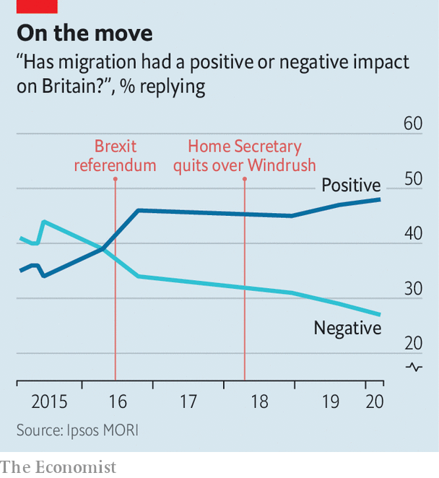

The political argument for a restrictive regime is weakening. Voters were warming to immigration even before they voted to leave the EU and thereby restrict it (see chart). The scandal in 2018 over the government’s shoddy treatment of the Windrush generation of Caribbean migrants illustrated that, if the public senses injustice, crackdowns can prove as politically perilous as liberal approaches. A survey in March by Ipsos MORI, a pollster, found that the overwhelming majority of voters want the number of migrants coming to Britain to work in care homes to stay the same or rise. Since the pandemic and its associated recession will significantly reduce overall immigration anyway, Ms Patel can afford to be a little more generous. ■

Dig deeper:  
For our latest coverage of the covid-19 pandemic, register for The Economist Today, our daily [newsletter](https://www.economist.com/newslettersignup), or visit our [coronavirus tracker and story hub](https://www.economist.com/coronavirus)

This article was downloaded by calibre from <https://www.economist.com/britain/2020/05/16/how-post-brexit-immigration-rules-will-exclude-key-workers>

|  |  |  |  |
| --- | --- | --- | --- |
| Previous | Articles | Sections | Next |

|  |  |  |  |
| --- | --- | --- | --- |
| Previous | Articles | Sections | Next |

#### Acute to chronic

# The cost of the pandemic to Britain’s economy is becoming clear

It will linger long after the threat to public health subsides

May 16th 2020 |

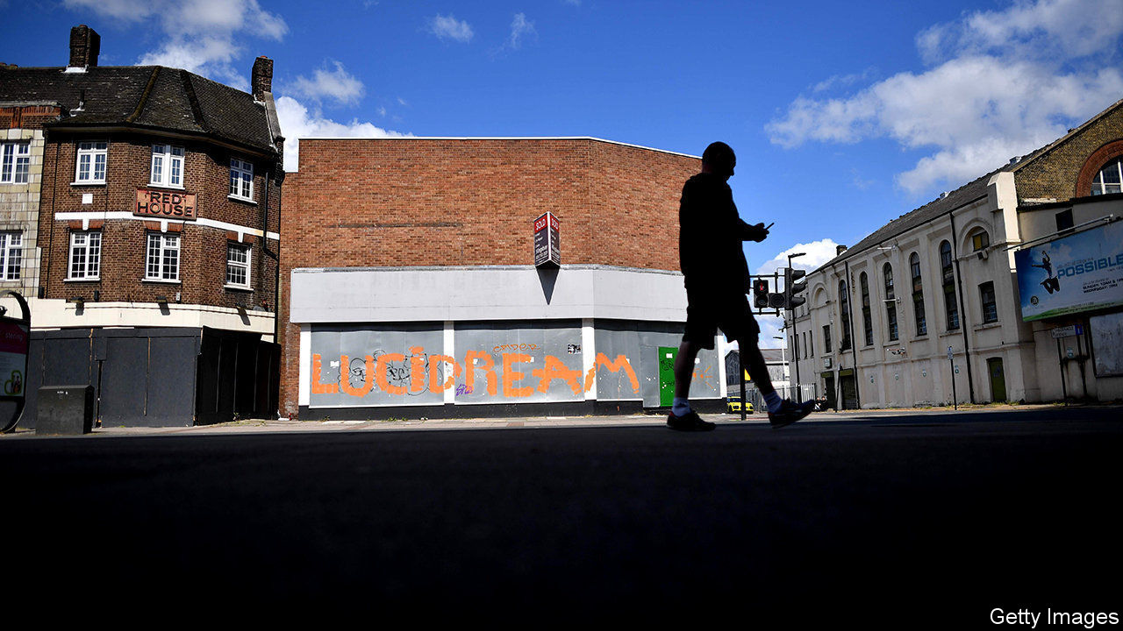

Editor’s note: The Economist is making some of its most important coverage of the covid-19 pandemic freely available to readers of The Economist Today, our daily newsletter. To receive it, register [here](https://www.economist.com/newslettersignup). For our coronavirus tracker and more coverage, see our [hub](https://www.economist.com/coronavirus)

THE LAST time Britain’s GDP fell by 2% quarter-on-quarter, the investment bank Lehman Brothers had just gone bust, bringing the global financial system to its knees. Then, in 2008, Britain was at the beginning of a steady rise in unemployment that would continue for years, and real wages had started a decline that would take more than a decade to undo. So it is alarming that, on May 13th, statisticians reported a similar fall in GDP in January to March 2020. The country was in lockdown for only a week of that period. The second-quarter figures, released in August, will make for astonishingly grim reading.

With many companies shut down, whether temporarily or permanently, Britons are flocking to the government for support. Universal credit, the primary welfare programme before the pandemic, has been swamped with applications, although it seems to be coping better than welfare systems in some other countries (see article). The government’s scheme for preserving jobs during the pandemic, under which the state pays up to 80% of a furloughed employee’s wages, has seen many more applications than was expected, according to Treasury insiders. More than one in five workers is now on it.

The mounting costs of providing this support in part explain the government’s shifting rhetoric over lockdown measures. Britons in many sectors have been told to return to their office, factory or site if teleworking is not possible (although some such employees were never told by the government to stop work). Some parliamentarians have been pushing Rishi Sunak, the chancellor, to wind down the job-protection scheme. Fearful of mass unemployment, however, on May 12th Mr Sunak extended it to the end of October—though he has sensibly tweaked it to allow bosses to bring back workers part-time from August. He also says that employers will soon have to foot more of the bill.

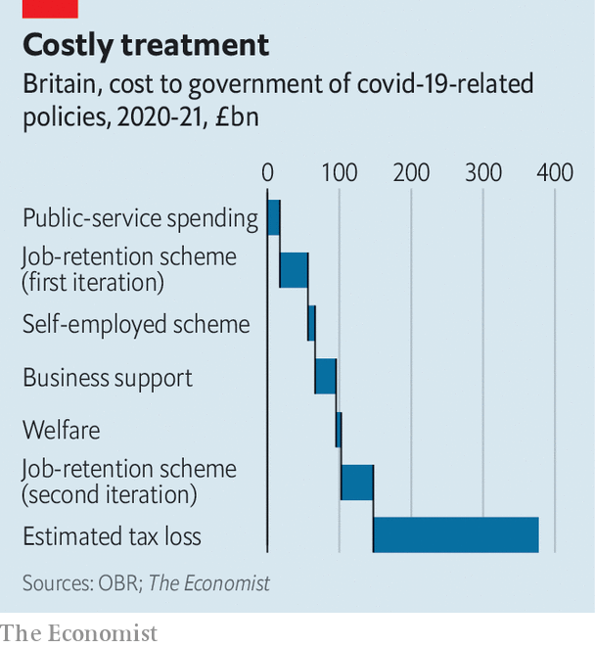

The extension of the scheme adds further costs to an already swollen fiscal bill (see chart). Even in the absence of any decline in output, and with no fall in tax revenues, this support would push up Britain’s budget deficit from 2% of GDP, before the pandemic, to 8%—its highest level since the global financial crisis of 2007-09. In reality, nominal GDP may fall by 12% or more this year, and tax revenues are collapsing. An annual deficit on a wartime scale looks inevitable, leading to substantially higher public debt.

A leaked government memo published on May 13th in the Daily Telegraph suggested that the deficit could hit around 15% of pre-pandemic GDP. Measures under consideration for balancing the books included raising income tax and freezing pensions spending. A brouhaha followed. In truth the Treasury has been looking for some time at how to raise revenue to pay the costs of an ageing population, regardless of the pandemic. For now, with government-borrowing costs near record lows Mr Sunak seems more focused on supporting the economy than on balancing the budget. But the memo is a sobering reminder: though the threat to public health should eventually pass, the economic costs of the pandemic will linger.■

Dig deeper:  
For our latest coverage of the covid-19 pandemic, register for The Economist Today, our daily [newsletter](https://www.economist.com/newslettersignup), or visit our [coronavirus tracker and story hub](https://www.economist.com/coronavirus)

This article was downloaded by calibre from <https://www.economist.com/britain/2020/05/16/the-cost-of-the-pandemic-to-britains-economy-is-becoming-clear>

|  |  |  |  |
| --- | --- | --- | --- |
| Previous | Articles | Sections | Next |

|  |  |  |  |
| --- | --- | --- | --- |
| Previous | Articles | Sections | Next |

#### Carry on Covid

# Criticism of Public Health England is mounting up

After the pandemic, the government is likely to rethink the executive agency’s role

May 16th 2020 |

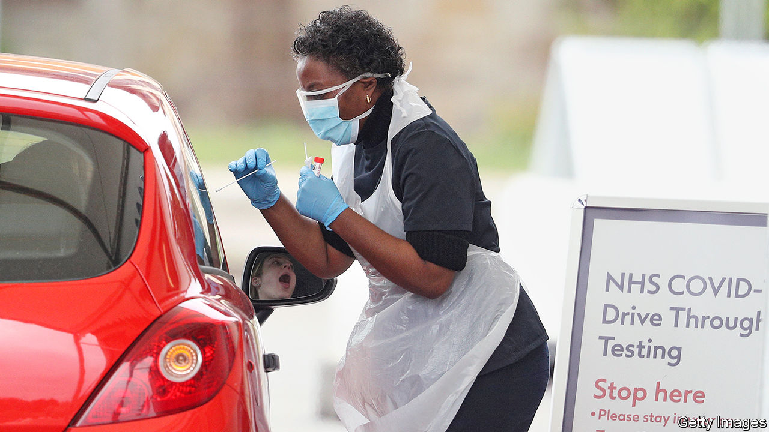

Editor’s note: The Economist is making some of its most important coverage of the covid-19 pandemic freely available to readers of The Economist Today, our daily newsletter. To receive it, register [here](https://www.economist.com/newslettersignup). For our coronavirus tracker and more coverage, see our [hub](https://www.economist.com/coronavirus)

ON MARCH 25TH Sharon Peacock, a director at Public Health England (PHE), appeared in front of a House of Commons committee. At the time, her agency was doing just 7,000 tests a day. Why, the chair of the committee, Greg Clark, wondered, were PHE concentrating testing in their own and NHS laboratories? Why hadn’t they brought private-sector laboratories into the system, as in South Korea? Ms Peacock paused. “That’s a good question,” she said. A written explanation was promised.

Two weeks earlier, the lack of testing capacity had pushed the government to give up on the test-and-trace strategy used by other countries to suppress the virus. At the time, PHE had responsibility for testing, ran contact tracing and was one of the government’s main sources of expertise. While the failure to raise capacity spreads well beyond PHE, there is concern across the health system—in the NHS, government and local authorities—that PHE has failed to rise to the challenge. Mr Clark is still waiting for an explanation of the testing strategy. (Nor did PHE respond to The Economist’s requests for clarification.)

Before the pandemic, PHE was well regarded. A review by the international association of public-health bodies concluded that it rivalled any in the world. Created as part of controversial reforms to the health system in 2013, it emerged from 129 organisations, including those responsible for health protection (watching for infectious diseases) and for health promotion (campaigning against smoking). The inspiration was America’s Centres for Disease Control and Prevention. In Britain the model seems unlikely to survive the crisis.

PHE spans the divide not only between health prevention and promotion, but also between central and local government. It disburses an annual grant, last year worth £2.9bn ($3.5bn), to local authorities, but has little sway (beyond offering advice) over how it is spent. So it is stuck in the worst of all worlds: without the connections needed to make things work on the ground or the medical heft at the top to lead the national response. Duncan Selbie, PHE’s chief executive, arrived after a career as a hospital administrator and, as one insider notes, is not a medical doctor. He has not had a prominent role in the crisis.

PHE has not worked well with local authorities. When the government gave up on suppressing the virus in March, PHE had just 290 staff working as contact tracers. At that point, it could have used local authorities’ experience in contact tracing for things like sexual health and food-borne diseases. Yet only now is that starting to happen. Local authorities are still confused about whether to contact the CQC, a regulator, or PHE about testing in care homes. A local leader characterises PHE’s response to the crisis as “carry on covid”.

Nor is it working well with the rest of the health system. Those in the NHS complain that PHE failed to give them warning about changes to guidance on protective kit. Explanations for the changes were lacking, too. “You have to be really clear with [medics] about why you are changing, especially if you are deviating from international guidance,” notes an observer.

Glimpses into PHE suggest a startling failure to get on top of the problem. In her evidence to the science committee, Ms Peacock said personal tests would be available within days from Amazon and Boots. Seven weeks later, they are still not. Britain is now testing 60,000 or so people a day, but numbers jumped only after the Office for Life Sciences, a smaller, more agile body, got involved, expanding the testing network to include three big laboratories involving universities and the private sector.

The fragmented system that has resulted has its own problems, particularly in data collection. The health department has brought in Dido Harding, the head of an NHS regulator, to sort things out, and to link the testing programme with contact tracing, which is still run by PHE. The Office for National Statistics is leading serological studies to see how widespread covid-19 is in the British population. It is an all-hands-on-deck-situation for the government. Yet effective organisations tend to accumulate responsibilities. Instead, some in the NHS joke that PHE is enjoying a period of “self-isolation”. ■

Dig deeper:  
For our latest coverage of the covid-19 pandemic, register for The Economist Today, our daily [newsletter](https://www.economist.com/newslettersignup), or visit our [coronavirus tracker and story hub](https://www.economist.com/coronavirus)

This article was downloaded by calibre from <https://www.economist.com/britain/2020/05/16/criticism-of-public-health-england-is-mounting-up>

|  |  |  |  |
| --- | --- | --- | --- |
| Previous | Articles | Sections | Next |

|  |  |  |  |
| --- | --- | --- | --- |
| Previous | Articles | Sections | Next |

#### Schools

# Why teachers are doing so little teaching

Teaching remotely is hard. Many British schools are barely trying

May 16th 2020 | PETERBOROUGH

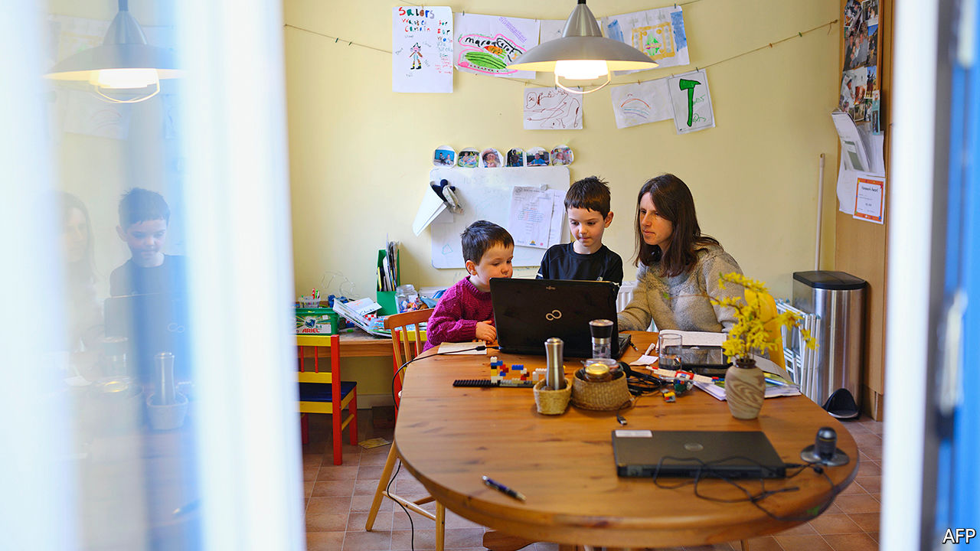

Editor’s note: The Economist is making some of its most important coverage of the covid-19 pandemic freely available to readers of The Economist Today, our daily newsletter. To receive it, register [here](https://www.economist.com/newslettersignup). For our coronavirus tracker and more coverage, see our [hub](https://www.economist.com/coronavirus)

LUCIAN STIOPU watches his son cycle round Central Park in Peterborough. Before the government imposed a lockdown, he says, the boy would spend about nine hours a day at primary school, allowing him to go to work in a prison. And now? Mr Stiopu’s son reports that his teachers are setting a bit of work online. It is “easy” and he dashes it off in less than two hours.

He might be showing off, but probably not much. Two months after schools closed, it is becoming clear that most children of all ages are doing rather little schoolwork, and even less that is difficult or stimulating. An entire cohort appears to be treading water.

Schools have had a rough time. On March 23rd they were given two working days’ notice to close, while remaining open to vulnerable pupils and children of key workers. On May 11th the government asked English schools to restart some classes in June, but the teachers’ unions are against that, and it seems likely that few children will return before September. Schools have had little guidance about what and how to teach the 98% supposed to be studying at home.

In France teachers and pupils were directed to a single online portal. Britain, by contrast, has seen a free-for-all. One maths teacher might use Microsoft Teams to assign problems that she devised herself; another will use email to assign lessons created by an online service such as White Rose Maths. Some send homework through the post. Few attempt anything resembling a lesson. Teacher Tapp, a polling company, finds that on a given day only 6% of state secondary-school teachers and 3% of state primary-school teachers have hosted an online streamed lesson that allows pupils to speak, via Zoom for example.

John Gilligan, the head of Hampton College in Peterborough, says he was warned against trying to deliver live lessons by his professional association and the teachers’ unions. Portals like Zoom may not be secure, he says; they also allow participants to peer into each others’ bedrooms, putting children at risk. He also concluded it would be unwise to push on with the curriculum. Because children who struggle to work from home would be unable to absorb new concepts, “disadvantaged students would become more disadvantaged”. Better to concentrate on reinforcing what they have already been taught.

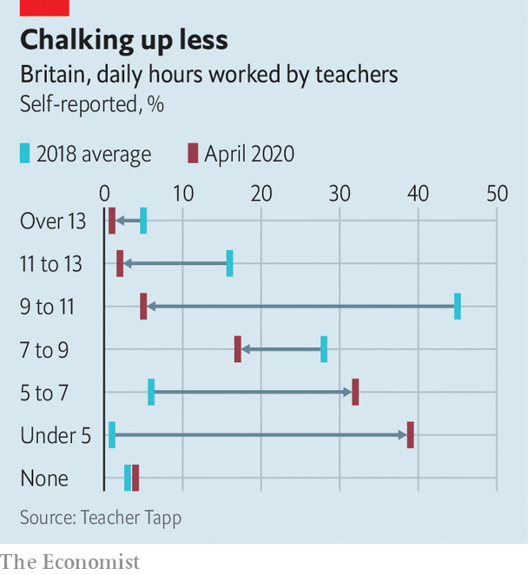

Many heads have made similar decisions. As a result, schoolchildren are largely idle. A poll of parents last month by the Sutton Trust, an education charity, found that 50% of secondary-school pupils and 64% of primary-school pupils were working three hours a day or less. Teachers, who normally put in long days, have stopped doing so (see chart). That is probably because little is expected of them, not because they are struggling with domestic obligations. Those without children are working as little as those with.

This is probably harming pupils. Studies show that young children—especially poor ones—backslide during the summer holidays, with the poor faring especially badly. Children with learning difficulties may be worst off. On a Peterborough housing estate, Anna Adams says that her autistic son, who loves maths, has been unable to get any work done at all. Worse, he has become so terrified of the virus that she is not sure he will ever return to school.

There are some exceptions. At the Michaela Community School in Wembley, teachers are recording lessons and ringing every child once a week. The school reckons that one in ten children is doing little or no work—but, given that many of the pupils are from poor families, that is not a bad ratio. With amazing speed, another group of teachers has created Oak National Academy, which provides online video lessons in various subjects. More than 6m have been viewed so far.

But the most striking difference is between state schools and private schools. The latter have leapt onto Zoom and similar services: 74% of private secondary-school teachers and 58% of private primary-school teachers use them on a given day, according to Teacher Tapp. Andrew Gordon-Brown, the head of the private Truro School in Cornwall, says that he advised teachers not to push on with the curriculum—but only for the first week of lockdown. Then they charged ahead. His staff claim to be working harder than ever.

It isn’t just the private schools. Those who charge for lessons, from music teachers to karate instructors, have often found ways of carrying on more-or-less as normal. Anouska Leckie, a Kumon tutor in Cardiff, switched from in-person group classes to live video lessons a week after the lockdown. She lost several clients at first: many of the children she instructs are from working-class immigrant families, who ran short of money. But some are returning, saying that their children are not being taught nearly enough by their schools. ■

Dig deeper:  
For our latest coverage of the covid-19 pandemic, register for The Economist Today, our daily [newsletter](https://www.economist.com/newslettersignup), or visit our [coronavirus tracker and story hub](https://www.economist.com/coronavirus)

This article was downloaded by calibre from <https://www.economist.com/britain/2020/05/16/why-teachers-are-doing-so-little-teaching>

|  |  |  |  |
| --- | --- | --- | --- |
| Previous | Articles | Sections | Next |

|  |  |  |  |
| --- | --- | --- | --- |
| Previous | Articles | Sections | Next |

#### Politics and labour

# Trade unions are back

The crisis is winning trade unions influence, attention and members

May 16th 2020 |

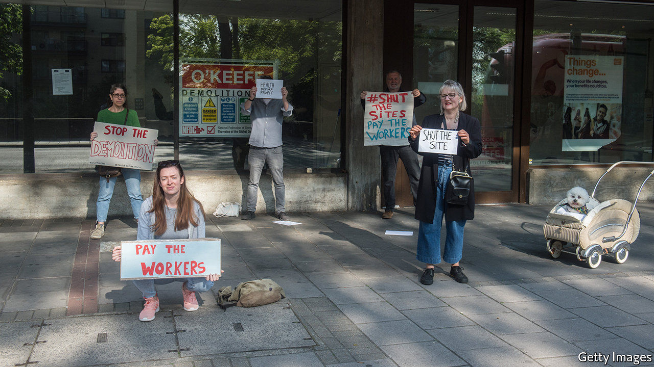

Editor’s note: The Economist is making some of its most important coverage of the covid-19 pandemic freely available to readers of The Economist Today, our daily newsletter. To receive it, register [here](https://www.economist.com/newslettersignup). For our coronavirus tracker and more coverage, see our [hub](https://www.economist.com/coronavirus)

IF BRITONS NEEDED reminding of the new dangers present in the workplace, a story that emerged this week reminded them: Belly Mujinga, a railway ticket-office worker who contracted covid-19 after being spat at by a passenger who said he was infected, died. The incident lent weight to the concerns which union leaders have expressed about Boris Johnson’s get-back-to-work plan. Manuel Cortes, general secretary of the TSSA, Ms Mujinga’s union, has said that it turns transport workers into “cannon fodder.” Frances O’Grady, general secretary of the Trade Union Congress (TUC), says that “it felt incredibly cavalier...The prime minister...threatened to unleash a stampede for public transport at a time when we just weren’t ready.” Four of the biggest unions, Unite, Unison, GMB and USDAW, say they will not recommend their members return to work until the correct policies and practices are in place.

The issue of health and safety at work, of marginal interest to most people most of the time, is suddenly at the front of everybody’s minds. That’s one reason why trade unions suddenly have new relevance and influence. Another is the government’s need for a united front in the war against covid-19. The unions were recruited to help put together the Jobs Retention Scheme (JRS), which guarantees workers 80% of their pay. The movement has not been so close to power since union leaders sat in smoke-filled rooms with ministers in the 1970s. “Unions are back,” says Ms O’Grady.

Thanks to swift and satisfactory negotiations over the JRS, Rishi Sunak, unusually for a Tory chancellor, wins plaudits from the union movement. “He’s very intelligent, he’s switched on, he’s not ideologically driven,” says Steve Turner, an assistant general secretary at Unite. Ms O’Grady is more circumspect. “The jury’s still out for me—I’ve been around the block a few times.” But she contrasts his policies favourably with Mr Johnson’s. “The reality is that it’s the chancellor who sets a much more sensible transition in the furlough scheme extension.”

Beyond getting a say on the furlough scheme, unions have won many battles during the crisis. The bakers’ union’s success in persuading Tim Martin, boss of the pub chain Wetherspoons, to reverse his decision not to pay his workers during the crisis, was widely noticed. Others have been smaller or less spectacular. The TUC got long-term agency workers the same pay as colleagues directly employed by firms. Unite won casual workers at the Marriott Hotel the right to be furloughed.

The big question is whether the unions’ new clout will last. Workplace safety is likely to remain a big issue for a long time, and there is plenty of public support for some aspects of unions’ agenda—a recent Survation poll showed 76% supporting a rise in the minimum wage and 67% in favour of eliminating zero-hour contracts—but the principal measure of union strength is membership. “It’s an incredibly high stakes moment for the unions,” says Gavin Kelly, chair of the Resolution Foundation, a think tank. “In the recent past, winning arguments has often not meant gaining members. This time it must.”

It may be happening. Since the beginning of March, Unison has recruited 40,000 new members, nearly half as many again as in normal times. Unions are using their new visibility to push their agendas. The TUC wants the government to establish a National Council for Reconstruction and Recovery, which would allow unions’ voice to be heard loudly. Ms O’Grady is determined that their new influence should not dissipate. “Like puppies, we don’t just want to be for Christmas.”■

Dig deeper:  
For our latest coverage of the covid-19 pandemic, register for The Economist Today, our daily [newsletter](https://www.economist.com/newslettersignup), or visit our [coronavirus tracker and story hub](https://www.economist.com/coronavirus)

This article was downloaded by calibre from <https://www.economist.com/britain/2020/05/16/trade-unions-are-back>

|  |  |  |  |
| --- | --- | --- | --- |
| Previous | Articles | Sections | Next |

|  |  |  |
| --- | --- | --- |
| Britain | Sections | Business |

International

Crime and covid-19: Covid nostra

.

|  |  |  |
| --- | --- | --- |
| Britain | Sections | Business |

|  |  |  |  |
| --- | --- | --- | --- |
|  | Articles | Sections | Next |

#### Covid nostra

# The pandemic is creating fresh opportunities for organised crime

And governments are not paying attention

May 16th 2020 | JOHANNESBURG, ROME AND SÃO PAULO

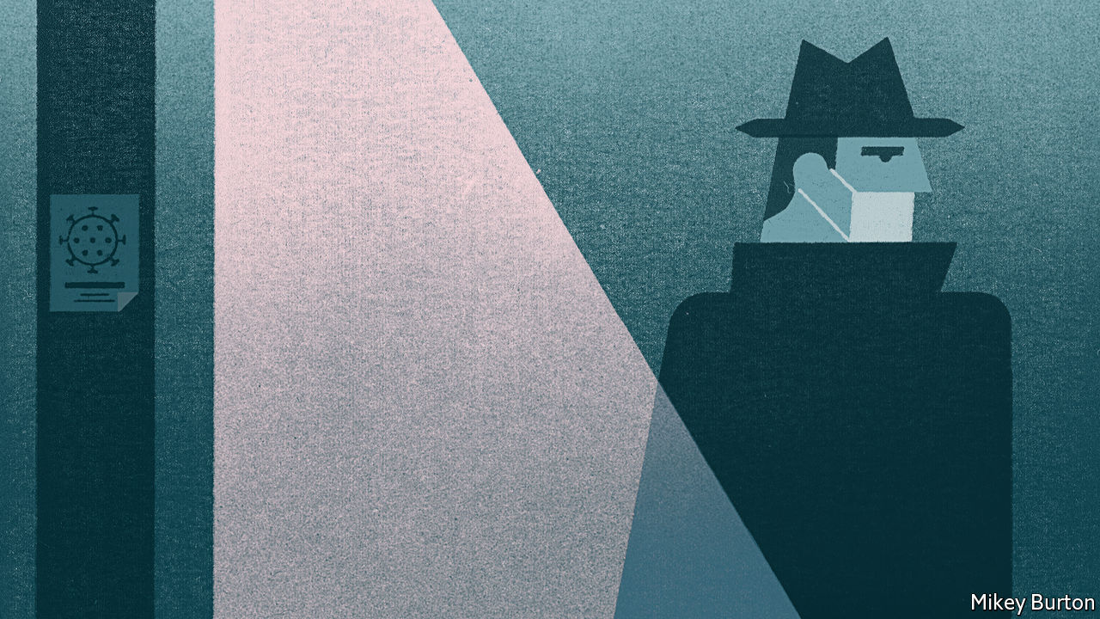

Editor’s note: The Economist is making some of its most important coverage of the covid-19 pandemic freely available to readers of The Economist Today, our daily newsletter. To receive it, register [here](https://www.economist.com/newslettersignup). For our coronavirus tracker and more coverage, see our [hub](https://www.economist.com/coronavirus)

KARACHI IS AMONG Asia’s most crime-ridden cities. And yet in eight days in March, after covid-19 forced it into lockdown, not a single car was reported stolen. El Salvador, which has one of the world’s highest murder rates, enjoyed four homicide-free days in the same month. Many countries have reported tumbling crime rates, as crooks, along with everyone else, have shut themselves away. Italy was the first European country to lock down, on March 9th. Even before then, many people were working from home. The number of crimes reported in Italy between March 1st and March 22nd dropped by 64% compared with the same period in 2019.

“I would not be surprised if crime statistics, which are dominated by less serious crimes like theft and various kinds of street crime, were to go down, at least temporarily,” says Jürgen Stock, secretary-general of Interpol, the world policing body. But government figures reflect only reported crime—and not all crime is reported, especially when lawbreaking, along with much else, has gone indoors. The Italian figures showed a drop of 44% in domestic violence. Police reckon that is because many victims dare not call to report assaults while their assailants are within earshot.

Meanwhile Gun Violence Archive, an NGO based in Washington, DC, counted more than 2,000 deaths by shooting in America between March 1st and April 19th—a 6% increase over the average in the same period during the past three years. That echoes what happened in the 1918-19 flu pandemic. According to Barry Latzer, an emeritus professor at the John Jay College of Criminal Justice in New York, murders in 1918 increased in each of the five worst-affected states. Sheltering in place shortens tempers. It also makes it easier for gangsters to locate enemies and rivals.

Most worrying, says Mr Stock, is the potential for covid-19 to create the ideal conditions for the spread of serious, organised crime. The pandemic is encouraging organised criminals to put old skills to new use. The global economic depression that looks likely to follow will offer them a chance to extend their reach deep into the legitimate economy. “The potential for problems arising from this is without precedent,” frets another international law-enforcement official.

New scams are already proliferating, some ingeniously simple. On March 16th the South African Reserve Bank issued a statement denying that it had sent collectors house-to-house to recover banknotes in case they had been contaminated with covid-19. Sales of counterfeit, often substandard, drugs have surged. In March Operation Pangaea, co-ordinated by Interpol and involving police forces in 90 countries, led to more than 100 arrests worldwide and the seizure of potentially dangerous pharmaceuticals worth more than $14m. Brazilian drugs gangs short of cash are robbing more banks.

Meanwhile the urgent need for personal protective equipment (PPE) has opened up a new field for ineffective, overpriced or even non-existent goods. Two factors have helped the criminals: the waiving of normal procurement controls by governments desperate to protect their health workers; and the impossibility of arranging face-to-face meetings between customers and suppliers. In the most elaborate scam so far, a group of fraudsters succeeded in getting the authorities in Germany’s most populous region, North Rhine-Westphalia, to part with €2.4m ($2.6m). The money was a down-payment for 10m masks. More than 50 vehicles were lined up to import the fictitious masks from the Netherlands before the ruse was discovered. It involved a website registered in Spain, an intermediary in Ireland and a firm in the Netherlands with a website that turned out to have been cloned by the scammers. With the help of financial institutions in three countries, investigators managed to block the payments, including €500,000 on its way to Nigeria.

## Making out like (masked) bandits

That attempted sting reflects an explosion in cybercrime since the lockdowns began. On the night of March 12th the Czech Republic’s second-largest hospital, the University Hospital in Brno, was hit by a ransomware attack (in which the target is prevented from accessing files until a payment is made). Urgent surgical operations had to be postponed and patients redirected to other hospitals. Several other medical facilities have experienced similar attacks since the start of the covid-19 emergency, according to Interpol.

But more traditional organised criminal activities have been hampered by the lockdowns. Protection rackets, prostitution rings, illegal gambling and the drugs trade all depend on people being able to move around freely. So do imprisoned bosses of organised crime groups if they are to continue to control their businesses. This is a particular challenge for the Brazilian drugs gangs, many of whose leaders are jailed. Lincoln Gakiya, a prosecutor for the state of São Paulo, says visiting family members often convey notes and information. Now incarcerated bosses have to rely on infrequent appearances by their lawyers to communicate with their subordinates.

Extortion provides many criminal groups with a regular flow of cash. It is especially important to the street gangs, or maras, of Central America. But collecting cash during a pandemic is tricky. Data quoted by the Global Initiative against Transnational Organised Crime comparing March 2020 with the same month last year showed 9% and 17% falls in extortion incidents registered by police in Guatemala and El Salvador (though most are not reported). In Honduras the decline was 80%. According to the FNAMP, an anti-gang unit in the country, Honduran gang leaders have warned transport firms that once the quarantine ends, protection money will have to be paid retrospectively.

The biggest money-spinner for most organised crooks is the drugs trade. Mr Stock says early reports suggest the global business, estimated at around $500bn, has been disrupted—but only temporarily and partially. “For many cartels and syndicates it’s not a big problem”, he explains, “because of the money that is available at that level. They have immense liquidity.”

The opium harvest in Afghanistan that supplies nearly all the world’s heroin has been largely unaffected. Coca farmers in Colombia, the world’s largest cultivator, have just had their best year on record, though in Peru a shortage of imported chemical precursors has made it harder to produce cocaine. The closure of pharmaceutical plants in China threatened the supply of precursors used in the production of methamphetamines, but the interruption was temporary.

The next stage in the supply chain—wholesale distribution—has been distorted. But gangs are already adapting. Syndicates that rely on drugs smuggled on flights, such as Nigerian gangs in South Africa, have been hit hard. Two members of Mexico’s Sinaloa cartel told Reuters that far fewer drugs are being transported in cars across the border into the United States since it was shut on March 21st. Syndicates seem to be using tunnels and drones instead. Officials in Brazil have reported that traffickers in cocaine, which enters from Colombia and Peru on its way to Europe and Africa, are switching consignments from land routes and onto boats travelling down the Amazon. With maritime and air traffic greatly diminished, it is even harder to get drugs out of Brazil. Yet seizures between February and April were up by 10%. Elvis Secco of the Brazilian Federal Police’s drugs and organised crime unit says traffickers are offloading their stockpiles and taking more risks, which partly explains why more narcotics are being impounded.

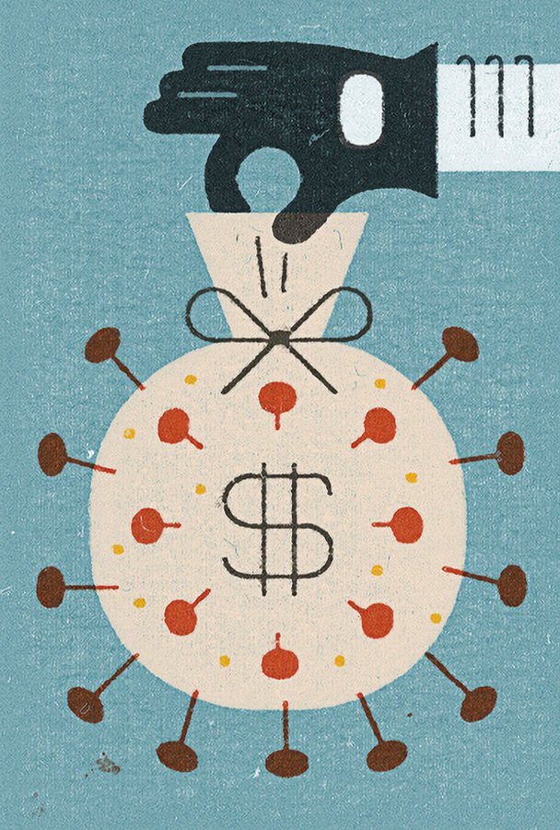

Cocaine prices in Europe and America have risen accordingly. But that also reflects the difficulties of retail distribution, the link in the supply chain that has probably had to be adjusted most. In Naples last month police dogs found 89 packages stuffed with narcotics waiting to be dispatched from a courier depot. The drugs had been ordered on the darknet. The courier firm had no idea of its role.

Shortly afterwards Interpol told its 194 members that drug-dealers were also using the cover of food deliveries to sell their wares. In Ireland police found 8kg of cocaine and two handguns hidden in pizza boxes. In the Cape Flats, a sprawl of townships on the outskirts of Cape Town, gangs are delivering drugs along with food parcels. Heroin prices there rose initially because of a mix of profiteering and new delivery fees (they have now returned to normal). In Lesotho getting heroin direct to your door costs 200-500 rand ($11-27), on top of the usual 1,200 rand per gram.

The Cape Town gangs are among several around the world that are making a big show of charity during the pandemic. Mobsters have been reported delivering food to the needy in Mexico and Italy. In El Salvador and Brazil they have enforced curfews. In Japan yakuza have offered to disinfect a quarantined cruise liner.

But even where such initiatives are not used as a cover for drug peddling, their effects are anything but benign. They enhance gangsters’ popularity and image as latter-day Robin Hoods. They guarantee future votes for the politicians whom mobsters sponsor. And they realise one of the fundamental aims of a true mafia: delegitimising the state by displacing official authority. A gang that enforces a lockdown is doing the job of the police; one that distributes food to the destitute, that of government welfare bodies.

A deep or prolonged depression will open up rich opportunities for crooks in at least three areas. High unemployment will make it easier for mobsters to recruit people. Government recovery schemes will give them a chance to muscle in on juicy public contracts. And lower corporate profits will make it easier for mafias to take over businesses that can then be used to launder illicit gains.

In Italy, after the financial crisis, some firms accepted loans at below-market rates in return for taking onto the books—or the board—a mafioso who then began to give the orders. According to the chief of the Italian police, Franco Gabrielli, his officers in the regions worst hit by covid-19 have already come across men carrying cash-stuffed briefcases that may be part of the Italian mafias’ version of “helicopter money”. The risk is that politicians already struggling to cope with the effects of the pandemic will shove its implications for the underworld to the back of their minds and the bottom of their agendas. ■

Dig deeper:  
For our latest coverage of the covid-19 pandemic, register for The Economist Today, our daily [newsletter](https://www.economist.com/newslettersignup), or visit our [coronavirus tracker and story hub](https://www.economist.com/coronavirus)

This article was downloaded by calibre from <https://www.economist.com/international/2020/05/16/the-pandemic-is-creating-fresh-opportunities-for-organised-crime>

|  |  |  |  |
| --- | --- | --- | --- |
|  | Articles | Sections | Next |

|  |  |  |
| --- | --- | --- |
| International | Sections | Finance & economics |

Business

Bankruptcies: Chapter 11’s new chapter

.

Profits seeping: America’s profit warning

.

Bankruptcies in Europe: Buying time

.

Chinese brands: Upping the Anta

.

Bartleby: Teachable moment

.

Austerity in Silicon Valley: The next garage

.

Schumpeter: The gathering swarm

.

|  |  |  |
| --- | --- | --- |
| International | Sections | Finance & economics |

|  |  |  |  |
| --- | --- | --- | --- |
|  | Articles | Sections | Next |

#### Eye of the hurricane

# America Inc faces a wave of bankruptcies

But some firms will be able to restructure rather than go broke

May 16th 2020 | NEW YORK

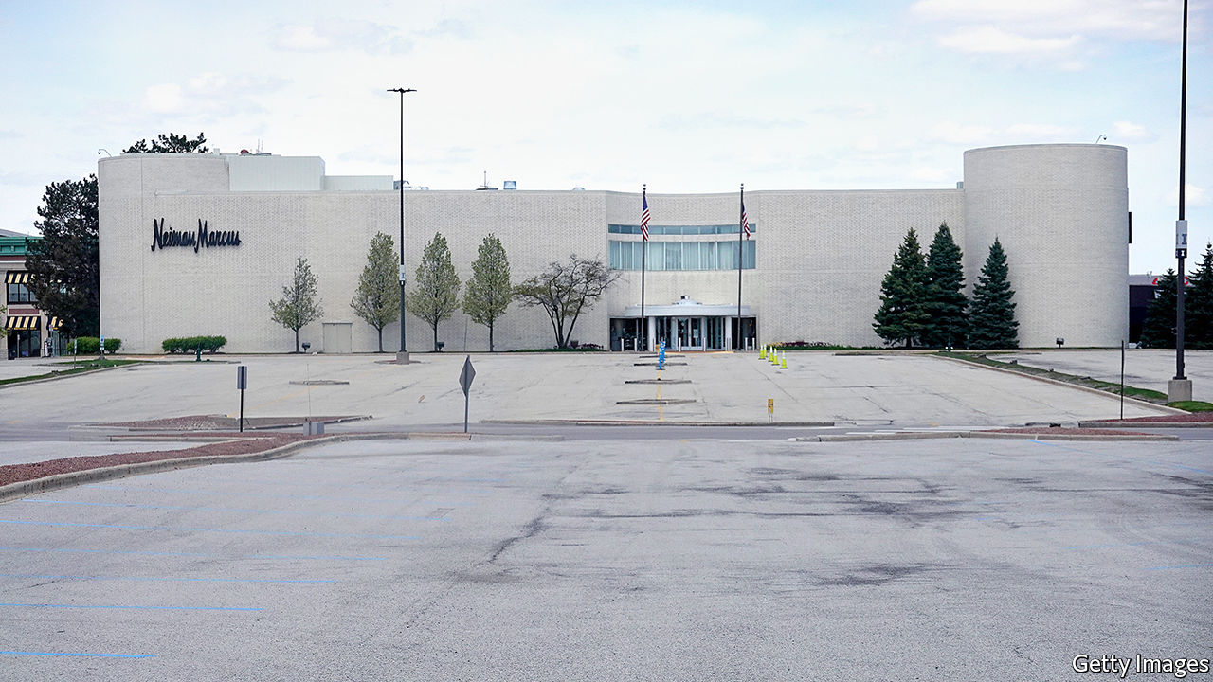

Editor’s note: The Economist is making some of its most important coverage of the covid-19 pandemic freely available to readers of The Economist Today, our daily newsletter. To receive it, register [here](https://www.economist.com/newslettersignup). For our coronavirus tracker and more coverage, see our [hub](https://www.economist.com/coronavirus)

“YOU WILL get business failures on a grand scale.” So declared James Bullard, president of the Federal Reserve Bank of St Louis, on May 12th. Peter Orszag, a former official in Barack Obama’s White House and now with Lazard, an investment bank, warned that the American economy could face “a significant risk of cascading bankruptcies”. How bad will things really get for America Inc?

The country has already seen a surge of corporate bankruptcies among big firms that puts 2020 on track to be the worst year since 2009, at the height of the global financial crisis. In recent weeks well-known firms ranging from Neiman Marcus, a department-store chain, and J Crew, a clothing retailer, to Gold’s Gym, a glitzy workout group, have gone bust. Hertz, a giant car-hire firm, and Chesapeake Energy, a pioneer of America’s shale industry, are both on the brink of bankruptcy.

As the American economy sinks further in the coming months, many more firms are sure to get into trouble. This raises three questions. What early-warning signs might reveal the scale of the coming wave of bankruptcies? How does the looming disaster compare to the pain endured during the financial crisis? And are there meaningful alternatives to outright bankruptcy?

First, to harbingers of doom. One is the upheaval in the market for “speculative grade” (or junk) bonds. In America, two-thirds of non-financial corporate bonds are rated junk or BBB, the level just above junk. In April, Goldman Sachs, another investment bank, predicted that over $550bn of investment-grade bonds will fall to junk status by October (adding roughly 40% by current value to the junk-bond market).

Edward Altman of NYU Stern Business School reckons that about 8% of all firms whose debt is rated speculative grade (about 1,900 in all) will default in the next 12 months. This figure could reach 20% over two years. He expects at least 165 large firms, those with more than $100m in liabilities, to go bankrupt by the end of 2020.

A measure known as the “distress ratio” also highlights the problem. Distressed credits are junk bonds with spreads of more than ten percentage points relative to US Treasuries. S&P Global, a credit-rating agency, reckons that distressed credits as a share of total junk bonds in America had grown to 30% by April 10th, up from 25% on March 16th. Of the 32 worldwide junk-bond defaults in April, a level not seen since the financial crisis, 21 took place in America. S&P Global estimates that the 12-month trailing default rate for junk bonds in America increased to 3.9% in April, from 3.5% in March. In Europe it rose to 2.7% from 2.4%.

A wave of defaults might unfold with varying severity across different industries. Thanks to the collapse of the oil price as well as other troubles in the shale patch, almost 70% of the speculative-grade debt in the oil-and-gas industry is at distressed levels. Five other sectors have ratios of 35% or higher: retail and restaurants, mining, transport, cars and utilities (see chart).

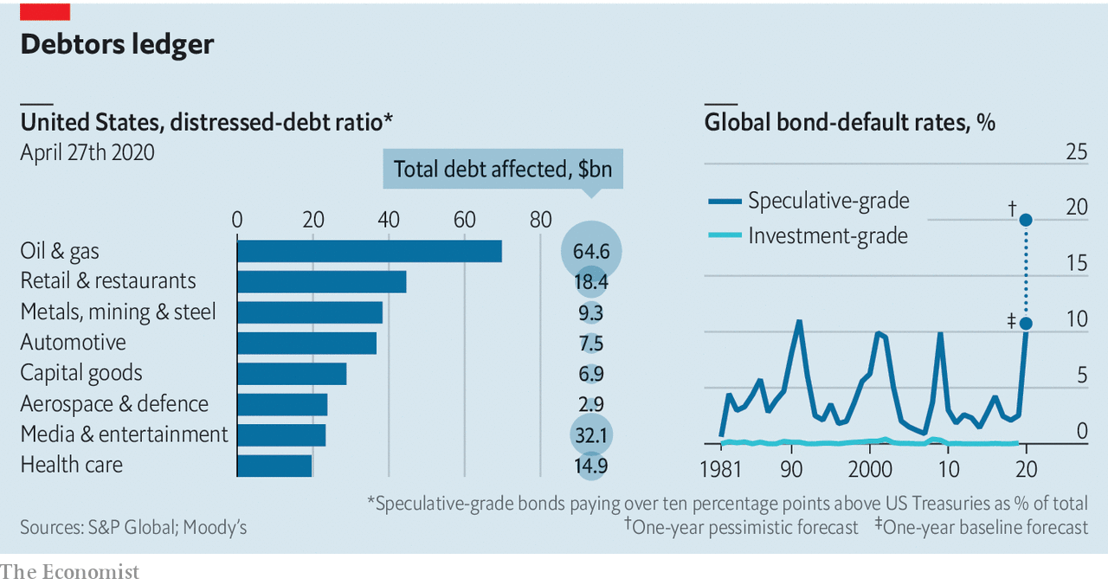

The upshot is that a second, bigger wave of bankruptcies is on the cards. How would that compare to past troubles? At the peak of the financial crisis, the global default rate for junk bonds was 10%. Moody’s, a credit-rating agency, predicts that if the current crisis is more severe than the financial crisis, as now seems likely, the default rate could rise to 20.8% (see chart). The coming bankruptcy wave could be worse than during the financial crisis because it will be more widespread, reckons Debra Dandeneau, a bankruptcy specialist at Baker McKenzie, a law firm. But she thinks it will take some months to arrive: “We’re in the eye of the hurricane now.”

Another big difference to the financial crisis arises from uncertainty. The nature of this pandemic makes it impossible to know when the economy might return to normal. As William Derrough, a restructuring specialist at Moelis & Company, points out, “It’s very hard to value a company that doesn’t have clear cashflow and visibility on its future markets.” Jared Ellias at the University of California at Hastings argues that “lenders don’t know whether to restructure out of court, grant forbearance or insist on Chapter 11 bankruptcy when you have no idea when a firm will make money again.” Worried about the coming deluge of cases, he organised a group of experts that last week petitioned Congress to appoint more bankruptcy judges and increase budgets for law clerks and other staff.

“It will be very difficult for courts to keep up with the onslaught,” says Judith Fitzgerald, a former bankruptcy judge now at Tucker Arensberg, a law firm in Pittsburgh. Amy Quackenboss of the American Bankruptcy Institute, an industry body, reports that members are busy, which will translate into more filings later on. Larry Perkins of Sierra Constellation Partners, a restructuring firm, thinks a legal bottleneck is “absolutely” possible unless courtrooms “evolve to digest it”. Vince Buccola of Wharton business school thinks part of the solution lies in embracing faster “pre-packaged” bankruptcy deals and debt exchanges (lenders agreeing to swap less onerous new debt for old unserviceable debt) done out of court.

A looming wave of bankruptcy cases points to the third question: how viable are the alternatives? There is good and bad news. The financial crisis saw a massive liquidity crunch and financial-sector implosion. But as Bruce Mendelsohn of Perella Weinberg Partners, an investment bank, observes, “this crisis is the opposite. Capital markets are strong and open with many firms able to access capital from government or from markets, but…the fundamental operations of businesses are disrupted.”

There is a flurry of activity among investors pouring money into so-called rescue funds. According to Preqin, a data firm, distressed-debt funds are looking to raise nearly $35bn. General Atlantic, a private-equity firm, is in the midst of raising nearly $5bn to invest in otherwise-healthy businesses squeezed temporarily by shutdowns. Bill Ford, General Atlantic’s boss, thinks that outside the retail sector, where many business models will prove unviable, “most firms will try to avoid bankruptcy and seek rescue capital instead.”

All restructuring firms are hiring, notes Michael Eisenband of FTI Consulting. He observes that there are more types of creditor today than during the financial crisis, so there is “more opportunity to get liquidity into firms in different ways.” He reckons few want to force liquidation because “if you can kick the can down the road, maybe a vaccine comes and…there is a better chance of getting a recovery for creditors.” Many hedge funds and non-traditional lenders (though not stodgy banks) are opting for debt-for-equity exchanges. That is so they “get the upside when the economy recovers”, says Thomas Salerno of Stinson, a bankruptcy lawyer.

So the good news is that many squeezed firms staring at bankruptcy might be saved through restructuring. Mr Derrough, a veteran of financial crises, explains that this involves five steps: stopping the bleeding; evaluating the injuries; performing the necessary surgery; rehabilitating the victim; and returning it to health. The bad news is that America Inc is at the start of phase one. As he puts it, “Most of what we are doing is blood transfusions. We haven’t even gotten to stopping the bleeding.”■

Dig deeper:  
For our latest coverage of the covid-19 pandemic, register for The Economist Today, our daily [newsletter](https://www.economist.com/newslettersignup), or visit our [coronavirus tracker and story hub](https://www.economist.com/coronavirus)

This article was downloaded by calibre from <https://www.economist.com/business/2020/05/16/america-inc-faces-a-wave-of-bankruptcies>

|  |  |  |  |
| --- | --- | --- | --- |
|  | Articles | Sections | Next |

|  |  |  |  |
| --- | --- | --- | --- |
| Previous | Articles | Sections | Next |

#### American corporate profits

# An earnings season to forget

America’s businesses give a hint of the carnage to come

May 16th 2020 |

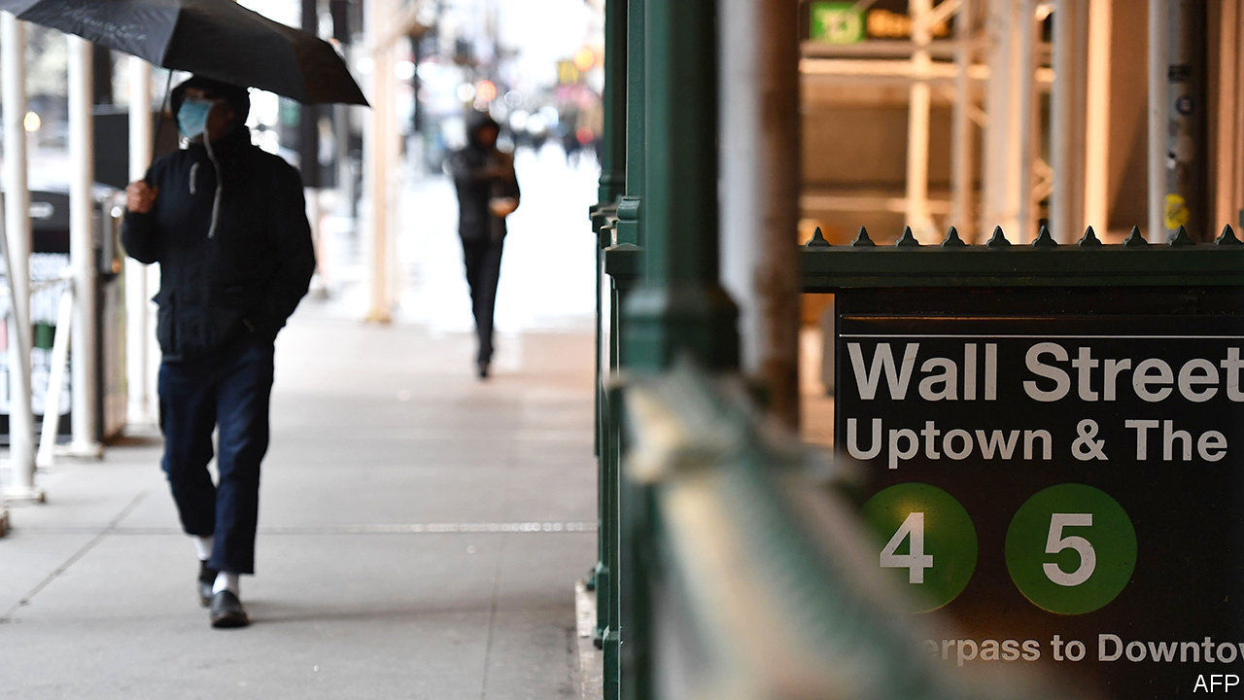

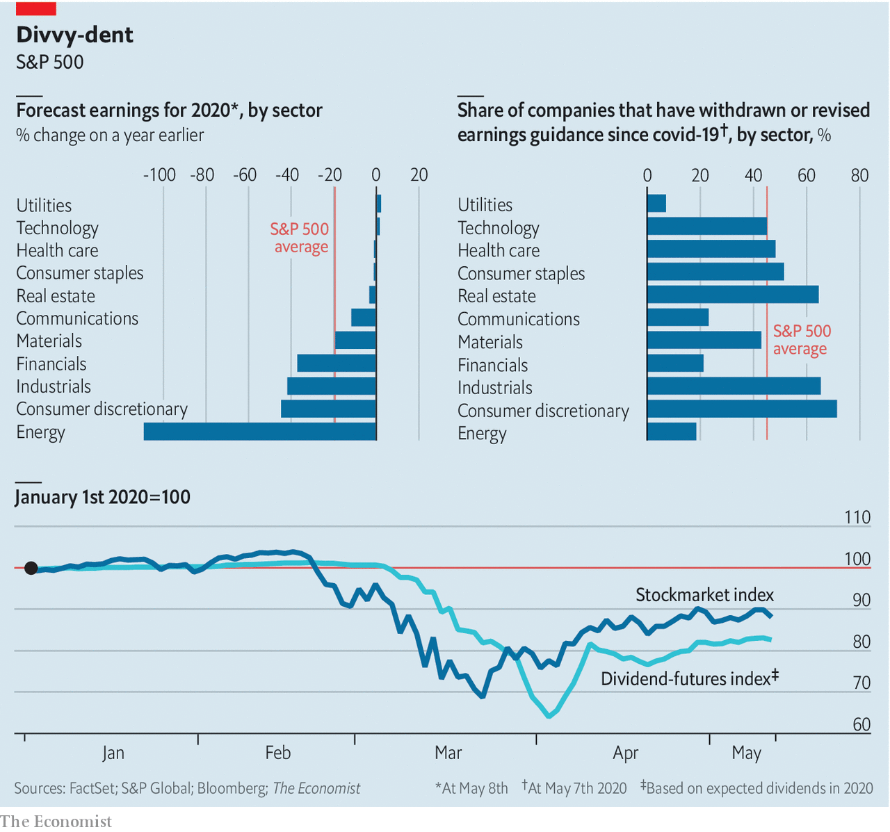

ON UNVEILING Amazon’s strong first-quarter sales, Jeff Bezos issued a warning: next quarter’s operating profits would fall as the firm covid-proofs its e-empire. No bonanza for shareholders, then. Ditto for much of the s&p 500. Nearly all its firms have now reported their quarterly results. Because America Inc locked down in mid-March, these do not reflect the pandemic’s toll. Few ceos have been as blunt as Mr Bezos about what comes next; 45% have suspended or revised guidance. Analysts expect profits to fall by 20% this year. The futures market is pricing in large cuts to s&p 500 dividends in 2020 and 2021. The bouncy stockmarket—not so much.■

This article was downloaded by calibre from <https://www.economist.com/business/2020/05/16/an-earnings-season-to-forget>

|  |  |  |  |
| --- | --- | --- | --- |
| Previous | Articles | Sections | Next |

|  |  |  |  |
| --- | --- | --- | --- |
| Previous | Articles | Sections | Next |

#### Buying time

# A wave of bankruptcies is coming in Europe

And it will not be pretty

May 16th 2020 | BERLIN

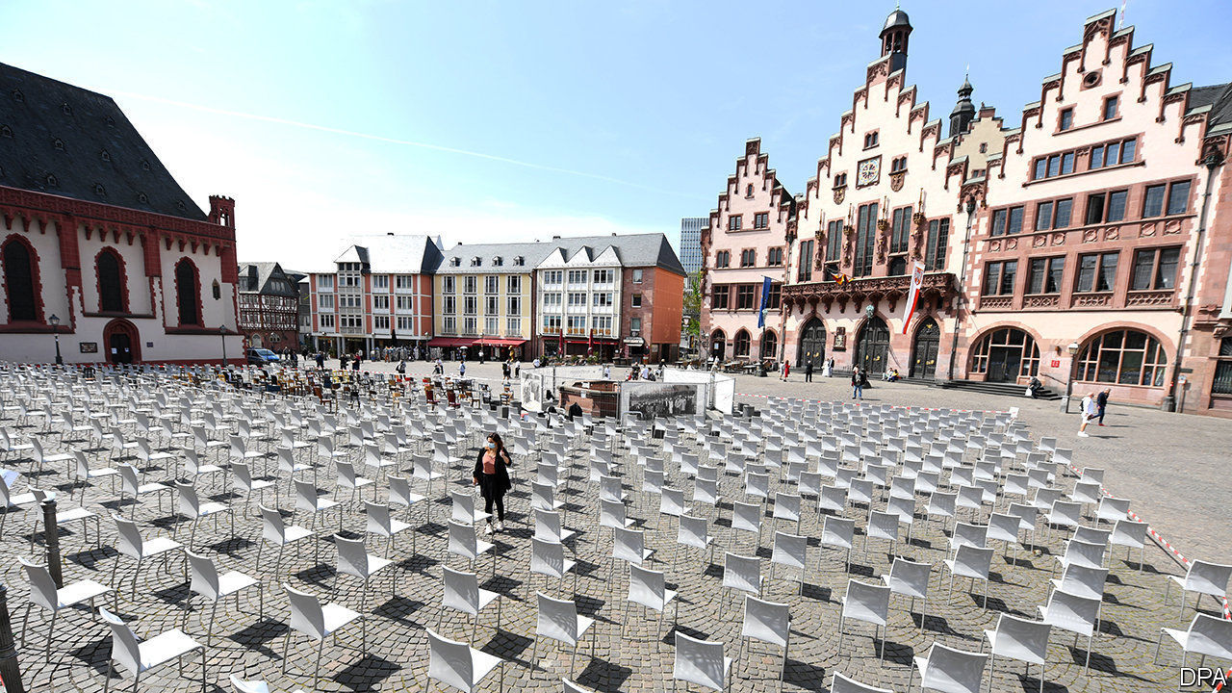

Editor’s note: The Economist is making some of its most important coverage of the covid-19 pandemic freely available to readers of The Economist Today, our daily newsletter. To receive it, register [here](https://www.economist.com/newslettersignup). For our coronavirus tracker and more coverage, see our [hub](https://www.economist.com/coronavirus)

EUROPEAN BUSINESSMEN who filed for bankruptcy used to be treated harshly. The word “bankrupt” derives from banco rotto, the practice in medieval Italy of smashing the benches that merchants sold their goods from if they did not pay their debts, to force them to stop trading. Until the mid-19th century defaulters were thrown into debtors’ prisons. Bankruptcy proceedings are now less violent, but in many European countries they mostly end in liquidation rather than restructuring.

The fear of multiple bankruptcies and mass unemployment because of measures imposed to contain the covid-19 pandemic is the main reason European governments are subsidising businesses on a vast scale. “No healthy company should go bankrupt because of corona,” promised Peter Altmaier, Germany’s economy minister, in mid-March when he announced extended credit lines, liquidity guarantees and grants for German businesses amounting to €750bn ($807bn). At the end of March the German government suspended insolvent firms’ obligation to file for bankruptcy until the end of September (and perhaps until March 2021)—provided they can prove their troubles were caused by covid-19. France, Spain and other European countries have introduced similar exemptions.

These emergency measures are buying time. Bankruptcies and unemployment have not yet risen sharply. According to the Institute of Economic Research in Halle (IWH) bankruptcies in March and April in Germany were no higher than in the same months last year. Yet rescue measures probably just postpone a surge in bankruptcies, says Steffen Mueller of the IWH. Mr Mueller thinks “zombies” will be swept away later this year, but worries that even healthy companies may not survive.

Governments have learned a lesson from the global financial crisis. Bankruptcies increased by 32% in western Europe in 2008. Ludovic Subran of Euler Hermes, a Paris-based credit insurer, is forecasting a rise of 19% compared with 2019 to 178,365 insolvencies this year. The corporate carnage was so brutal in 2008 because of the credit crunch, explains Mr Subran. A sudden slump in the availability of loans sealed the fate of many firms. This time EU governments have reacted far faster by pumping liquidity into the economy. Moreover, the rate of bankruptcies was very low between 2002 and 2007 whereas this time Europe has seen a clean-out in the past five years, with many firms going bust.

Mr Subran’s forecast seems optimistic considering that some industries suddenly lost all their business. The most vulnerable firms are in the hospitality, transport and non-food retail sectors. They were among the most insolvency-prone businesses before the covid crisis. Germany’s Karstadt Kaufhof, an ailing department-store chain, and France’s Orchestra Prémaman, a troubled clothing retailer, both filed for receivership in April. In Britain Carluccio’s, a restaurant chain, Brighthouse, a rent-to-own retailer, and Laura Ashley, a fashion chain, tumbled into administration in March.

The other weak link is Europe’s 25m small and medium-sized enterprises (defined as firms with fewer than 250 staff), which employ over 90m people. According to SMEunited, a European lobby group, 90% of Europe’s small firms are affected by the pandemic and 30% of them say they are losing 80% of sales or more. CPME, France’s small-business federation, says 55% of small firms are concerned about bankruptcy. The French government’s €7bn solidarity fund for small companies has already been tapped by 900,000 firms.

Behemoths have been rescued by the state, as so many jobs depend on them. France and the Netherlands are providing a taxpayer-funded bail-out of about €10bn to salvage Air France-KLM from bankruptcy. Germany will follow with a bail-out for Lufthansa. Small businesses will suffer most in spite of short-term work schemes, cash payments, delays to tax deadlines and credit guarantees. But never before have governments done so much to try to help them avoid the Schuldturm—the prison tower that was the destination, in the past, for those who couldn’t pay their debts. ■

Dig deeper:  
For our latest coverage of the covid-19 pandemic, register for The Economist Today, our daily [newsletter](https://www.economist.com/newslettersignup), or visit our [coronavirus tracker and story hub](https://www.economist.com/coronavirus)

This article was downloaded by calibre from <https://www.economist.com/business/2020/05/16/a-wave-of-bankruptcies-is-coming-in-europe>

|  |  |  |  |
| --- | --- | --- | --- |
| Previous | Articles | Sections | Next |

|  |  |  |  |
| --- | --- | --- | --- |
| Previous | Articles | Sections | Next |

#### Upping the Anta

# Anta, an ambitious Chinese sportswear firm, does some fancy footwork

It does some fancy footwork

May 16th 2020 |

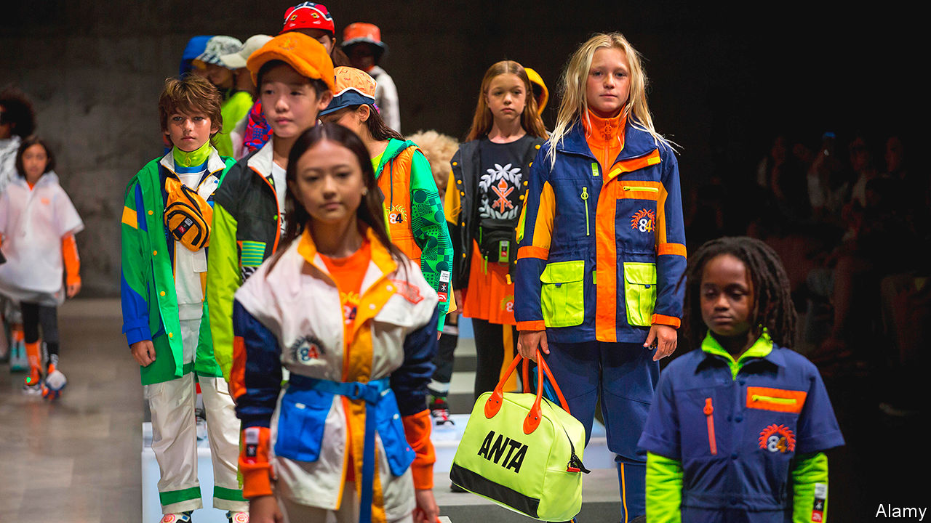

DING SHIZHONG, the founder and boss of Anta, the world’s third-biggest sportswear firm by market capitalisation, refused to let the covid-19 pandemic interfere with sales. In early February, as the virus forced shops to close, Mr Ding gave each of his 30,000 employees a new assignment: hawk Anta’s apparel and shoes to personal contacts on WeChat, a messaging platform. Such resolve to protect revenues is admirable. Yet it reflects insecurity.

Anta, established in 1991, has long been runner-up on its home turf to Nike and Adidas. The Western sportswear powerhouses together accounted for over two-fifths of China’s market in 2019, according to Euromonitor, a market-research firm. Anta has a sixth of the market but it is moving fast. Revenues grew by over 40% in each of the past two years, double the rate of the industry. Operating profit hit 8.7bn yuan ($1.2bn) in 2019. But that is still only half the sum made in China by Nike.

Anta’s aim is to become “a Chinese brand that stands out in the world”. It is perhaps best known in the West as the shoe sponsor for Klay Thompson, a star player with the Golden State Warriors basketball team, and Manny Pacquiao, a Filipino boxer. But the brand generates few foreign sales. Even in China, many urban youngsters think Anta “lacks the cool factor”, says Lu Ge of the Beijing Institute of Fashion Technology—despite being the official kit supplier for China’s Olympic athletes.

That perception stems in part from Anta’s customer base. Its shops are concentrated in medium-sized cities, to cater to consumers that are less well off than those in Beijing or Shanghai, the preferred haunts of Nike and Adidas. A pair of Anta shoes typically costs a third less than a similar pair of Nikes, observes Dallas Cai of Oriental Patron, a broker. Pricier and associated with more global superstars, Nike and Adidas have far more brand appeal.

Mr Ding’s all-hands-on-deck strategy and Anta’s clientele may have insulated the firm from the worst of covid-19’s ravages. Ms Cai observes that, as China began to re-open in late February, residents of cities where Anta is strong may have been less fastidious about social distancing than counterparts in richer locales. Revenues at Anta fell by 20-25% in the first quarter year-on-year, according to the firm’s latest financial update. That looks rosy compared with Adidas. It saw sales in China drop by 58% in the same period.

Relying on rivals’ bad luck is not a long-term plan. Mr Ding recently wrote that Anta aspires to make the leap from an “affordable brand” to a “desirable” one. He has some more upmarket trademarks at his disposal. In 2009 Anta acquired the Chinese operation of Fila, a sportswear firm with Italian roots. Last year, in a $5.2bn deal, the firm bought a majority stake in Amer Sports, a Finnish outfit with assets including Wilson tennis rackets and Salomon skis. But that may not be enough to take on and beat Nike and Adidas. Shifting perceptions will be hard.■

This article was downloaded by calibre from <https://www.economist.com/business/2020/05/16/anta-an-ambitious-chinese-sportswear-firm-does-some-fancy-footwork>

|  |  |  |  |
| --- | --- | --- | --- |
| Previous | Articles | Sections | Next |

|  |  |  |  |
| --- | --- | --- | --- |
| Previous | Articles | Sections | Next |

#### Bartleby

# The pandemic increases the challenges facing business schools

Teachable moment

May 16th 2020 |

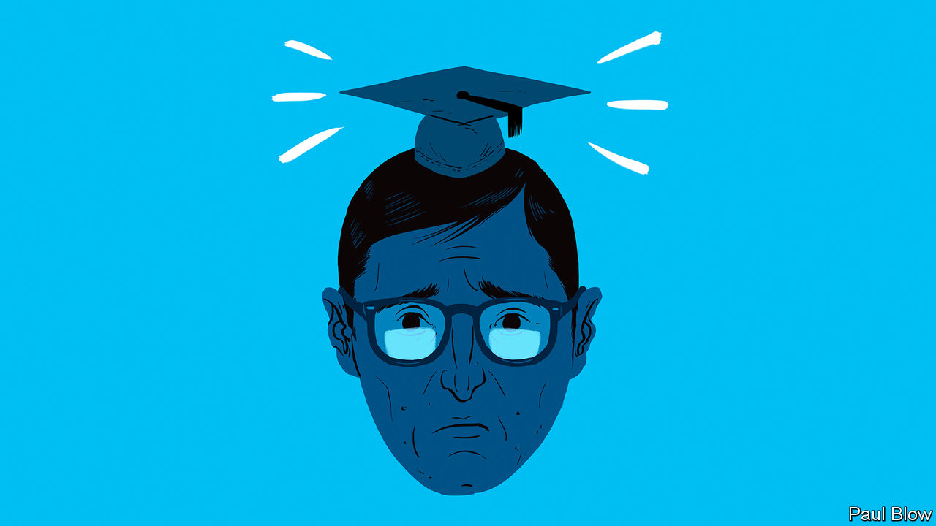

Editor’s note: The Economist is making some of its most important coverage of the covid-19 pandemic freely available to readers of The Economist Today, our daily newsletter. To receive it, register [here](https://www.economist.com/newslettersignup). For our coronavirus tracker and more coverage, see our [hub](https://www.economist.com/coronavirus)

LOCKDOWN HAS delivered a nasty shock to academia, with universities around the world closing for the summer term, disrupting the plans of millions of students. Business schools are suffering along with the rest, but the shutdown has occurred when the sector is already facing a host of problems. A survey of the deans of American business schools by Eduvantis, a consultancy, found that almost all thought the pandemic would lead to permanent closures.

Bartleby contacted seven leading schools in America, Britain and France to see how they were coping with the crisis. Unsurprisingly, the immediate reaction has been to switch to teaching online. Many are putting a brave face on the issue. Christoph Loch, dean of the Judge school at Cambridge, says: “If we do this right, if we do it strategically, this is going to stay beyond covid.” Meanwhile the INSEAD school in France maintains that it is hard to imagine going back to a world where the successes from online learning will not be combined with person-to-person exchanges.

The pandemic also presents a teaching opportunity. The Wharton School at the University of Pennsylvania has launched a course called “Epidemics, Natural Disasters and Geopolitics: Managing Global Business and Financial Uncertainty”. The London Business School will shortly run a course on “The Economics of a Pandemic”.

Online courses are all very well. But part of the motivation for attending business school is to take advantage of networking opportunities that could last for the rest of students’ careers. Some of this can be done online. At the MIT Sloan School of Management, virtual student networking has included trivia nights, hackathons and a programming boot camp. In keeping with its location, activities at the Haas School in Berkeley, California, have included remote yoga and mindfulness classes. At INSEAD, students gather in virtual break-out rooms for further discussions, with the groups picked at random to ensure interaction with a broader group of classmates.

Nevertheless, just as a friend you made on Facebook is not the same as someone you grew up with, virtual ties are unlikely to be as strong as normal ones. That has led to some dissatisfaction among students. At Wharton, more than 1,000 MBA students have signed an online petition arguing that the school should reduce fees, which run to $150,000 for a two-year course. The petition claims that virtual-classroom technology is “unable to fully replicate” the usual teaching environment, and that other elements of the course, such as foreign travel and extra-curricular activities, “have been essentially cancelled”.

The rapid economic downturn caused by the pandemic is a complicating factor. In the past, business schools have benefited from recessions, as young people have chosen to continue their education rather than risk entering a shaky jobs market. But this time could be different.

First, it is not yet clear when business schools can reopen for traditional teaching. None of the schools had a firm timetable for that to happen. And candidates may wait until they do, rather than pay top dollar for an online course. Another survey, by Poets&Quants, a website for news about business schools, found that 43% of prospective MBA students thought that fees should be lowered, and that a third might defer their courses until normal teaching can resume.

Second, the pandemic is likely further to discourage students from applying to business schools abroad. Around half of all American business schools experienced a decline in overseas applications last year, thanks to anti-immigration political rhetoric and the greater difficulty in getting visas to work once a degree was obtained.

Neither America nor Britain has covered itself in glory in recent weeks. A survey of international students by IDP Connect found that, among Anglophone countries, Britain and America ranked behind New Zealand, Canada and Australia in terms of how they have handled the pandemic. The war of words between America and China over the virus will also have an effect. Students from the People’s Republic may be more inclined to study in their own country.

That is bad news for both universities and business schools, as international students are very lucrative. Things may go back to normal in a few years’ time; the virus may be conquered and international relations may settle down. But as with many other sectors of the economy, there may be a big shakeout among business schools before that happens.

Dig deeper:  
For our latest coverage of the covid-19 pandemic, register for The Economist Today, our daily [newsletter](https://www.economist.com/newslettersignup), or visit our [coronavirus tracker and story hub](https://www.economist.com/coronavirus)

This article was downloaded by calibre from <https://www.economist.com/business/2020/05/16/the-pandemic-increases-the-challenges-facing-business-schools>

|  |  |  |  |
| --- | --- | --- | --- |
| Previous | Articles | Sections | Next |

|  |  |  |  |
| --- | --- | --- | --- |
| Previous | Articles | Sections | Next |

#### The next garage

# Silicon Valley in the pandemic

The crisis has hit tech’s spiritual home hard, but it is already planning ahead

May 16th 2020 | SAN FRANCISCO

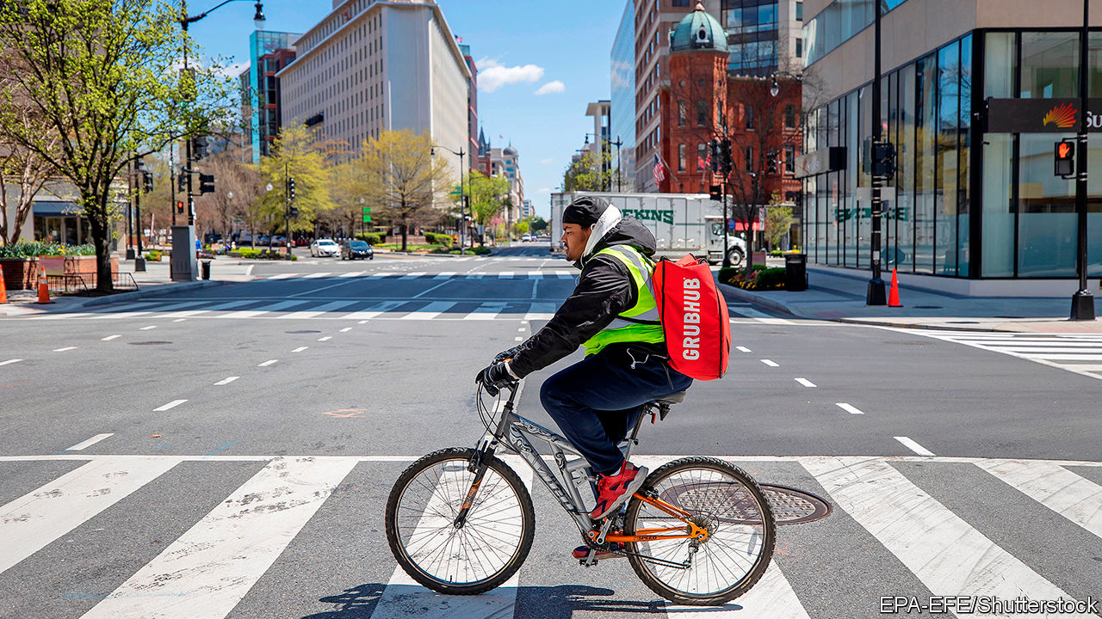

Editor’s note: The Economist is making some of its most important coverage of the covid-19 pandemic freely available to readers of The Economist Today, our daily newsletter. To receive it, register [here](https://www.economist.com/newslettersignup). For our coronavirus tracker and more coverage, see our [hub](https://www.economist.com/coronavirus)

FIRING SOMEBODY is hard under any circumstances. But doing it over a video call is brutal. “It’s not the best environment for this, with people at home and kids in the background,” observes Marwan Forzley, the boss of Veem, a startup based in San Francisco which allows firms to transfer money cheaply. He recently had to let go 30 of its employees.

Mr Forzley speaks for many in Silicon Valley. The largest American tech firms may be the winners from a global pandemic. Demand for their online services has exploded among people and businesses in lockdown. But many startups in tech’s heartland are hurting. Hardly a day goes by without news of more lay-offs and firms going out of business. Yet amid the doom and gloom, venture-capital (VC) firms and entrepreneurs are already doing the thing they believe they do best: divining the future in their crystal balls.

Californian tech firms and their financiers were among the first in America to take the threat of coronavirus seriously. Some venture capitalists began refusing to shake hands at the beginning of February (and were ridiculed for it). The moneymen also moved quickly to “triage” companies in their portfolio, classifying them according to how likely they were to survive and what they should do. Mostly this involved letting people go. “The shocking thing is how fast everything has moved,” says Marco Zappacosta, who runs Thumbtack, a marketplace for local professionals from plumbers to dog trainers, which laid off 250 of its 900 employees.

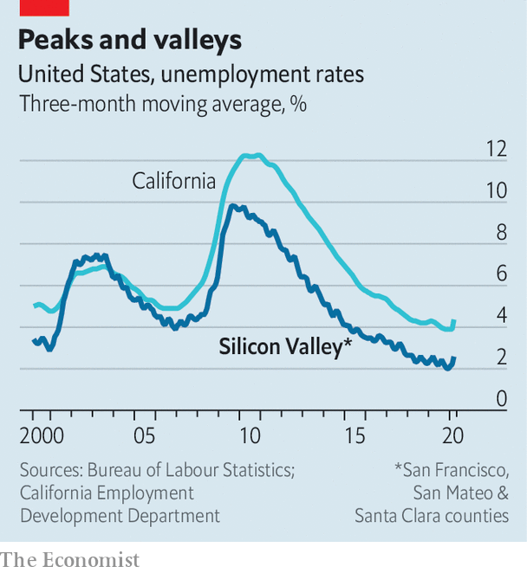

Definitive figures are hard to come by. When big firms cut back it makes the news. Airbnb and Uber recently announced they would let go 1,900 and 3,700 workers respectively. Layoffs.fyi, a website that tracks dismissals in the tech industry by adding up numbers from press reports, has counted about 17,600 jobs lost since mid-March. But this misses many sackings at smaller startups. Although still well below the national average and the peak during the financial crisis of 2007-09, unemployment in the region is edging up (see chart). Some VCs expect workforces to shrink by 15% on average, adding up to total job losses in excess of 125,000.

Yet Silicon Valley’s denizens are not ones to dwell on bad numbers. VCs are scouting for promising firms whose valuations have dropped and which need fresh capital. Investments in America are only down by 25% compared to before the pandemic, according to PitchBook, a data provider. For startups with cash in the coffers, it is an opportunity to scoop up weaker rivals. On May 12th it emerged that Uber, a shrinking ride-hailing service with a growing meal-delivery arm and $9bn in the bank, is seeking to acquire GrubHub, which also delivers food. A few days earlier Uber led a $170m funding round in Lime, an ailing startup that rents out electric scooters and bicycles. Expect more such deals—and more criticism that the likes of Uber are trying to use the pandemic to monopolise markets.

Silicon Valley’s leading VC firms are also trying to seize new opportunities. More than one sees the tech industry’s sweet spots moving from services that cater to consumers and involve the physical world, such as electric scooters and online ticketing, to offerings for business that are delivered virtually, including specialised web-based software and digital infrastructure.

Much of the venture capital flowing in recent weeks has been aimed at deeply technical targets, such as Confluent, which manages corporate data. The firm raised $250m in April. Startups in telemedicine and online education are also doing well. And business is improving for some firms that had looked less resilient to the virus, such as Veem and Thumbtack. Firms want to move money cheaply and people stuck at home are planning to give their nests a makeover, driving demand for local services.

Looking further forward, the debate now revolves around how the pandemic will change Silicon Valley—and with it much of the tech industry. The crisis will accelerate existing trends. The Valley will continue to spread out, reckons Randy Komisar of Kleiner Perkins, another VC firm. Even before the virus hit, an exodus of sorts was under way. Exorbitant property prices, near-permanent traffic jams and the jarring number of homeless people have pushed a growing numbers to leave.

Startups have been moving away or have become “fully distributed”, with only their most important employees living in San Francisco and the rest spread across the world. Such dispersion is likely to speed up if a consequence of covid-19 is that working remotely becomes the norm. It looks likely. Big Silicon Valley companies, including Facebook and Google, are letting employees work from home until the end of the year. Twitter says they can do so indefinitely.

Another question is whether venture capital, Silicon Valley’s lifeblood, will go virtual and distributed as well. Some hope that the crisis will disrupt what Pete Flint of Nfx calls the “archaic world of venture capital”. In April, his firm launched an online service where startups can input the information that investors want, from founders’ biographies to business plans, and then get a decision on funding within nine days.

Silicon Valley may no longer be the only place that matters as startups hunker down in cheaper locations with fewer distractions. Frontier is one such firm. It has decamped to Vancouver to build a marketplace for remote workers. It was founded a few months before the virus struck and got its first funding a few weeks ago. Elliot O’Connor and his co-founders are holed up in an Airbnb, using DoorDash and other delivery services to feed themselves. It feels like working in the proverbial garage, he says—not in the Valley, but of the Valley.■

Dig deeper:  
For our latest coverage of the covid-19 pandemic, register for The Economist Today, our daily [newsletter](https://www.economist.com/newslettersignup), or visit our [coronavirus tracker and story hub](https://www.economist.com/coronavirus)

This article was downloaded by calibre from <https://www.economist.com/business/2020/05/16/silicon-valley-in-the-pandemic>

|  |  |  |  |
| --- | --- | --- | --- |
| Previous | Articles | Sections | Next |

|  |  |  |  |
| --- | --- | --- | --- |
| Previous | Articles | Sections | Next |

#### Schumpeter

# Creative destruction in times of covid

Is now the time for entrepreneurial true grit?

May 16th 2020 |

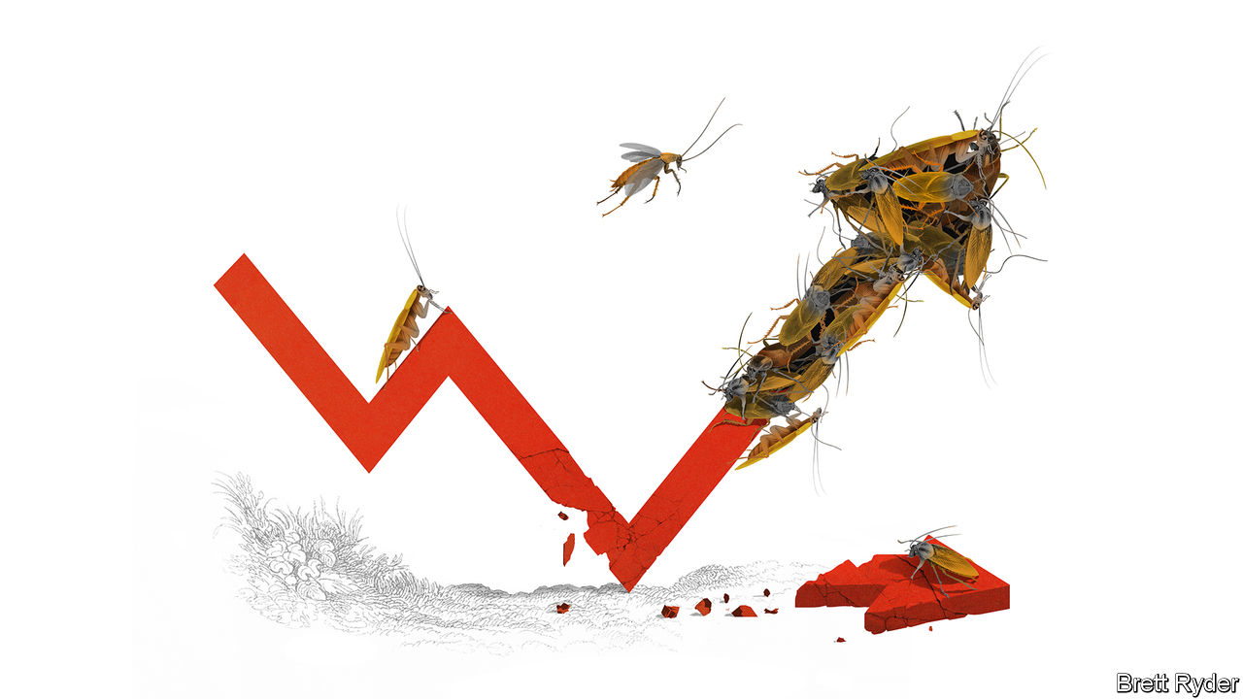

Editor’s note: The Economist is making some of its most important coverage of the covid-19 pandemic freely available to readers of The Economist Today, our daily newsletter. To receive it, register [here](https://www.economist.com/newslettersignup). For our coronavirus tracker and more coverage, see our [hub](https://www.economist.com/coronavirus)

A STRUGGLING Airbnb was still called AirBed&Breakfast when its founders decided to bet its future on the Democratic National Committee in Denver in 2008. Their air-bed idea was not popular with the 80,000 people congregated to select a presidential candidate. So they focused on breakfast instead, peddling $40 boxes of cereals called Obama O’s and Cap’n McCain’s (their quip: “Be a cereal entrepreneur”). The timing was as bad as the pun. The event came just weeks before Lehman Brothers collapsed at the height of the financial crisis of 2007-09. Yet shortly afterwards they obtained their first-ever funding. The angel investor who backed them dubbed them “cockroaches” for their survival skills. That may not be the most tasteful way to describe people in the hospitality trade. The founders, though, considered it the best compliment they had ever received.

Like Airbnb, some of the best-known names in business started during steep slumps, including Uber (2009), Microsoft (1975), Disney (1923), General Motors (1908) and General Electric (1890). Disruptive products and services, too, have emerged in times of crisis, notably Apple’s iPod as the dotcom bubble burst in 2000 and Alibaba’s Taobao, an online-shopping mall, during China’s SARS epidemic of 2003.

Such stories loom large in startup folklore as evidence of entrepreneurial true grit. Yet they are rarities. Our calculations indicate that among almost 500 of today’s biggest listed firms in America, whose origins date as far back as 1857, a much larger number started life in expansionary years than during recessions. Of those founded since 1970, more than four-fifths were born in good times (see chart). That, of course, overlooks innumerable firms created along the way that have either not made it to the top, or fallen by the roadside. But it suggests that however hard it is for the enterprising to build a lasting business, it is even harder for those who start off with the economic winds blowing in their faces.

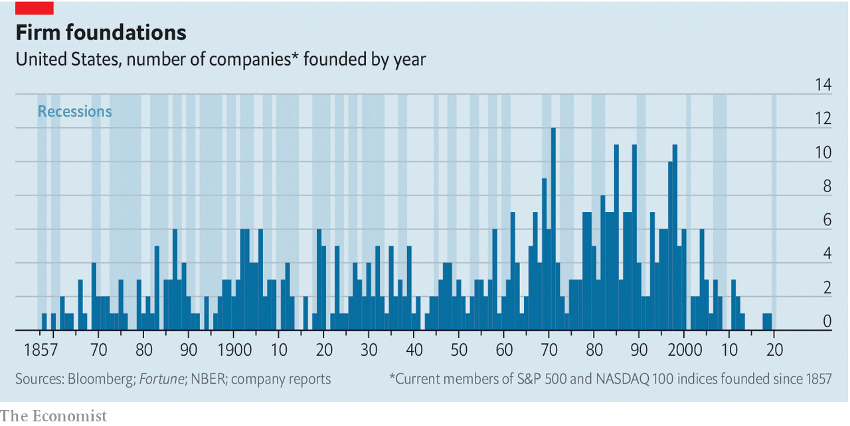

Save for a few industries such as health care, it is safe to assume that investment in innovation will plummet during the covid-19 pandemic. It usually does in times of crisis. Venture capital (VC) will also dry up as everyone keeps their heads down and tries to preserve cash. In 2007-09, VC funding in America fell by almost 30%. Yet this column would not be named after Joseph Schumpeter, the father of creative destruction, if it did not believe that following a slump, a burst of entrepreneurial activity will eventually emerge. As he wrote in “The Theory of Economic Development”, published in 1911 (itself a recessionary year), “the very logic of the capitalist system [is that] after some time of depression, new entrepreneurs would emerge. And then there would be a new ‘swarm’ of entrepreneurs. A wave of prosperity would start up and the whole cycle would roll on.” Assuming this remains the case, will the protagonists be tiny startups coming out of nowhere? Will they be better-funded entrepreneurs who have long prepared for such a moment? Or will they be the titans of tech?

With the world in upheaval, enterprising minds are already whirring. Some of them are altruistic: schoolchildren, for instance, have been 3D-printing plastic visors for front-line workers. Some of them are saucy, such as the Thai bodybuilders, put out of work by lockdown, who last month set up Bsamfruit Durian Delivery, promoting it on Facebook not only with photos of durians and mangoes, but of taut abs and bulging bosoms. Some of them will simply be hungry for fame and fortune, believing, like Michael Moritz of Sequoia Capital, a VC firm, that social changes accelerated by the crisis, such as food delivery, telemedicine and online education, will eventually generate lucrative business opportunities. They will also expect the economic slump to wipe out incumbents, muting competition and freeing up space and manpower—provided governments do not interfere with the inevitable by propping up zombie firms.

But even with the best ideas in the world, first-time entrepreneurs will struggle to convince investors to give them capital in the depths of the crisis, not least if they can only pitch to them over Zoom. Instead, the more likely standard-bearers of creative destruction will be existing firms, albeit small ones, which raised enough money before the crisis to survive it and will maintain their flair for innovation throughout, says Daniele Archibugi of Birkbeck, University of London. There may be plenty of such firms. According to Crunchbase, a data gatherer, startups raised about $600bn worldwide in 2018 and 2019. That provides a cushion of support. They will, however, have to be quick at shifting from growth to survival and back again, and at embracing new business plans if their old ones are no longer viable.

## Betting on an accumulator

Yet it is not just small, scrappy firms that push innovation forward. Big firms have a critical role to play, too. Alongside creative destruction in times of crisis, Schumpetarian academics point to “creative accumulation” in economic upswings, when incremental innovation is carried out in the research-and-development labs of giant firms. In Europe during the global financial crisis such corporations increased investment into new products and ideas, as did the most innovative small firms. The cash-rich tech giants, such as Microsoft, Amazon, Apple and Alphabet, have become examples of creative accumulation, helping foster innovation during the good times. They will probably continue to do so during the crisis. As they expand into health care, fintech and other industries, they could even be part of a new wave of creative destruction.

That is the optimist’s scenario. A more pessimistic one is that big tech will use its moneybags and muscle to stifle competition, by buying or scaring off more enterprising rivals. What is in little doubt, though, is that the covid-19 crisis, which has turned so many people’s lives upside down, will eventually produce a wealth of new business opportunities. If it attracts swarms of entrepreneurs crawling over cosy oligopolies so much the better. But even if the tech titans prevail for now, they will inevitably find themselves victims of the forces of change. Schumpeter’s “perennial gale of creative destruction” will one day blow them away, too. ■

Dig deeper:  
For our latest coverage of the covid-19 pandemic, register for The Economist Today, our daily [newsletter](https://www.economist.com/newslettersignup), or visit our [coronavirus tracker and story hub](https://www.economist.com/coronavirus)

This article was downloaded by calibre from <https://www.economist.com/business/2020/05/16/creative-destruction-in-times-of-covid>

|  |  |  |  |
| --- | --- | --- | --- |
| Previous | Articles | Sections | Next |

|  |  |  |
| --- | --- | --- |
| Business | Sections | Schools brief |

Finance & economics

The global economy: A good kind of bubble

.

Turkey in trouble: A host of difficulties

.

Geopolitics and capital markets: Feuding over funds

.

European Central Bank: Lane speaking

.

Free exchange: The great levelling

.

|  |  |  |
| --- | --- | --- |
| Business | Sections | Schools brief |

|  |  |  |  |
| --- | --- | --- | --- |
|  | Articles | Sections | Next |

#### A good kind of bubble

# Could travel bubbles offer a route to economic recovery?

The economic gains would be large, but the health requirements could be vexing

May 14th 2020 | SHANGHAI

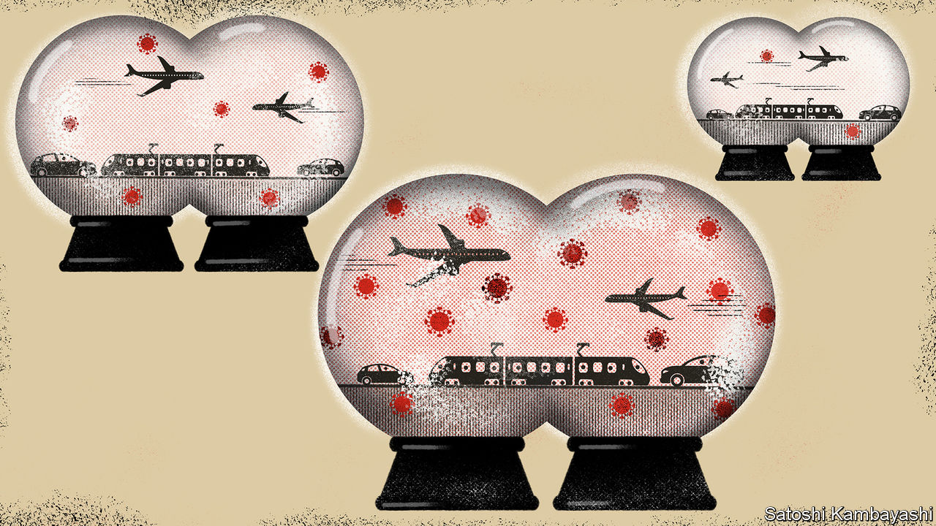

Editor’s note: The Economist is making some of its most important coverage of the covid-19 pandemic freely available to readers of The Economist Today, our daily newsletter. To receive it, register [here](https://www.economist.com/newslettersignup). For our coronavirus tracker and more coverage, see our [hub](https://www.economist.com/coronavirus)

IT MAY BE a painful fact to contemplate during these locked-down days, but last year the world was more mobile than ever, with people taking 4.6bn flights. In April this year, though, planes carried just 47m passengers; that level of mobility, annualised, would set the clocks back to 1978. The virtual halt to travel has exacerbated the global economy’s woes, complicating trade ties, upending business and devastating the tourism industry. Little wonder that governments want to restore links. An idea gaining favour is the creation of travel “bubbles”, binding together countries that have fared well against the coronavirus.

A closer look yields some grounds for optimism. The Economist has identified potential bubbles that account for around 35% of global GDP, 39% of all trade in goods and services and 42% of the world’s spending on tourism. But the challenge of connecting them also underscores how hard restarting the global economy will be.

Simply returning borders to pre-virus days is, for now, inconceivable. Many health experts, first critical of travel restrictions, have come to view strict controls as useful, especially for places that have contained local infections. “Every inbound case is a potential seed that can grow into an outbreak,” says Ben Cowling, an epidemiologist at Hong Kong University.

The first bubble is due to come to life on May 15th between Estonia, Latvia and Lithuania, among Europe’s best performers in taming the virus. Their citizens will be free to travel inside the zone without quarantine. The next might be a trans-Tasman bubble, tying New Zealand to Australia’s state of Tasmania, both of which have kept new cases down. China and South Korea have launched a “fast track” entry channel for business people. “My expectation is that there will be a large number of small travel bubbles,” Mr Cowling says.

But in the same way that regional trade deals are more efficient than bilateral pacts, the economic benefits from making the bubbles bigger would be greater. Based on an analysis of infection data, The Economist sees two large zones that could emerge as bubbles, subsuming the smaller ones that are now being formed.

The first is in the Asia-Pacific region, where countries from Japan to New Zealand have recorded fewer than ten new infections per 1m residents over the past week. The second is in Europe: using a laxer threshold—fewer than 100 new cases on the same basis—the bubble could reach from the Baltic to the Adriatic, and take in Germany (see map). Our Asia-Pacific bubble would, thanks to China and Japan, account for 27% of global GDP. Our European one would make up 8%.

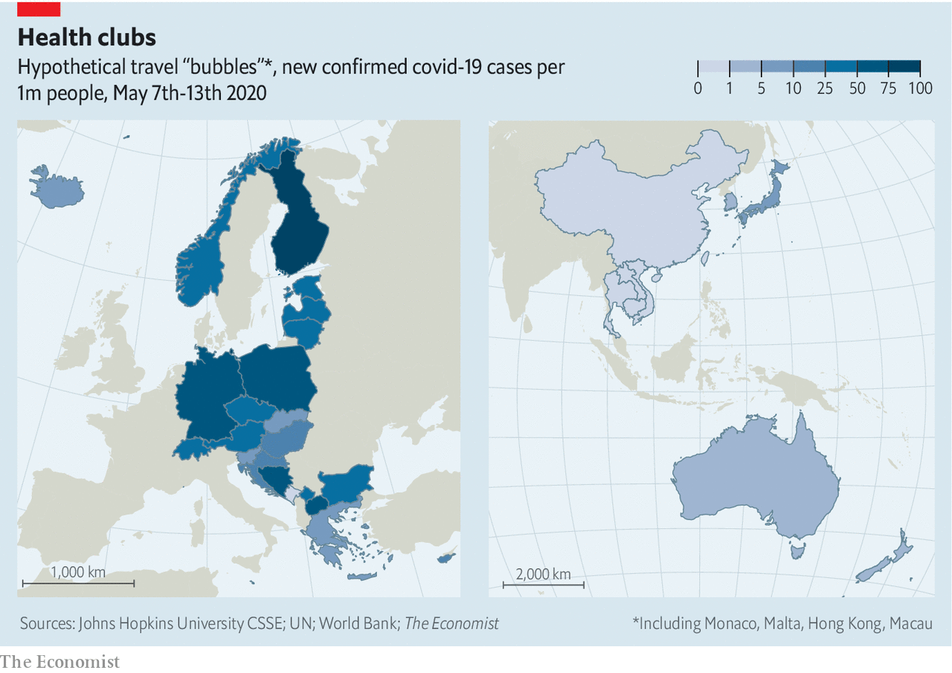

One measure of the potential value of the bubbles is their degree of trade integration, showing whether the economies are complementary. For the countries in our Asia-Pacific bubble, an average of 51% of their overall trade is with each other. In our Baltic-to-Adriatic bubble, it is 41%. Small countries would gain the most by reconnecting with larger neighbours.

Free movement would be especially helpful for countries such as Thailand and Greece that rely on tourism. Factory Asia and Factory Europe also rely on workers shuttling back and forth. Before the pandemic, on a normal day up to 3.5m people would cross an internal border in the European Union, and 700,000 would go between Hong Kong and mainland China.

The bubbles would have spillovers beyond their boundaries, positive and negative. Much trade these days is in services, not goods, requiring less of a physical presence. Britain would be outside the Baltic-to-Adriatic bubble, but London’s financiers would still hope for business, even if they could not visit their clients. Or if, for instance, Vietnam enters the Asia-Pacific bubble and Indonesia does not, investment that might have flowed to the latter could be diverted to the former.

In any case, the public-health requirements for creating the travel bubbles will be vexing. In trade terms, they resemble an extreme version of non-tariff negotiations: countries will need to harmonise their approaches to managing the pandemic. That is a tall order when America and Europe cannot even agree on whether it is safe to wash chickens with chlorine.

Consider the question of whether countries that have high but similar infection rates might form travel bubbles. This in effect describes Britain and France for now: recording hundreds of deaths a day but not quarantining each other’s citizens. This could, however, pose two problems. First, given that both countries still call for social distancing, they do not actually want to see people crowd onto the Eurostar. Second, if one starts to vanquish the virus, it might opt to close its borders to the other. “Contaminated” travel bubbles are thus likely to be less productive and less stable.

The ideal is “clean” bubbles. For these to work, countries first have to control infections domestically, says Teo Yik Ying, dean of the Saw Swee Hock School of Public Health at the National University of Singapore. Then they have to be open with their partners: sharing data about infection levels and testing, and disclosing how they trace and isolate those who might have the virus. “This will all be underpinned by trust between governments,” Mr Teo says.

The need for trust immediately puts the Asia-Pacific bubble into doubt, as underlined by the region’s latest spat: China suspended some beef imports from Australia after it called for an inquiry into the origins of covid-19. Poorer nations might also be excluded. Laos and Cambodia have reported few infections, but wealthier countries have little faith in them.

More robust testing could help overcome the trust deficit. Take the fast track between South Korea and China. So long as business travellers test negative for the virus before departure, they are quarantined for just one or two days and are tested once more before being allowed out. But that is cumbersome, which helps explain why China admitted only 210 South Koreans in the first ten days of the agreement.

The upshot is that there are no real shortcuts. Michael Baker, an epidemiologist at the University of Otago in Wellington, sees developed countries splitting into two blocs: those like New Zealand and South Korea that aim to eliminate the coronavirus and those like America and Britain that merely want to suppress it. These blocs could, in time, resolve into two travel zones, he says. Goods and money would still flow between them. But people would find their horizons dictated by whether they were on the clean or contaminated side of the divide. ■

Dig deeper:  
For our latest coverage of the covid-19 pandemic, register for The Economist Today, our daily [newsletter](https://www.economist.com/newslettersignup), or visit our [coronavirus tracker and story hub](https://www.economist.com/coronavirus)

This article was downloaded by calibre from <https://www.economist.com/finance-and-economics/2020/05/14/could-travel-bubbles-offer-a-route-to-economic-recovery>

|  |  |  |  |
| --- | --- | --- | --- |
|  | Articles | Sections | Next |

|  |  |  |  |
| --- | --- | --- | --- |
| Previous | Articles | Sections | Next |

#### A host of difficulties

# Turkey’s defence of the lira has been unwise and ineffective

The country is trying to strengthen its currency—at the expense of weaker banks

May 16th 2020 | ISTANBUL AND HONG KONG

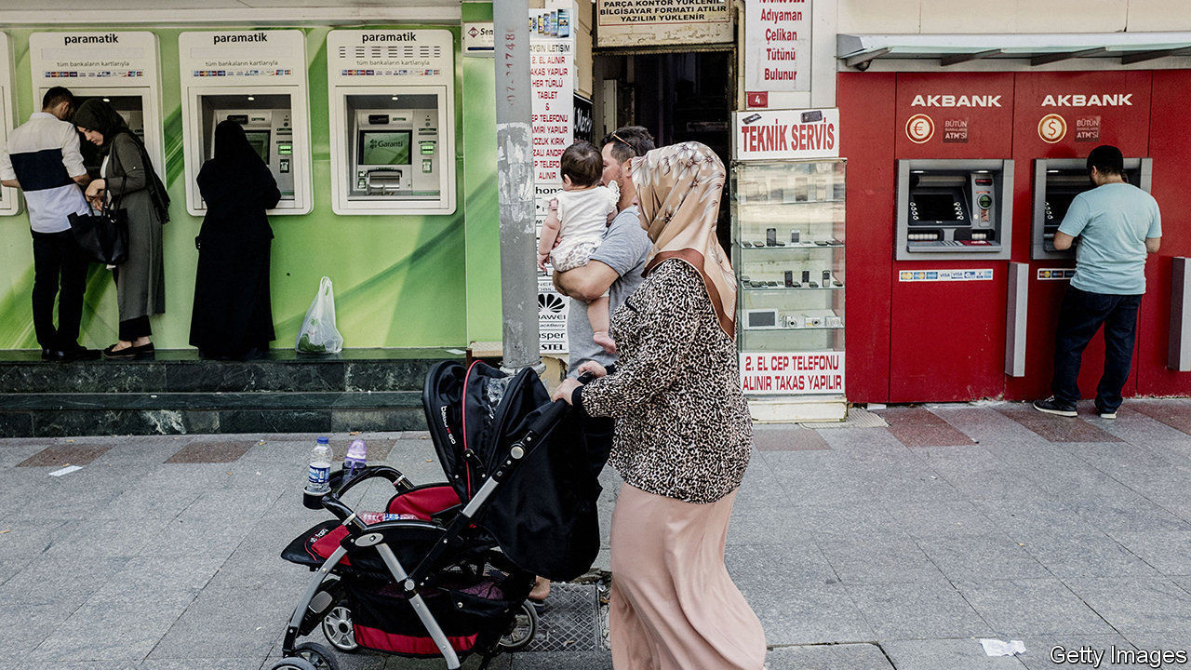

POLICYMAKERS IN emerging markets frequently complain that foreign capital is fickle. But foreign capital could be forgiven for having a similar gripe about emerging markets. On a conference call on May 6th Turkey’s finance minister, Berat Albayrak, was solicitous and reassuring, telling nervous overseas investors that the country’s dollar reserves were adequate and its commitment to market principles was firm. But the next day the banking regulator turned cold, reprimanding three foreign banks, BNP Paribas, UBS and even Citigroup, which helped host the call, for failing to meet their lira obligations on time. As punishment, it barred them from the country’s currency market. Four days later, the mood changed and the ban was lifted.

These shifts in official demeanour, from hospitality to hostility to something in between, all reflect a consistent concern about the currency. The lira has lost about 15% of its value against the dollar so far this year, the most among big, commodity-importing emerging markets. In trading on May 7th it briefly weakened to 7.27 against the dollar, beyond the point it reached in August 2018, after America imposed sanctions on Turkish officials in retaliation for the detention of an American pastor.

To stop the lira’s slide, regulators have tightened limits on the amount of lira local banks can provide to foreign financial institutions, making it harder for foreigners to bet against the currency. And they have imposed new restrictions on the spread of “misleading or wrong information” in financial markets. “They want to discourage people from talking about these issues,” says Mustafa Sonmez, an economist. People are “not to criticise”. He ought to know. He and dozens of others, including two Bloomberg journalists, were indicted last year on charges of seeking to “destabilise the economy” during the 2018 crisis.

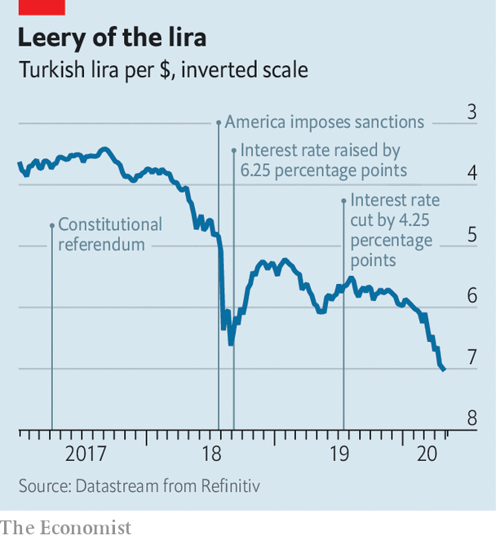

The authorities have intervened in more conventional ways as well. GlobalSource Partners, a consultancy, estimates that the central bank, often acting through the state banks, has burned through roughly $35bn in foreign reserves this year trying to prop up the lira. How much more it can spend is a matter of controversy. The country’s “gross” foreign assets (including gold) stood at over $87bn on May 12th. But on the other side of its balance-sheet, the central bank reports foreign liabilities worth $71.3bn. It has also entered into currency swaps with local lenders, obtaining dollars in exchange for lira on the condition that the transaction will be reversed in due course. Deduct those borrowed dollars from the total, and its net reserves have dipped below zero.

Officials say they are seeking additional swap lines from foreign central banks. The country already has an arrangement with China (worth $1bn) and another with Qatar (worth $5bn). But it has little hope of obtaining a similar agreement with America’s Federal Reserve. A Fed policymaker recently pointed out that its swap lines are limited to countries that enjoy “mutual trust” with America. The feelings that now prevail between Turkey and America are probably mutual, but hardly trustful.

Turkey bounced back from the 2018 currency crisis by belatedly raising interest rates (and releasing the pastor). But the central bank’s boss was fired last year by the country’s president, Recep Tayyip Erdogan, who has governed with little restraint since winning new powers in a referendum in 2017. To revive growth and restore the president’s popularity, the new central-bank governor has cut rates to 8.75%, more than two percentage points below the rate of inflation. “When you have a negative real interest rate, that is not a recipe for currency stability anywhere,” says Paul McNamara of GAM, an asset manager.

The country has thus tried to strengthen growth, at the expense of weakening the currency. And it has tried to fortify the currency—but at the expense of weakening the banks, which will eventually need some of their dollars back if they are to meet their own foreign-currency obligations, points out Brad Setser of the Council on Foreign Relations, a think-tank.

Turkey should “abandon this strategy”, says Piotr Matys, a currency strategist at Rabobank. “The most rational move would be to let the lira float freely and publish a package of reforms, ideally overseen by the IMF.” There is but one problem. Mr Erdogan wants nothing to do with the IMF. On that, he has been far from fickle. ■

This article was downloaded by calibre from <https://www.economist.com/finance-and-economics/2020/05/16/turkeys-defence-of-the-lira-has-been-unwise-and-ineffective>

|  |  |  |  |
| --- | --- | --- | --- |
| Previous | Articles | Sections | Next |

|  |  |  |  |
| --- | --- | --- | --- |
| Previous | Articles | Sections | Next |

#### Feuding over funds

# America files a new financial salvo at Beijing

The White House seeks to stop a government pension fund investing in China

May 14th 2020 |

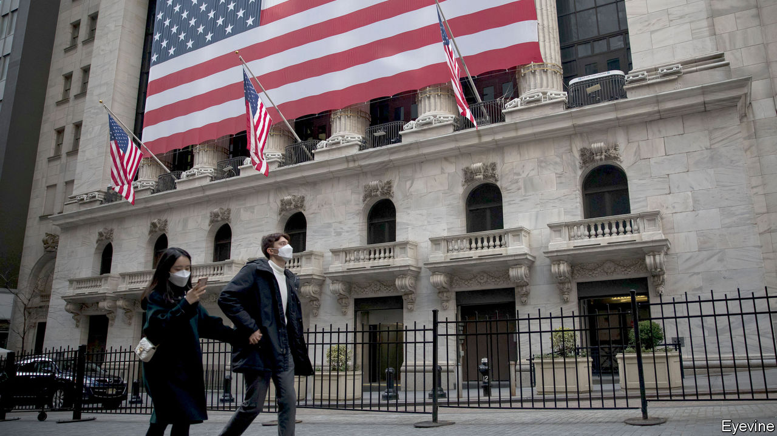

Editor’s note: The Economist is making some of its most important coverage of the covid-19 pandemic freely available to readers of The Economist Today, our daily newsletter. To receive it, register [here](https://www.economist.com/newslettersignup). For our coronavirus tracker and more coverage, see our [hub](https://www.economist.com/coronavirus)

LAST SEPTEMBER a leak suggested that Donald Trump’s administration was mulling steps to rid American exchanges of Chinese firms and force investors to dump stocks listed in mainland China. The share prices of Alibaba, an e-commerce giant, and Baidu, a search engine, slid. So did the yuan. Within a day, however, the government denied having such plans, calling them “fake news”. Insiders say “old-school” Republicans on Capitol Hill, who favour free markets, prevailed over the president’s jingoistic entourage. Markets sighed in relief.

This week, though, the rhetoric was amplified. On May 11th administration officials urged the independent board overseeing the Thrift Savings Plan (TSP), the government’s main pension fund, worth $600bn, to freeze plans to invest in Chinese firms. Investors’ money, they argued, would be at risk if the firms were to be later whacked with American sanctions punishing China for its alleged culpability in allowing the coronavirus to spread. Defence hawks argue that the pension fund risks investing in firms that supply China’s military and surveillance services. Beijing reacted furiously, saying that restrictions would only hurt America’s interests.

The amounts immediately at stake are small. TSP’s guardians had planned to start investing part of the money it earmarks for foreign investment—some $40bn—into funds that track an index that includes some China-based stocks in the second half of this year. Markets mostly shrugged off the news.

The measure is, however, belligerent. It is America’s first serious attempt to limit investment in Chinese firms. Intent on “financial decoupling”, Washington seems ready to explore “all avenues”, says Eswar Prasad of Cornell University. Tariffs already make it less palatable for American companies to invest directly in China, since repatriating goods made there is costlier.

Discouraging investors from holding Chinese stocks would put portfolio flows at risk. And there is a lot of money at stake. Chinese firms have raised over $336bn on American venues since 2000, and another $81bn through initial public offerings (see chart). Their total market capitalisation in New York is close to $1.1trn, about the same as China’s holdings of Treasuries. American portfolio holdings in China amount to $150bn. Before the latest announcement, that seemed likely to pick up: the weight of Chinese stocks listed on the mainland and abroad in the MSCI Emerging Markets index, a popular benchmark, has risen from 30.5% two years ago to nearly 40% today.

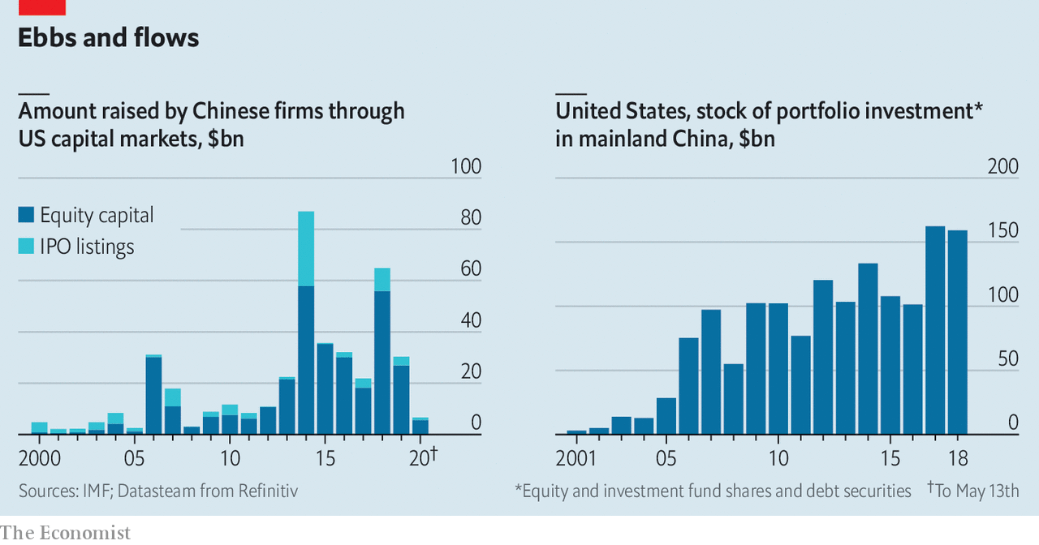

Tensions are already affecting sentiment, says Ivy Wong of Baker McKenzie, a law firm. Chinese firms wanting to list in New York are more tentative in their preparations. Some listed in America, such as Alibaba and JD.com, are already turning to Hong Kong to issue new shares. But it is unclear whether the White House can legally ban investors from buying Chinese stocks. It could force Chinese firms to delist from America, but that, says a lawyer, would “traumatise” markets. It could make life so difficult for firms that they volunteer to relist elsewhere—but the dire economic situation makes this risky too.

Another difficulty is that most Chinese firms listed in America are not actually Chinese, but are legally domiciled in offshore centres and use “variable-interest entities” (VIEs). These have contractual rights over part of the revenue or profit generated by mainland firms, which own the assets and intellectual property. An American ban on Chinese companies might fail to reach VIEs; but a broader legal net could risk ensnaring the Chinese arms of American multinationals.

A forceful attack would also have unintended effects. It would prevent American investors from earning good returns on fast-growing Chinese stocks. Delisting firms in haste could mean savers lose, if share prices tumble. Discouraging Chinese companies from listing in America would have costs too. Wall Street banks would lose the fat fees they make helping Chinese companies list, says Hao Zhou of Commerzbank, a German lender.

There are good reasons to demand more scrutiny of Chinese firms listed in New York: some are exempted from the same level of reporting as American peers. (This week Luckin Coffee, a Chinese firm listed in New York through a VIE, sacked its bosses amid an accounting scandal). But the best way to uncover, if not deter, fraud may be to keep firms in the system, rather than driving them away, says Matthew Doull of Wedbush Securities, an investment firm.

Washington has made its first move but it may be unwilling to do much more. The Securities and Exchange Commission, America’s markets watchdog, wants better disclosure but may be less keen on outright financial warfare. Jay Clayton, its boss and a former capital-markets lawyer, advised Alibaba on its VIE when it listed in New York in 2014. ■

This article was downloaded by calibre from <https://www.economist.com/finance-and-economics/2020/05/14/america-files-a-new-financial-salvo-at-beijing>

|  |  |  |  |
| --- | --- | --- | --- |
| Previous | Articles | Sections | Next |

|  |  |  |  |
| --- | --- | --- | --- |
| Previous | Articles | Sections | Next |

#### Lane speaking

# How to fight an economic crisis in a monetary union

Philip Lane, the ECB’s chief economist, lays out his framework

May 16th 2020 |

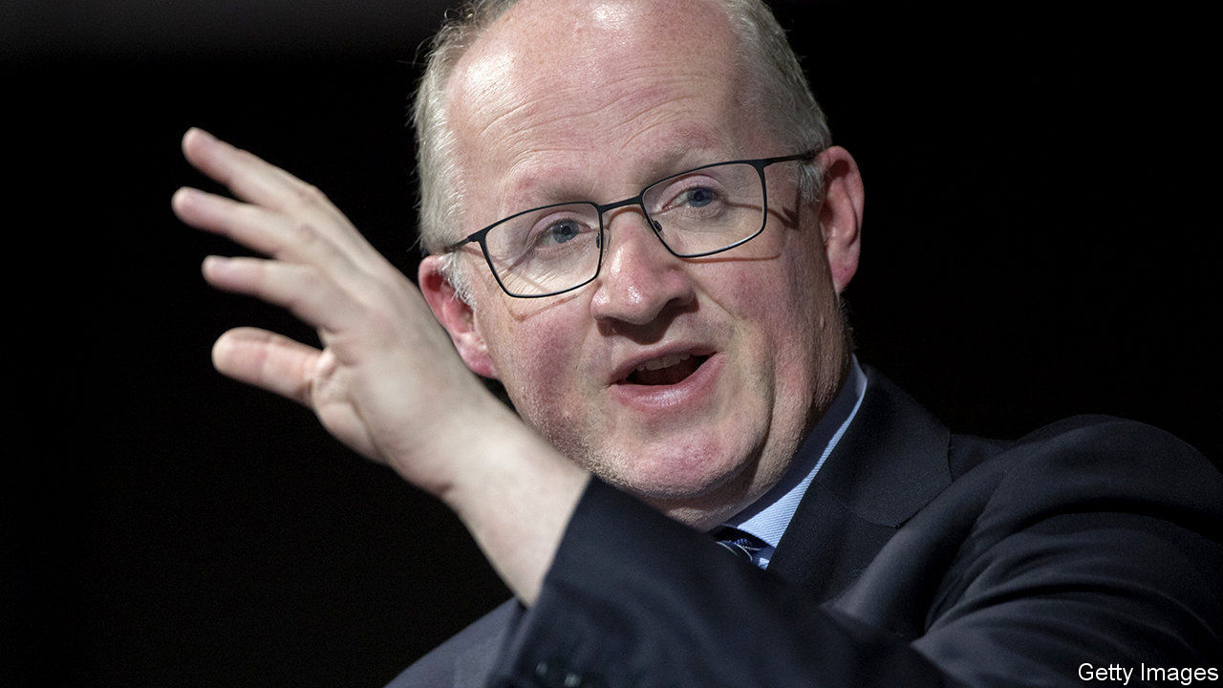

Editor’s note: The Economist is making some of its most important coverage of the covid-19 pandemic freely available to readers of The Economist Today, our daily newsletter. To receive it, register [here](https://www.economist.com/newslettersignup). For our coronavirus tracker and more coverage, see our [hub](https://www.economist.com/coronavirus)

WHEN PHILIP LANE joined the European Central Bank (ECB) nearly a year ago, he hardly expected to be fighting off the economic effects of a pandemic. The bank’s preoccupations back then seem quaint now. The euro area’s economy was sputtering and the ECB was forecasting a growth rate of 1.4% for 2020. Now Mr Lane, the bank’s chief economist, speculates that GDP might fall by 5-12% this year.

Like other central banks, the ECB has cooked up an alphabet soup of schemes—including the Pandemic Emergency Purchase Programme (PEPP), which will buy bonds worth €750bn ($815bn). Unlike other rich-world banks, though, the ECB must fend off suspicions that it cannot act freely. On May 5th Germany’s constitutional court ruled that the Bundesbank would have to stop participating in the ECB’s five-year-old quantitative-easing scheme unless it is shown to be “proportionate”. Some fear the PEPP could face a legal challenge next.

Christine Lagarde, the bank’s president, has vowed that it is “undeterred” by the ruling. It could probably pass the court’s test, but may not wish to accede to a national court. The row makes its credibility with investors paramount. Ms Lagarde is neither an economist nor an experienced central banker, so it falls to Mr Lane to provide the technical underpinning for that credibility. He puts forward policies and develops the ECB’s intellectual framework.

The Irishman has all the credentials he needs. As an academic in America and Ireland, the Harvard-trained economist studied cross-border capital flows, which were at the root of the euro area’s sovereign-debt crisis in 2010-12. He was part of a circle of wonks proposing ways to fix flaws in the euro’s architecture. As governor of Ireland’s central bank from 2015 to 2019, he made policy too. His experience and his understated style, say colleagues, give his arguments greater force. (It might help that his accent has become familiar over time.)

The job of central banks in the crisis is to ensure that the conditions for a recovery are in place, and to stabilise panicking markets. Mr Lane identifies an extra role for the ECB, as the central bank of a monetary union: to avoid an “unwarranted” tightening in financial conditions resulting from investors dumping riskier (eg, Italian) government debt for safer (eg, German) bonds. The flight to safety, first analysed by Mr Lane and others during the debt crisis, is what the PEPP now tries to tackle. It makes purchases “flexibly”, rather than in rough proportion to each member country’s GDP, as the ECB’s other schemes do.

A flight to bunds would also be averted if debt were jointly backed by member states. In 2018 a group of advisers, led by Mr Lane, recommended the use of sovereign-bond-backed securities to the European Commission. Joint issuance is back on the table as members discuss how to fund the recovery. But with northern states still reluctant to share risks, it seems unlikely. So it falls to the ECB to avert panic.

When Ms Lagarde said in March that it was not the ECB’s job to close spreads, investors took fright. But Mr Lane defends the sentiment. Eliminating spreads is not the aim: “Market discipline operates in the euro area.” It is a point of satisfaction that the ECB’s bond-buying over the years has pushed down risk-free rates, but that differentiation between members remains.

Modest levels of spreads may be desirable, but not huge gaps. Debt-laden Italy and Spain have been hit hard by the virus, but have spent relatively little on stimulus. What if they lose access to markets? If countries face solvency trouble, says Mr Lane, other tools must kick in—eg, the euro area’s bail-out fund. That could help to unlock unlimited bond purchases by the ECB.

Higher public debt will be a feature of the post-pandemic landscape. Cautious households will probably save more, providing demand for that debt. The rich world will start to resemble Japan. Low inflation may not persist, though. In the near term, Mr Lane says, the pandemic is “surely disinflationary”. But he reserves judgment on the long term. Shorter supply chains could push up inflation. Lots of firms could go bust, handing survivors pricing power.

For now, the incentives of monetary and fiscal authorities align neatly. With policy rates at or below zero, central banks are devising new ways to lower borrowing costs. That suits governments, which are issuing vast quantities of debt to fund stimulus. Expect a clash, though, when central banks decide raise interest rates. You could imagine politicians in America or Britain appointing a pliable central-bank head. That is less likely in the euro area, argues Mr Lane, where “19 sovereigns watch each other”. But, as Germany’s judges have revealed, the institutional environment in which the ECB operates is all too messy. It is just as well that Ms Lagarde is a former politician and a lawyer. Economics will only get you so far. ■

Dig deeper:  
For our latest coverage of the covid-19 pandemic, register for The Economist Today, our daily [newsletter](https://www.economist.com/newslettersignup), or visit our [coronavirus tracker and story hub](https://www.economist.com/coronavirus)

This article was downloaded by calibre from <https://www.economist.com/finance-and-economics/2020/05/16/how-to-fight-an-economic-crisis-in-a-monetary-union>

|  |  |  |  |
| --- | --- | --- | --- |
| Previous | Articles | Sections | Next |

|  |  |  |  |
| --- | --- | --- | --- |
| Previous | Articles | Sections | Next |

#### Free exchange

# Why the pandemic could eventually lower inequality

History suggests it could precipitate shifts towards a more equal income distribution

May 16th 2020 |

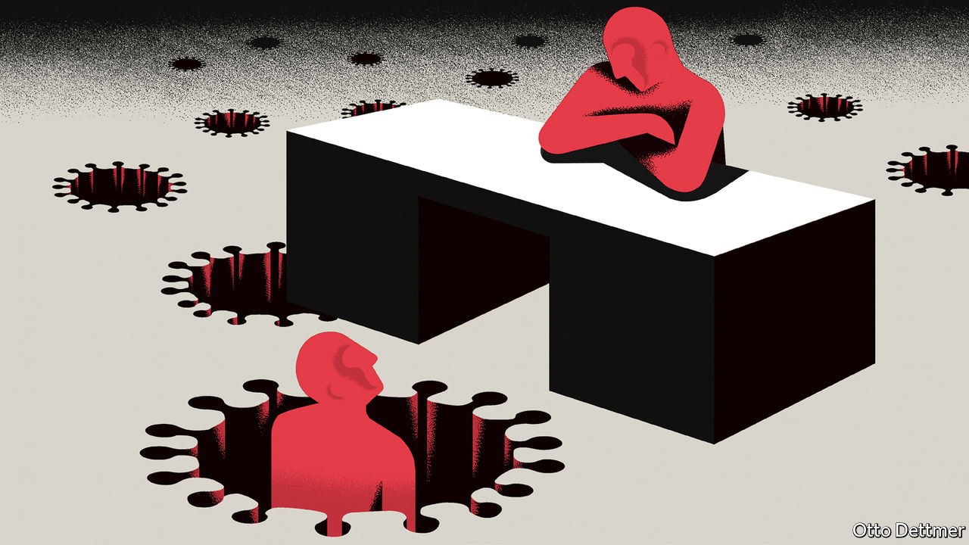

Editor’s note: The Economist is making some of its most important coverage of the covid-19 pandemic freely available to readers of The Economist Today, our daily newsletter. To receive it, register [here](https://www.economist.com/newslettersignup). For our coronavirus tracker and more coverage, see our [hub](https://www.economist.com/coronavirus)

FOR AMERICA’S poor, the covid-19 pandemic has delivered a swift and brutal reversal of fortune. At the start of the year unemployment was plumbing new lows. Years of wage growth for low-income workers had healed some of the scars left by the global financial crisis. Already by 2016, the most recent year for which figures are available, the economic expansion had produced a smaller rise in American income inequality, after taxes and transfers, than any expansion since the early 1980s. Between 2016 and 2019 the weekly earnings of low- and middle-income workers grew at an annual average pace of 3.8%. Since covid-19 struck, however, a host of economic statistics—and legions of pundits—have pointed to a resurgence in inequality. Yet if history is a guide, the pandemic could eventually render the distribution of income more egalitarian.

There are many reasons why the well-heeled might suffer less in the pandemic. Much of the plunge in asset prices that occurred in March has since been retraced. In places like New York City and Los Angeles, covid-19 seems to have hit poorer neighbourhoods harder. Low-wage earners are often less able to work from home or maintain social distancing. Interruptions to schooling widen the gaps in achievement between children from richer backgrounds and those from poorer families.

Meanwhile, workers on the lower rungs of the income ladder have borne the brunt of job losses. America’s unemployment rate rose by roughly ten percentage points, to 14.7%, in April—the highest since the Depression. The jobless rate for workers with a college education went up by nearly six percentage points, to 8.4%; that for workers without a high-school diploma leapt by just over 14 percentage points, to 21.2%. A new paper published by the Becker Friedman Institute at the University of Chicago reinforces the point. Between February and April, find its authors, employment among workers in the top fifth of the income distribution dropped by 9%. In the bottom fifth, by contrast, it plunged by 35%.

Were the crisis of unemployment to end as swiftly as it began, the effects of these uneven job losses on inequality would be limited, and fleeting. Many jobless workers are earning more in unemployment benefits than they did on the job, thanks to a top-up of $600 per week enacted by Congress in March. Of the more than 20m Americans who were out of work in April, 78% were reported to be temporarily laid off. But the danger is that temporary job losses become permanent. The authors of the Becker Friedman paper calculate that active employment—or the number of workers counted on payrolls—declined by 14% between February and April. About 40% of that fall occurred at firms that had ceased operations, at least temporarily. Not all will reopen. A new working paper by Jose Maria Barrero of Instituto Tecnológico Autónomo de México, Nicholas Bloom of Stanford University and Steven Davis of the University of Chicago is similarly gloomy, concluding that 42% of pandemic-related job losses will be permanent. Meanwhile, the crush of claimants has overwhelmed some state governments and slowed the flow of unemployment aid. Top-up benefits are due to expire in July, when millions will still be jobless.

The most vulnerable workers are therefore likely to be squeezed hard by the recession. But if history is a guide, those at the top of the income distribution could yet face a reckoning. Disruptive global events have often precipitated shifts towards a more equal distribution of income and wealth. In his influential book, “Capital in the Twenty-First Century”, Thomas Piketty points out that high levels of inequality in the late 19th and early 20th centuries were reduced by the calamitous events of the period from 1914 to 1945. In that time the share of income earned by America’s top 1%, for instance, dropped from 19% to 14%. The combination of depression, war, inflation and taxes compressed incomes and laid waste to vast fortunes. Walter Scheidel, a historian, goes further still in his book on long-run inequality, “The Great Leveller”. Since antiquity, he argues, only four forces have ever managed to reduce inequality in a sustained way: war, revolution, state failure and pandemic. (The troubles often coincide: a pandemic contributed to the failure of the Roman empire; another coincided with the end of the first world war.)

Past crises are a far cry from today’s difficulties. The Black Death compressed income gaps by dramatically reducing the ratio of workers to arable land. Even in the worst possible case, covid-19 will kill far fewer than the 30-60% of Europeans felled by bubonic plague. Stockmarkets could plunge again, but it is very unlikely that they will match the collapse of nearly 90% that took place between 1929 and 1932. Yet some comparisons can still be made. The debts racked up by governments during this pandemic will in some cases reach heights last seen during the world wars. When governments eventually balance the books—and especially if they reduce debt burdens via taxation, financial repression or debt restructuring—the wealthy could find themselves footing the bill.

## Time for a redeal

Furthermore, the crisis could have indirect effects that influence the trajectory of inequality. In a critique of Mr Piketty’s arguments published in 2017 Marshall Steinbaum, now of the University of Utah, argued that the wars and the Depression of the 20th century mainly led to greater egalitarianism by discrediting ruling elites and the regressive policies that had enabled the rises in inequality in the first place. That created space for social democracy to bloom. Inequality fell not only because of higher taxes but also because of extensions to the welfare state.

History need not repeat itself. Governments and economic systems of all kinds have struggled to manage the pandemic effectively and equitably. But it does not take much imagination to see that if politicians allow the costs of the pandemic to be borne unequally they could sow the seeds of a transformative populist backlash. They would do well to heed the lessons of the past. ■

Dig deeper:  
For our latest coverage of the covid-19 pandemic, register for The Economist Today, our daily [newsletter](https://www.economist.com/newslettersignup), or visit our [coronavirus tracker and story hub](https://www.economist.com/coronavirus)

This article was downloaded by calibre from <https://www.economist.com/finance-and-economics/2020/05/16/why-the-pandemic-could-eventually-lower-inequality>

|  |  |  |  |
| --- | --- | --- | --- |
| Previous | Articles | Sections | Next |

|  |  |  |
| --- | --- | --- |
| Finance & economics | Sections | Science & ... |

Schools brief

Bad times: The widespread damage from climate change

.

|  |  |  |
| --- | --- | --- |
| Finance & economics | Sections | Science & ... |

|  |  |  |  |
| --- | --- | --- | --- |
|  | Articles | Sections | Next |

#### Bad times

# Damage from climate change will be widespread and sometimes surprising

It will go far beyond drought, melting ice sheets and crop failures

May 16th 2020 |

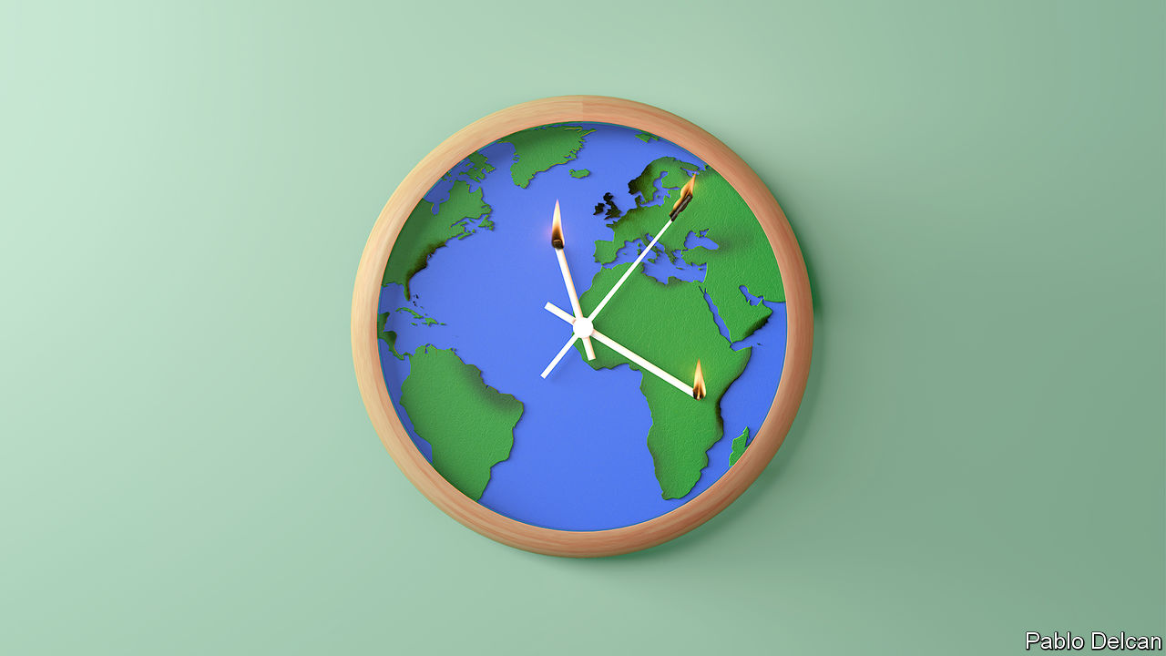

Editor’s note: This is the fourth in a series of climate briefs. To read the others, and more of our climate coverage, visit our hub at [economist.com/climatechange](https://economist.com/climatechange)

ON NOVEMBER 21ST 2016, a line of thunderstorms passed through the Australian state of Victoria. By the end of the following day, it had sent 3,000 people to hospital. Storms typically hurt people by blowing down buildings, flooding streets or setting fires. In this case, though, the casualties were caused by asthma. Late that afternoon a peculiarly powerful downdraft generated by the storm front pushed a layer of cold air thick with pollen, dust and other particles through Melbourne. The city’s ambulance service was swamped within hours. At least ten people died.

The risks that weather and climate pose to human life are not always as specific to the peculiar circumstances of time and place as that sudden-onset asthma epidemic. But they are complex functions of what, where and who, and their mechanisms are not always easily discerned. What is more, they can interact with each other. For example, if the southern spring of 2016 had not brought weather particularly well suited to the growth of allergenic grasses, would that stormy afternoon have been so catastrophic? Such complexities mean that a gradual change to the climate can lead to sudden changes in the impacts on human beings when things pass a certain threshold. And that threshold will not necessarily be discernible in advance.

Not all the ways in which today’s weather harms people will be exacerbated by climate change. But research suggests that many of them will. Most of the problems people have with weather and climate come from extremes. When means shift a little, extremes can shift a lot (see chart). Today’s rare extremes become tomorrow’s regular disturbances; tomorrow’s extremes are completely new.

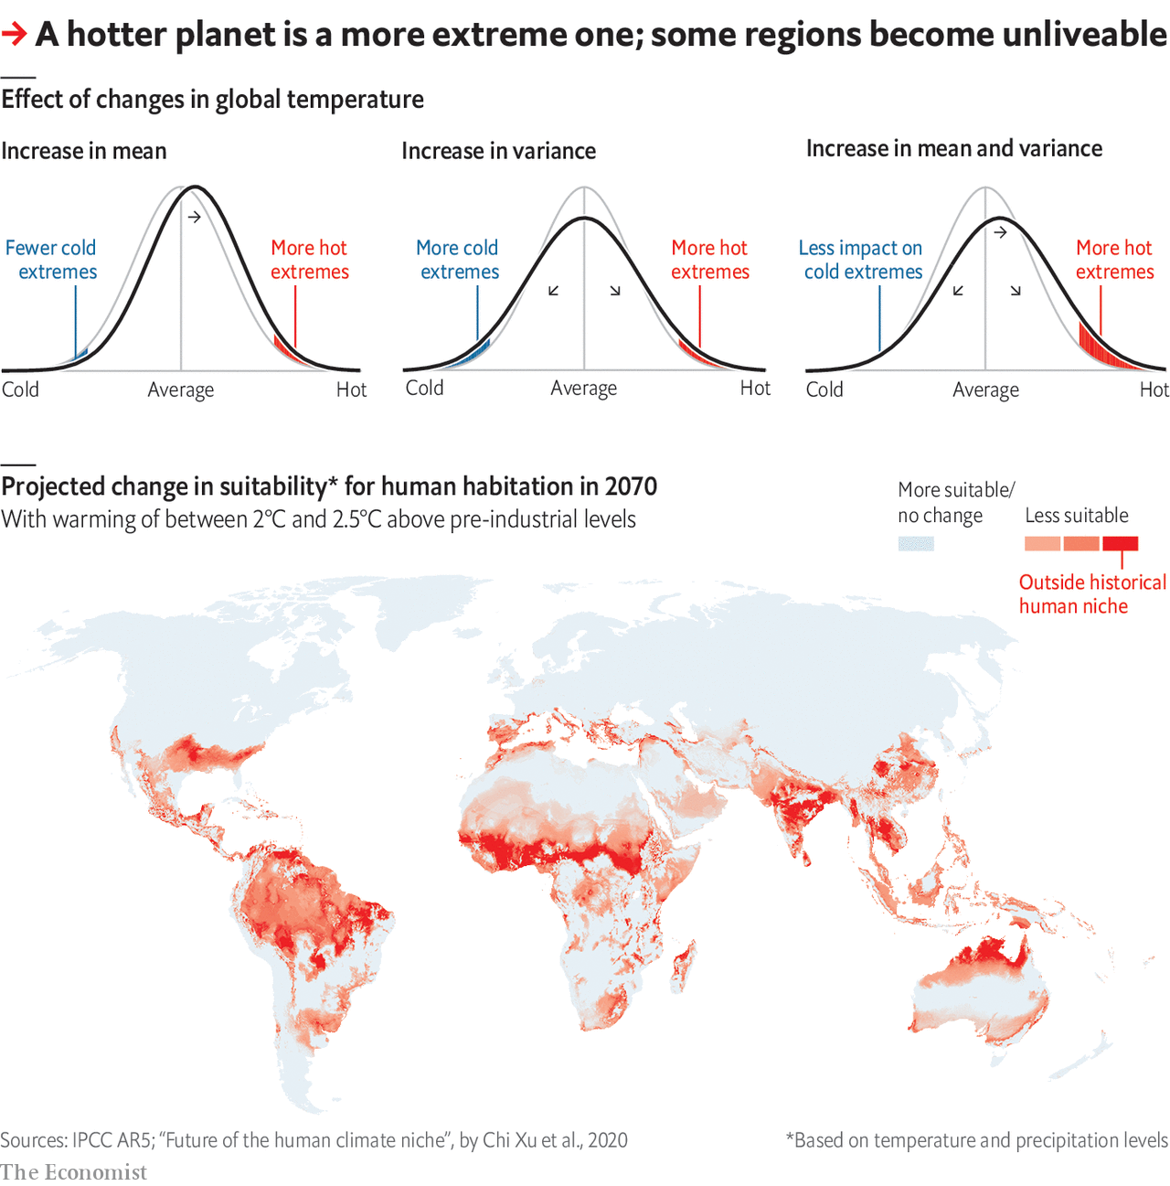

How damaging these impacts will be to the economic and physical welfare of humankind depends on how much warming takes place and how well people adapt—both of which are currently unknowable. But it is possible to get a qualitative sense of what they could mean by looking at the range of timescales over which they operate. At one end, a thunderstorm’s pollen surge, sweeping by in minutes; at the other, sea-level rise which could last longer than any civilisation in human history.

In terms of short-lived events, the worst sort of bad day that the world’s weather can offer is generally taken to be the one on which you get hit by a tropical cyclone, which is why hurricanes (as they are known in the Atlantic) and typhoons (as they are known in some other places) have become so heated a part of the arguments about climate change. A single hurricane can do more than $100bn in damage, as Harvey did when it hit Houston in August 2017, or kill thousands, as Maria did the following month in Puerto Rico.

Tropical cyclones can only form over a sea or ocean with a surface temperature of 27°C or more. The area where such temperatures are possible will definitely increase with warming. But that does not mean hurricanes will become more common. Their formation also requires that the wind be blowing at a similar speed close to the surface and at greater altitudes—and this condition, models say, will become less common in future over many of the places where hurricanes spawn. Thus models do not predict a great increase in the number of tropical cyclones; Atlantic hurricanes may well become more rare.

But more heat in the oceans means that those tropical cyclones which do get going are more likely to become intense. There is thus broad agreement among experts that the proportion of hurricanes which reach category four or five looks set to increase. So, too, does the rainfall associated with them, because warmer air holds more moisture. Studies of the flooding caused by Hurricane Harvey suggest that warming due to climate change increased its rainfall by about 15%. Extreme rainfall events of many sorts increase in warmer worlds.

The heat which powers hurricanes at sea can, on land, kill directly. Humans cool themselves by sweating, a process that becomes less effective the more humid the atmosphere. Combining the heat and the humidity into something called the wet-bulb temperature (WBT) allows scientists to measure temperatures in a way that reflects that difficulty (similar measures in America are called the heat index). WBTs of 35°C and above are lethal.

Until recently it was thought that WBTs that high would not be seen until warming had continued for decades. A review of weather-station data from 1979 on, however, shows that for very brief periods local WBTs almost that high are already being experienced occasionally in South-East Asia, the Persian Gulf and the coastal south-west of America, and that their frequency had doubled since 1979. With 2.5°C (4.5°F) of global warming above pre-industrial levels, which is quite possible in the second half of this century if action on emissions is not significantly increased, these unliveable conditions will become a regular occurence in parts of the humid subtropics.

Another recent study defines climates which people find liveable according to where, historically, they have lived, and then sees which such areas move beyond those climatic bounds as the world warms. Temperature rises quite plausible by 2070 would see many areas where people live today develop climates unlike any that people have lived in before (see map). Some econometric analyses based on interannual differences suggests that, in general, higher temperatures lead to lower labour productivity and more violence.

In the nearer term, there is an increased likelihood of heatwaves. Between August 3rd and 16th 2003, Europe saw 39,000 more deaths than would have been expected on the basis of previous years. The excess mortality was due to a summer that was hotter, by some estimates, than any for the previous 500 years. Modelling suggests that, even in 2003, climate change had made such a heatwave at least twice as likely.

Extreme heatwaves are becoming more frequent not only because temperatures are climbing. Warming-induced changes in the climate system can weaken the processes that normally move weather around the world, allowing conditions to get stuck. Such stalling can be the difference between a hot week and a lethal month, or in winter a cold snap and a deep freeze.

## Springtime and harvest

Hot summers can also harm crops, both directly—many important crops are very sensitive to temperatures above a certain threshold—and through water stress. Milder winters can also do harm by allowing pests to survive, hurting yields.

When unusually hot and dry conditions suck the moisture off the land, the subsequent droughts do not just exacerbate the problems for farmers. They also increase the risk and severity of fires—which an increase in the amount of lightning will, in some regions, spark off more frequently. This is an issue not just in warm, fire-prone places such as Australia. For several months in the summer of 2019, large swathes of northern Russian and Canadian forest—and even some of Greenland’s few woodlands—went up in flames.

Unusual infernos have plagued California for many years now, again as a result of parched conditions, which are drying out rivers, lakes and underground aquifers across the entire south-west of the state. This is no regular drought. It is 19 years in the making, enough for it to be classed as a “megadrought”.

Tree-ring records show only four such in the region over the past 1,200 years, and suggest that this could be as bad as the worst of them, which took place in the 17th century. Such droughts are linked to changing patterns of circulation in the ocean. Models suggest that such patterns are themselves altered by warming, which can thus change the frequency of other large-scale regional shifts in the climate.

And then there is the longest term change: sea level. The sea’s rise comes from three different mechanisms—the expansion of the oceans as they absorb more heat, the addition of meltwater from shrinking glaciers on land, and the physical break down of ice sheets such as those on Antarctica and Greenland. The first two factors are currently driving an increase of about 1cm every three years, and are set to do so at a similar rate well into the 21st century even if global warming is held well below 2°C; the time it takes seawater to warm up gives the process a significant inertia. Such rises will erode coasts and increase flooding—especially when pushed inland by the surges intense storms produce.

The big unknown, though, once you get to the century time scale, is the stability of the great ice sheets. It is widely believed that there are points of no return after which such sheets are doomed slowly to collapse, thus increasing sea levels by many metres. Where these points of no return are is not clear. It is possible that they might be passed even if warming is kept to 1.5°C above the pre-industrial.

A high likelihood of drought and crop failures; changes to regional climate that upset whole economies; storms more destructive in both their winds and their rains; seawater submerging beaches and infiltrating aquifers: what is known about the impacts of climate change is already worrying enough. The known unknowns add to the anxiety. It is not just the question of the ice sheets, an uncertainty massive enough to weigh down a continent. There are other tipping points, too, which could see ocean currents shift, or deserts spread. And in the spaces between all these troubles are the unknown unknowns, as surprising, and deadly, as a thunderstorm that kills through pollen.■

Sign up to our fortnightly climate-change newsletter [here](https://www.economist.com/theclimateissue/)

Dig deeper:  
Climate brief 1: [Why tackling global warming is a challenge without precedent](https://www.economist.com/schools-brief/2020/04/23/why-tackling-global-warming-is-a-challenge-without-precedent)Climate brief 2: [How modelling articulates the science of climate change](https://www.economist.com/schools-brief/2020/05/02/how-modelling-articulates-the-science-of-climate-change)Climate Brief 3: [Humanity’s immense impact on Earth’s climate and carbon cycle](https://www.economist.com/schools-brief/2020/05/09/humanitys-immense-impact-on-earths-climate-and-carbon-cycle)[The Economist’s climate-change hub](https://economist.com/climatechange)

This article was downloaded by calibre from <https://www.economist.com/schools-brief/2020/05/16/damage-from-climate-change-will-be-widespread-and-sometimes-surprising>

|  |  |  |  |
| --- | --- | --- | --- |
|  | Articles | Sections | Next |

|  |  |  |
| --- | --- | --- |
| Schools brief | Sections | Books & arts |

Science & technology

Health data and privacy: Looking without looking

.

Protecting great apes from covid-19: Maintaining other species’ barriers

.

Wirelessly charging electric cars: It’s time to cut the cord

.

Industrial standards: Shear, veer, cheer

.

|  |  |  |
| --- | --- | --- |
| Schools brief | Sections | Books & arts |

|  |  |  |  |
| --- | --- | --- | --- |
|  | Articles | Sections | Next |

#### Health data

# The pandemic has spawned a new way to study medical records

It preserves confidentiality while liberating useful information

May 14th 2020 |

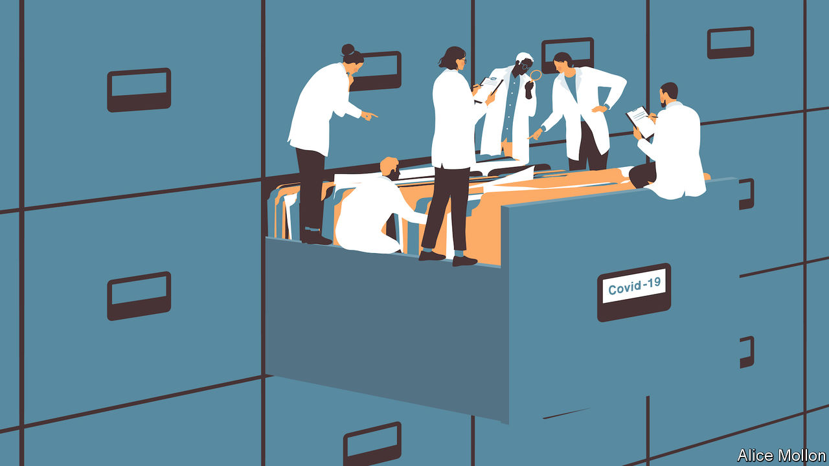

Editor’s note: The Economist is making some of its most important coverage of the covid-19 pandemic freely available to readers of The Economist Today, our daily newsletter. To receive it, register [here](https://www.economist.com/newslettersignup). For our coronavirus tracker and more coverage, see our [hub](https://www.economist.com/coronavirus)

ON MAY 7TH an article appeared on medRxiv, an online repository for medical research. It showed, for England at least, the degrees to which SARS-CoV-2, the virus that causes covid-19, discriminates in its deadliness between various groups of people. Men are more likely to die than women. The old and the socially deprived more likely than the young, well-off and well-connected. Those with uncontrolled diabetes or severe asthma, more likely than those without. And members of the country’s ethnic minorities more likely than those of its white majority.

None of these, even the first (for men are more vulnerable than women to quite a wide range of infections), is exactly a surprise. Even the finding that current smokers actually have a lower risk of death from the illness than do non-smokers, though superficially arresting, is in line with the results of other studies that used different methods—though a possible protective effect on asthma patients of steroid inhalers looks worth following up. But the actual results of this study are not really the remarkable thing about it. That, according to its lead author Ben Goldacre, a clinician and data scientist at the University of Oxford, is the method of analysis by which they were obtained. Instead of extracting sensitive patient records from the databases of the company which manages them on behalf of general practitioners (GPs, Britain’s network of family doctors), the team behind the paper developed a suite of software that lets them run their massive analysis on the data in situ.

The research was carried out by studying the medical records of some 17m people on the books of GPs in England and the 5,683 covid-attributable deaths therein. GPs are the first port of call in England’s National Health Service (NHS) for any non-emergency matter, and thus hold the most complete records of patients’ health. Studying these at this scale and degree of detail, with individual records linked up to causes of death, has never been done before. Merely making plans to meddle with such primary-care data has been a cause of great national concern in Britain in the past. Dr Goldacre’s research was possible only because of the incentives created by the pandemic, and the ingenuity of the group of epidemiologists and data scientists he assembled, who call themselves the OpenSAFELY Collective.

## The bottom of a locked filing cabinet

In normal circumstances, merely obtaining permission to look at such a trove of sensitive health data would take months, perhaps years, of jumping through hoops held by ethics committees, computer-security checkers and so on. Running the analysis and getting it published might take months more. These are not, though, normal circumstances, and in fact it took OpenSAFELY a mere 42 days to go from idea to publication.

Three factors made this pace possible. The first is the existence of notices, signed by the country’s health minister, Matt Hancock, which give a wide range of people within the NHS broad licence to have access to and process health data in connection with fighting covid-19. These Control of Patient Information (COPI) notices make it much easier to get data wrangling done. Numerous people close to the government’s digital efforts to fight the disease tell tales of COPI notices being waved in the faces of anyone who offers resistance to a particular data transfer. The OpenSAFELY team was acting on behalf of the NHS, and so had the power of the COPI notice behind its actions, speeding its way.

More important though, was the political heft arrayed under the OpenSAFELY banner. Academic expertise on electronic health records was provided by a team at the London School of Hygiene and Tropical Medicine, renowned for such work. The nitty gritty was covered by the Phoenix Partnership (TPP), a British company which stores, on behalf of GPs, the electronic health records of some 50m people. And Dr Goldacre himself is one of Britain’s foremost medical glitterati. He was once a columnist on a national newspaper and has nigh-on half a million followers on Twitter. His personal brand completed the picture, along with the data scientists and coders at his Evidence-Based Medicine DataLab in Oxford.

## Beware of the leopard

The most important component of OpenSAFELY’s success, though, was its approach to the records themselves. It did not try to copy them, or move them out of TPP’s data centre for processing. Instead, its coders wrote software which let them perform their analysis within that data centre. Even then, Dr Goldacre’s crew were not given free rein to poke around inside TPP’s systems. Instead they wrote a series of programs which let them interrogate the patient records through a secure connection. A log was also kept of all queries that the group ran on the records—thus the watchers were themselves watched.

This combination, not requiring their own copies of a patient’s data and leaving a log of every action they took, made it easier to trust OpenSAFELY. Dr Goldacre’s system has even brought Britain’s fiercest privacy advocates on board. MedConfidential, a group that focuses on the confidentiality of medical records, has stated its support for this approach. “It was designed and built to promote both research and patient confidentiality at the same time, rather than suggesting they’re opposites,” says Sam Smith, one of the group’s co-founders. John Chisholm, who chairs the ethics committee of the British Medical Association, a doctors’ trade union, said that the study contained “hugely valuable information about risk factors” for death from covid-19.

This kind of research, mining medical records for patterns which might help serve the provision of health care, is still in its infancy. But it is most advanced in Britain, for two reasons. The first is that the single medical market of the NHS has created huge patient-record companies like TPP. The second is that the NHS’s norm of GPs being the first point of call for health care means that they have become a catch-all for medical data, and hold the richest, most unified data sets. In China, for instance, people tend to go directly to hospital when they are ill, rather than to visit a GP. Scandinavian countries do have joined-up records, and are often the subjects of medical-research projects for that very reason. But their small, homogenous populations make them less than ideal from a research perspective. The American system, meanwhile, is fragmented across a zillion private providers, though the health care system of the Veterans Affairs department does have a large number of people in a unified arrangement.

For now, therefore, Britain remains ahead. Dr Goldacre says it is “the only country on the planet with the scale of data needed to deliver these analyses”. And new challenges are coming. The team will look at the impacts of covid-19 on children, and the potential protective effect of inhaled steroids. OpenSAFELY is also beginning to work with other health-record firms besides TPP, to extend the range of data available for analysis.

If OpenSAFELY’s approach continues to work as it is extended in this way, others will surely follow suit. Dr Goldacre and his collaborators have made this easy by leaving a trail of tools, in the form of open-source software that can be downloaded free, by anyone, from GitHub, a popular code repository. That code may be tweaked to run any query on any kind of database.

The broad adoption of this methodology would have big implications. Electronic-health-records systems would cease to be mere stores of data, and would start to become active pieces of the infrastructure underpinning medical research, shifting with the needs of science. This would be particularly important for the development of medical artificial-intelligence, which requires large quantities of well curated data in order to learn about ailments with sufficient accuracy.

Covid-19 will not last for ever. The cover of national emergency will eventually pass. Those who wish to study health records in future will need more specific justifications than the sweeping permissions offered by COPI notices. But the OpenSAFELY team has shown that it is possible to get interesting results without copying data and without asking anyone to trust them with a large, sensitive data set. In doing so, they may have made those justifications a little easier to find. ■

Dig deeper:  
For our latest coverage of the covid-19 pandemic, register for The Economist Today, our daily [newsletter](https://www.economist.com/newslettersignup), or visit our [coronavirus tracker and story hub](https://www.economist.com/coronavirus)

This article was downloaded by calibre from <https://www.economist.com/science-and-technology/2020/05/14/the-pandemic-has-spawned-a-new-way-to-study-medical-records>

|  |  |  |  |
| --- | --- | --- | --- |
|  | Articles | Sections | Next |

|  |  |  |  |
| --- | --- | --- | --- |
| Previous | Articles | Sections | Next |

#### The pandemic and wild animals

# Protecting great apes from covid-19

Gorillas are bad at social distancing

May 16th 2020 |

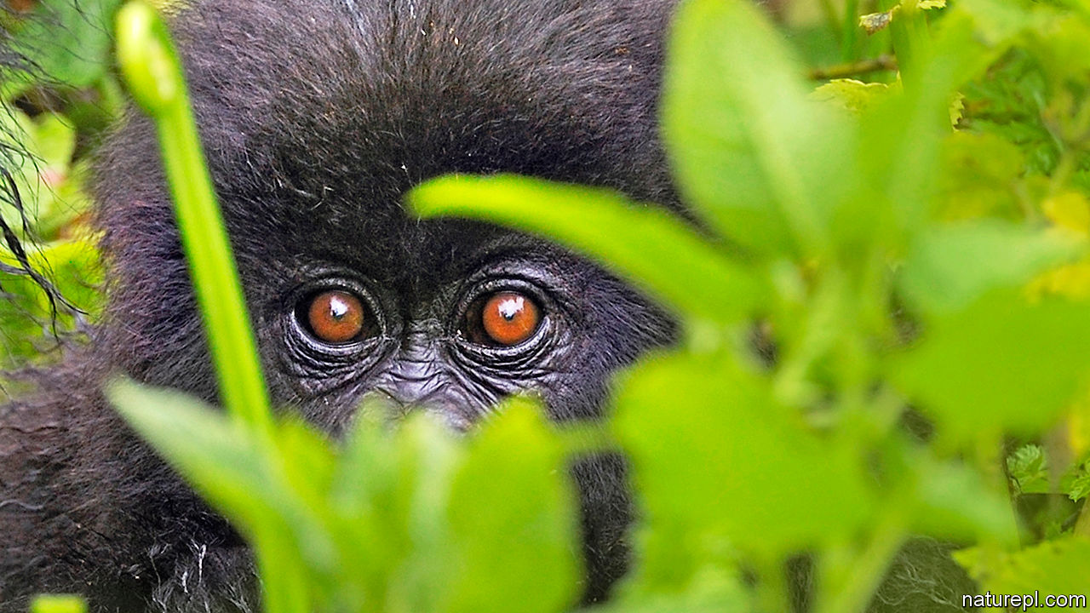

Editor’s note: The Economist is making some of its most important coverage of the covid-19 pandemic freely available to readers of The Economist Today, our daily newsletter. To receive it, register [here](https://www.economist.com/newslettersignup). For our coronavirus tracker and more coverage, see our [hub](https://www.economist.com/coronavirus)

LATE IN 1990, when Paul Kagame was hiding on the Congolese side of the Virunga Mountains preparing to invade Rwanda, his army, the Rwandan Patriotic Front, were not the only formidable inhabitants of that densely forested volcanic range. The Virunga are also home to mountain gorillas. Soldiers are notoriously trigger-happy when it comes to wildlife, but Mr Kagame ordered his men not to shoot the apes. “They will be valuable one day,” he said.

He was right. By 2017, with Mr Kagame now installed as Rwanda’s president, that country’s wildlife-tourism industry, of which gorilla-watching on the Rwandan side of the Virungas accounts for 90%, was worth around $438m a year. But now the world’s gorillas, and also their great-ape cousins, the chimpanzees, bonobos and orang-utans, face another threat from their human neighbours: covid-19.

Great apes share about 98% of their DNA with human beings, and are vulnerable to many of the same diseases. So far, there have been no reported cases of wild apes sickening with the new coronavirus. But some other non-human primates are certainly susceptible. In China, for example, rhesus macaques have been infected deliberately and successfully as part of vaccine trials. Moreover, research done by Amanda Melin of the University of Calgary, in Canada, and her colleagues, suggests that many other primates are at risk. The virus infects people by locking onto ACE2, a protein found on the surface membranes of certain cells—particularly those of the airways into the lungs. The ape version of ACE2 is, Dr Melin has discovered, identical to the human variety, so apes are likely to be particularly susceptible to SARS-CoV-2.

Conservationists are worried. “What’s nerve-racking about covid-19 is its novelty,” notes Richard Wrangham, a chimpanzee expert at Harvard University. But primatologists like Dr Wrangham are already familiar with the harm caused by diseases of human origin. Though conservation efforts have protected many apes from habitat loss and poaching, the Faustian bargain made to do this, says Peter Walsh, an ape conservationist at Cambridge University, is that the apes are then exposed to potentially deadly viruses.

Dr Walsh and a group of colleagues at Thomas Jefferson University, in Philadelphia, and at the University of Louisiana, Lafayette, estimate that Ebola alone is responsible for the deaths of a third of the world’s wild gorillas over the past three decades. Human respiratory viruses are the leading cause of death among chimpanzees at Gombe Stream National Park in Tanzania and Kibale National Park in Uganda. Tony Goldberg of the University of Wisconsin-Madison was “intellectually prepared, but not emotionally prepared” for the devastation caused in 2013 by an outbreak of rhinovirus C at Kibale, which killed 9% of one group of chimps. A covid-19 outbreak would be “another problem that the apes don’t need”, he observes.

Jane Goodall, a pioneering primatologist who began her research on chimpanzees at Gombe 60 years ago, is also worried. Tanzania has not enforced a full anti-covid lockdown, so villagers who live around the park could still spread the disease to the chimps. At Tchimpounga Chimpanzee Rehabilitation Centre in Congo-Brazzaville, where her research institute also works, health checks are mandatory for humans and chimps alike.

The closure of conservation sites because of the pandemic poses another problem for apes. Around 40% of Virunga National Park’s revenue has disappeared overnight, says Emmanuel de Merode, its director. “This will present major challenges to ensuring that conservation efforts continue uninterrupted,” he adds. Dr Walsh fears that if local economies are harmed by the closure of tourism sites, people will turn to poaching.

Some ape populations will cope with covid-19 better than others. Though chimpanzee troops are generally controlled by a dominant adult male, there are usually plenty of subordinates willing and eager to step in, should he die or be incapacitated. Mountain-gorilla groups, however, are normally harems that have several females but only a single adult male. If this silverback were to die of covid-19, the females—likely to have been infected as well—would probably disperse to join other groups, spreading the virus further.

Mr de Merode says that if a gorilla tested positive for covid-19, his park “would consider a veterinary intervention to isolate and treat the individual, but we would be in unknown territory”. Most primatologists think isolating a sick ape would be unfeasible. Rather, laments Dr Wrangham, “we would just have to sit back and watch.”■

Dig deeper:  
For our latest coverage of the covid-19 pandemic, register for The Economist Today, our daily [newsletter](https://www.economist.com/newslettersignup), or visit our [coronavirus tracker and story hub](https://www.economist.com/coronavirus)

This article was downloaded by calibre from <https://www.economist.com/science-and-technology/2020/05/16/protecting-great-apes-from-covid-19>

|  |  |  |  |
| --- | --- | --- | --- |
| Previous | Articles | Sections | Next |

|  |  |  |  |
| --- | --- | --- | --- |
| Previous | Articles | Sections | Next |

#### Cutting the cord

# Wireless charging of electric cars looks increasingly promising

No need for lots of cables

May 16th 2020 |

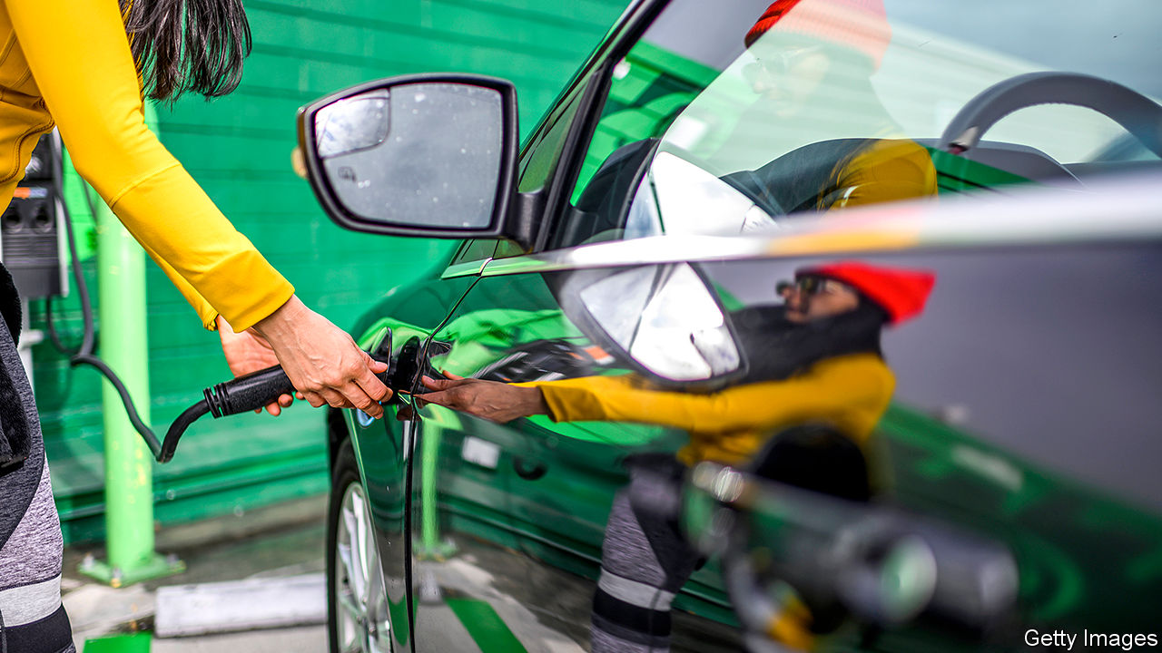

THEY MAY BE facing extinction in the electric-transport revolution, but one benefit of cars with internal combustion engines is that they are easy and quick to refuel, so travelling a long way in one is rarely a problem. Not so for their successors. In the absence of universal standards, electric cars come with a variety of charging systems and different sorts of cables and sockets. Extended journeys therefore need careful planning to make sure that the battery is fully charged at the start and that compatible fast-charging stations are available en route.

It would be much more convenient if electric cars could be recharged wirelessly. Some electric toothbrushes and other small devices, such as mobile phones, can already be topped up in this way using a process called electromagnetic induction. This employs an alternating mains current flowing through a coil to create a varying magnetic field, which then generates another current in a second coil placed alongside it according to principles elucidated in the 19th century by Michael Faraday. The device containing the second coil then converts the transmitted power into direct current, which is used to recharge a battery.

As users of electric toothbrushes and phones will know, device and charger must be both close to each other and precisely aligned for this process to work. That is tricky to achieve with an electric car, which sits above the ground and requires higher levels of energy transfer.

These problems are being overcome with advances like that made by WiTricity, a firm based near Boston, Massachusetts. This company was founded in 2007 to commercialise the work of Marin Soljaèiæ and his colleagues at the Massachusetts Institute of Technology. Dr Soljaèiæ knew, in theory, that by having the transmitting and receiving coils resonate at the same frequency it should be possible to transfer greater amounts of energy over longer distances, and he sought to turn that knowledge to practical account. In one experiment, he and his colleagues sent enough power over a two-metre gap to illuminate a 60 watt bulb. They also did safety tests and found that transmission of this power could be done without harming people in the vicinity.

WiTricity is working with a number of carmakers and sold its first commercial system in 2018 to BMW, which fits it to some of its 530e hybrid cars. Alex Gruzen, WiTricity’s boss, expects further developments soon. He says the arrangement can transmit power from the grid to the car’s battery with an efficiency of up to 93%, which is similar to that achieved by a plug-in system. Nor does a car’s receiving coil have to be positioned directly above the charging pad on the ground—a useful feature of resonating coils being that they do not have to be so closely aligned to transmit power.

As to how much power can be transferred, and how quickly, this is a question of cost and design. For most uses at home, a wireless charger of 11 kilowatts might suffice. That would provide around 50km of range per hour of charging and cost around $2,000, says Mr Gruzen. At this price, he says, a wireless system would be competitive with plug-in home-charging units.

Another advantage of wireless recharging is what Mr Gruzen calls “power snacking”. This is topping up the battery when a car is stationary for a short time. The company provides systems to recharge taxis in this way while they wait in line, and to do the same for electric buses at bus stops. It is also possible to charge vehicles while they are on the move. That might make sense in places where vehicles often queue up, such as at airports, but Mr Gruzen does not think digging up motorways to install a charging lane is a realistic proposition.

Other companies are producing wireless-recharging systems which use various forms of magnetic-resonance induction. So far these are mostly for commercial vehicles, though such systems are bound to encourage the spread of the technology to cars as well. Momentum Dynamics, a Pennsylvanian firm, for instance, announced in March a deal to supply wireless rechargers to GreenPower Motor Company, a producer of electric shuttle buses.

Wireless recharging of electric trucks is also coming. In February, a team led by Omer Onar at the Oak Ridge National Laboratory, in Tennessee, demonstrated a 20 kilowatt set-up that thus takes three hours to recharge the 60-kilowatt-hour battery pack in a hybrid UPS delivery truck. The team have also developed a 120 kilowatt fast-charger, which Dr Onar says would be capable of wirelessly charging electric cars at a similar rate to a Tesla Supercharger, one of the fastest plug-in systems available.

Crucially, as did not happen for plug-in vehicles, standards are being developed that should, at least in theory, permit any suitably equipped electric vehicle to use any wireless charger. China recently ratified a set of national criteria similar to those being developed and promoted by industry groups in the West, including WiTricity. As China has been one of the countries most forcefully pushing the electrification of vehicles, its clout in the marketplace might ensure that most companies, foreign ones included, keep to the standards it has set. ■

This article was downloaded by calibre from <https://www.economist.com/science-and-technology/2020/05/16/wireless-charging-of-electric-cars-looks-increasingly-promising>

|  |  |  |  |
| --- | --- | --- | --- |
| Previous | Articles | Sections | Next |

|  |  |  |  |
| --- | --- | --- | --- |
| Previous | Articles | Sections | Next |

#### Industrial standards

# Which way a wind turbine turns might not seem to matter

But it does

May 16th 2020 |

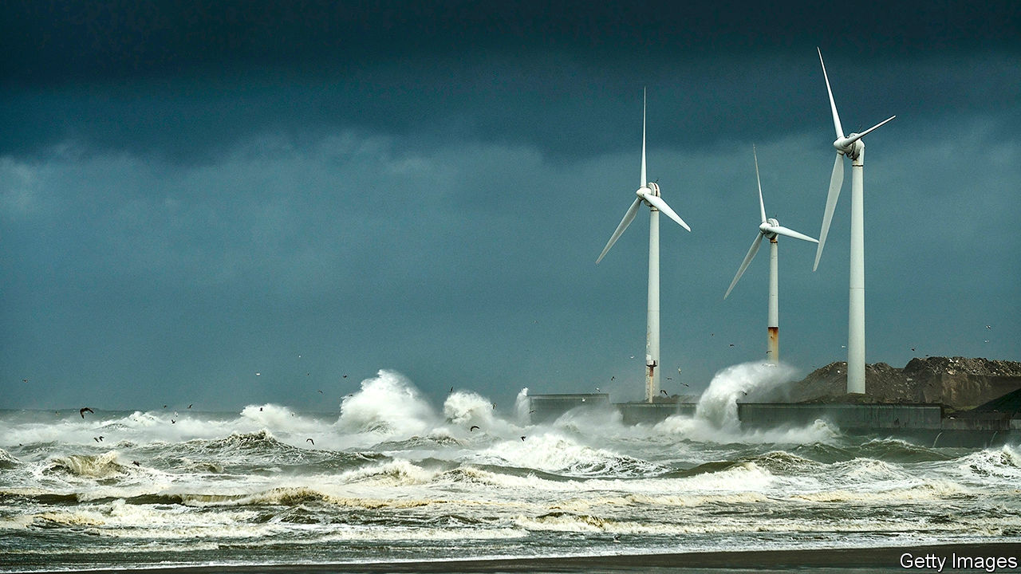

IF THE HANDS of dial clocks swept over their faces the other way around, that would be the direction known as “clockwise”. And they would tell the hour just as faithfully. It is convenient to have all clock hands turn in the same direction, but it is an accident of history which direction that is. Similarly, it seems an arbitrary but efficient choice by wind-turbine makers that the blades of almost all of those devices turn clockwise. However, a study presented on May 4th to the General Assembly of the European Geosciences Union (held online, instead of in Vienna, as planned), suggests that in the northern hemisphere, where 96% of these turbines are found, universal clockwiseness may be bad.

For a single turbine it does indeed not matter. But turbines are usually planted in groups. If, in such a group, one turbine is behind another then it does matter, according to Antonia Englberger of the German Aerospace Centre, in Oberpfaffenhofen, and her colleagues. They have built a computer model which simulates the flow of air over a turbine turning in either direction, and then calculates the effect this has on a second turbine, downwind of the first. By day, the team conclude, there is no difference. But at night the power output of the downwind device may be up to 23% higher if its upwind colleague is turning anticlockwise.

The reason lies in the nocturnal behaviour of the bottom few hundred metres of the atmosphere, known as the boundary layer. By day, the sun’s rays heat the ground, which heats the nearby air, which rises in whorls of turbulence, resulting in a well-mixed boundary layer that behaves in the same way at all altitudes. The consequence, for a wind turbine, is that its rotor blades feel the same wind speed and direction whether they are at the top or the bottom of their rotation.

At night, however, the ground cools. The whorls therefore often go away and the boundary layer stops mixing. Friction with vegetation or buildings now means that air close to the ground moves more slowly than air higher up—an effect known as altitude-related wind shear. And the amount of shear, given the blade-span of modern turbines, is large enough for Earth’s rotation to come into play. This pushes moving air to the right in the northern hemisphere and to the left in the southern, a phenomenon called the Coriolis force. The faster the airflow, the larger the deviation. Thus wind shear begets wind veer, a gradual change in direction with height.

That matters for turbine pairs because the air that pushes against the blades of the upwind device, and thus gets them to rotate, say, clockwise, is itself deflected by those blades in the other direction. This turns it into a turbulent wake with a rotation (in this case) going anticlockwise. This anticlockwise rotation conflicts with the Coriolis-induced veering tendency of the undisturbed wind around the wake. And that hampers the wake’s ability to pick up energy from this surrounding, undisturbed wind and then go on to hit the second turbine with renewed vim.

In the case that the first turbine rotates anticlockwise, the wake will be clockwise, thus matching the northern-hemisphere wind veer. This lets it gain energy from the surrounding air to deliver to the next turbine—the opposite of what now happens. And in the southern hemisphere this all works the other way around, so conventional, clockwise turbines do best.

Retooling factories in light of Dr Englberger’s discovery, to make turbines run anticlockwise instead, would certainly be expensive. Whether the extra power that could be squeezed out of the wind by doing so would make that worthwhile would require a lot more investigation. Her result does, however, show neatly how even apparently arbitrary decisions can have unintended consequences.■

This article was downloaded by calibre from <https://www.economist.com/science-and-technology/2020/05/16/which-way-a-wind-turbine-turns-might-not-seem-to-matter>

|  |  |  |  |
| --- | --- | --- | --- |
| Previous | Articles | Sections | Next |

|  |  |  |
| --- | --- | --- |
| Science & ... | Sections | Economic & ... |

Books & arts

Disinformation and democracy: The rhythm of struggle

.

British fiction: Down to Brixton

.

Johnson: What’s that again?

.

Home Entertainment: Catch up on the finest French television dramas

.

Home Entertainment: Design your own board game

.

Perspectives: Confinement has always been part of human life

.

|  |  |  |
| --- | --- | --- |
| Science & ... | Sections | Economic & ... |

|  |  |  |  |
| --- | --- | --- | --- |
|  | Articles | Sections | Next |

#### Disinformation and democracy

# The weapons of political warfare

Four new books explore how the struggle between Russia and the West has played out and evolved

May 16th 2020 |

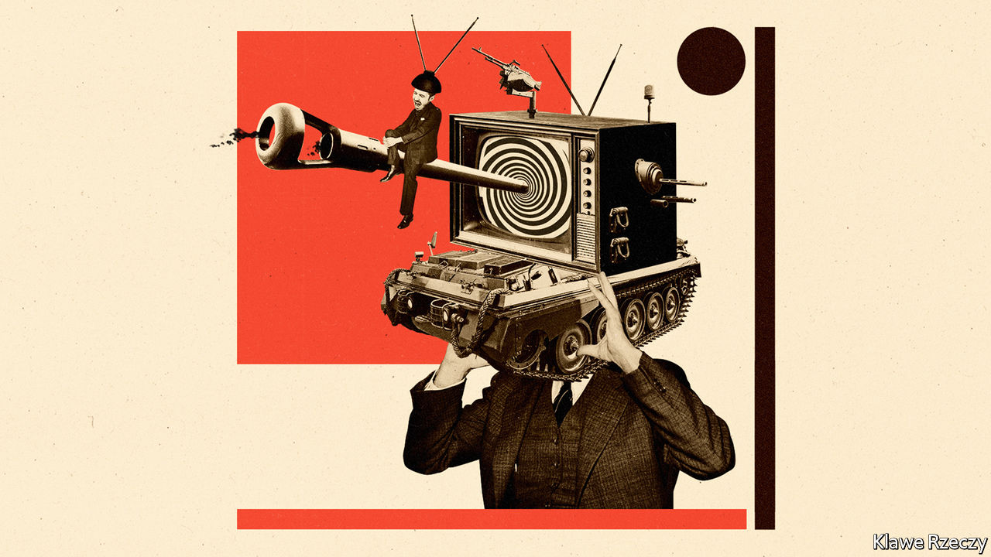

Active Measures. By Thomas Rid.Farrar, Straus and Giroux; 528 pages; $30. Macmillan; £25.

Russians Among Us. By Gordon Corera.William Morrow; 448 pages; $32.50. William Collins; £20.

From Russia with Blood. By Heidi Blake.Mulholland; 336 pages; $30. William Collins; £20.

The Folly and the Glory. By Tim Weiner.To be published by Henry Holt in October; $29.99.

IN HIS ANNUAL lecture in December, General Sir Nick Carter, Britain’s chief of defence staff, warned that “the idea of political warfare has returned”. Tanks and jets still mattered, he assured a bemedalled audience, but authoritarian rivals were unpicking the seams of society and politics in the West using disinformation, espionage, assassinations, cyber-attacks and proxies. General Carter had struck on the same problem identified by George Kennan, a renowned American diplomat, at the outset of the cold war. Americans, Kennan said, viewed war “as a sort of sporting contest outside of all political context”. Russians grasped “the perpetual rhythm of struggle, in and out of war”.

Four new books reveal different facets of how that murky struggle between Russia and the West has played out and evolved. In “Active Measures”, Thomas Rid, a professor at Johns Hopkins University, surveys the history of disinformation, with an emphasis on the KGB’s prodigious output. “The Folly and the Glory” by Tim Weiner, a veteran journalist, examines America’s campaign of propaganda against communist rivals. Gordon Corera, a security correspondent for the BBC, looks at Russia’s “illegals” programme of deep-cover sleeper agents in “Russians Among Us”. And in “From Russia with Blood”, Heidi Blake, a journalist for BuzzFeed News, investigates Russia’s killing spree in Britain.

The notion that invisible weapons—“facts, fakes and ideally a disorienting mix of both”, as Mr Rid puts it—can yield famous victories is widely accepted today. That is in no small measure thanks to Russia’s intervention in America’s presidential election of 2016 using inflammatory social-media posts and the publication of hacked emails. But the practice was pioneered in the 1920s and refined in the cold war.

At first the CIA was “even more prolific and brazen” than the KGB, explains Mr Rid. A CIA-funded printing house in Berlin churned out more than 855,000 media items in 1957 alone, including pamphlets, forged and real, as well as a magazine devoted to jazz. Personalised horoscopes were sent to unnerve Stasi officials. In 1951 one front organisation was sending 15,000 propaganda-packed balloons east every month and maintained three ballooning bases until 1960.

But the KGB’S efforts would come to dwarf that. By the middle of the 1960s it was co-ordinating 300-400 “active measures” annually—everything from fuelling the European peace movement to, in later decades, spreading allegations that America had created AIDS as a weapon. A large bureaucracy was devoted to the task. One campaign, directed against America’s plans to build neutron bombs, cost $200m (over $700m in today’s money). In 1985 the annual budget for active measures was conservatively put at $3bn-4bn (more than $7bn today).

Mr Rid pulls important insights out of this tangled history. Three stand out. One is that disinformation is not the same as fabrication. In fact, it can be most effective when “larger truths” are “flanked by little lies”. The KGB circulated genuine accounts of racial violence in America in the 1960s through fake black activist groups, just as real emails were spread through phoney cut-outs in 2016. But precisely because active measures exploit pre-existing divisions, it can be hard, if not impossible, to measure whether they are effective or not.

## Can you believe it?

A second lesson is that disinformation is not only corrosive to open societies, which depend on collective trust in facts, but also takes a subtler toll on the perpetrator. “When vast, secretive bureaucracies engage in systemic deception, at large scale and over a long time,” warns Mr Rid, “they will...undermine the legitimacy of public administration at home”. Soviet propagandists often deceived themselves, he notes. “It is impossible to excel at disinformation and at democracy at the same time.”

That did not stop America from trying, argues Mr Weiner. Though Kennan believed that “the disrespect of Russians for objective truth” led them “to view all stated facts as instruments for furtherance of one ulterior purpose or another”, the CIA itself would come to own or underwrite 50 news outlets around the world. America’s most illustrious newspapers all employed “at least one journalist working or moonlighting for the CIA”, claims Mr Weiner. Radio Free Europe, a CIA-funded station, was at best a source of vital news in Soviet-occupied Europe; at worst it was “a poison factory”, one former employee says, devoted to “creating chaos”.

Both countries used information as a crowbar to widen social or political divisions in the other, but Mr Rid denies any moral equivalence. The CIA, he says, “retreated from the disinformation battlefield almost completely”. When it did wage information war, it was often of a different character: distributing translated copies of “1984” into Ukraine or smuggling newsprint into Poland. America’s worst excesses in political warfare were typically curbed, eventually, by checks and balances that did not trouble Soviet agencies. “What they do to us we cannot do to them,” as Estonia’s president noted after a landmark cyber-assault in 2007.

That becomes clearer when turning to the other arrows in Russia’s quiver. Mr Corera’s account of Russian spies who burrowed into American suburbs in the 1990s, having stolen the identities of dead infants, is gripping. Many raised their unwitting children as bona fide Americans and retired there. That reflects the stamina of Russian intelligence, but also an asymmetric advantage. No young CIA or MI6 officer would want to “spend two decades working in Volgograd pretending to be a Ukrainian”, points out Mr Corera.

Ms Blake’s book explores another one-sided battle. She describes how associates of Boris Berezovsky, an oligarch who fell out with Vladimir Putin, died one after the other in London, at a rate which “defied natural explanation”. American spies repeatedly told their British counterparts that Mr Putin’s agents were probably responsible, but pusillanimous British leaders, mindful of the roubles flooding into London’s property market, swept these concerns aside. Ms Blake’s argument rests on eyebrow-raising claims that Russian spies have developed undetectable poisons that can cause fast-acting cancers and “mood-altering substances” to induce depression and suicide.

The evidence for that lurid suggestion is slender. But it relates to the third of Mr Rid’s arguments: that technology has transformed the arena of political warfare. This is evident from Mr Corera’s account of the revolution in Russia’s illegals programme. The age of biometric border controls and social-media backstories made it significantly harder to create aliases that would stand up to scrutiny. A new and more prosaic generation of illegals travelled between Russia and the West under their real names, hidden in a flood of émigrés, says Mr Corera. But as technology closed one door, it opened another.

Soviet disinformation had to be laundered into the West, typically through the media. “If they did not have press freedom, we would have to invent it for them,” the KGB’s disinformation chief quipped in 1964. The internet changed the nature of that conduit. Information could be stolen in vast quantities and spread anonymously, quickly and cheaply, often through credulous activists and amplified by harried journalists untroubled by its provenance. “A significant and large proportion of the disinformation value-creation chain was outsourced to the victim society,” concludes Mr Rid. More perversely, the Western panic around false news stories often overstated the effectiveness of those campaigns—and thus compounded their disorienting effects.

Like Kennan in 1948, Western intelligence officers and soldiers are now relearning how to wage political warfare. Last year General Carter launched a new division of the British army devoted to “information manoeuvre and unconventional warfare”. It “routinely conduct[s] operations below the threshold of armed conflict in the virtual and physical dimensions”, boasts Britain’s defence ministry, somewhat cryptically. One of its units, the 77th Brigade, has been active in countering disinformation around covid-19. Whether it also sends customised horoscopes to Russian spies is not disclosed.■

This article was downloaded by calibre from <https://www.economist.com/books-and-arts/2020/05/16/the-weapons-of-political-warfare>

|  |  |  |  |
| --- | --- | --- | --- |
|  | Articles | Sections | Next |

|  |  |  |  |
| --- | --- | --- | --- |
| Previous | Articles | Sections | Next |

#### British fiction

# A spirited and entertaining novel of Brixton in the mid-20th century

In “Pomeranski” Gerald Jacobs dramatises the lives of Jewish families in the south London neighbourhood

May 16th 2020 |

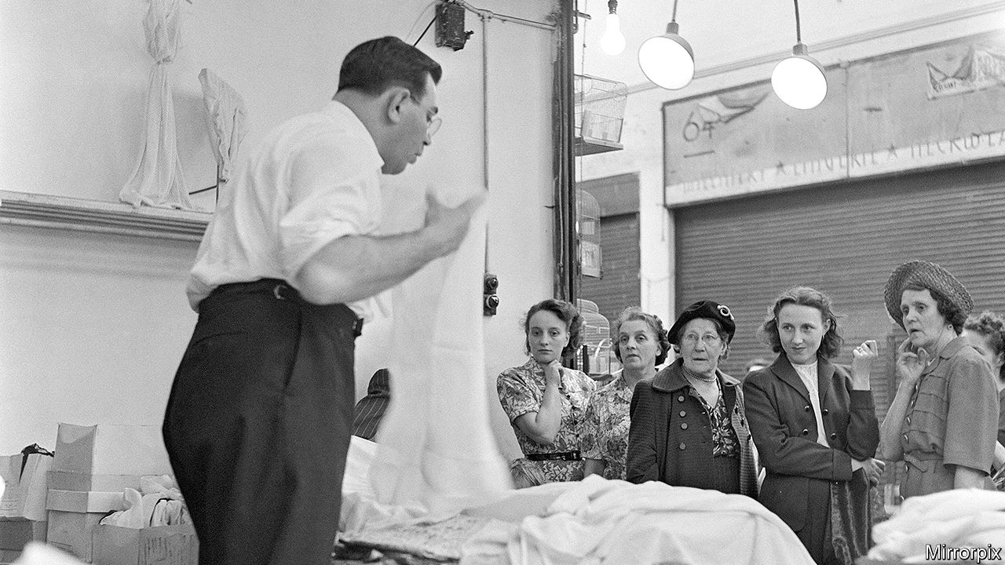

Pomeranski. By Gerald Jacobs. Quartet Books; 256 pages; £12.

VINCENT VAN GOGH once lived in Brixton, where the fledgling artist fell in love with his landlady’s daughter. Formerly famous as a hub of post-war British Caribbean life, more recently a magnet for gentrifying hipsters, the south London neighbourhood boasts a rich cultural history. Until now, though, the area’s literary chroniclers have overlooked the Jewish families who settled in the place Gerald Jacobs calls a “dynamic urban village”.

A long-serving literary editor of Britain’s Jewish Chronicle, Mr Jacobs has written a spirited and entertaining novel of Brixton in the mid-20th century, peopled with characters who balance on a knife-edge between “legit gesheft” (above-board business) and more rackety sorts of enterprise. At times, it reads almost like a low-key, south-of-the-Thames version of “The Sopranos”, but with slices of Bakewell tart in place of Sicilian cannoli.

After the death of Benny Pomeranski in 2000 his son Simon—who has swapped the retail hustles of his parents’ generation for the more genteel profession of drama lecturer—learns about the misadventures that shaped his father’s life. Benny, along with his pals, migrated south from the war-battered streets of the East End (a more familiar stamping-ground for earlier Jewish novelists of London). In Brixton, Benny and his wife Bertha make a decent living from their dress shop, Pomeranski Gowns, but his heart lies with a group of friends who meet in the Astoria café.

These “Astorians” comprise not only “fairly conventional male Jewish shopkeepers” with dreams of a racier existence, but some gay and black confederates. A series of escapades, charmingly told if loosely connected, depict Benny and his mates—among them “Maxie the Ganoff” (“thief”), “Spanish Joe” and “Fancy Goods Harry”—as they sidestep the law to recapture the “rule-breaking” thrills of their slumland youth. “Benny the Fixer” and his chutzpadik gang nurture Robin Hood fantasies as they raid a crooked jewellers or cheer on the career of “Kid Joey”, a half-Jamaican, half-Irish Brixton boxer. They believe a “moral framework” blesses their scams. Not so “Little Jack” Lewis—a big cheese among “South London’s more felonious residents”, weapons-grade thug and sinister proof that playing at crime may lead swiftly down into darkness.

Colourful and episodic, “Pomeranski” scatters its stories liberally. A detour to Kingston, Jamaica, gives readers a tantalising glimpse, but no more, of the island’s long-settled Jewish community. It might have benefited from a tighter focus on fewer figures, such as near-tragic Sam “the Stick” Golub, crippled in childhood and driven by a “constant quest for revenge”. Ultimately, the book endorses Bertha’s scorn for the “nonsense” of treating “petty thieving and threatening people as a sort of political stance”. Mr Jacobs, though, keeps the mood genial and the yarns flowing. The wheezes of his Astorians add an exuberant shot of yiddishkeit to “the everlasting drama that was Brixton”.■

This article was downloaded by calibre from <https://www.economist.com/books-and-arts/2020/05/16/a-spirited-and-entertaining-novel-of-brixton-in-the-mid-20th-century>

|  |  |  |  |
| --- | --- | --- | --- |
| Previous | Articles | Sections | Next |

|  |  |  |  |
| --- | --- | --- | --- |
| Previous | Articles | Sections | Next |

#### Johnson

# Why Zoom meetings are so dissatisfying

Internet chats disrupt the automatic, split-second cues on which conversation relies

May 16th 2020 |

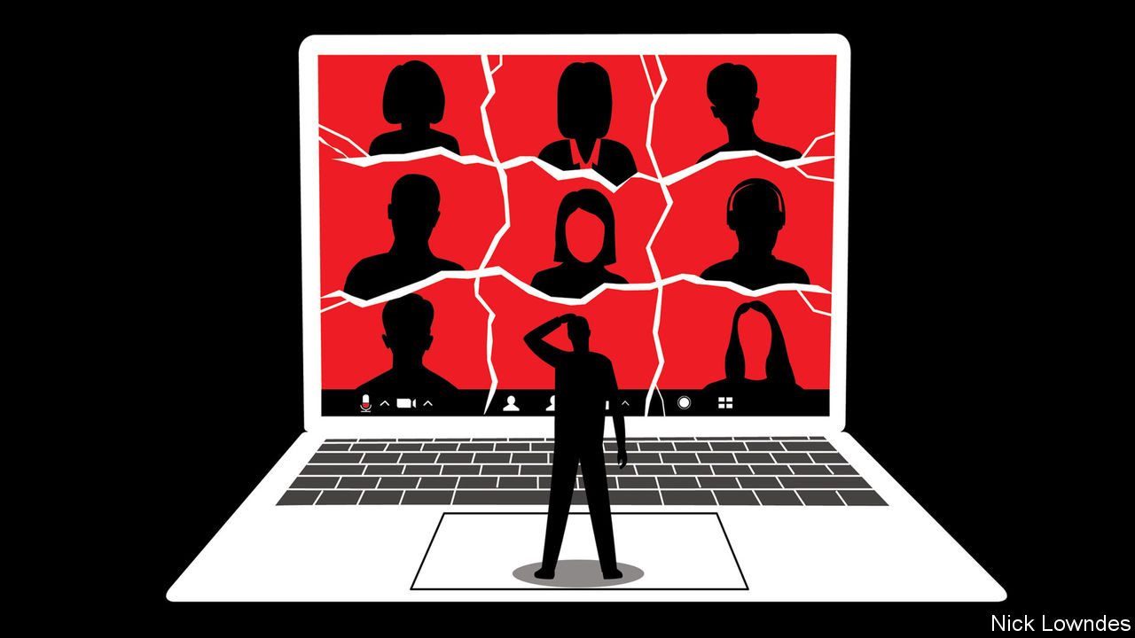

Editor’s note: The Economist is making some of its most important coverage of the covid-19 pandemic freely available to readers of The Economist Today, our daily newsletter. To receive it, register [here](https://www.economist.com/newslettersignup). For our coronavirus tracker and more coverage, see our [hub](https://www.economist.com/coronavirus)

READERS OF A certain age will remember when long-distance calls were expensive, international calls ruinously so, three-way calls exciting and video calls the stuff of science fiction. How quickly people take yesterday’s achievements for granted. Today, international video hangouts are free and widely available. Instead of treating them as a miracle, endless commentators have complained about “Zoom fatigue”. Much of their criticism has been about the video: a lack of eye contact, self-consciousness (whether about skin, hair or bookshelves) and the like.

Yet the main reasons Zoom conversations are draining are to do with audio, in which the limitations of the technology run up against habits of speech. Studies find that most cultures observe a conversational rule of “no gap, no overlap”. Despite the various stereotypes that exist about taciturn or interrupting ethnicities, turn-taking is well-organised and almost instantaneous from Mexico to Denmark to Japan.

All that is disrupted in online meetings. Audio and video are chopped into tiny pieces, sent via different channels to the recipient, and then reassembled. Such “packet switching” is robust. DARPA, the Pentagon agency that pioneered the internet, wanted to be sure an enemy could not cut a single line and disable the connection. But some packets may arrive late for reassembly. When they do, the software has a basic choice: to wait, leading to a delay, or to gather what is available, leading to glitches.

Video-calling platforms tend to use audio that arrives quickly but is of middling quality. Zoom says it aims for, and often achieves, a lag of just 150 milliseconds—quicker than the blink of an eye. Yet even when that goal is reached (and it often isn’t, especially when the internet is crowded), that is a lot more time than it seems. Under “no gap, no overlap” rules, the typical silence between the end of one face-to-face conversational turn and the next is about 200 milliseconds. The wait easily exceeds that threshold if Zoom users experience a 150-millisecond lag after the first speaker, followed by another 150 milliseconds for the reply.

Adding these pauses to work calls can make speakers seem less convincing. A study by Felicia Roberts of Purdue University and colleagues found that positive answers to questions (such as “Can you give me a ride?”, “Sure”) were rated as less genuinely willing if the responder took more than 700 milliseconds to reply. That is because it requires less time than that to plan and utter an automatic, positive statement. Above that limit, hearers correctly perceive that the speaker is using extra time to craft a response, perhaps a hedge or a polite “no”. Unfortunately, this means that colleagues who think they are giving forthright answers might come across as cagey on video calls.

A bigger problem may be interruptions, says Ms Roberts, as delays mean that speakers are not able to properly time their turns. In person, when two people overlap one speaker may quickly yield; on a video call it takes longer for this clash to be resolved. Repairing these snags regularly is tiresome.

To make matters worse, colleagues who are hard to understand, even if only for technical reasons, are rated as less trustworthy. Studies find that a foreign accent reduces the believability of factual assertions (such as “a giraffe can go without water longer than a camel”), as does printing such statements in a fuzzy or low-contrast font. In humans’ primitive psychology, the simpler something is to understand, the easier it is to believe. This same bias would unfairly punish the worker cursed with a dodgy internet connection.

With effort, listeners are able to mentally compensate for glitches and delays. “The First Circle”, a novel by Alexander Solzhenitsyn published in 1968, suggests darkly that this is easiest to do during bland exchanges. In the book, intellectuals at a Soviet work camp test a secure calling system by having one engineer read a newspaper over the line, and another rate the quality of the call. The hearer gives a surprisingly high score, despite the spasmodic transmission: he has correctly guessed the missing words, thanks to the formulaic propaganda in the newspaper. Any meeting where it is so easy to predict what colleagues will say raises the question of why it is held in the first place.

There is at least one upside. When workers finally return to offices, they may actually look forward to real face-to-face meetings again—to say nothing of post-work gatherings with friends.

Dig deeper:  
For our latest coverage of the covid-19 pandemic, register for The Economist Today, our daily [newsletter](https://www.economist.com/newslettersignup), or visit our [coronavirus tracker and story hub](https://www.economist.com/coronavirus)

This article was downloaded by calibre from <https://www.economist.com/books-and-arts/2020/05/16/why-zoom-meetings-are-so-dissatisfying>

|  |  |  |  |
| --- | --- | --- | --- |
| Previous | Articles | Sections | Next |

|  |  |  |  |
| --- | --- | --- | --- |
| Previous | Articles | Sections | Next |

#### Coup de théâtre

# Catch up on the finest French television dramas during lockdown

The fifth season of “Le Bureau des Légendes” (“The Bureau”) has been cult viewing

May 16th 2020 |



Editor’s note: The Economist is making some of its most important coverage of the covid-19 pandemic freely available to readers of The Economist Today, our daily newsletter. To receive it, register [here](https://www.economist.com/newslettersignup). For our coronavirus tracker and more coverage, see our [hub](https://www.economist.com/coronavirus)

WHEN IT COMES to screen drama, the French have long considered cinema and the film d’auteur to be the nobler art, one that helps define national identity. Television drama was traditionally treated as its poor cousin: unsophisticated, formulaic and risk-averse. Yet in recent years this hierarchy has been upended. France now offers plenty of compelling viewing on the small screen.

A good place to start is “Dix Pour Cent” (“Call My Agent!”), which centres on a dysfunctional talent agency in Paris. The series follows half a dozen highly strung agents as they struggle to manage their roster of stars. The agents’ caprices and rivalries veer from the comic to the poignant, with occasional lapses into melodrama. All this is sustained by sharp dialogue, self-deprecating angst and warmth. In a twist, each episode also features a French film star—Isabelle Adjani, Juliette Binoche, Jean Dujardin—playing themselves. Produced for France 2, a public broadcaster, “Dix Pour Cent” attracted wider attention when Netflix bought the rights. A fourth and final season is currently in post-production in France.

For a moodier pace, and the intrigue of contemporary espionage, it is well worth catching up with “Le Bureau des Légendes” (“The Bureau”, pictured), a cult hit from Canal+. Starring Mathieu Kassovitz as Guillaume Debailly, an espion progressively trapped by his own lies, the fifth season launched during lockdown. The bureau in question runs undercover agents for the French intelligence service. But this smart, unhurried Gallic take on a spy thriller features no special effects and few stunts. Rather it relies on psychological complexity, intricate geopolitics and a form of slow-burn realism said to have met with approval even among French intelligence officers.

Equally unsentimental is “Baron Noir” (another Canal+ production), a political drama. Set in the gilded salons of the Elysée presidential palace, as well as the northern port of Dunkirk, it focuses on the compulsive and self-serving character of Philippe Rickwaert, superbly played by Kad Merad. A one-time Socialist mayor and member of parliament, he is out to play power politics at all costs, even to himself.

What most of these series share, along with others such as “Engrenages” (“Spiral”) or “Les Revenants” (“The Returned”), is the adoption of an American-style TV-writing structure: a pool of writers, overseen by a showrunner who enjoys overall creative control. Not all French directors have taken well to being treated as hired hands. But series creators, such as Éric Rochant of “Le Bureau des Légendes”, also a director himself, have now earned power and prestige.

The results speak for themselves. When she started out, Fanny Herrero, creator of “Dix Pour Cent”, analysed the best contemporary American television drama, realising that its French counterpart “had to modernise”. Now it has. Régalez-vous. ■

Dig deeper:  
For our latest coverage of the covid-19 pandemic, register for The Economist Today, our daily [newsletter](https://www.economist.com/newslettersignup), or visit our [coronavirus tracker and story hub](https://www.economist.com/coronavirus)

This article was downloaded by calibre from <https://www.economist.com/books-and-arts/2020/05/16/catch-up-on-the-finest-french-television-dramas-during-lockdown>

|  |  |  |  |
| --- | --- | --- | --- |
| Previous | Articles | Sections | Next |

|  |  |  |  |
| --- | --- | --- | --- |
| Previous | Articles | Sections | Next |

#### Your turn

# For hours of escape, invent a board game

It is a chance to combine the most enjoyable elements of other people’s creations

May 16th 2020 |

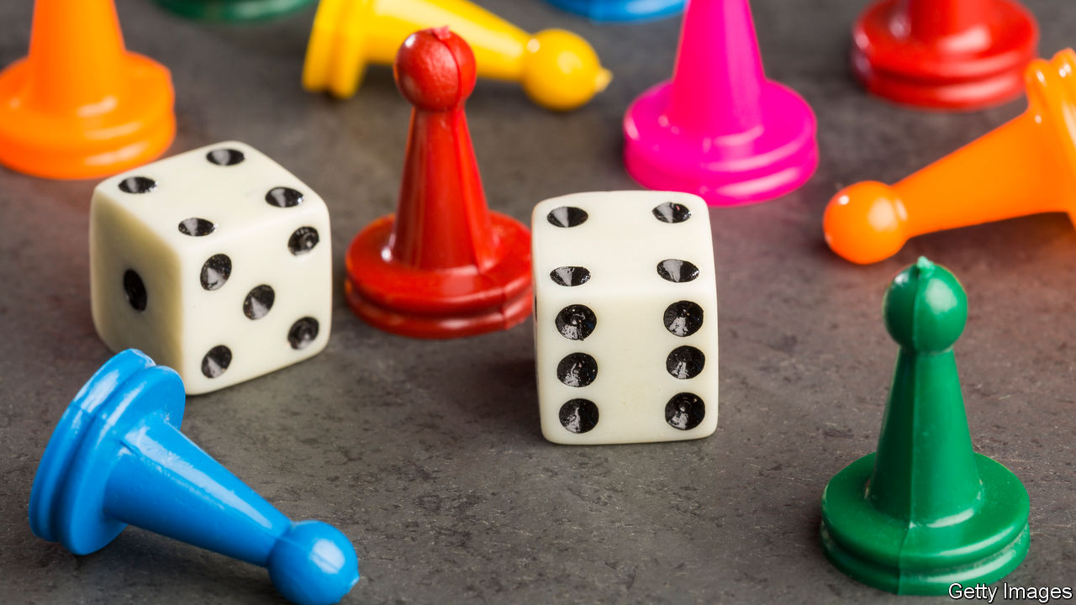

Editor’s note: The Economist is making some of its most important coverage of the covid-19 pandemic freely available to readers of The Economist Today, our daily newsletter. To receive it, register [here](https://www.economist.com/newslettersignup). For our coronavirus tracker and more coverage, see our [hub](https://www.economist.com/coronavirus)

ON A DISTANT planet, a rocket crashes. The surviving astronauts—a medic, miner, soldier, scavenger, scientist and engineer—had been on a mission to collect rare minerals and other resources. Now they have to co-operate to rebuild their craft and dig up as many precious rocks as they can shift, all before their dwindling oxygen supplies expire. They also have to cope with landslides, tunnel collapses and attacks from helicopter-like birds, wolf creatures and herds of space-mammoths.

Life is not easy for characters on Planet Ozerdale. But at least they have plenty of opportunity for heroics and energetic outdoor activity, and are able to spend time with a reasonably large social group. For your correspondent’s 14-year-old son, stuck in lockdown with his brother and their parents, the outer-space scenario was alluring. He dreamed up the intergalactic mission a few days after his school closed. Inventing—and typing up—the rules for a home-made game, debating strategy for confronting aliens and working out how to fly away to freedom have offered several welcome hours of diversion.

Designing your own board game lets you combine the most enjoyable elements of other people’s. The best involve both luck and strategy. Intricate and complex battles between armies, as in “Diplomacy”, “Risk” or “Axis and Allies”, tend to be open-ended and last many hours. A hard time limit, represented by the disappearing oxygen, is preferable. Tasks that require some collaboration can be satisfying, as when players in “Pandemic” work together to stop a deadly virus spreading, or when rivals trade resources in “Settlers of Catan”. But vicious competition can be relished, too, especially if it means putting your annoying relatives in their place. On Planet Ozerdale, the different astronauts work together to display a range of talents. Some, if lucky, can outperform the others.

Is it more rewarding to create a new game, calibrate sometimes complicated rules, make hexagonal tiles for the board, set up a website to share the idea and anticipate how others will be entertained—or to get down to the absorbing business of rolling the dice, defeating monsters and dodging asteroids? In your correspondent’s household, the most intense excitement seems to come in the early stages of crafting a new thing.

For the inventor the pleasure is from being a storyteller of sorts, one who introduces a cast of characters, bestows each with attributes (a scientist able to invent new technology; the miner with geological nous) and then dreams up novel scenarios for them. For those who lead others in role-playing games, such as “Dungeons and Dragons”, it may be a small step to put a game on a board. For their audience—especially parents, who are prone to being baffled by many intricate rules—having cardboard tokens in hand helps to keep things simple. The real goal, whether for those trapped at home during lockdown, or astronauts stranded on a planet of wolf aliens, is to have a chance to escape. ■

Dig deeper:  
For our latest coverage of the covid-19 pandemic, register for The Economist Today, our daily [newsletter](https://www.economist.com/newslettersignup), or visit our [coronavirus tracker and story hub](https://www.economist.com/coronavirus)

This article was downloaded by calibre from <https://www.economist.com/books-and-arts/2020/05/16/for-hours-of-escape-invent-a-board-game>

|  |  |  |  |
| --- | --- | --- | --- |
| Previous | Articles | Sections | Next |

|  |  |  |  |
| --- | --- | --- | --- |
| Previous | Articles | Sections | Next |

#### Perspectives

# Even before lockdowns, confinement was part of human life

And in some cases it was sought out

May 16th 2020 |

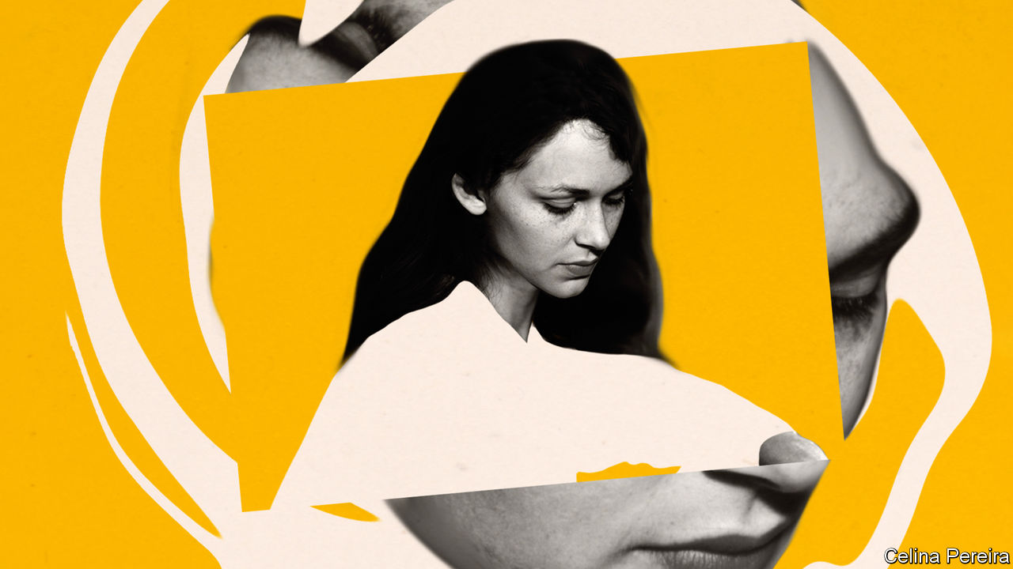

Editor’s note: The Economist is making some of its most important coverage of the covid-19 pandemic freely available to readers of The Economist Today, our daily newsletter. To receive it, register [here](https://www.economist.com/newslettersignup). For our coronavirus tracker and more coverage, see our [hub](https://www.economist.com/coronavirus)

VERY GRADUALLY, now here, now there, the rules that have kept a large share of the world’s people immured in their homes are being relaxed. There can be no sudden burst from confinement, like young colts in spring. But already the parties are being planned, the long drives to see relations, the sheer revelling in independence and unfettered life. This peculiar imprisonment will end, and most people—physically, at least—will be free.

Yet, in myriad ways, confinement will continue as it always does. Alarms ring at the start of the day, and watches are strapped on, to submit to the limits of time. Bodies are roped with belts and ties, forced into unkind shoes and crammed into the narrow bounds of buses and tubes. Children, brushed and tidied, are packed off to school. And this, of course, is the daily round that many have been pining for.

It gets no looser as the day goes on. Office workers stay in one room, or one small cubicle, completing set tasks. From the window they may envy the gardeners and builders round about. But the outside labourer still works within the limits of his ground, to the limits of tools and strength, within the unpredictable imperatives of nature. And as workers and non-workers alike snuggle into the comfortable confines of their beds, sleep wraps them closely round a second time.

Confinement, of all kinds and degrees, is part of human life. The word does not normally denote imprisonment, still less isolation, but the setting of limits. Those limits are often self-imposed or set by generally benevolent forces: parents, society. Confinement to the home and thereabouts by state order is rare, but in emergency that too has been, by and large, accepted.

Physical restriction, after all, starts early, with the full-term fetus curled in a space it fills completely. This presumably seems cosy to some, intolerable to others; attitudes to confinement may well be laid down in utero. Newborn infants, when asleep, will sometimes fling out their arms as if to check that the limits are still there, and to seek reassurance. And for long centuries, persisting to the present in places, this reassurance was partly provided by swaddling the child in linen bands as tightly as could be.

The purpose of swaddling was also to make the limbs grow straight, as saplings are braced and tied; and here the moral purpose of confinement enters the picture. As the limbs were straightened by the bands, so the mind of the growing child was straightened by careful instruction in discipline and manners. Rote-learning of noun declensions and multiplication tables kept the brain focused in a tunnel of repeated sounds. Beatings for forgetting, and deferential behaviour to superiors, kept the body in check. Confinement in starched clothes in a church pew, or in mosque or synagogue, for long hours of the Sabbath ensured community cohesion. When young men and women subsequently went off the rails, as many did, they had plainly not been confined enough.

Much of that sort of restriction has disappeared from modern life. It is no longer bearable, though echoes of it have resurfaced in current public-information campaigns: the repeated mantras about hand-washing, the threat of tighter rules for disobedience. But attitudes to confinement are not merely a matter of prevalent social norms. They also lie in the mind and mood of the beholder.

Down the ages, fear of confinement was often inculcated through stories

For Hamlet in his half-madness, the world itself comprised “many confines, / wards, and dungeons, Denmark being one o’ the worst.” It was an “unweeded garden” (gardens being hedged and walled, as even Eden had been enclosed), possessed by “rank and gross” things. The Romantic poets tended to agree. Percy Bysshe Shelley thought himself confined by the entire institutional structure of his age, especially the interdiction of free love; “heart-withering custom’s cold control” was a dead hand that he could not escape. Both Samuel Taylor Coleridge and John Keats felt “pent” in London, though Samuel Johnson had equated the city with life itself, and they had its whole width to wander in. Like the caged birds that were bought to swing at tenement windows, poets too could not sing among shops and chimney stacks.

Down the ages, fear of confinement was often inculcated through stories. A large number of fairy tales featured maidens confined indoors: the Sleeping Beauty in a palace-room behind thick thorns, Rapunzel in a high tower. Princes rescued them, but there was usually no obvious sign that their confinement had ended. It was perhaps just the fate of women to be shut up, as in the Song of Solomon (“A garden enclosed is my sister, my spouse”) or in medieval nunneries, or in the harems of the East; after all their inexplicable or forward behaviour, the ancients thought, was caused by the womb drifting in an unchecked way. The agony that may be hidden in such closed rooms is perhaps summed up by the old use of “confinement” as a euphemism for childbirth, when a pregnant woman disappeared into a female world full of secret rituals, desperation, pain and shame.

## This lime-tree bower my prison

Yet even strict confinement was not necessarily fearful. It might offer, paradoxically, a means of escape. In Greek myth, some characters—Myrrha, who had slept with her father, or the Heliades, who had offended the sun god—were turned into trees as punishment. For others, however—the nymph Daphne, turned into a laurel tree as Apollo pursued her, or Syrinx, turned into a reed to frustrate Pan—that gradual spread over their soft skin of gnarled bark or hard outer layer, that stiffening of their limbs, was deliverance. Restriction could mark the beginning of a different and, in some ways, freer life.

Many encountered this paradox. Within a few lines, world-hating Hamlet also averred that “I could be bounded in a nutshell, and count myself a king of infinite space.” While the body was held, the mind leaped outwards. Julian of Norwich, in confinement and in vision, saw a “little thing”, only the size of a hazelnut, in God’s hand, and was told it was “all that is made”. She was one of hundreds of anchorites in pre-Reformation England, most of them women, who had entered a confinement so permanent that the Office of the Dead was recited over them, and the door of their tiny cell was sealed. They were not isolated; people consulted them, and through a window food would be passed in, the chamber pot passed out. But they were bounded, as in that nutshell. In this locked place, salvation could be found and God encountered. Jesus himself had told his followers not to pray in public, but to “enter into thy closet, and…shut the door…and thy Father...shall reward thee openly.” For each monk, nun or hermit their cell was, and is, their spiritual touchstone. As Abba Moses, a Desert Father, said, “Sit in your cell, and your cell will teach you everything.”

Another self-imposed confinement, for those of a platonic cast of mind, was that of the soul within the body. When souls lost their feathers, as Socrates explained in “Phaedrus”, they fell from the heavenly realms and, on reaching solid ground, took on the covering of mortality. In this double casing of Earth and body, they could experience beauty; on recognising it, they would feel their feathers growing again and recall their heavenly beginnings. Romantic poets treasured this notion of confinement awakening the soul; of seeing, through the smallest earthly forms, “into the life of things”. For Wordsworth, in his “Ode on Intimations of Immortality”, the soul’s visions could be unlocked even by the sight of a wild pansy in the grass.

They could be set free, too, when he lay on his couch in the small, dark rooms of Dove Cottage, where the views from the tiny windows were only of banks and close stone walls. Writers and thinkers in all disciplines have long found confinement useful, even essential. It can be technical: strict adherence to harmony and counterpoint, or to metre and rhyme. As Wordsworth himself explained, just as nuns were content with their narrow rooms, and hermits with their cells, he too for a while enjoyed “the sonnet’s scanty plot of ground”. More often, however, confinement is simply physical. Its purpose is focus, away from distraction. Virginia Woolf believed that women could never flourish as writers unless they had not only “money enough to travel and to idle”, but also independence of mind and spirit, in a room of their own.

The rooms, or cells, or sheds, need not be austere or viewless. Dylan Thomas’s writing shed at Laugharne had a prospect so beautiful, looking over “full-tilt river and switchback sea/Where the cormorants scud”, that it could not help appearing sometimes in his poems. Yet the lands he travelled were interior. Rainer Maria Rilke felt that his retreat at Muzot, a small square tower in the Alpine foothills, held the secrets of his poems; for it was there that he could mine his inner life, immersing himself in “inwardness”.

Physical feats of exploration, too, often rely on confinement. To stumble on the wonders of limestone formations underground, potholers must squeeze through tunnels and bores that can barely admit them. In the deep ocean, where a diver can no longer swim freely because of the weight of water above, two scientists and a pilot cram into a cabin six feet across in a tiny sphere of titanium, the deep-diving submersible DSV Alvin, as it drops two miles or so into the dark.

A dive on Alvin could last no longer than nine hours. But Al Worden, an astronaut on Apollo 15, spent 67 hours in lunar orbit in a command-module cabin with 6.17 cubic metres of space, while his two colleagues walked on the Moon. Other things confined him too: his clumsy space suit, and the minute-by-minute schedule imposed by mission control. In the simple poems he wrote afterwards (for he felt that the official debriefing only scratched the surface), the narrowness of his circumstances never rated a mention. He noticed only how unconfined he was, among the pirouetting stars, gazing at the “cloudy frail earth”, on which all the colours of the universe seemed to be focused:

Earthbound no more, we travel afar  
To see for ourselves just where we are.

Dig deeper:  
For our latest coverage of the covid-19 pandemic, register for The Economist Today, our daily [newsletter](https://www.economist.com/newslettersignup), or visit our [coronavirus tracker and story hub](https://www.economist.com/coronavirus)

This article was downloaded by calibre from <https://www.economist.com/books-and-arts/2020/05/16/even-before-lockdowns-confinement-was-part-of-human-life>

|  |  |  |  |
| --- | --- | --- | --- |
| Previous | Articles | Sections | Next |

|  |  |  |
| --- | --- | --- |
| Books & arts | Sections | Graphic detail |

Economic & financial indicators

Economic data, commodities and markets

.

|  |  |  |
| --- | --- | --- |
| Books & arts | Sections | Graphic detail |

|  |  |  |  |
| --- | --- | --- | --- |
|  | Articles | Sections | Next |

# Economic data, commodities and markets

May 16th 2020 |

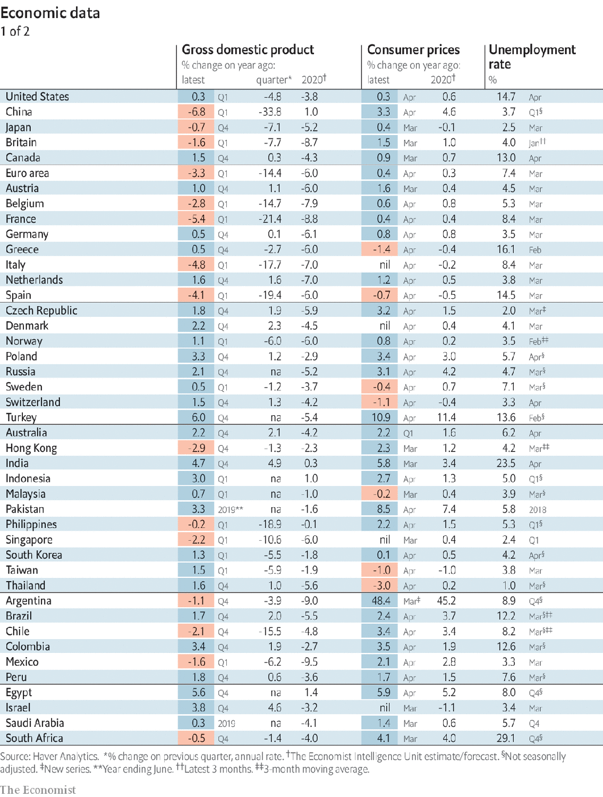

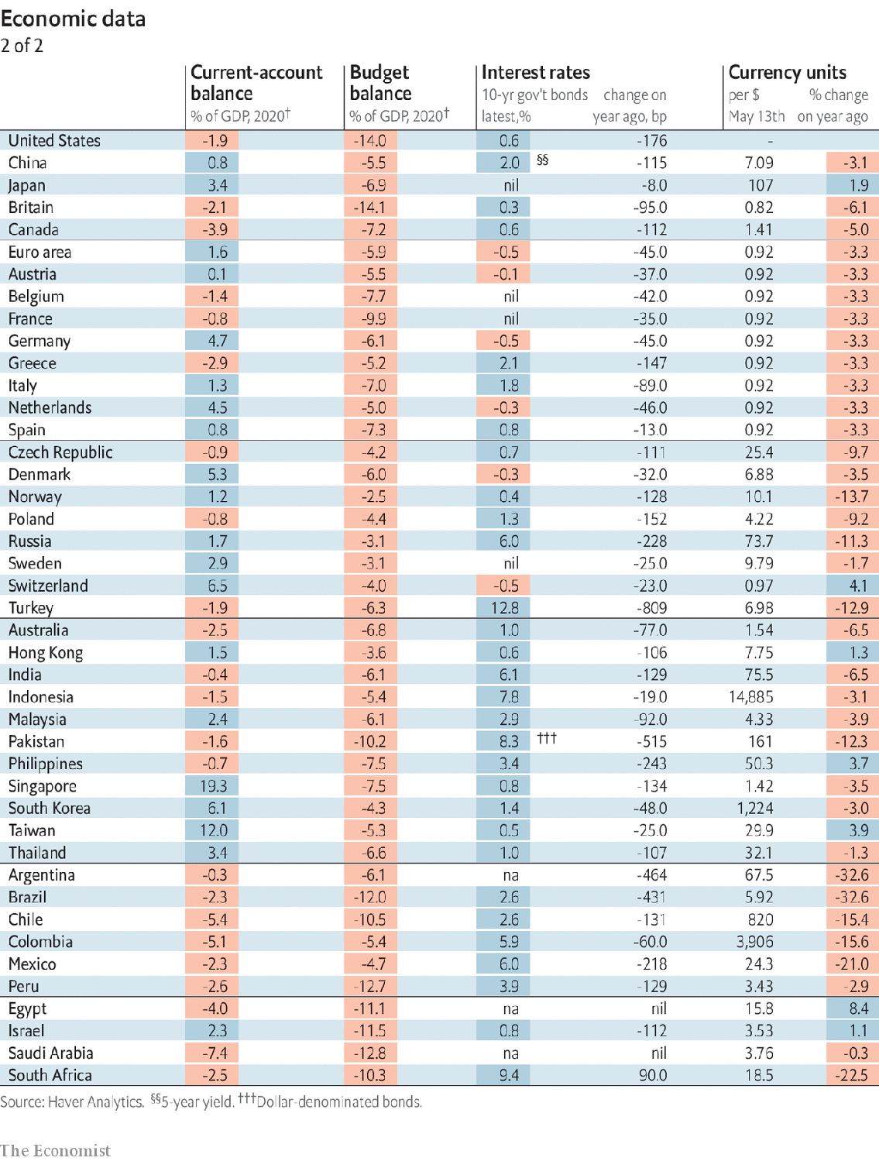

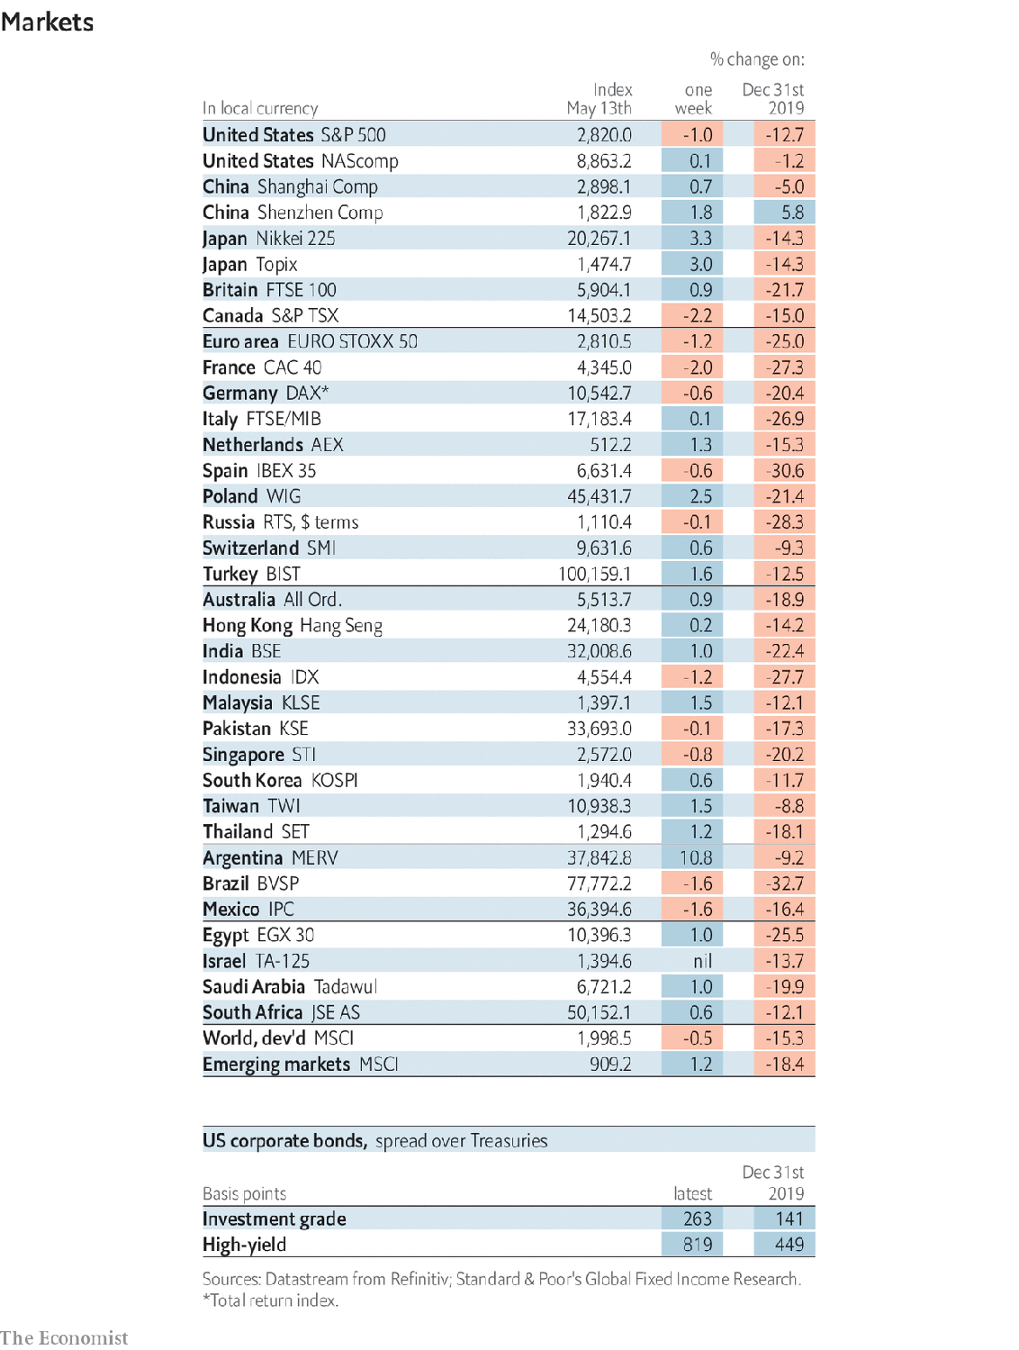

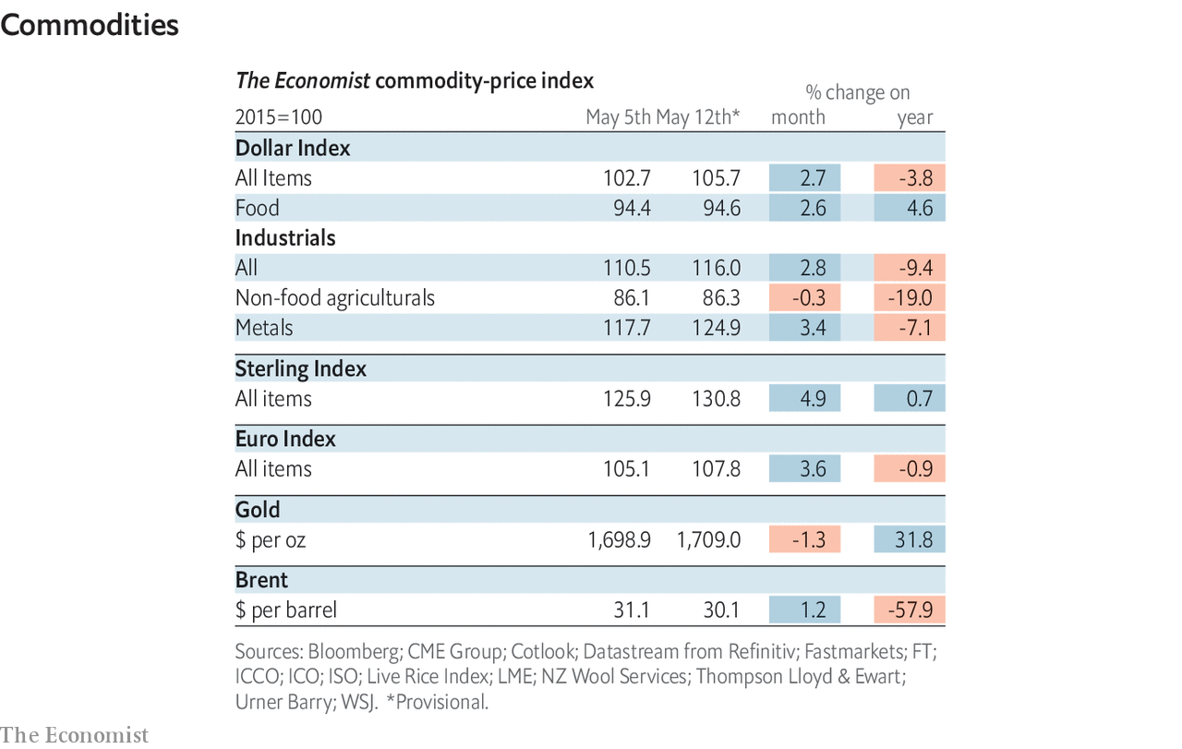

This article was downloaded by calibre from <https://www.economist.com/economic-and-financial-indicators/2020/05/16/economic-data-commodities-and-markets>

|  |  |  |  |
| --- | --- | --- | --- |
|  | Articles | Sections | Next |

|  |  |  |
| --- | --- | --- |
| Economic & ... | Sections | Obituary |

Graphic detail

Travel and covid-19: The covid network

.

|  |  |  |
| --- | --- | --- |
| Economic & ... | Sections | Obituary |

|  |  |  |  |
| --- | --- | --- | --- |
|  | Articles | Sections | Next |

#### The covid network

# Phone data identify travel hubs at risk of a second wave of infections

Well-networked areas tend to have more infections than their average incomes and population densities suggest

May 16th 2020 |

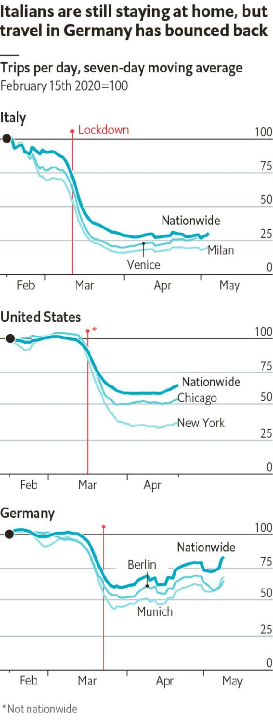

NOW THAT the first wave of covid-19 infections has crested, governments are starting to relax their lockdowns. In Italy shops will open their doors from May 18th. Parts of Germany and America are also reopening on a state-by-state basis. Mobile-phone data show that people are buzzing around a bit more than they did in April.

Greater mobility raises the risk of a second wave of cases. For countries where policies are set locally, a big worry is that outbreaks could begin in areas with lax rules and spread elsewhere. In theory, this risk should mirror “interconnectedness”—the amount of travel to and from each region. One possible explanation for why Lombardy was hit so hard by covid-19 is that it is the best-networked part of Italy.

Teralytics, a Swiss technology firm, has compiled data from Germany, Italy and America that support this hypothesis. Each time a mobile phone leaves one location and arrives at a new one for an hour or more—whether such travel is within a city or for longer distances—Teralytics logs the journey. In the week before lockdowns began, the firm recorded 5.7bn trips. Travel fell by 40% once they were implemented.

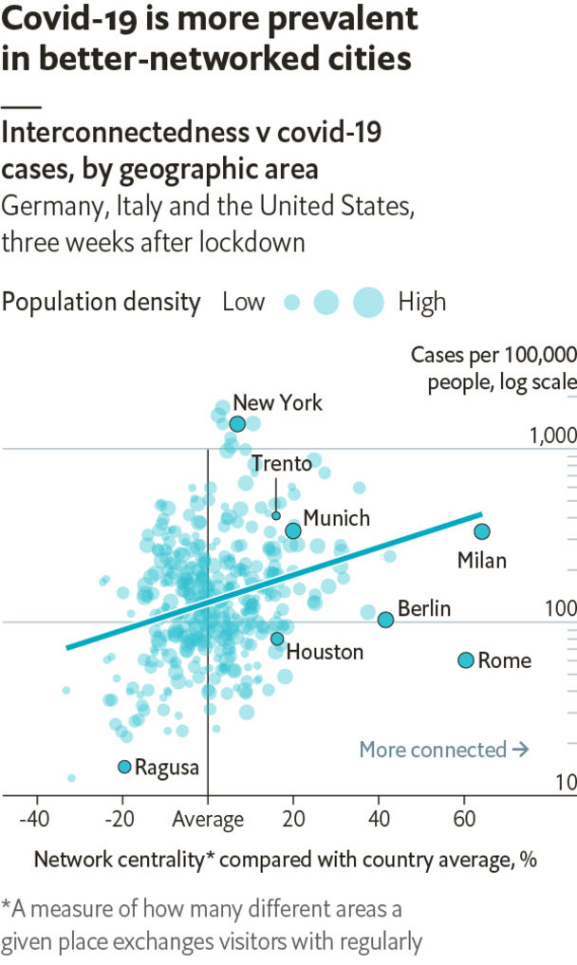

To test how interconnectedness affects vulnerability to covid-19, we built two statistical models to predict local infection rates during the period just before lockdowns. The first relied solely on each area’s population density and income. The second added on two measures of propensity for travel: its number of journeys and its “network centrality”, or how many other places it tends to exchange visitors with.

The more elaborate model fared better, with 30% more explanatory power than relying on population density and income alone. Interconnectedness matters a lot. In all three countries, better-networked areas had more infections than the simple model predicted. Less-networked ones had fewer.

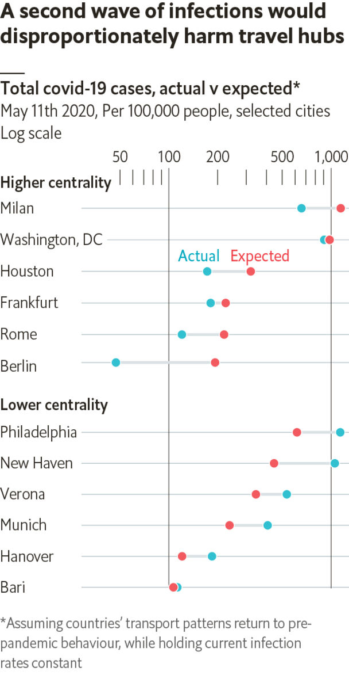

Governments should treat travel hubs with caution. So far, many German cities have seen surprisingly few infections—perhaps because the country tests widely, and began locking down earlier in its epidemic (as measured by the death toll) than Italy did. Now that Germany is easing restrictions, its infection rate may rise again. Well-networked Frankfurt is probably at greater risk than, say, comparatively disconnected Hanover, and should reopen relatively slowly. Milan in Italy, and Houston in America, should be cautious, too. ■

Sources: Teralytics; Eurostat; US Census Bureau; national statistics; The Economist

This article was downloaded by calibre from <https://www.economist.com/graphic-detail/2020/05/16/phone-data-identify-travel-hubs-at-risk-of-a-second-wave-of-infections>

|  |  |  |  |
| --- | --- | --- | --- |
|  | Articles | Sections | Next |

|  |  |  |
| --- | --- | --- |
| Graphic detail | Sections |  |

Obituary

Eavan Boland: Visions in the ordinary

.

|  |  |  |
| --- | --- | --- |
| Graphic detail | Sections |  |

|  |  |  |  |
| --- | --- | --- | --- |
|  | Articles | Sections | Next |

#### Visions in the ordinary

# Eavan Boland died on April 27th

The Irish poet who recovered and championed women’s voices was 75

May 16th 2020 |

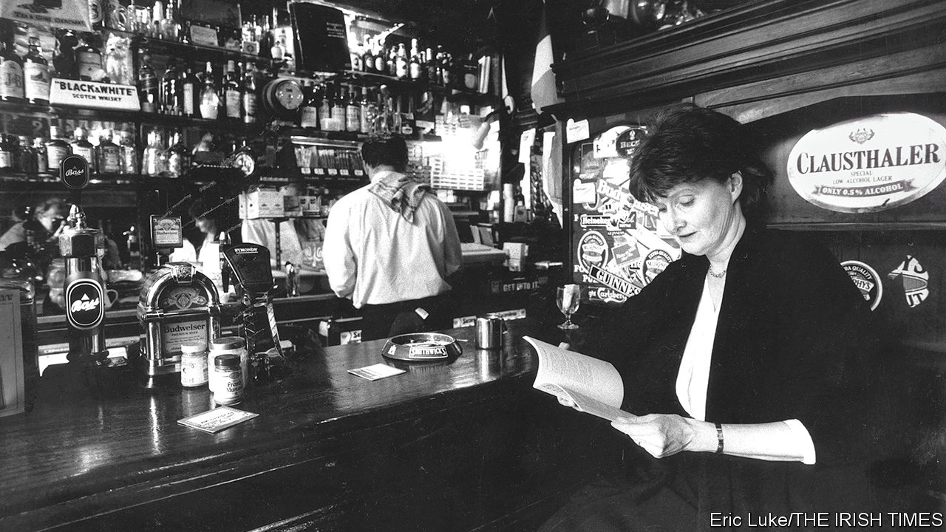

WHEN SUMMER nights were warm, Eavan Boland liked to stand in the front doorway of her small suburban house in Dundrum, outside Dublin. She would look at the buddleia, and at the lamplight glossing the leaves of the hedge. Yet these things were not simply visible to her. She saw them with her body. It was as if she was part of some great continuum, or stood in a place of myth, like the women singers she imagined in the hard west of Ireland whose mouths were filled with “Atlantic storms and clouded-over stars/and exhausted birds”.

This sense of communality, which led her to be one of Ireland’s finest poets, was essentially a woman’s feeling. And it was missing almost entirely from Irish poetry. There the voice was male, bardic, authoritative, grown sweet and self-confident on the flattery of princes. It was “I”, not “we”. The poet was a hero, a seer, a towering figure (Yeats above all), whose themes were history, epic and elegy. This was not a world for women. When they featured in the work they were mostly objectified, passive and silent. No page recorded “the low music/of our outrage”. Their own poems were not encouraged, as if they were women’s-magazine things that would defile the pure, visionary flow. If she were to write in the men’s style, with their assurance, she would fit right in, as she fitted into the clever literary conversations in the pubs round St Stephen’s Green when she was at Trinity College. But once she was married and the mother of two small daughters, happy if she could jot down just one line or one image, that was not her life.

Her days now revolved round cooking, washing up, nappies, feeds; lifting the kettle to the gas stove, setting her skirt over a chair to have it without creases for the morning. They were full of small untidinesses and oversights which assumed huge importance, like the loaf forgotten by the cash register, or washing left wet. They were full, too, of hidden satisfactions: a row of cups winking on their saucers, a copper pan well polished, fresh green celery feathers. Much of this was so ordinary that it might have seemed unremarkable. Certainly it was not named in Irish poetry. But ordinariness, “dailiness”, was precisely what she wanted to capture. The surfaces of things could barely hold what was under them; just as the small, routine gestures of many couples contained the unspoken steadfastness of love.

Other “women’s subjects” needed tackling more forcefully. She had no qualms about that. The whole poetic tradition had to be scrubbed and abraded with the wash stones of resistance. So an anorexic torched her witch-body, its “curves and paps” until, “thin as a rib”, she could slip back into Adam again, “as if I had never been away”. A menstruating woman confronted the moon, “dulled by it/thick with it…a water cauled by her light…barren with her blood.” Shockingly, a wife who believed “I was not myself, myself” in her everyday dutifulness felt herself remade when her husband, coming home tight, split her lip and knuckled her neck “to its proper angle”; and was grateful for his remodelling.

Yet the all-too-ordinary often slipped into something else. She was too deeply read in the myths and epics of Ireland for it to be otherwise. The life that was lived in a brick house could still have a visionary quality. In “Night Feed”, she noticed not only the rosy zipped sleeper, the hard suckling, the silt of milk left in the bottle, but the movements of earth and stars, and the “long fall from grace” as the feed ended. The stopping of the tumble-dryer, like death, began “to bury/The room in white spaces.” An old florin, brushed on a shelf, turned into a silver salmon.

That everyday life was also not remote from history. But she preferred to call it The Past: a place of shadows, fragments, defeats, rather than heroics. The Troubles appeared, through an ancient television set, as “grey and greyer tears” and “moonlight-coloured funerals”. Emigration to America was a woman in a gansy-coat on the deck of the Mary Belle, holding her half-dead baby to her. In “Quarantine” the worst year of the famine, 1847, was encapsulated in a couple found frozen, he still carrying her, holding her feet against his breastbone to try to warm them. Just two people’s deaths, how they had lived, what they had suffered,

And what there is between a man and woman.  
And in which darkness it can best be proved.

Such themes were inevitable, for her discovery of her woman’s voice in poetry was meshed to her discovery of Ireland. She had left that home at the age of six, when her diplomat father was posted to London and then New York. When at 14 she returned, she did not know the secret language of the country, especially of Dublin, which she grew to love. As a woman she saluted “Anna Liffey” as the river rose in the hills above her house, flowing through black peat and bracken, then claiming and “retelling” the city for her, putting the pieces together, as she went on trying to.

Ireland, though, could still disappoint her. In 1991, when the monumental Field Day Anthology of Irish Writing came out, she was one of only three contemporary women poets included. Furious, she fired up her campaign for women to be noticed and, through poetry workshops, for poetry to be extended to all who had no voices. After 1996 a professorship at Stanford, alternating with trips home, allowed her to check on progress from abroad. By the 21st century, to her delight, women poets were flourishing in Ireland, and two new Field Day volumes were devoted to women’s writing. Though she never liked to take credit, she had been a voice and a constant encouragement; she had changed the conversation.

Make of a nation what you will  
Make of the past  
What you can—  
  
There is now  
A woman in a doorway.  
  
It has taken me  
All my strength to do this.

This article was downloaded by calibre from <https://www.economist.com/obituary/2020/05/16/eavan-boland-died-on-april-27th>

|  |  |  |  |
| --- | --- | --- | --- |
|  | Articles | Sections | Next |